Subscribe to DeepL Pro to edit this document.
Visit www.DeepL.com/pro for more information.
Haesh A. И.

Materials of the meeting with Meishe Yakushko on 26.04.1999

A Trip to Meisha Yakushku in Kiryat Yam
Meishe Yakushok lives in the Haifa suburb of Kiryat Yam on Pinchas Sapir Street 3/5 on the 2nd floor. From Haifa, bus number 59, near the end of the route.
Meichet was born in 1914. His wife is from Plunge. He is not a good storyteller, which is more due to his age than to a language barrier, since he speaks Russian correctly and does not confuse cases, accents and verb forms.
The conversation, which lasted a little over an hour, was, as I expected, uninformative, but still yielded some new bits of knowledge and, quite valuable, Meichet identified quite a few new faces in the photographs.

Contents of a talk on transcribing a sound recording
I was born in Zeimyalis. I came to Israel in 1969, and before that every year we would gather and go to Zeimyalis to the pit where they were buried (that is, he didn't live there immediately after the war). There were two synagogues in Zeimyalis.
I knew Lazer Haesh and his wife Frieda.
That's where we lived near the bazaar. (I show Meisha the plan of Žeimialis to show him the place where the Jacks lived. I show him the main landmarks: the church - 7, the church - 36. When I show the house of Leizer Haesch - 2 , Meishe specifies).
Leyser Haesh had three houses . He traded in flax and wheat. (Meisha has a hard time figuring out the plan, he can't show his house). There is a Tarutz. Iron Store. We lived near Tarutz. My father used to sell apples. We grew them ourselves.
When they were being chased to the pit, I was told that Leizer Haesch said in Latvian, "Glabet, glabet!" (He can't find the Russian word, I ask him to say it in Yiddish.) "Ratevet, ratevet!" (I translate: "Rescue, rescue!" Meische repeats, "Rescue, rescue!").
There Iser's store was near Leizer Haesh, selling manufactures, Iser, Iser.
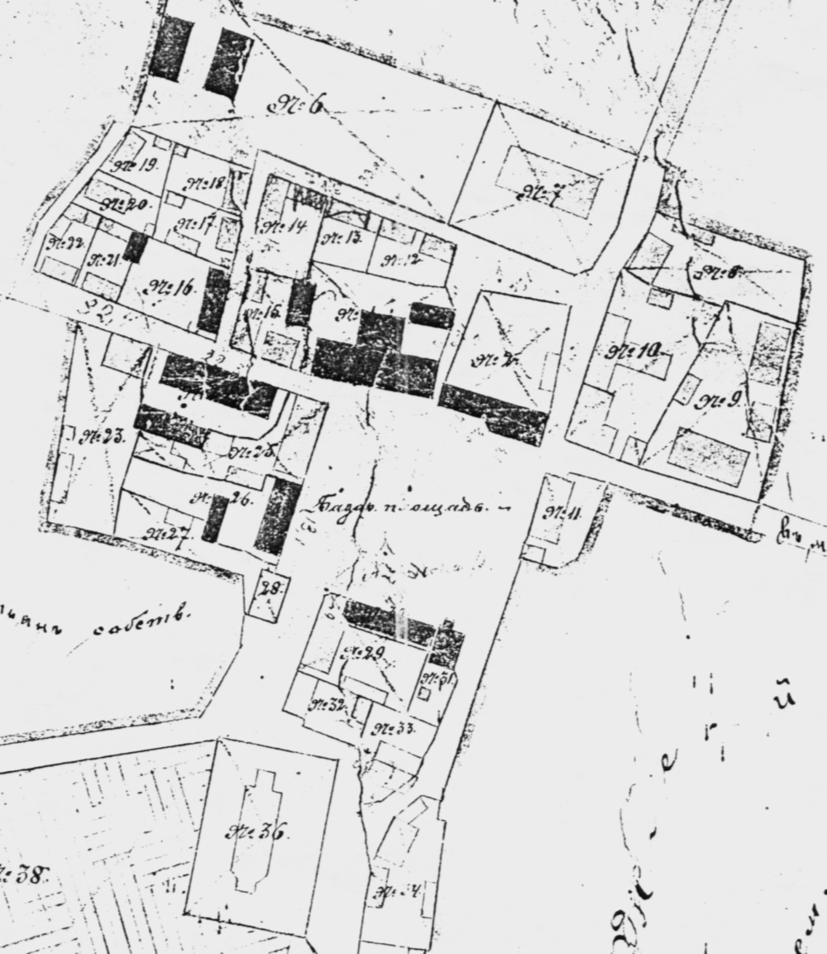
Fig. 1. Plan of the place Zeimeli. 1897 (partial excerpt)
I first went to cheder and then to high school. (Showing photo 7-1 , asking me to name the people I recognized.)
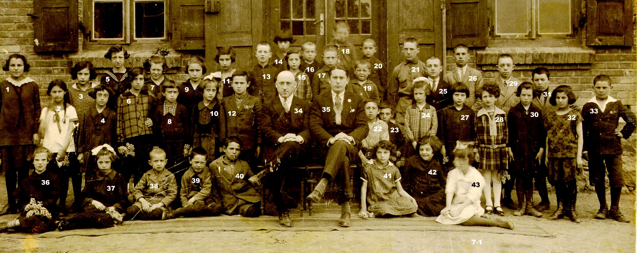
Fig. 2. Teachers and students of the Jewish school. Paschalis
35 - Volovitch Zyamka (Zalman). He was a teacher. He taught all subjects.
34 - the second teacher. There were two of them, I don't remember his name.
1 - Hanka Singer, confidently recognizes.
5 - Rohka Itkin.
7 - Rohka, she was a hairdresser later, I forget her last name.
12 - Leibke Gans (? doubtful, see below).
17 - Dovidka Tarutz.
40 - Meike (Meir) Yakushok.
42 - my sister, Basya Yakushok. She died in Tel Aviv.
19 - My brother Israel Yakushok.
26 - Itzka Burstein.
25 - Leibke Hans (I point out that there were already 12 Leibke Hans). Meische says, "I don't remember," - that is, he can't identify exactly. Then he clarifies, "It's Itzka Ganz. There were four brothers."
There are no Lithuanians in the picture. It was a Jewish school. It was built around 1935. There was a school and a base-midrash there .
29 - Orca, I don't remember the last name.
31 - Faifka, I don't remember the last name.
33 - Oh, it's me, Meishe Yakushok.
(Goes back to number 25 again and states definitively: "Leybka Ganz").
6 - Etka Burstein.
10 - Hanka Gel.
(Showing photo 3-3).
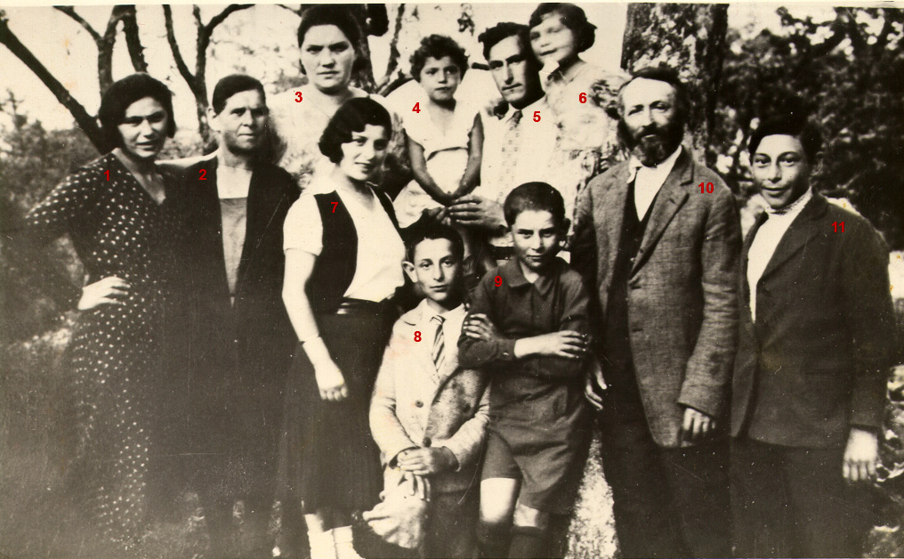
Fig. 3.
7 - Stirka.
5 - Tsalka.
9 - Haimke Jakushok.
(I show Figure 4-3).
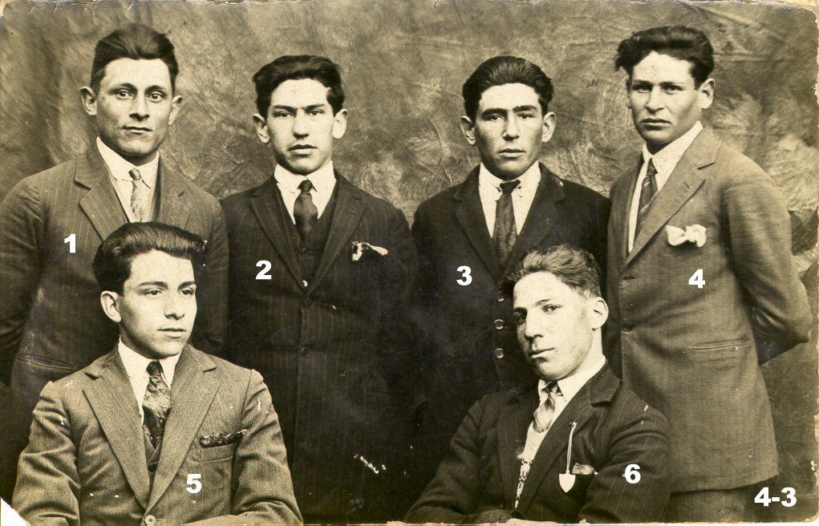
Fig. 4
1 - Feifke Ganz.
2 - (I do not agree that it is Hirschke Kremer).
3 - tailor.
4 - Tzemach Yakushok.
5 - Leibke Gans.
6 - Eruhim Man.
(I show Figure 6-2).
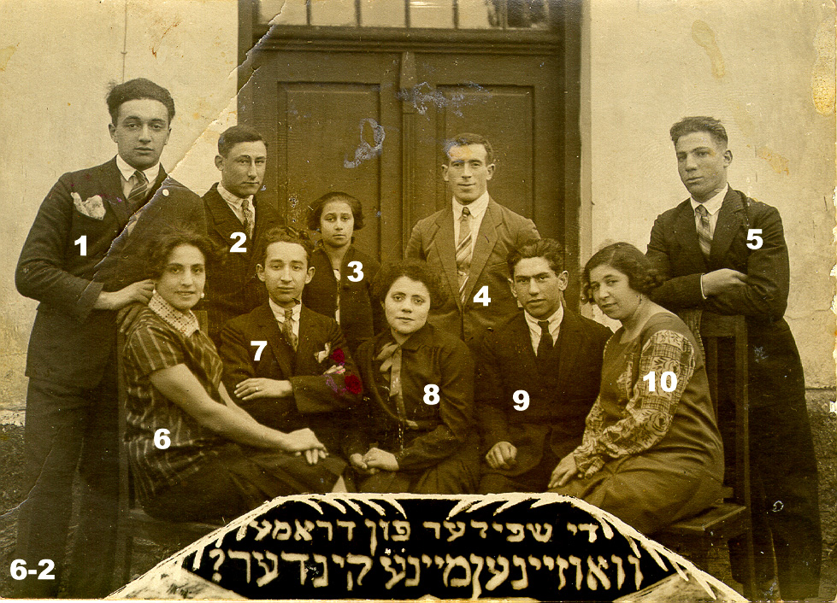
Figure 5 . Players in the drama "Where Are My Children?
1 - Boruch Itkin.
2 - Tsalka.
3 - doesn't know.
5 - Eruhimke Man.
4 - That's right Simcha Tabak is in Africa. I met him at a wedding in Tel Aviv.
6 - Hodke Yakushok.
(I show Figure 7-2).
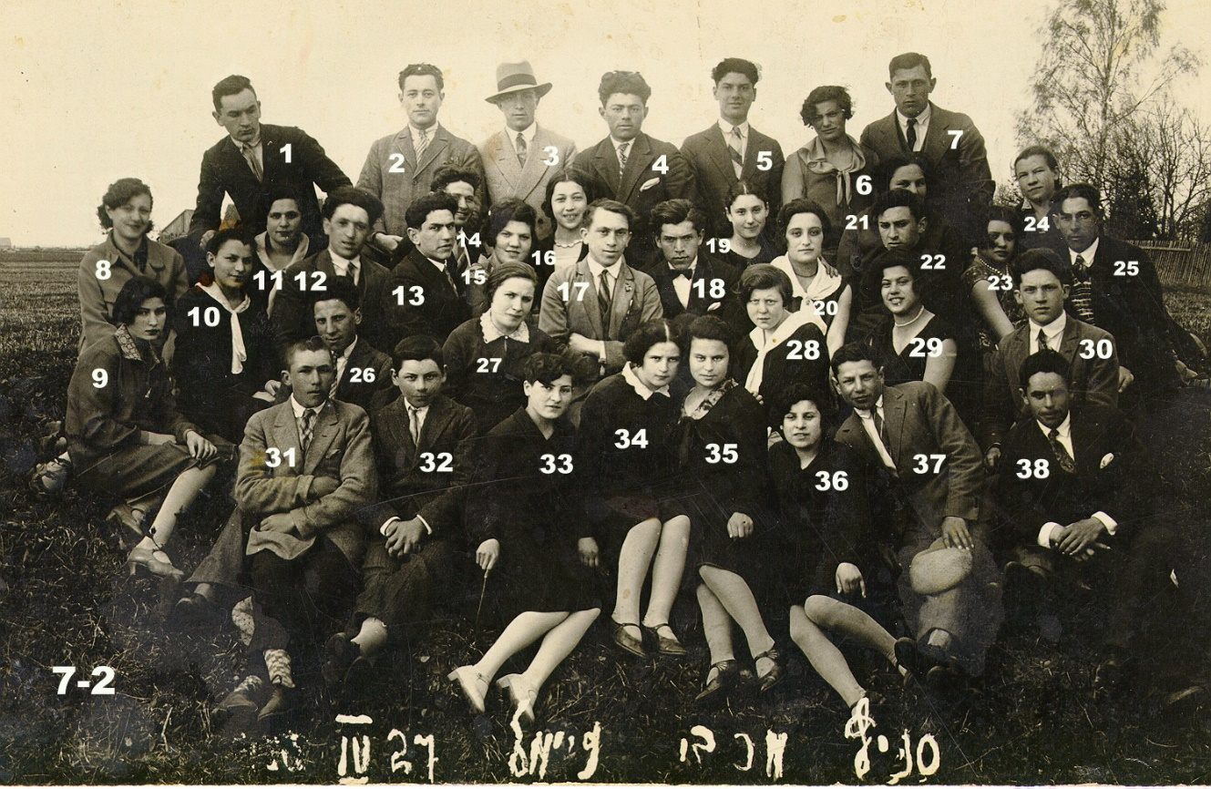
Figure 6. Maccabi's unit. Zeimelis. April 1927.
32 - I, Meishe Yakushok.
31 - Mateske Lakunishok.
16 - Zelda Lakunishok.
26 - Orca Man.
38 - Levi Yakushok, my older brother, he didn't go to school, he was in yeshiva in Ponevezh.
12 - Dovidka Tarutz.
15 - Lib Man.
35 - Haika Marchunska.
3 - Shifka, right, Tobacco.
20 - Door, that's right, Schneider, she lived in the beis midrash.
19 - Etka Burstein.
28 - Rochka Glaeser.
(I show Figure 9-1).
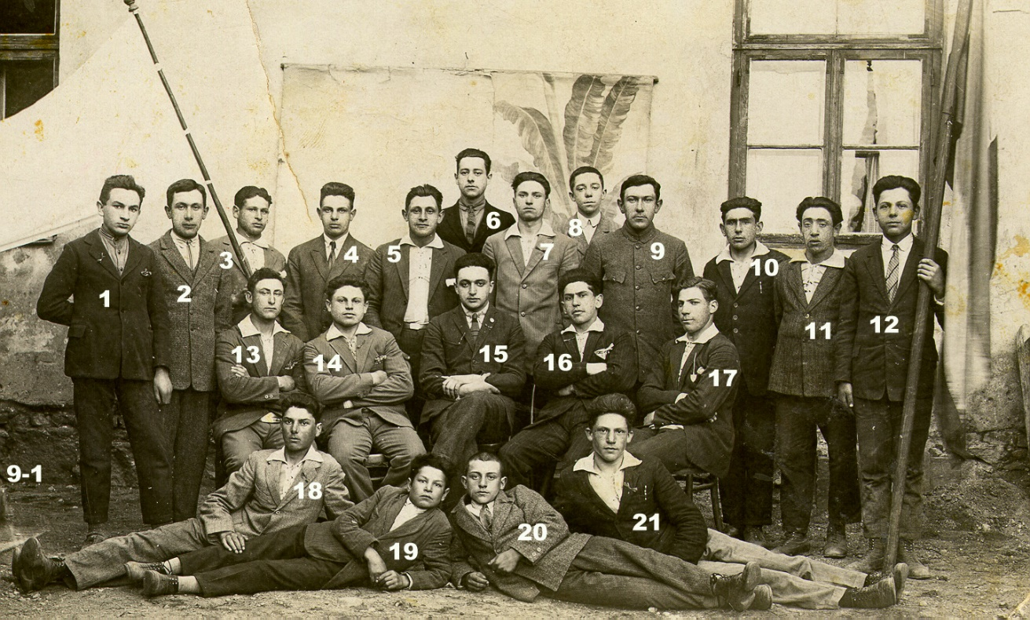
Fig. 7.
13 - Tsalka Marchunsky.
15 - Boruchke Itkin.
18 - Itzka Burstein.
17 - Orca Man.
8 - Sroelka Hayes. He was a photographer. He was the only son of Hana Hayes. He went to Linkuva and lived there, and Hana stayed in Zeimyalis.
4 - Zyamka Beder.
5 - Yakushok from another branch, name not remembered.
There were never any pogroms in Zeimyalis. There was a sanitary doctor, Uzenas, who checked the cattle. Fleischmann, Mateske Lakunishok, Man the old man, but not Leyser and the fourth. They wanted to make a pogrom. Came from Siauliai and closed the case properly. They got ten years each .
There were two fires. I put them out. My father saw the fire at 12 o'clock at night. Cattle on the farm were burning. There was arson. Tanczkunas and Dunda. Lithuanians. When my father went out a week later at the same time, there was a second fire. Ten or twelve years before the war.
During World War I, only Lakunishok left. And we were not kicked out. The Germans were in Zeimelis. I remember a German put me on a horse. All the Jews made cupcakes for the Germans, so there would be something to eat. We went to Riga. We lived in Zolotonosha in the Ukraine during World War I, and then we came back.
(We must assume that all these facts refer to the period after his return, because in 1915 Meichet was a year old and exile he could not remember).
When they built the school, they eliminated the cheder.
We left in World War II on bicycles and on foot. For the first four days we waited for the Russians to go back (it should be understood that the Russians would chase the Germans). There were 5 brothers in the family, 2 were killed. The elder Leivi was a rabbi, he was in Kaunas at the beginning of the war, he ended up in the ghetto and from there he was taken to Germany. The second brother Hatzke was killed (at the front).
I was in the Zionist organization Beitar. Geneche Tarutz was the leader of Beitar.
In the Smetona days, I was in "Akhshara," an organization that prepared me for emigration. I wanted to go to Israel.
I knew Leyser Man, he was a butcher. Meike Man was his son, I met him in Siauliai. I worked there in the post-war years as a store manager. Before the war I worked, I don't remember who.

Formatting, illustrations and explanations of the text - the author of the publication.
The number is illegible, there may be an error in its definition.
These houses do not appearon the 1897 plan.
All photos are numbered by Barry Mann.
The Beth-Midrash (בֵּית מִדְרָשׁ, house of learning; place of Torah study and especially Mishnah, Talmud, and post-letalmudic rabbinic literature.
The information is not very accurate. For details and accuracy see Anatoly Haesh "Lithuanian "Beilis case" (1930-1931)" in the almanac "Jewish Starina" #2(49) March-April 2007. Haesh1.htm (berkovich-zametki.com) Accessed 24.05.2022.
Copied from the surviving document - "Plan of the town of Zheimeli owned by landlord Prince Anatoly Pavlovich Livin, Kovno province, Ponevezh county. Compiled in 1897". The original plan is at the Lietuvos centrinis valstybės archyvas (LCVA). Ф. 1250. Opt. 3. Д. 7737. P. 727 (Lithuanian Central State Archives).
Zeimelis 3-3 1934 Text.jpg (1016×628) (mannbarry.net) Date of reference 2.06.2022.
Zeimelis 3-3 1934 Text.jpg (1016×628) (mannbarry.net) Date of reference 2.06.2022.
Zeimelis 4-3 Text.jpg (1021×656) (mannbarry.net) Date of access June 3, 2022.
Zeimelis 6-2 Text.jpg (979×706) (mannbarry.net) Date of access June 3, 2022.
Zeimelis 7-2 Text.jpg (1498×976) (mannbarry.net) Accessed 4.06.2022.
Zeimelis 9-1 Text.jpg (1442×869) (mannbarry.net) Accessed 4.06.2022.

