Subscribe to DeepL Pro to edit this document.
Visit www.DeepL.com/pro for more information.
Haesh A. И.

Proceedings of the second meeting with F.J. Zagorski on 9.09.1983
Memories of Fayvl Yosifovich Zagorsky

Tape recording in Leningrad 9.09.1983
The old German baron gave his land for the synagogue in Jemelah and gave his building material.
------
In the synagogue Fayvl remembers such utensils: a horn to blow the trumpet on the new year, called a shofar in Hebrew, then a finger, apparently a pointer, which was used to lead the prayers, and finally a very beautiful silver plate, the size of a regular-sized book, on which were inscribed the Ten Commandments of Moses. The plate was suspended by the edges on two chains and hung in the most honorable place, apparently in front of the ark.
------
Fivel remembers that Leyser's face was red.
------
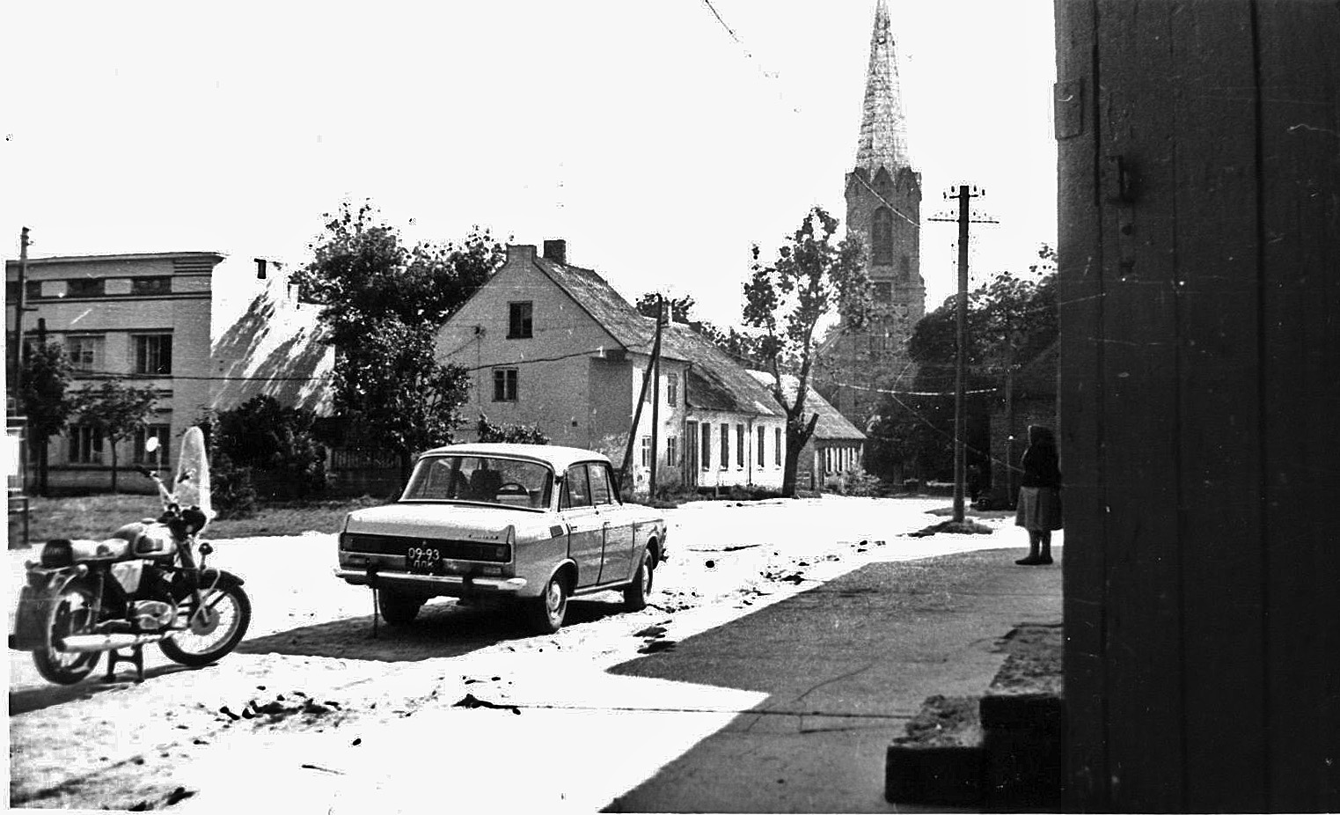
Fig. 1
On the back of the photo text in pencil: "18. Bazaar square. View towards the Lutheran Church. Behind the car is the house of Rosa Abramovich (presumably). On the left is a house built on a plot formerly owned by Leiser Haesch. 31.08.1982. Photo by A. Hayesh ".
About picture #18 of 31.08.1982 he, Favel, said that the leftmost house belonged to Shulgeifer and was built by him on the site of a long old building, like a barn, which belonged to Leiser Haesch, and it together with the plot was bought by Shulgeifer. The corner house belonged to Abramovich, who married Schulgeifer and took his last name. There used to be a door off the corner. The one-story house adjacent to the corner house is Abramovich's pharmacy. It was entered through a door on the left side of the house. Then at the very kirk is Milunsky's one-story house. In the corner house Ehrlich rented an apartment from Schulgeifer. Fayvl's own house was closed by these houses. It was on the street that runs in front of the kirk, to the left of the Milunsky house and not next to it. In the house that stands on the corner, in the room whose window overlooks the door of the apothecary, Fayvl played chess with the apothecary Schulgeifer.
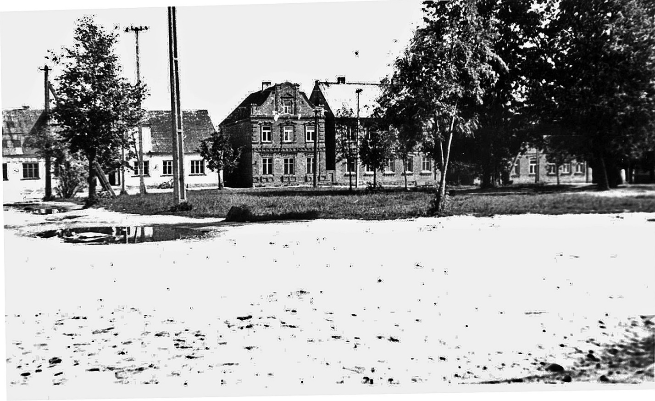
Fig. 2
On the back of the photo text in pencil: "17. Bazaar Square in Jaimele. View towards the house where the canteen is now. 31.08.1982. Photo. A. Haesh.
Picture #17 on the left is the house inherited by two cousins of Zagorski, not related to Faivel. The left half of the house belonged to Nisha Zagorski and the right half to Velvl Zagorski. Then facing the square is the house of Leyser Zagorski. Down there, as in all the other houses, was a shop. It belonged to Wasserman, and in 1923 Faivel went to work there as an errand boy. Then the two-story house of the Lithuanian Bunis.
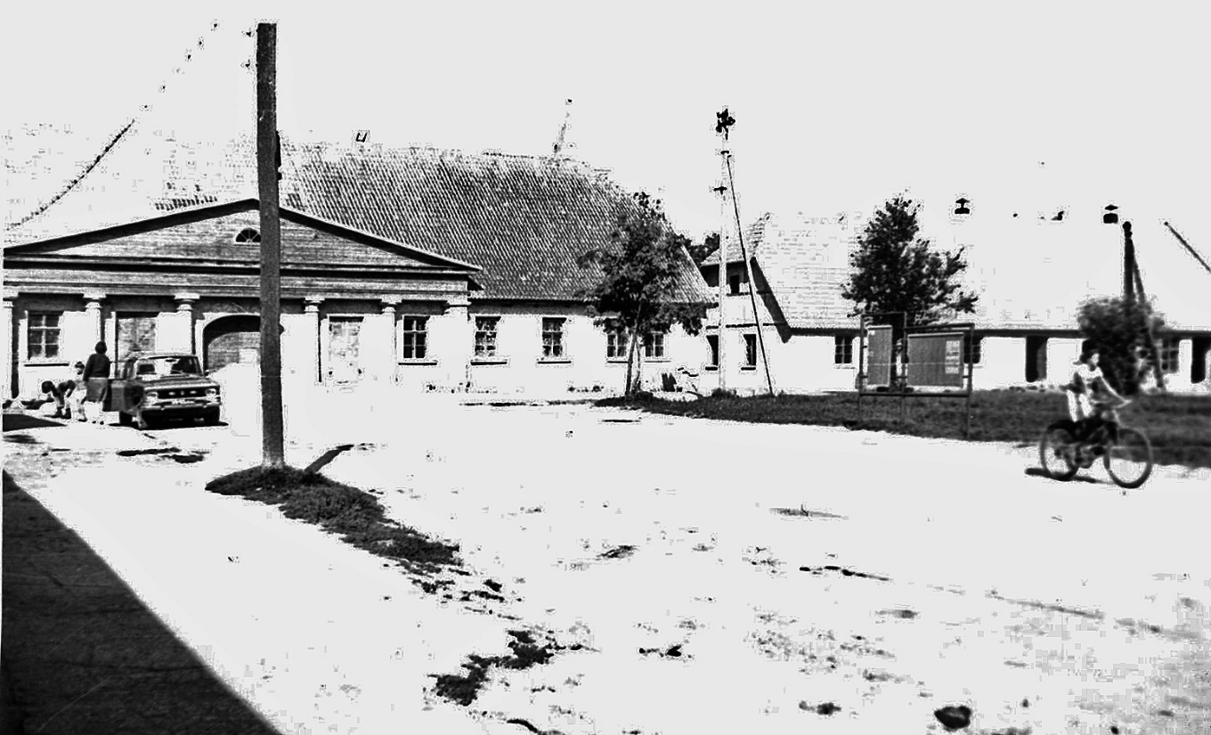
Fig. 3.
On the back of the photo text in pencil: "16. Bazaar Square in Jaimele. On the left is the house of Israelson, on the right is the house of Leiser Haesch. 31.08.1982. Photo by A. Hayes.
In picture #16, the left house belonged to many owners. The latter: to the left of the gate - Vilenchik, and to the right - Izraelson. There was a large mill in the yard.

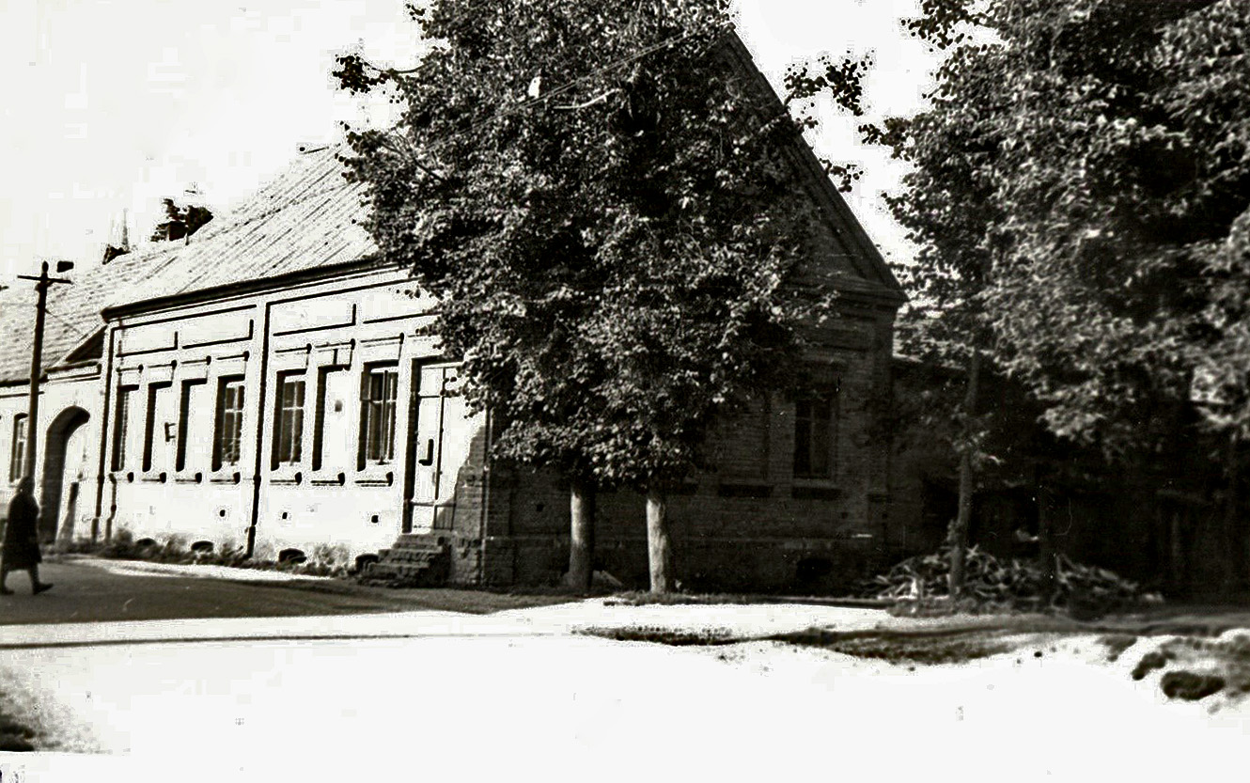
Fig. 4
On the back of the photograph is text in pencil: "12. The house of Leizer Haesch in Žeimeliai, closest to the church. 31.08.1982 Photo by A. Haesch".
Picture #12 shows the house that belonged to Leyser Haesch. On the corner was the bakery of the Lithuanian Kaushastis, whom Faivel had met in Žeimelės in 1946. There was a drive-in gate, as Faivel said - a drive-in courtyard.
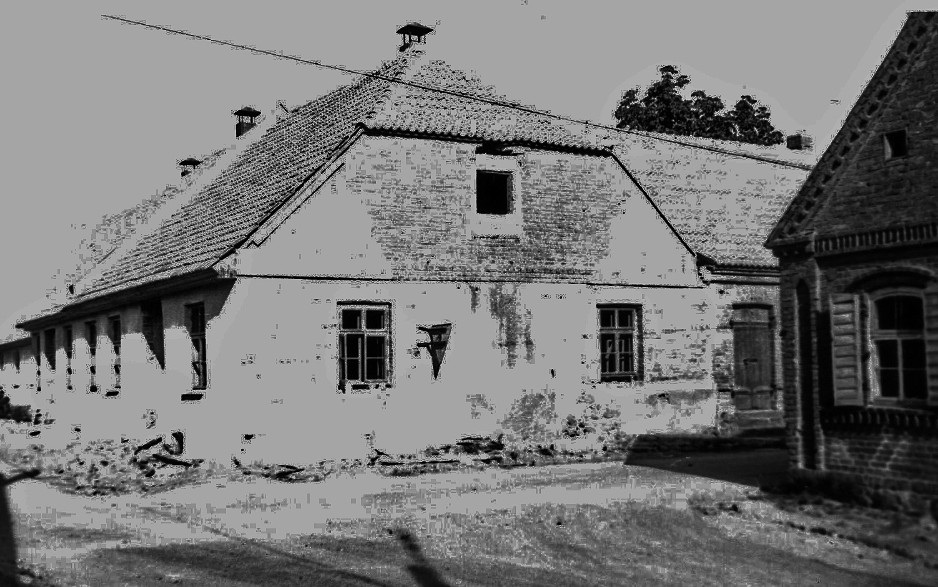
Fig. 5
On the back of the photograph is text in pencil: "7. The main house of Leiser Haesch. Overhaul. On the right edge of the house of Matys Haesh. 3.08.1982. Photo by A. Hayesha".
Picture #7 is the main house of Leiser Haesch. From the corner two windows are the shop, and then the two windows of Leyser's apartment and the door of his front door. But Faivel went to Leyser's from the courtyard. There was a drive-in courtyard from the square to the gate. On the right side of the picture you can see Meishe Haesh's house. On the left in it is the window of Wolfson's manufactory shop, and on the right is the barbershop. From Bauska Street the Meische house housed the militia, from the corner a little farther away.

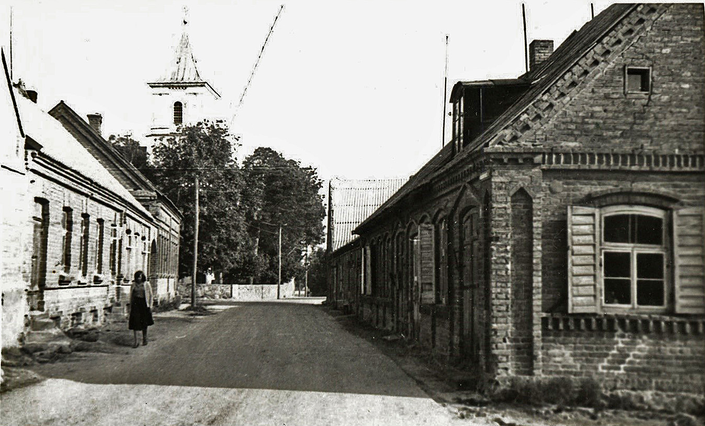
Fig. 6
On the back of the photo text in pencil: "3. View from the square. In the foreground on the right is the house of Matys Haesch, inherited by Moses Haesch, behind it the second house of Moses, the last house, probably also belonged to him. On the left is the house of Leiser Haesch. In the background is the church. 31.08.1982. Photo by A. Haesh".
Picture #3 shows the Meische house on the right and the former Leyser barn on the left, where they tried to set up an electric mill.
------
Faivel says that he knows the surname Strashun, because the Jews of Jeimel said that they were some kind of kinsman of the Strashuns. But who said this and in connection with what, Faivel does not remember. But he does know that there was a Strashun library.
------
Faivel left Jaimele on the Wednesday or Thursday after the outbreak of war. He was working in Siauliai at the time and came to his mother in Zeimeli on Saturday, 21. On 22 the war began, and on Thursday evening we left, he specifies. The Germans were in Kaunas on Tuesday, and they didn't go into Zeimeli at all. The Lithuanians shot everyone, and they say they spared a bullet for my mother, so they threw her into the pit alive.
After the war, on the last Sunday in August, about 30 people came to the pit. They collected money for the fence and the cement slabs that were used to fill the pit. The last time the Jews were at the pit was four years ago. They applied to the administration, asking why the monument wasn't made, and they were told to write a letter. They don't give us any money for that. Back in the 70s, there were about 30 people.
Faivel points out that all Lithuanian localities are wooden houses, while Žeimeli is all stone houses.
------
Fivel asks for copies of #3,14,16,18.
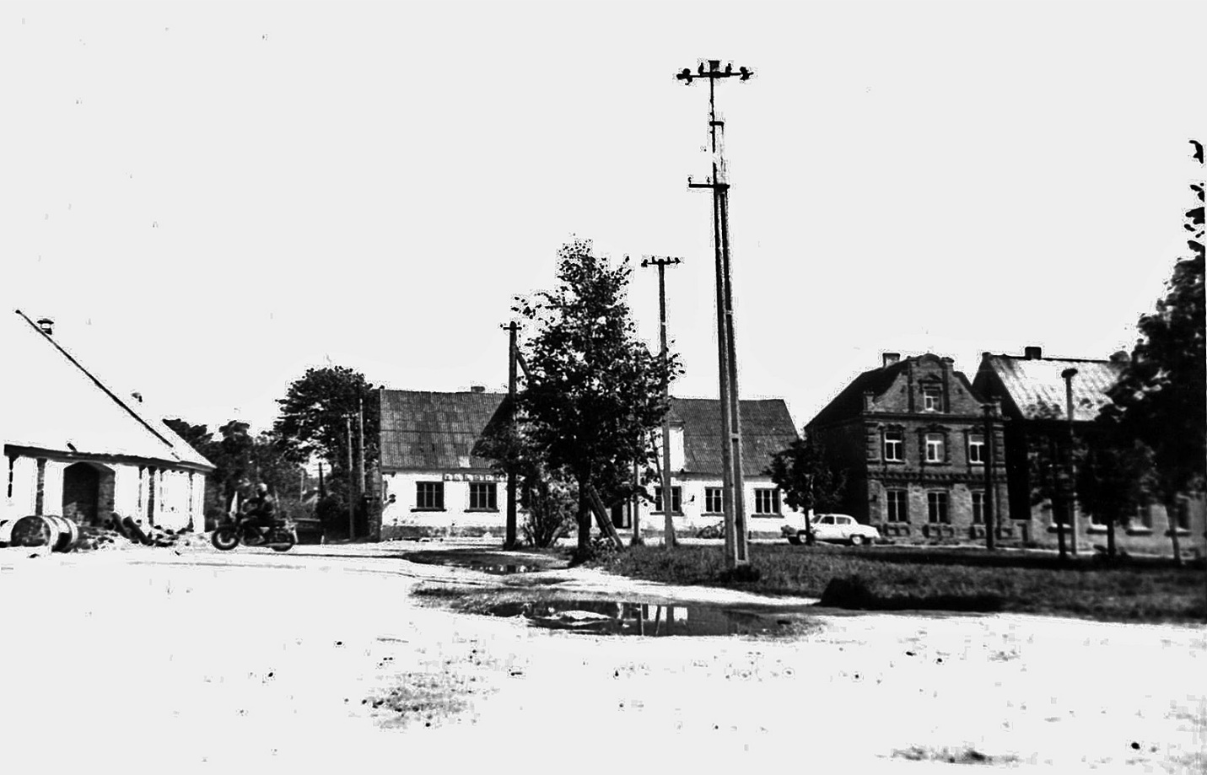
Fig. 7.
On the back of the photo text in pencil: "14. Bazaar square in Jaimelei. On the left is the main house of Leizer Haesh, on the right is Pasvalio Street, then the house with the canteen. 31.08.1982. Photo by A. Hayesha".

Formatting, illustrations and explanations of the text - the author of the publication.
Presumably the German Baron Grothuß (Gro=Bersteln und Neuhof // Kurlänische Güter=Chroniken, mit urkundlichen Quellen zusammengestellt und herausgegeben von Friedrich Khlopmann, Kurländischem Landbeamter ErsterBand/ Mitau, 1856. Pp. 193. Cipher of the Russian National Library 13.18.4.56.
All photos were taken during the author's visit with his father Zheymyalis on 31.08.1982. In January 2022 all photos are improved by Barry Mann (USA).

