Subscribe to DeepL Pro to edit this document.
Visit www.DeepL.com/pro for more information.
Haesh A. И.

Proceedings of the Third Meeting with F.J. Zagorski 7-8.08.1987
Memories of Fayvl Yosifovich Zagorsky

Handwritten entry in Leningrad 7.08.1987
Jewish Library in Zeimelis
I first entered this library in 1923 as a reader. The people in charge at the time were Yudel Rappoport and Abram Ehrlich. There were 250-300 books in the library at that time. The library was located in the Hera house in the mezzanine (semi-blackroom), behind the Big Inn on Joniskis Street. On the side of the inn it was the next house to it, the Hera house. Behind it is an alley and the house of Hai Haesh.
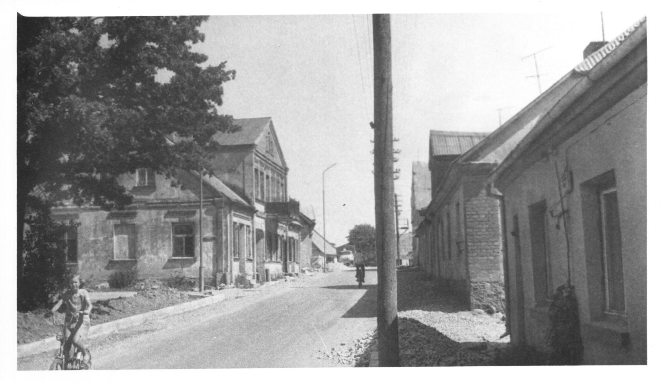
Fig. 1. Joniskis street. On the right front left wing of the Big tavern, behind it the house of Hera . 17.07.1983
In 1927 the Jews built an elementary school and a room in it was set aside for a library. The books were Sholom Aleichem, Sholom Ash, Gorky in Hebrew, Dostoyevsky in translation, Artsybashev.
Readers were charged 25 cents a month, then there were amateur evenings: performances, theater. There was Gordon's play "Orphan," "The Village Boy. The proceeds went to the library. There was an audience of about a hundred or more. Performances were in the Lithuanian gymnasium. The play "Mirele Efros" by Gordon was staged. The library in Kaunas was replenished with it. Zagorski drove around for books himself. The books were given out by Faivel Zagorski once a week on Saturdays. He was the chief custodian of the library.
The library had a reading staff: Leizer Milunsky, Hirsch Kremer, Faivel Zagorski (in 1935) .
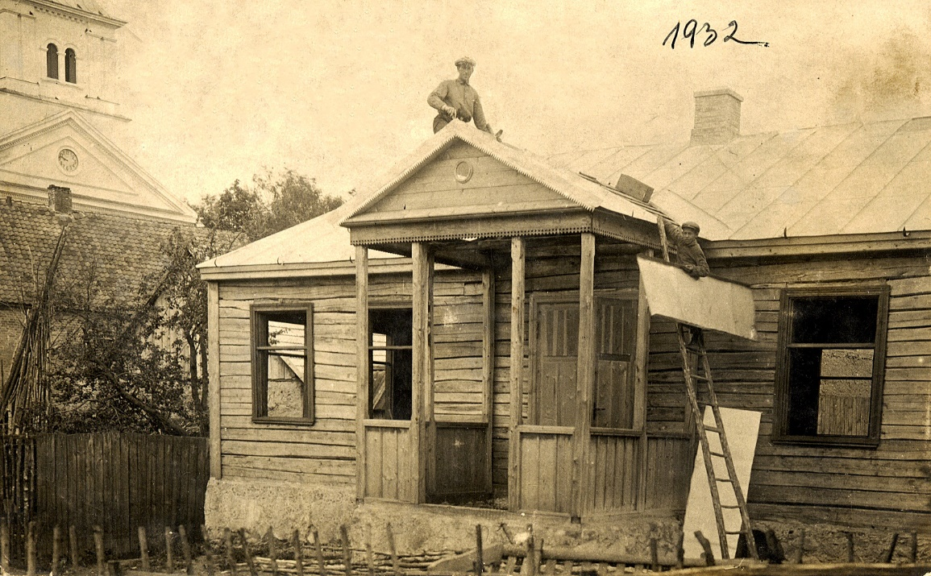
Figure 2. Jewish school before construction was completed
At that time Rappoport and Ehrlich left. Ehrlich to Africa and Rappoport to Israel. The library existed while Zagorski was in Žeimelis, and he left to work in Šiauliai in 1940. Further fate of the library is not known to him.

Handwritten entry in Leningrad 8.08.1987
Navet
In 1929, there was such a story in Zeimelis. Before, everyone used to slaughter cattle in their homes. But this year they made a slaughterhouse, and the carver slaughtered the cattle in the slaughterhouse. Before slaughtering the carcasses, they invited the inspector from the neighboring customs office. It was Saturday, after the lighting of the stars. The customs officer was late and came very late. He checked the carcass and went home. And there was a well next to the slaughterhouse. The log cabin had been taken apart and so there was no fence. Everybody knew that and didn't go there. And for some reason the customs officer went a little differently in the dark and fell into the well.
His wife grabbed him because he didn't come home. She ran in, got the people up. They started to pry into the well and lifted up the body. The Jews were accused of premeditated murder. There was a high-profile case all over Lithuania. It dragged on for a long time. Although there were non-Jews among the buyers, because Jews do not buy the back of the carcass, and although the buyer was a frail man who could not kill in any way, the case took a bad turn. The Jews were sentenced to 15 years.
Then the community began traveling all over Lithuania, collecting money for lawyers, etc. They collected 15,000 litas. The case was reconsidered. But still the Jews were not acquitted, although they were given a sentence of 1.5 years instead of 15 years. It was the most high-profile case in Zeimelis.

Formatting, illustrations and explanations of the text - the author of the publication.
Big tavern is the historical name of the house with columns, the left wing of which, looking from the facade, belonged to Vilenchik, the right one to Izraelson.
On the back of the photo, text in pencil: "18. Zeimyalis 17.07.1983. Joniskis street. View from the Bazarnaya Square".
The personnel of the library board are described in detail by Zagorski (see entry dated 4.06.1989).
Photocopy of Barry Mann from a photograph from the personal archive of Israel Yakushka. Which of the dates of construction - 1927, named by F. Zagorski or 1932, marked on the photo is more reliable, it is difficult to say.
The subject of the slander is stated by Zagorsky in somewhat more detail (see entry from 3.06.1989).

