Haesh A. И.

Proceedings of the fourth meeting with F.J. Zagorski 4-5.08.1988
Visiting Zagorski in Kaunas

Yukna's list
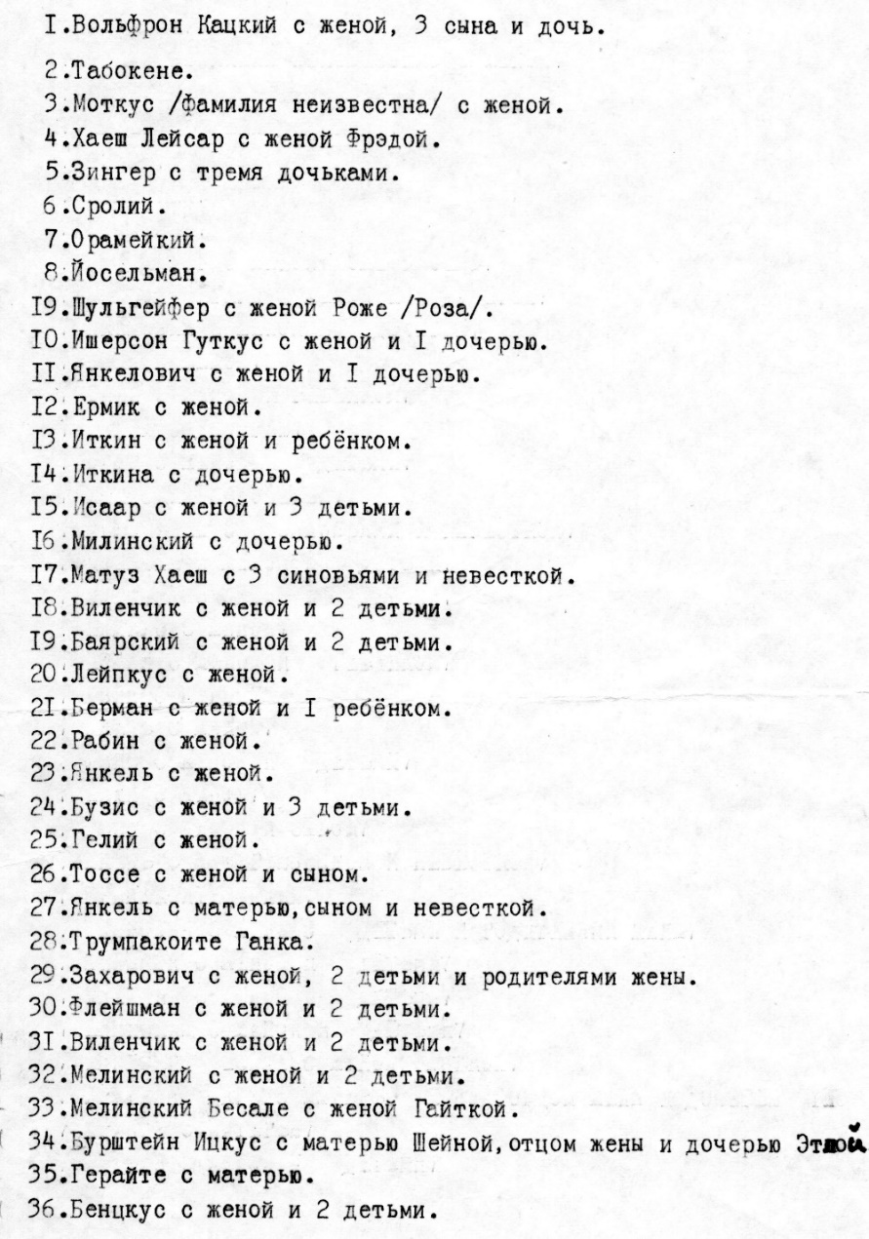
Fig. 1. List of Jews of Zeimelis shot on 8.08.1941, compiled by J. E. Jukna in 1983.

Zagorski's comments of 4.06.1988 to the list compiled by Jukna
1. Wolfson Hatze and his wife (fat, big, can't remember the name), three sons Abe, Schmerl and ..., daughter Ginda. Abe became a tailor after the war (WWI). His father Hatze went around the villages before World War I and sewed for whoever ordered. Hatze's other sons had a grocery trade. They bought a house from Abramovich and lived near the village hall.
2. Tabak Eta (~70 years old) and her mother Sheina (~90 years old). Age given by 1941. Both did not work, lived on Yoniskis Street, and were dependent on children. The children were adults. One was married in Palanga, the second daughter was married in Africa, the third was married to ... (there were 4 daughters and 2 sons in all).
3. there was no Motkus in Žeimelis. There was Motel Yakushok. He evacuated before the Germans came, then went to Israel and died there at the age of 95.
4. haesh - clearly.
5. Singer died, his grandchildren all went to Siauliai and all escaped (Basia, Hane and 2 other girls). He was a clay pot dealer, died ~1930-1933.
6. Srol Berman. Evacuated with Zagorski Srol and his wife and children: Zalman, Leibl, Rivka. Zalman was in the war, lost an arm. Leibl was hunchbacked, they didn't take him. Lost sight of them.
7. Oramer Zack. An old bachelor. Pauper. Always someone will feed him. Something he will help, he will be fed.
8. Josel Man. His widow and her daughter Feige Man. He was a merchant, had many houses, lived off the rent, and traded in linen.
9. Shulgeifer Abram and his wife Rosa. Pharmacist, b. 1895 They lived in a corner house, in a pharmacy. Childless. The child was adopted in 1928. At the time of the execution he was 13 years old. He was rescued by the priests of Zeimialys and Lauksody.
10. Israelson Iser with a daughter and two sons (Berlom by his first wife, and by his second son Mendele, daughter Dweirele). Wife number two Bryna. A manufactory shopkeeper. Large store in the Great Inn on the corner. Iser owned half of the Grand Inn.
11. Elia Yankelevich and his wife (2 daughters, but they were not in the action).
12. Yermik and his wife - no such thing.
13. Itkin Boruch. Haya's wife, a boy of a year and a half, Boruch's mother-in-law Zerna Kremer, and Hana Itkin's mother.
14. My mother-in-law was not in Žeimelis.
15. Iser was only Israelson. There were no others. See #10.
16. Genese Milunska and her daughter Pepa. The rest of the children (all Milunskys) lived independently. Genese kept a grocery store.
17. Such a thing does not know, did not happen.
18. Vilenchik Simhe, wife Feiga and two children (Tufka and Dweirele). Large merchant in flax, and then bought 13 hectares of land and went out to live for the locality. Had eight cows.
19. Mendel Boyarsky, Hase's wife and boy Avremele, Hanele's daughter. Hase's wife had a grocery store, and he had a bus and took passengers to Siauliai.
20. Leipkus and his wife. There are none of these.
21. Berman Benyomin with his wife and two boys. She gave the boy to the farm "as a boy" (a laborer). On the eve of the execution they brought him back. They demanded that [the owner] give him back to his mother. Berman was a tailor.
22. Schneider (rabbi) with his wife and two children. He said, "Let us die with dignity in the name of G-d.
23. Yankel Karo and his wife. They live in Leningrad. A letter was received about him, that he had died.
24. Ehrlich Buzya with his wife Feige and two children: boys Zelik and Srolik. Ehrlich and Vilenchik were companions, trading in flax. When the government monopolized the linen trade in 1934, Ehrlich went to Siauliai and became a partner in a stocking factory to buy a stocking machine. When the Soviets came, they took everything away from him, and he went back.
25. Gel Srol and his wife Bluma and two boys (Idelke). Gel leased land and his wife had a grocery store.
26. Tosse Honé with his wife and two boys. Bought hides (cows, sheep, etc.), dried, salted and took to the tannery in Šauliai. Quite wealthy.
27. It is not clear by one name.
28. Trumpakoyte (translated as short leg) Hana. The old maid.
29. Zorokhovich Zalmen with his wife Feige and a boy. There was a butcher. Lived with his wife's parents Leizerman .
30. Fleischmann Abel and wife Mine, a gymnasium daughter and son Notele (10-12 years old). Scrap cabbie.
31. Repeats #18.
32. Genesa's children: Elijah and his wife Zelda, his daughter and son-in-law. He came from somewhere, got stuck and died. Elijah is a miller.
33. Leizer Milunsky. Co-owner of the mill, had a wife and son Mendele.
Genesa also had a third son, Meishe Milunsky, with his wife and two boys. He was a former flax merchant, and since 1934 he had been renting land and doing something else, I don't know what.
34. Burstein Azriel and his wife Sheine, a daughter. There was also a son, Itzka. But he was married and lived elsewhere. Yukna has it all wrong.
35. Ger Rohel with Taube's mother. Dentist.
36. It's not clear, doesn't know such a thing.

From my handwritten diary of 4.06.1988
At 3:30 p.m., after lunch at Zagorski's, I was at Griniavicius' house. I traded him the rarest photo of Zeimelis , a view of the house, which, according to my father, belonged to Leyser Haesch. Leyser sold this plot to Schulgeifer. He had a small plot of his own at the back of Leyser's house and acquiring an exit to the square was very desirable to him. Just before the war, according to Zagorski, Schulgeifer erected a new house on this lot and demolished the old Leiser Haesch house. Thus, the photograph restored something that no longer exists, something that my father vaguely remembered when he was with me in Žeimelis. There is no such picture in Yukna's possession either.
Shulgeifer, according to Zagorski, could not practically use his house, as it was confiscated in ~1940, and then Shulgeifer himself was shot [8.08.1941].
A visit with Faivel and Nohim Zagorski to Zeimyalis

From my handwritten diary of 5.06.1988
5.06.1988. We took Naum Zagorski's Zaporozhets car to Zeimyalis.
When we arrived in Zeimyalis, the first thing we did was go to the grave of the executed. Large peons were laid there.
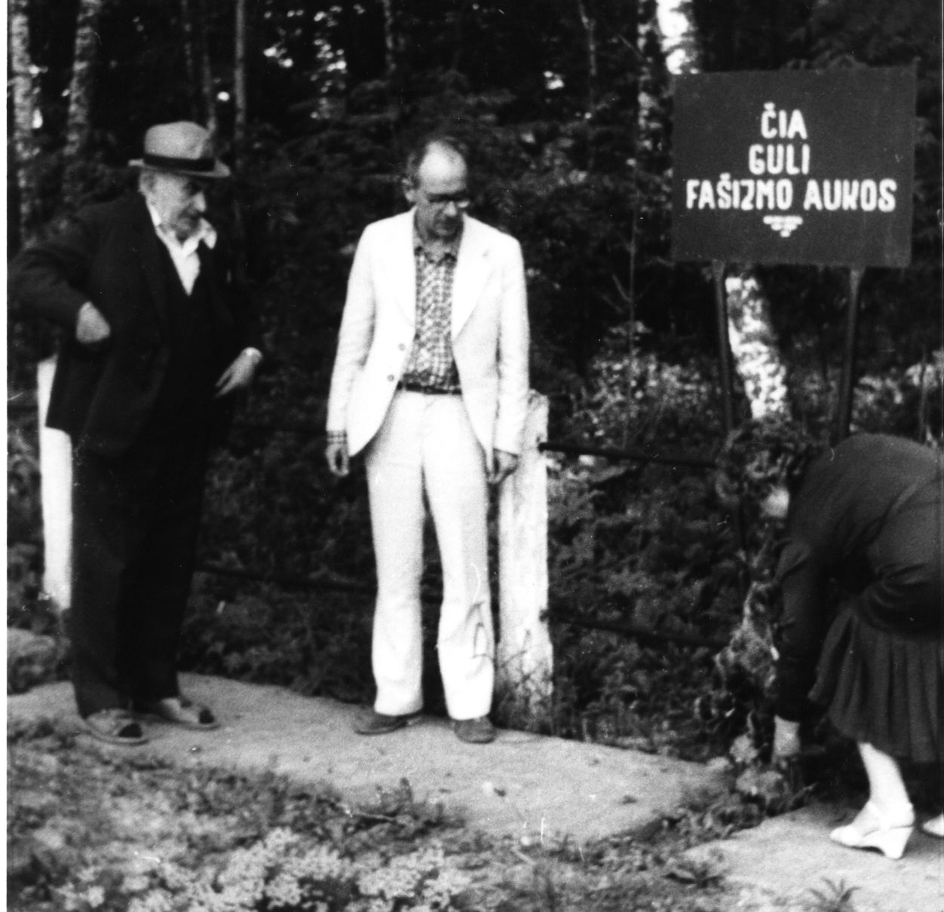
Fig. 2. Laying of peons on the grave of Jews of Zeimyalis. 5.06.1988
(Faivel Zagorsky, Anatoly Haesh, Ludmila Grudino)
Faivel read a speech he had written in Hebrew beforehand, but he spoke in Russian for our sake. He addressed the dead, saying that we had come to them, sympathized with their anguish. He cried. Took volokardin afterwards. He recited the Kaddish in Hebrew.
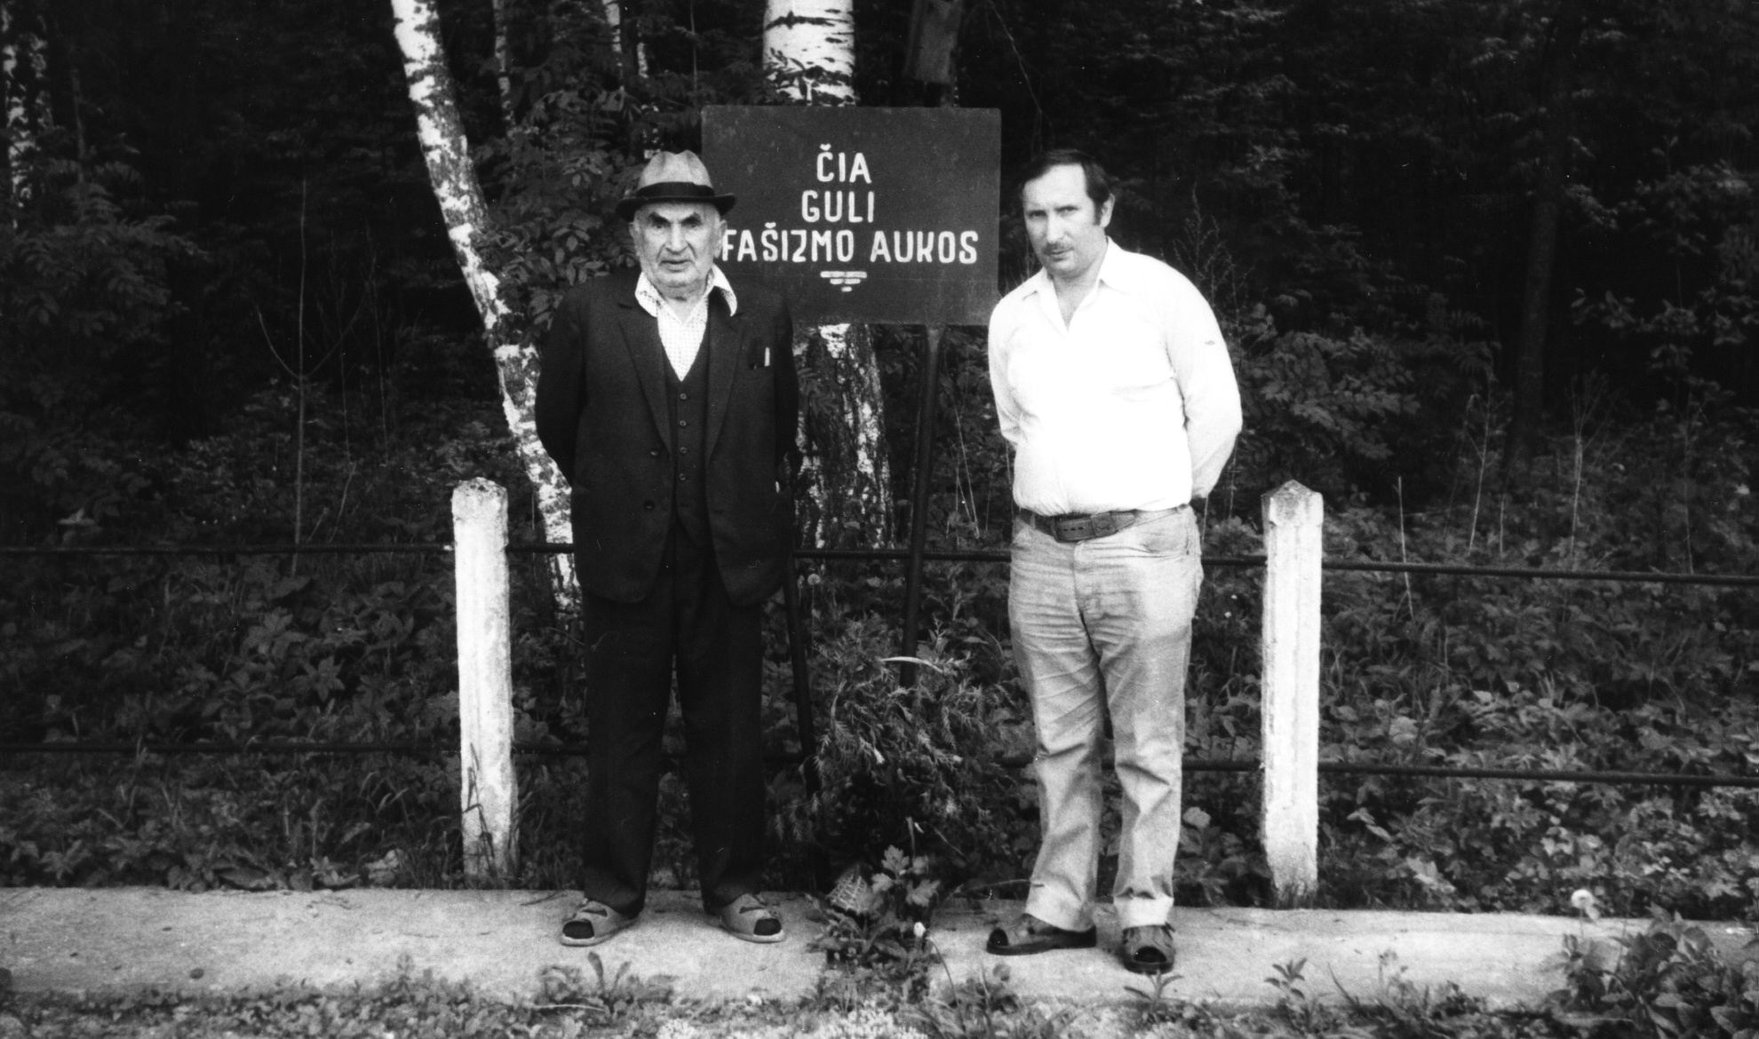
Fig. 3. Faivel and Nohim Zagorski at the grave of Jews of Zeimyalis. 5.06.1988
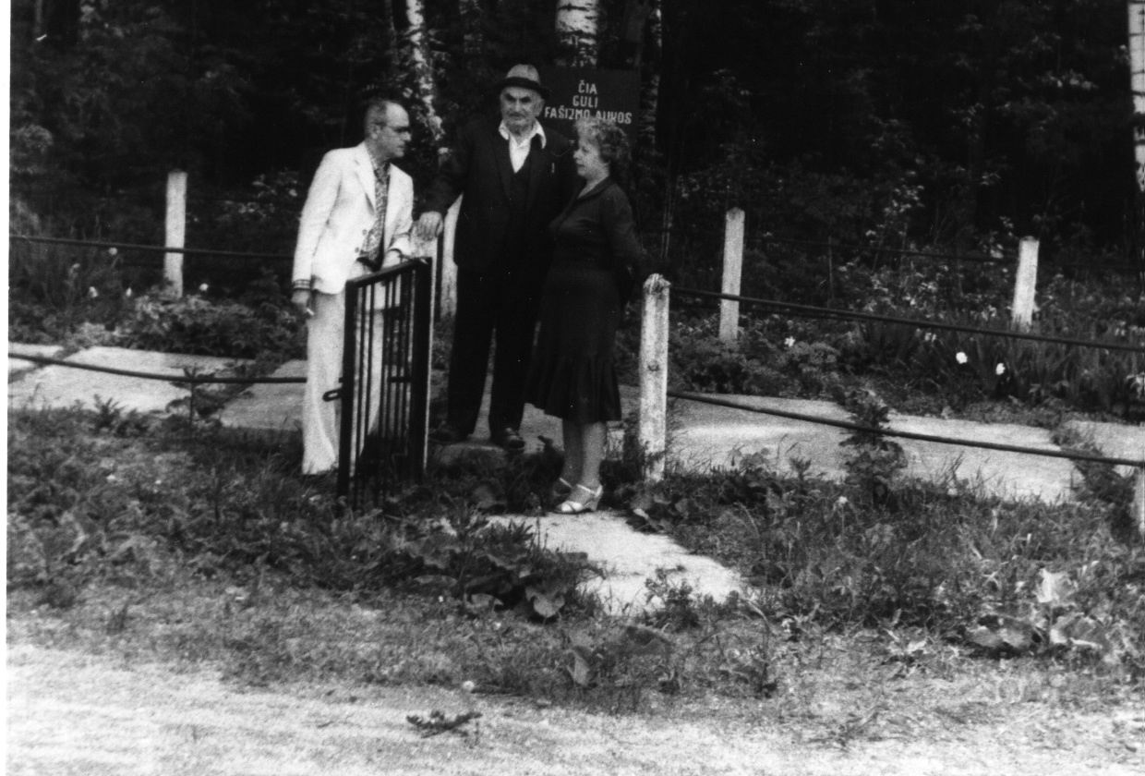
Fig. 4. A. Haesh, F. Zagorski, L. Grudino at the grave of Zeimyalis Jews.
5.06.1988
While walking around Žeimelis with Zagorski , he showed his house, located on the bend of [Linkovska] Street leading from the square to the school, white, one-story, with three windows. If you count the house across from the Meishe Haesch house (the corner house), where the canteen is now [see below], as the first (the Zagorskys lived there too, but not Fyvl's relatives), then the Fyvl house is the seventh. There was one room in the house, the furthest from the square [right window], for the tinsmith.
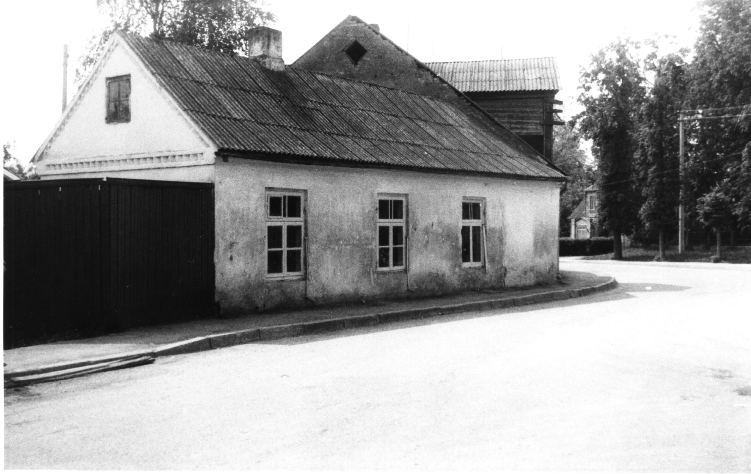
Fig. 5. The house of Faivel Yosifovich Zagorsky in Žeimialis. 5.06.1988.
The next house [Linkovskaya St.,] No. 9 of Alter Abramovich. In the house lived his clerk Tsemahovich. The next house [Linkowska Street] #11 also belonged to Abramowicz, the widow Tsofnis lived there. The next house was Abramovich's warehouse. Yukna said it was a prison. Nowadays there is a savings bank in this house. The next house is Wolfson's. He bought it from Abramovich. He also owned (Hatze Wolfson) the next house .
Then we passed the Lutheran Church (where Latvians and Germans prayed).
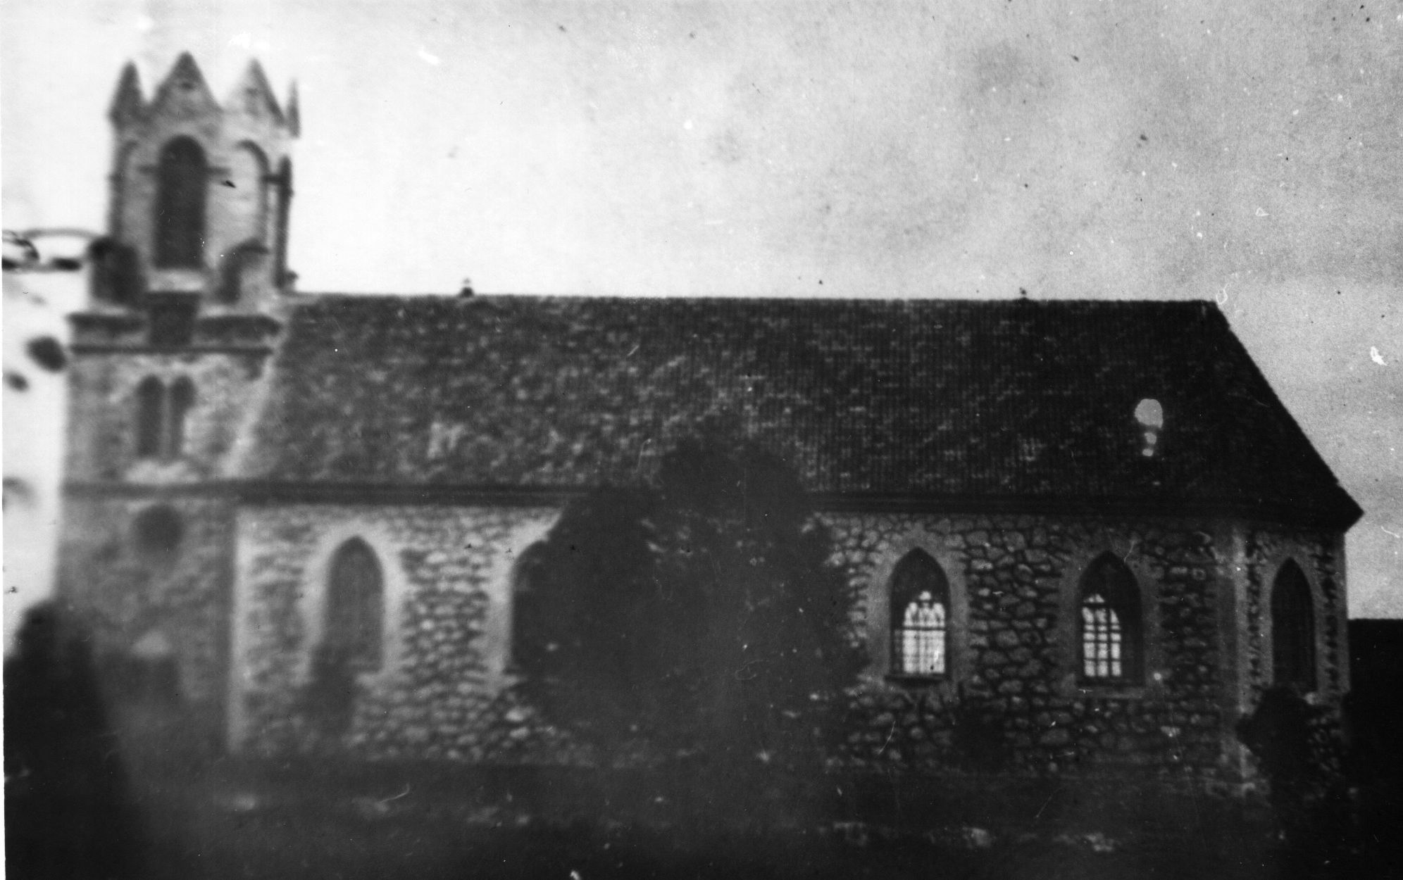
Fig. 6. Lutheran church
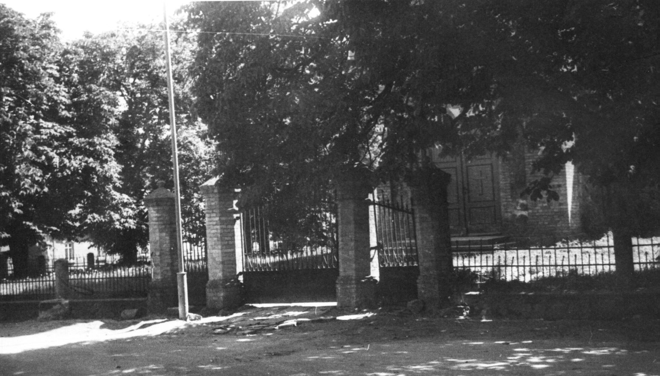
Fig. 7. The fence and entrance to the Lutheran church
On the back of the photo, text in pencil: "16. Zeimyalis 17.07.1983. The gate of the Lutheran church".
Behind the pharmacy building, which belonged to Schulgeifer, that is the neighboring house in the direction of the kirk, standing across the street from it - the house of Genesa Milunska.
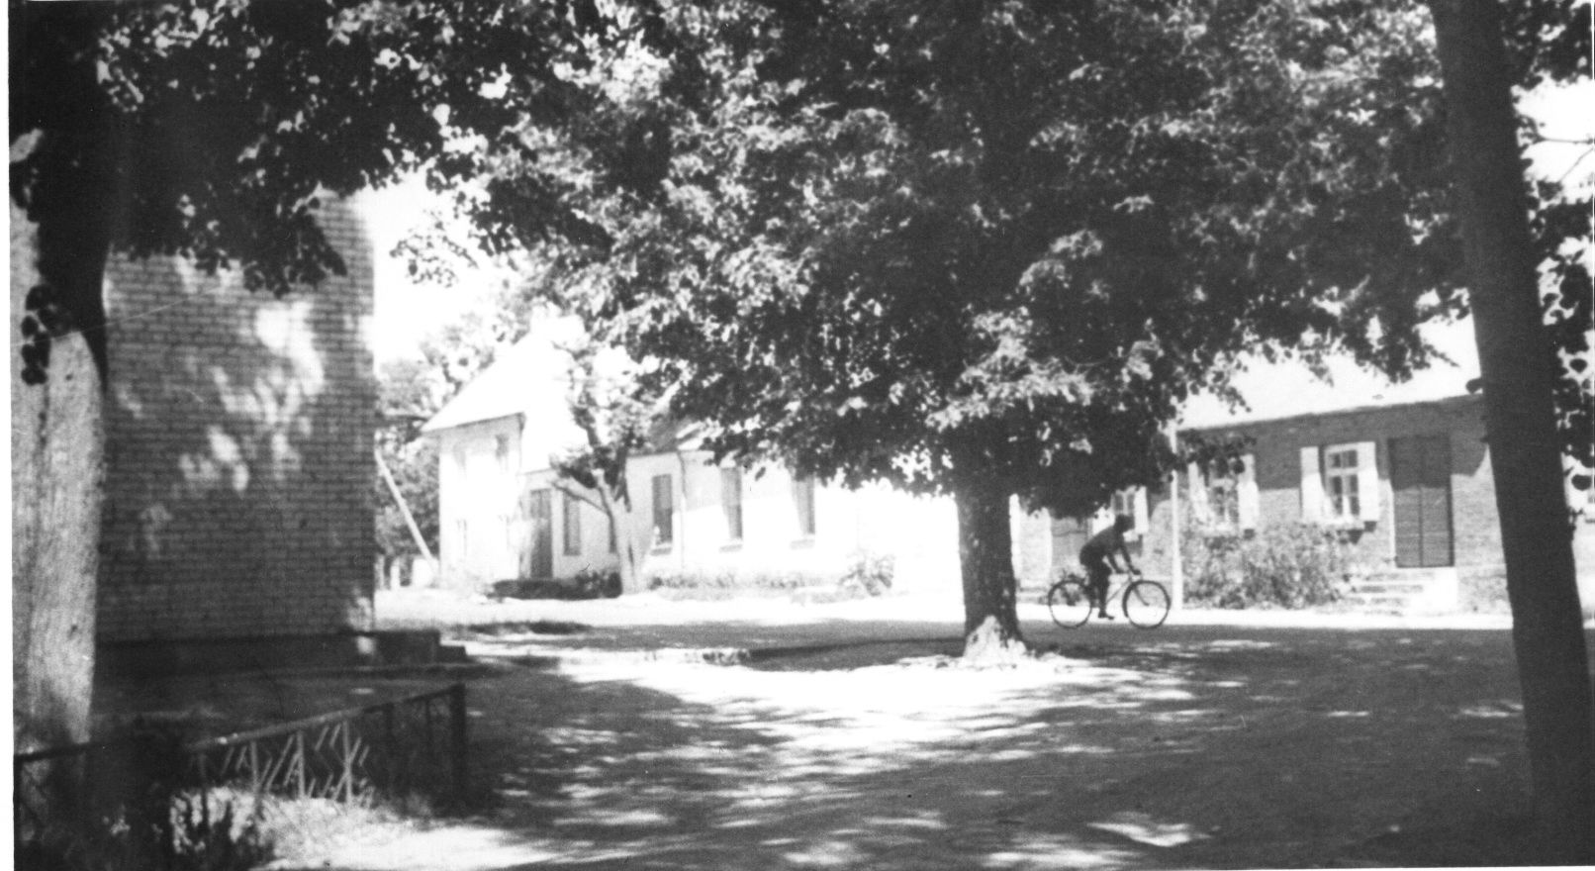
Fig. 8. The first house on the right is Genesa Milunska's. 17.07.1983
On the back of the photo, text in pencil: "17. Zeimelis 17.07.1983. View from the church in the direction of Bazarnaya Square".
On the square, across from the pharmacy, is the one-story brick house of Bera Green.
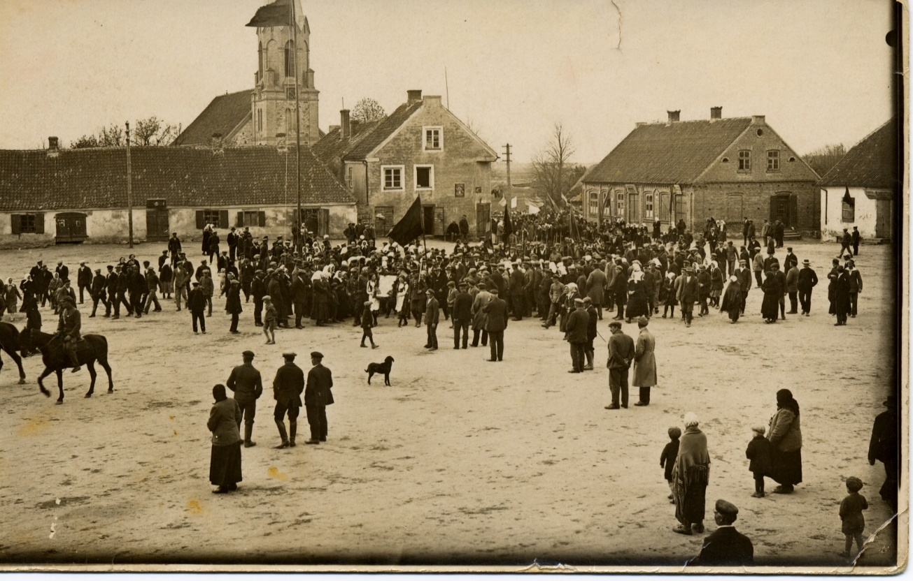
Fig. 9. Bazaar Square. Zeimelis. ~1928 г.
The next house on the square, its [white on the right] piece can be seen behind the house of Green - Lithuanian Lupas, and beyond that Tarutz, Yankelevich and Boyarsky.
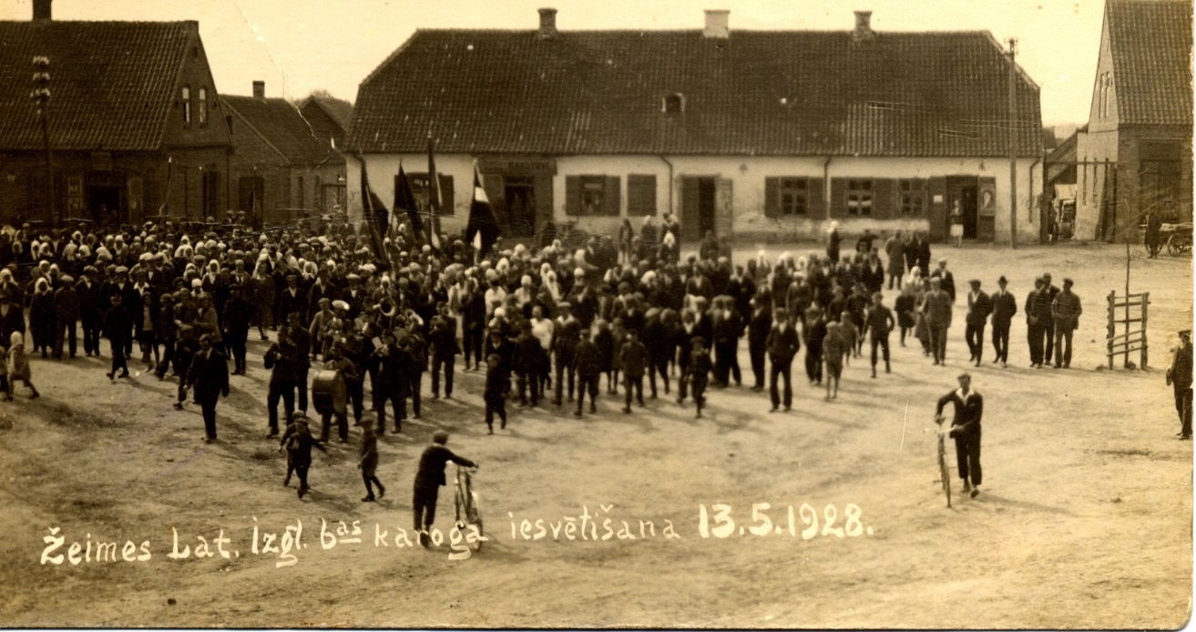
Fig. 10. Lupas House. 13.05.1928
Zagorski went on to describe the house where the canteen is now [26 on Zagorski's plan of 8.01.1983], a corner house, the first opposite the Meishe Haesh house. Nison Zagorski lived in it (on the very corner). He returned from Africa to the old maidens. One of them, Esther Zagorsky, got married. On the opposite end of the house lived Mendel Zagorski.
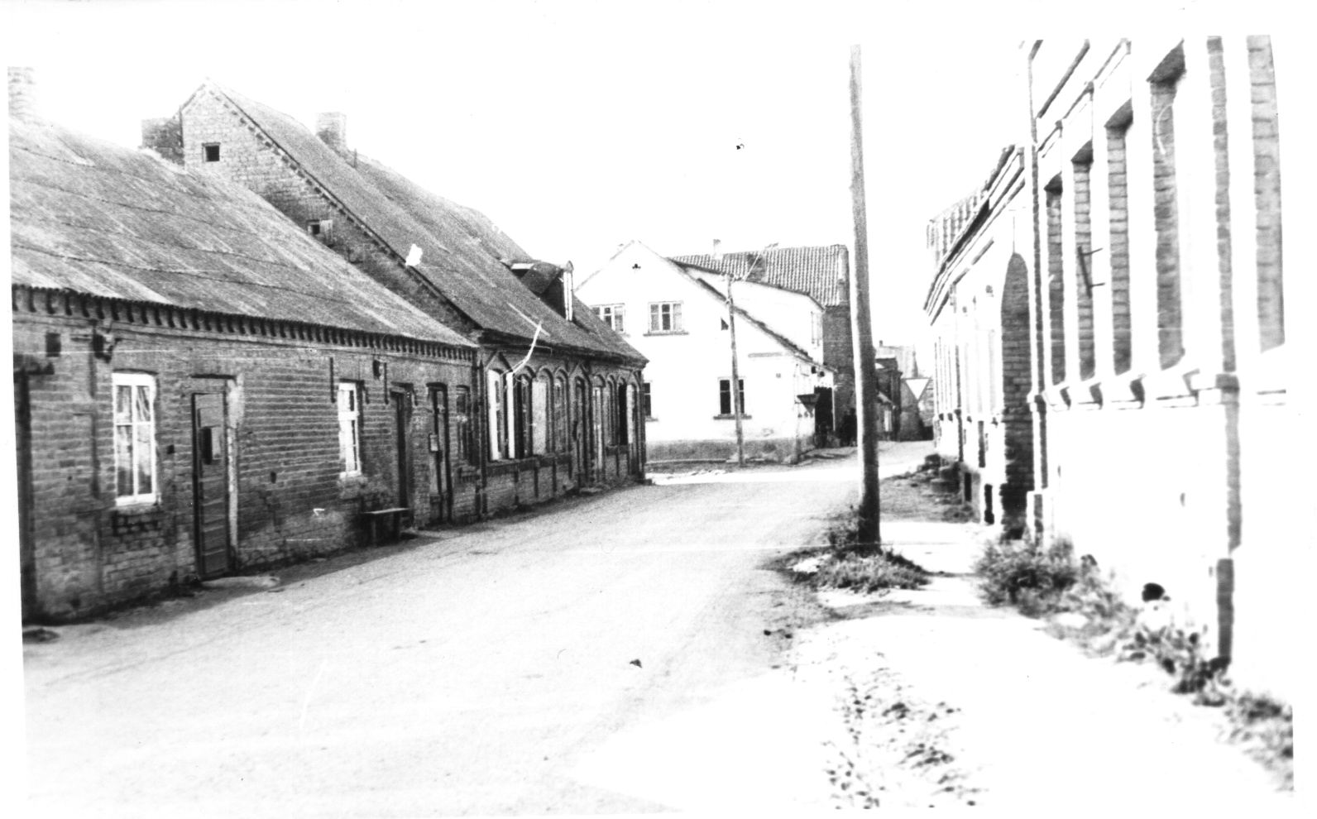
Fig. 11. Bauska Street
On the back of the photo text in pencil: "5. View from the church. In the foreground on the left is the house of Moses Hayes followed by the house of Matys Hayes, inherited by Moses. On the right is the house of Leyser Hayes. In the back, a bright house on the corner of Pasvallio Street and Bazarnaya Square once belonged to Nisha Zagorski. Now it has a canteen. 31.08.1982. Photo by A. Hayesha".
Between the [Leiser] Haesh houses (7 and 6 on [Zagorski's] plan from 8.01.1983) when passing this time we saw a passageway. Yukna said that there was a gate , but it has not survived. Behind the Big Inn as we passed, or maybe even behind the Little Inn, was a building (a former barn) where, according to Zagorsky, a power plant was made.
Between the church and the house of [Leyser] Haesch, according to Zagorski, the priest planted trees . There used to be a road leading to the house of Josel Man. He sued the priest for a long time for blocking his way. The Jewish community took an active part in these disputes.
Then, walking along the backside of Joniskis Street, we passed the little house where Zagorski had been a student.
Then we came to Yonish Street. There stands next to the Big Tavern a two-story big stone house of Roheli Ger (13 according to [Zagorski's] plan from 8.01.1983). The Jewish Bank was located there on the second floor.
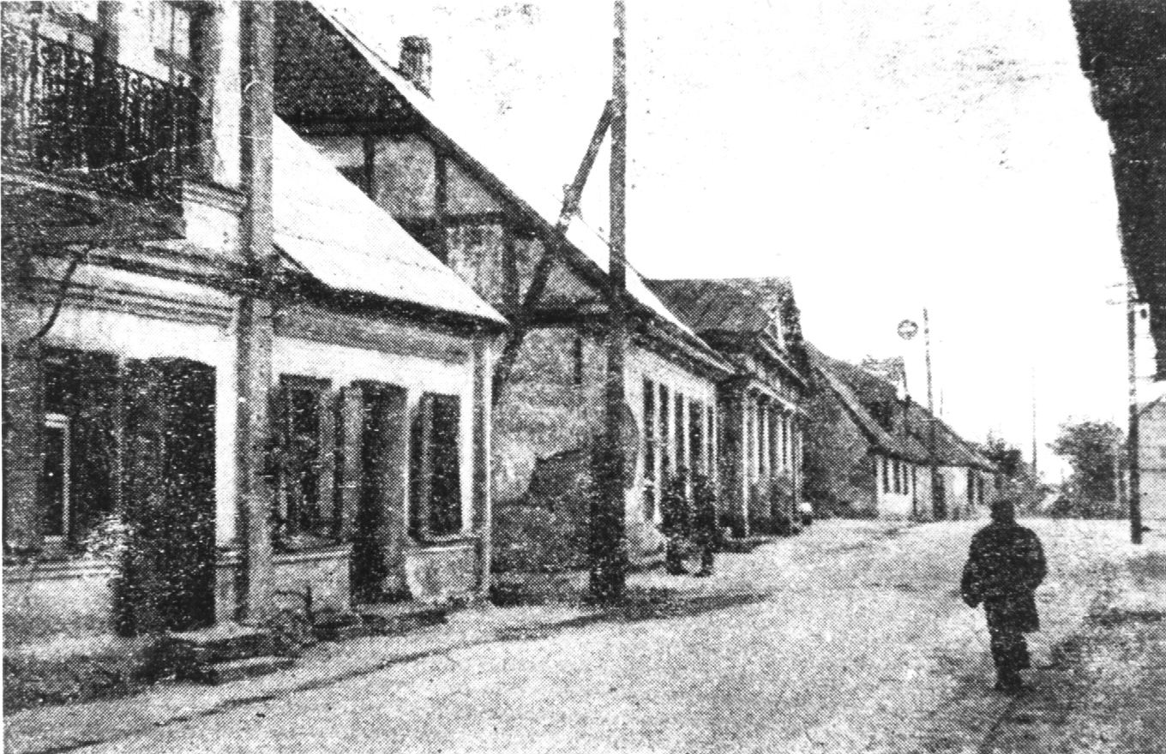
Fig. 12. Žeimelis. 1959, on the left - the house where the Jewish Bank was located
There is a later photo of the house, in which it can be seen in its entirety. Judging by the content of the inscription on the picture: "The arch on Yoniskis Street to the courtyard of the former Jewish Bank" , the entrance to the bank was from the courtyard.
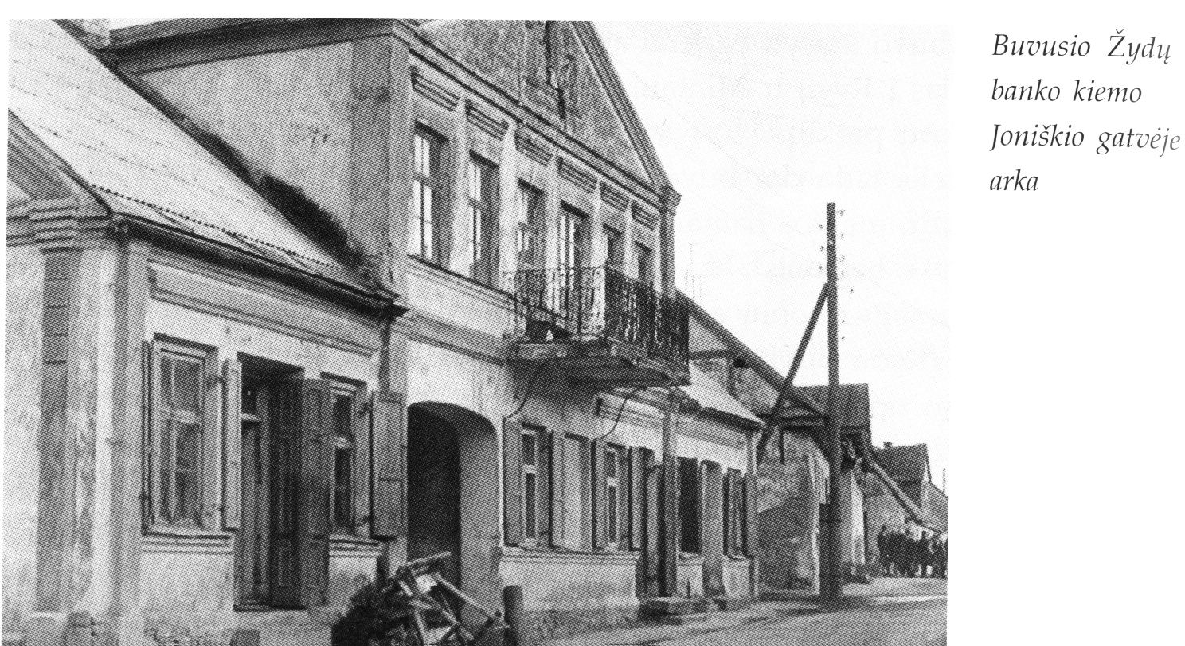
Fig. 13. the House of Hera
Two houses (15 and 16 according to [Zagorski's] plan of 8.01.1983), in particular the Hai Haesh house, are now demolished. A boarding house for the elderly and lonely residents of Žeimelis is being built in their place.
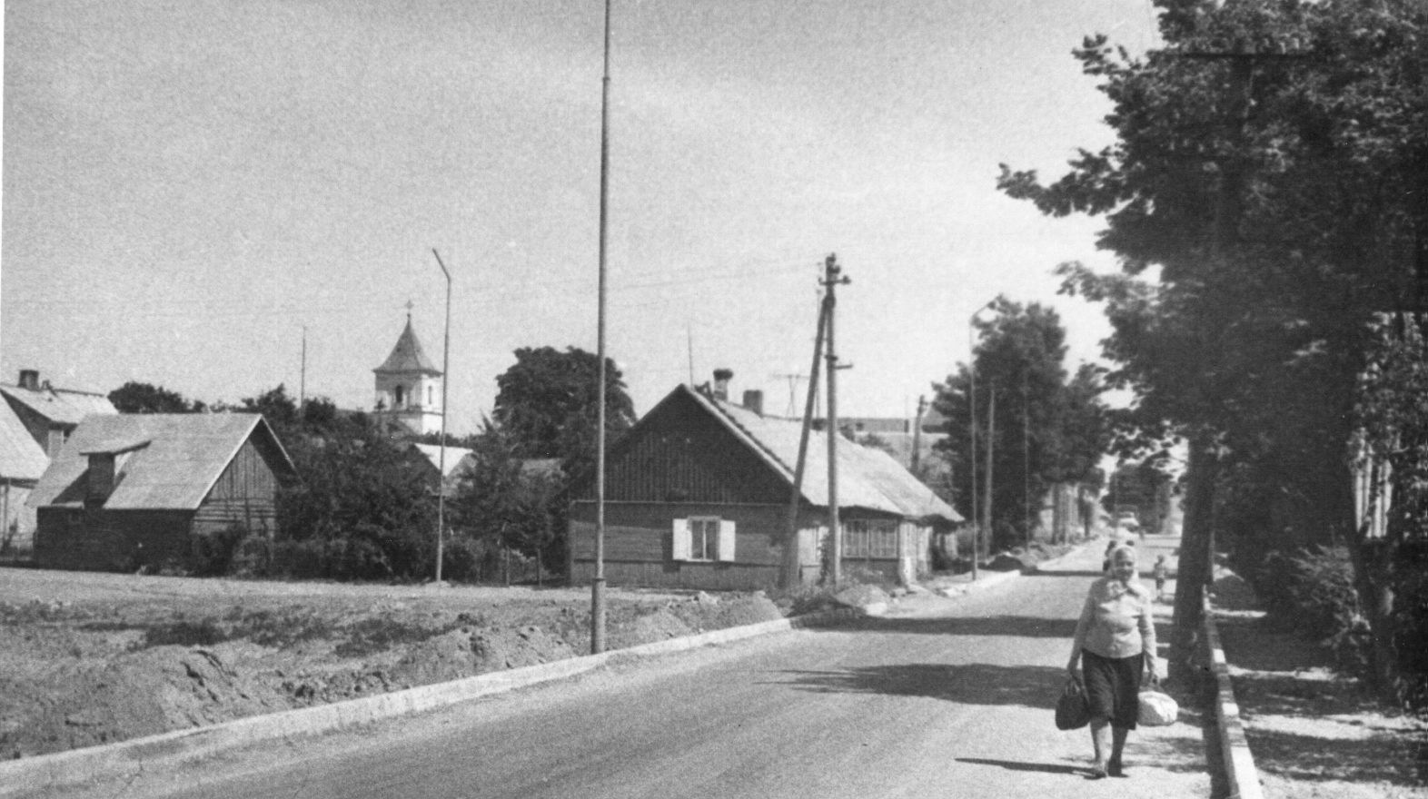
Fig. 14. Behind the scene on the left is a bus station booth. 17.07.1983
On the back of the photo, text in pencil: "19. Zeimyalis 17.07.1983. Joniskis street near the bus station".
Further down the road to the bus station, I did not write down which side, but rather on the opposite side is the house of Elias Milunsky .
Then we went back past Meishe Haesh's house and walked toward the river. In the place where the [Zagorski's 8.01.]1983 plan marked 28, there is a small stone house. Zagorski said it was the house of Meishe Haesh.
Farther down the road, there was a vacant lot where the synagogue used to stand. Yukna said that no pictures of it had survived.
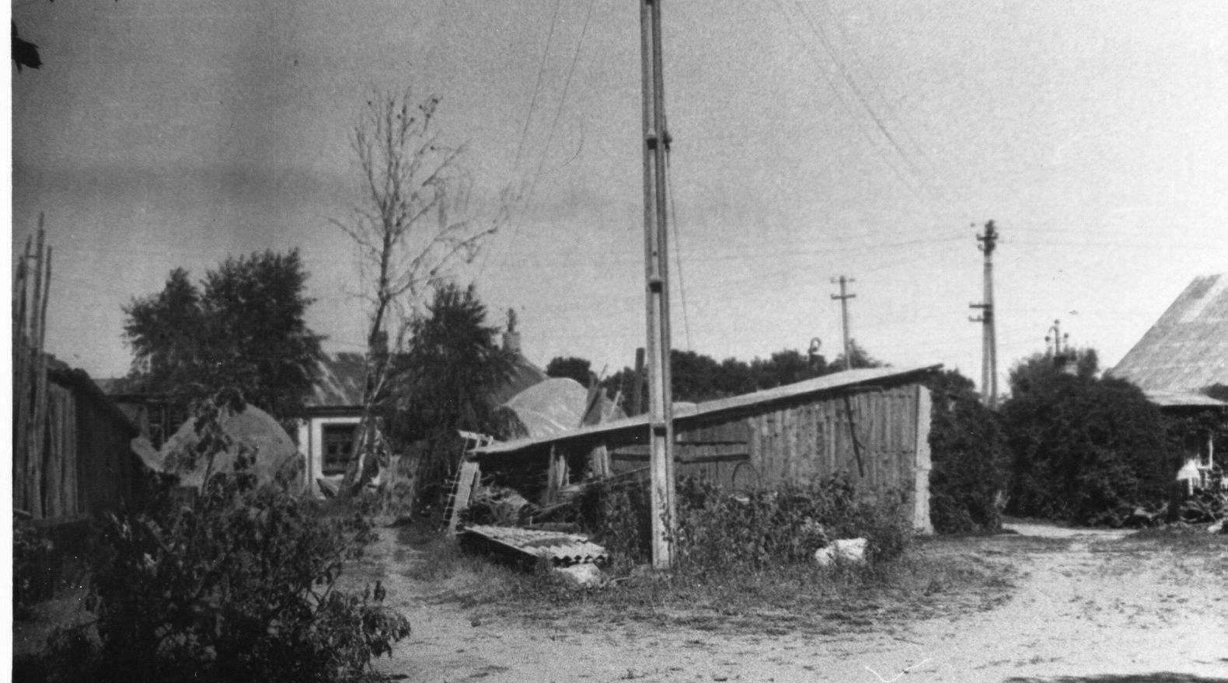
Fig. 15. A vacant lot, where a synagogue used to stand. 17.07.1983
On the back of the photo text in pencil: "10. Zeimelis 17.07.1983. Somewhere there was a synagogue. View from Pasvallio street".
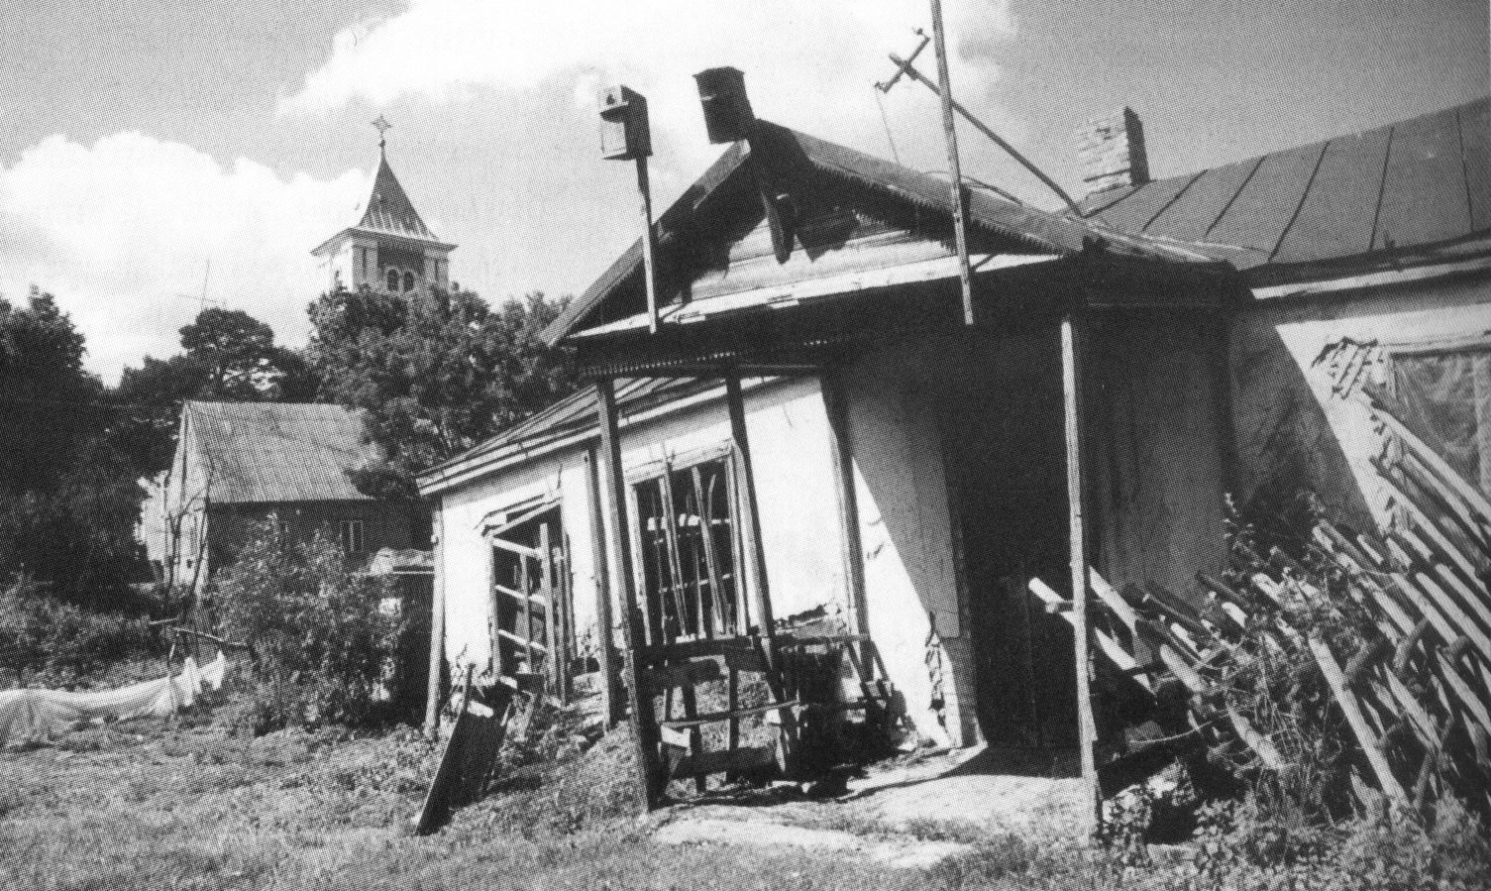
Fig. 16. The former Žeimelis Jewish School today. 2003 г.
Photo by A. Petrašiūnas
In the back is a small one-story building of a former Jewish school, closer to the road and farther away is the rabbi's house. It was rented to whoever was the rabbi at the time, and belonged to the community.
Then we walked across the bridge and to the right, to the Jewish cemetery. It is heavily overgrown, but there are still many monuments with very good inscriptions . According to Faivel, Feigah Haesh is buried there, and he knows the location of her grave, but because of the rain and thunderstorms, he can't find the grave. He said that there was some kind of structure above the grave stone, like a cabin or a canopy.
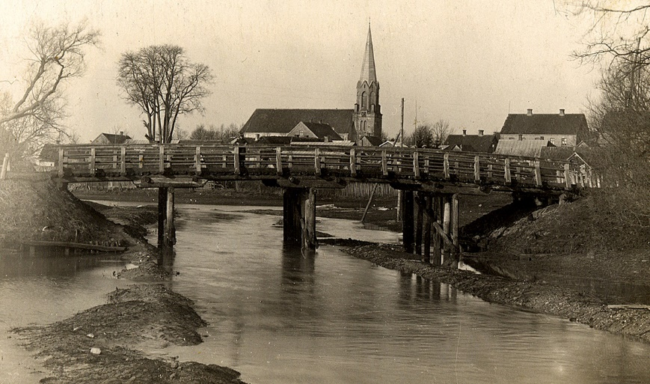
Fig. 17. bridge over Bershtalis
In general, Faivl Yosifovich acted surprisingly young, emotional, went bravely in the rain to the cemetery, soaked his feet, but remained cheerful.

Formatting, illustrations and explanations of the text - the author of the publication.
Jonas Edvardovich Jukna was a history teacher at the local school and then director of the school museum he created, actually a local history museum. He settled in Zeimelis after the Great Patriotic War.
Perhaps the name recorded from F. Zagorski must be Ora-Meer.
See Home Page (mannbarry.net)for a photo of the bus.
Probably not recorded correctly by ear from the words of F. Zagorski. It should be Leyser Man.
The ~1928 photo postcard is not reproduced, replaced by the original photo (see below).
Translation of the inscription "Here lie the victims of fascism.
The recitation of the Kaddish is the last good that one who remains alive in this world can do for his deceased relative.
J. E. Jukna accompanied us on our walk around Žeimelis. E. Jukna.
This paragraph is not illustrated because during the fifth meeting with Zagorski he described these houses in more detail. The drawings will be placed there.
The arch of the gate is clearly visible in the photo (see above)
The trees can be seen in the photograph mentioned in the previous footnote, and especially clearly in the photograph "12. House of Leyser Haesch, closest to the church", taken on 31.08.1982 (see ibid.).
Translation from the Lithuanian by Roza Belyauskienė (Vilnius).
Presumably based on the preceding text and the "31" on Harry Skikne's Memoirs - Harry Skikne's Memoirs (mannbarry.net) this house can be seen in Fig. 1 of the file "Proceedings of the Third Meeting.docx". The house was clearly built according to the same design as the Hera house, which housed the Jewish Bank.
Translation from the Lithuanian by Roza Belyauskienė.
In 1999, Barry Mann cleared and thoroughly surveyed this cemetery, posting the results online. Zeimelis Jewish Cemetery (mannbarry.net)
The list was received with a letter from J. E. Jukna dated December 8, 1983. It is in the personal archive of the author of the publication.
Žeimelis // Lietuvos TSR urbanistikos paminklai. Vinius, 1978.T. I, p. 138 (Monuments of urban planning of the Lithuanian SSR. Vilnius, 1978. Vol. 1, p. 138).
Žeimelis. I dalis. Versmė. Vilnius, 2010, p. (Žeimelis. I dalis. Versmė. Vilnius, 2010, p. 130).
Ibid. 578.
Photocopy of Barry Mann from a photograph from the personal archive of Israel Yakushka.

