Haesh A. И.

Proceedings of the Fifth Meeting with F.J. Zagorski, 3-4.06.1989
Memories of Fayvl Yosifovich Zagorsky
My acquaintance with Zagorski in the time since our first meeting in Kaunas in 1983 has noticeably strengthened, and Faivl Yosifovich's stories, partly repeating past stories, have become much more detailed.

Transcript of an audio recording made in Leningrad on June 3, 1989

Local history section
А. What did the old-timers tell you about the appearance of Jews in Žeimelis, what happened before you were born, what do you know about the history of the Jews of Žeimelis in general?
Ф. At the end of the last century we had a famous rabbi Cook . He was born somewhere in Poland . Rzemialis was his first place of service. As a young rabbi he chose a small place. He stayed with us, I don't know exactly how long, maybe five years, then he was taken as a rabbi 18 kilometers away to Bausk. At the beginning of the century or the end of the last century, he went to Palestine. He was a famous figure in the Zionist movement. There are rabbis who are against this movement. They are waiting for the coming of the Messiah. And Cooke believed that one could help the Zionists, that they were building a Jewish state, one could work together with them. Such rabbis were in the minority.
А. How long have Jews been in Zeimelis?
Ф. I don't know. But I remember well that once we boys were looking at the monuments in the old cemetery. The first ones were all in the ground, and you couldn't make out anything on them. And at the end of the cemetery, among the latest, most recent graves we found a monument that was already, I remember well, a hundred and fifty years old. Now it's probably two hundred. We are now in the year 5749 from God's creation of the Earth, and that monument was 5500, maybe 5520 or 5530. You don't write secular dates on monuments. The first graves in this old cemetery were probably a hundred years or more older. That is something we have not been able to find out. This allows us to judge the age of the community, because when Jews created a community, its first attributes were always the cemetery and the synagogue.
А. Maybe the old folks were sharing memories of the past?
Ф. They could only know what they were told themselves or what they had seen under tsarism, but what was 200 years ago no one told them. However, when I was 10 or 12 years old I was told such an incident from the life of our community from the old czarist times.
The rich usually did not want to serve in the army. So somehow they negotiated with the military presence and surrendered a boy from a poor family instead of a rich one. The poor were afraid to speak outright against it. They pressured the boy's father, let's call him Haim-Boruch, to protest against such injustice. The father began to threaten that he would write a complaint. They told him:
- What are you, Haim-Boruch. How could I! What do you want?
- I want to be given money.
- Well, how much do you want?
- Plenty.
- You want a lot, how much?
- No, I want a lot.
What to do with him? We didn't go to our own rabbi, we went to another rabbi and consulted with him. Chaim-Boruch was a simple Jew. The rabbi advised them how to buy Chaim. They took a hundred or two hundred rubles and exchanged them for one ruble each in silver coins. They poured some of them out on the table, called Chaim, and continued to pile them one by one.
- Look, Haim, well, is that enough now?
The man's eyes widened; he had never seen so much silver.
- Well, that's enough," he said.
That's how he was fooled. I was told this as an example of the wisdom of the rabbi.
I also remember this. Back in tsarist times there was a system of almsgiving in the community. A simple handout would not feed a poor man: he would eat it all up. Instead, they gave him a small loan so he could have money for turnover: for example, he could buy some herring, sell it by the piece and earn something on it. The head of the business was Isroel Greene, who was either the chairman or the cashier. And since all the clients were poor and could not guarantee repayment for each other, Greene took a pledge from them, such as silver spoons given as wedding gifts, a silver wine glass, etc.
When in 1915 all the Jews were evicted from Žeimelis in 24 hours, there was such chaos and haste that there was no time for bail . Then the war was over. Many came back. I remember in 1921-1922, every Saturday in the synagogue there was a scandal: Green was demanded to return his things. He said he had lost everything, and had his defenders, too. <...>. I don't remember how the case ended, maybe he didn't pay anything. Or he gave something back. All I remember is the constant scandals.
А. Was the pincas of the congregation carried on?
Ф. No it wasn't, and if it ever was, it got lost in World War I.
А. Were there any memorable events in your congregation?
Ф. When I was an adult, in 1932 there was such an incident. There was a slaughterhouse on the outskirts of the place. At that time there was a law that the meat of a slaughtered cow had to be looked at by a veterinarian and given permission to use it. Jews mostly cooked on Saturday night. The case was in February. The Jews slaughtered a cow on the Sabbath and went to call the vet. He wasn't home. They waited for him and didn't bring him in until 10:00. The vet didn't want to look at the carcass because they forgot to bring water and towels to the slaughterhouse to wash their hands after the examination. He got angry and went out. There was an old abandoned well next to the slaughterhouse. In the darkness, the vet fell into the well and drowned.
Four Jews were accused of killing a veterinarian and arrested. There was a pogrom mood in the village. There was a rumor that peasants from the surrounding villages had come to Zeimyalis to take advantage of the opportunity to pogrom, rob and kill Jews. The leaders of the community called and wrote to Šiauliai and asked that the head of the neighboring border guard be ordered to send border guards to be on duty in the place. All in all, the Jews were terrified. But fortunately everything turned out all right. Investigators came from Panevėžys. They examined the corpse and concluded that it had been an accident. The arrested were released.
But the vet's relatives were influential people and did not leave the case alone. They got other investigators to come, dug up the coffin, and examined the corpse again. They concluded that the vet had first been killed and only then thrown into the well, since no water was found in his lungs. The Jews were arrested again, tried and given 12 years in prison.
This decision brought the entire Lithuanian Jewish community to its feet. They collected a lot of money, hired a lawyer, and he filed an appeal. The case was reconsidered, the Jews were not completely acquitted, but their sentence was reduced from 12 years to a year and a half. They served their time and returned to Zeimelis.
А. Who led the community? What were the community organizations?
Ф. Rabbi and the head of the synagogue.
There was a Jewish bank in Žeimelis, which at first conducted rather large transactions, such as issuing money against promissory notes and guarantors. A merchant who bought goods in Šiauliai, where the wholesale bases were located, paid for the goods with a bill of exchange, in which he indicated that he was obliged to redeem the bill of exchange within a certain period of time, for example, two or three months in advance. The seller of goods sent the bill of exchange to the Zeimyal bank, where the debtor redeemed his bill of exchange at a specified time. From such operations, the bank had an income to justify its maintenance, and the merchant saved on working capital and did not have to spend money transfers from Žeimėlis to Šiauliai. The bank was maintained and managed by Elijah Dovid Jankelewicz. He was the manager, accountant, and cashier, all at once.
But gradually the bank's business declined. Once upon a time the Jews roamed the villages and bought flax, wheat, grain, eggs. Then the state imposed a monopoly on trade in flax, grain, and wheat. The Lithuanians organized their own cooperative to buy eggs. Other cooperatives were also created. By 1935-37, all Jewish life was over. The elderly had grown old, the young had gone to America. At first we had 15 shops, then they all closed. Consumer demand went down. We didn't need so many shops. And Lithuanians in every village opened their own shops and almost stopped shopping in the city. The Jewish economy went into decline. Banking operations declined: no one issued promissory notes anymore, no one took money, and those who took money did not pay it back.
А. What was the number of Jews in Zeimyalis in different years?
Ф. Before World War I, about 100 Jewish families lived in Zeimyalis. After the war many did not return, in the 20s there were about 70-80 families, and in recent years very few, maybe 40-50 families. And those were incomplete. Me and my mother, what kind of family is that!? Or your grandfather with his old lady. Is that a family? There were single women whose children went away. Like now in the villages, the children go to the city, and the old people stay.
А. What do you attribute this decline in economic life to? Maybe with the Smetona regime in Lithuania after 1926 or Hitler's rise to power in Germany in 1933.
Ф. No, Jewish life was not concerned at that time. In 1933 there was a world economic crisis. There were 14 million unemployed in America alone. In my opinion, the reason was that after the war everything was destroyed. We had to rebuild it all, rebuild it all. There were a lot of factories and plants. And when everything was rebuilt, everything was bought, everyone was satiated, then life went on as usual. The production that had been calculated for the years of famine was too much, and the crisis arose. And in Jewish life, the main cause of the crisis was the state monopoly on the flax and wheat trade, which was the most important source of Jewish income.
А. Did the Jews trade in lumber?
Ф. No. We didn't have forests. And the forest was state property, too. There were no private timber traders.
А. Were there Jewish farmers in bourgeois Lithuania?
Ф. Were. I'll start with your grandfather. He was leasing land. He didn't work it himself, he just rented it. It was a big loss for him, but he liked to farm, he liked to yell at people. What kind of a farmer was he? And there were no Jewish peasants in Zeimeles.
There was a Jewish village near Linkuva, about twenty kilometers from Žeimelis. There were 10-12 families in it, who worked their own land. But this village was created in the last century. The Jews there were considered peasants, they had state support, received timber for construction and loans. They didn't rent land, they owned it. I was also told that there were large Jewish landowners with 40-60 hectares each in Suwalkiya, in Mariampol. They themselves and their children worked the land. But after the war, the children of such big landowners went to universities, and hardly anyone stayed to work as a peasant.
А. What other social organizations were there in Zeimelis?
Ф. There was a Zionist organization. The teacher Zalman Wolowitz organized in 1932-1933 a "Halutz" branch in the locality. This organization prepared young people to be sent to Palestine to work on the land. There were many malarial swamps in Palestine, they had to be drained and eucalyptus trees had to be planted to draw out moisture. When I went to Israel, they showed me the eucalyptus trees near my house and explained that they proved that there had been a swamp on the site of the house before.
The "Halutz" branch in Žeimelis did not teach farming itself. Those who wished to do so went to Wolowitz. He sent inquiries to Halutz, found out if there was a place, and, after receiving a positive answer, sent those who wished there letters of recommendation. This is how Abramson, born in 1902, left us to study and emigrated to Palestine in 1936, then Shmulka Tarutz in 1905 and Abke Ger, both in 1936. When I was in Israel, they were no longer alive. In the same year, Esther Kremer left through Halutz. After World War II, her brother left to join her, but his departure was no longer connected to Halutz.
In Zeimyalis there was also the Keren Kayemes Foundation, which collected money to buy land in Palestine. Various sheikhs owned large tracts of land there. They themselves lived somewhere in France or Cairo. With the money raised by the fund, the Central Zionist Organization bought land from the sheikhs, on which these chalutzim ("pioneers") were based.
In the last years before the war, the pharmacist Avrom Shulgeifer was the chairman of the fund. There were piggy banks posted in the houses. People were poor, they couldn't donate litas or pollytas at once. They threw five or ten cents into the piggy bank. Shulgeifer sent us young people around the houses to collect the money in the piggy banks.
There was an organization called "Lineh Sateveh" (Charity Sleepover). There was no special initiator or leader. It was an ancient Jewish custom, and there was no need to discover anything, to come up with new ideas. Young people: Abe Ger, his sister - the dentist, me, and Esther Kremer got together and organized this "Lineh Sateveh". We seldom had to spend the night, though; we didn't spend the night with the light patients, only with the heavy ones, and those were taken care of by their relatives during the day and by us at night.
The congregation also collected money so that boys from poor families could learn Torah. The collection was called "Talmud-tora. I was from such a family. We were taught by an ordinary Melamed, a bearded rabbi. He didn't know any secular sciences himself. He only taught us how to pray and translated the prayers into Yiddish so that we could understand them. This school or cheder was run by the rabbi and the head of the synagogue. Their concern was that the boys know how to pray and that they were literate and could read and write, that was not important. They rented a room in a private house for the cheder, and there the rabbi taught all the boys together. I remember at one time there was a cheder in Yosele Man's house, which was a halupa behind your grandfather's house. It was in several other houses, too.
Then we had the Hevra Kadisha, the funeral brotherhood. It had its own prayer house. More precisely, it had a room in the house built for the rabbi. The leadership of the brotherhood was re-elected every year. Elections were held during the great autumn festivals: on Yom Kippur or Sukkos. Everyone would gather and choose a few electors, then everyone would go their separate ways and whoever the electors chose would be the year in the Hevre Kadisha. At first up to 20 people were elected, but in recent years there were 5 or 6. They read prayers for the deceased, washed him, dressed him in akrichim, and buried him. The grave, of course, was dug out for a fee by a Lithuanian, or by one of the needy Jews, because it was hard work, and in the Hevre Kadisha, everyone was old. But they lowered the coffin into the grave themselves. They buried it on a board. The coffin boards on the sides and top, and on the bottom the deceased lay directly on the ground.
The community had a library. I still have a picture of its activists . I joined them in the first half of the '30s. There used to be other people in their 20's. There were over 300 books in the library. The money to buy them came from amateur plays. There are famous Jewish playwrights. e.g. Gordon. We staged his play "Hosid - Yeshime" (Hosid the Orphan), then "The Boy from the Village" and many others. In the 20s we had plays quite often, but then rarely, once every six months: on Passover, on Shvuez. There were 10-12 people in the drama club, including girls. We bought books in Kaunas. We got a catalog from there, the activists gathered and decided what to buy.
They took the books to Linkuva or 18 kilometers away to Vashkai and exchanged them for their books in the libraries there. There were Jewish libraries in every place.
А. Have you heard anything about German barons?
Ф. After World War I there was a land reform in Lithuania. The German barons and all others who had more than 80 hectares were deprived of excess land. They gave it to those who did not have it: why should you have 100-200 hectares, and others have nothing. Barons Haan and Grotoizen lived next door to Zeimelis. Haan was rich, had his own estate, a roller mill. To it the Jews carried flour for fine grinding. There was a coarse grinding mill in the township. Later the Jew Gitel came to Zeimelis. He set up a power plant in the back of the Great Tavern, and then a fine grinding mill.
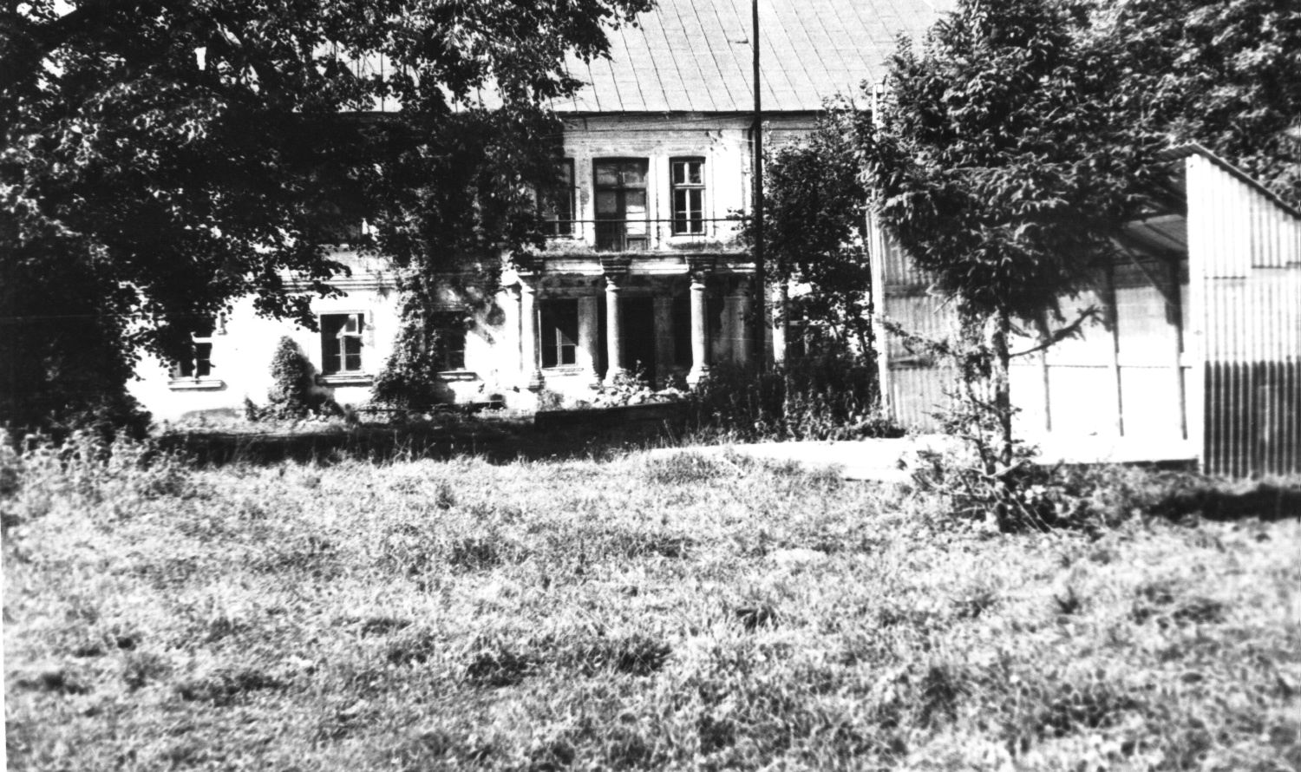
Fig. 1. Baron Haan's estate. 1982 г.
On the back of the photo text in pencil: "20. Baron Haan's estate, not far from Žeimelis. The main estate. Leyser Haesch did business with the baron. 31.08.1982. Photo by A. Haesh".
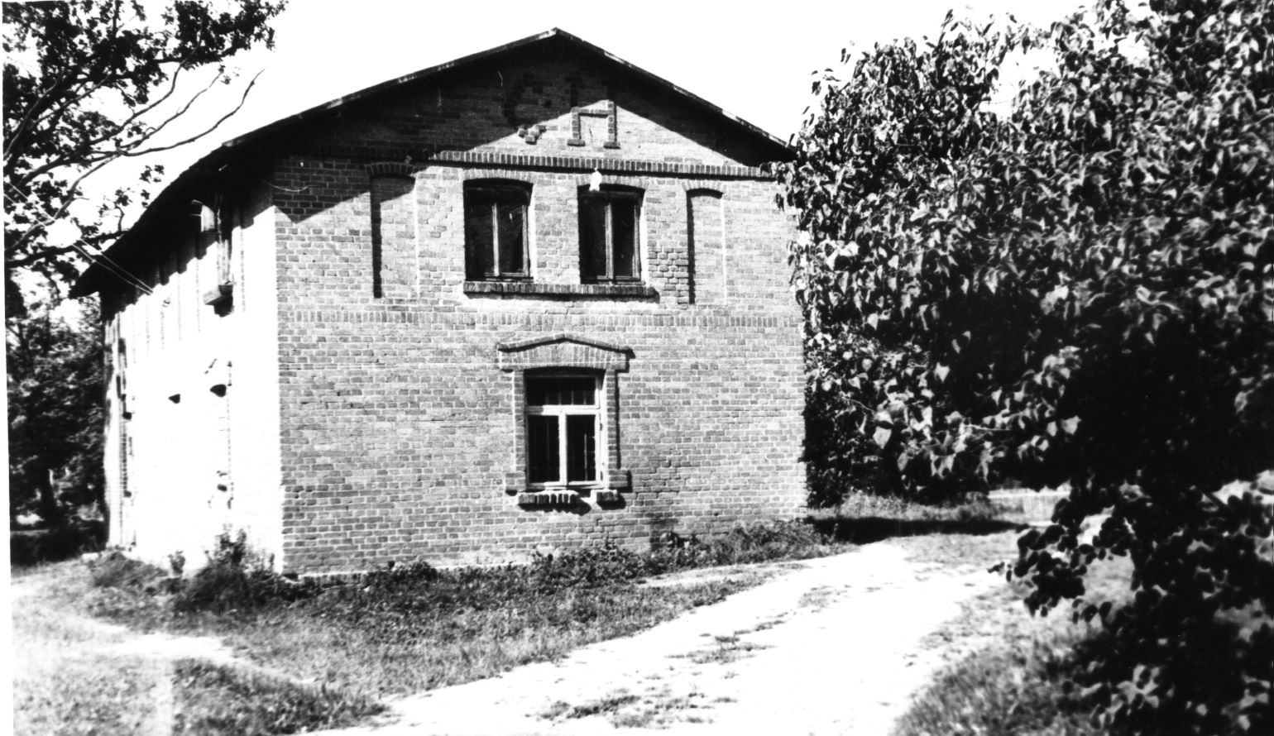
Fig. 2. House on Baron Haan's estate. 1982 г.
On the back of the photo text in pencil: "21. House in the estate of Baron Haan (Hahn), not far from Žeimelis. The main manor house. Leyser Haesch did business with baron. 31.08.1982. Photo by A. Haesh".
Grotoizen had a huge apple orchard. He rented it out to Jews, who tilled it, harvested their crops, and at the end of the summer took the apples in wagons to Siauliai to sell them .
I continued to show Fyvl Yosifovich various photographs and asked about them.
А. Photo 17 (31.08.1982) . The eastern side of the square (corresponds to the lower view in Fig. 79 "The layout of the square in Zeimelis at the beginning of the 20th century" of the article "Zeimelis" ).
Ф. From left to right.
First house. In the left half was the little grocery store of Nisha (Nison) Zagorski, my namesake. In the right half lived Velvl Zagorski. In the 20s he also had a shop with small trade, after his wife's death a Lithuanian man kept the shop, then there was Bekane, but recently there was no trade - there was an apartment house.
Second house. The two-story, brick Leyser Zagorski house. He is Velvle's brother, and Nison is their cousin. On the first floor was the manufactory shop of Leyser's wife Golda. At that time there was a door in place of the middle window, which was then bricked up. Golda is registered in "All Russia" as a merchant of the 2nd guild [BAKALEY: <...> ZAGORSKAYA Golda Leyz., m. Zheymeli, Natziunsk. v. <...>] . The Zagorskys lived on the 2nd floor. They had 3 daughters, all married. Then Golda went bankrupt, grew old. On the first floor the Lithuanians rented space for a workshop.
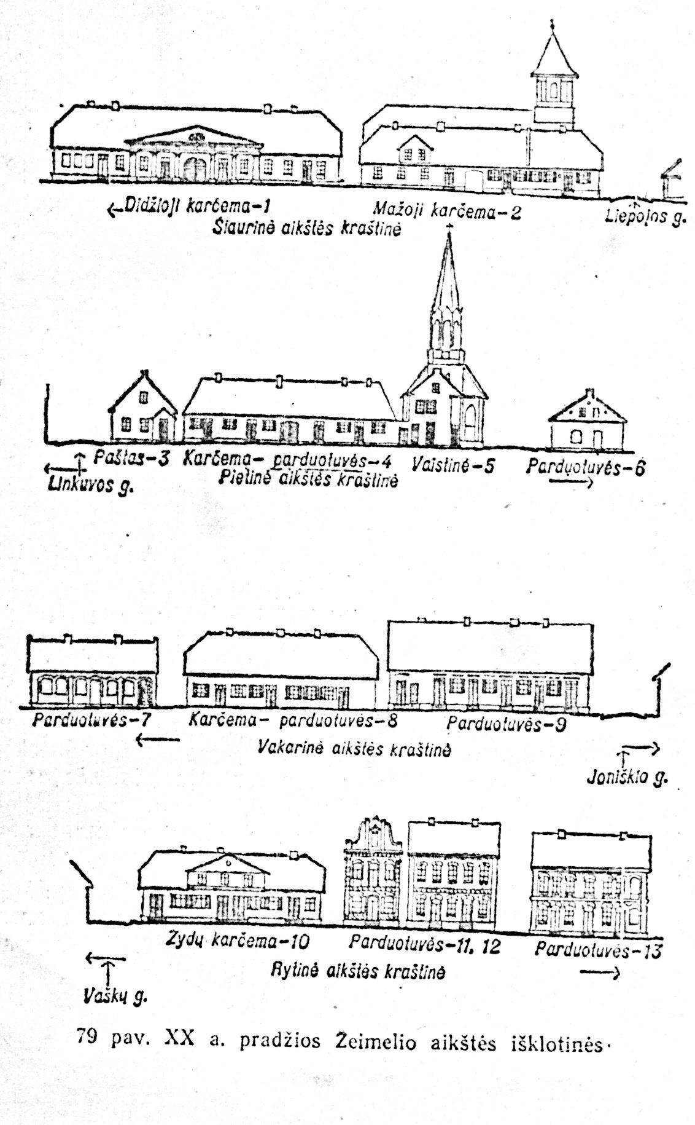
Fig. 3. The layout of the square in Žeimelis in the beginning of the 20th century.
Translation of captions
Large tavern - 1 Small tavern - 2 Liepaja Street
North side of the square
Post Office - 3 Korchma - stores - 4 Pharmacy - 5 Shops - 6
Linkuvos St.
South side of the square
Stores - 7 Korchma - stores - 8 Shops - 9
Ioniskio St.
West side of the square
Jewish tavern - 10 Shops - 11, 12 Shops - 13
Vashku St.
East side of the square
Although Zagorski was looking at photo 17, dated August 31, 1982, in which the pre-existing entrances to the benches of the houses were bricked up, a photo was found in which they are and you can even see the horse stall.
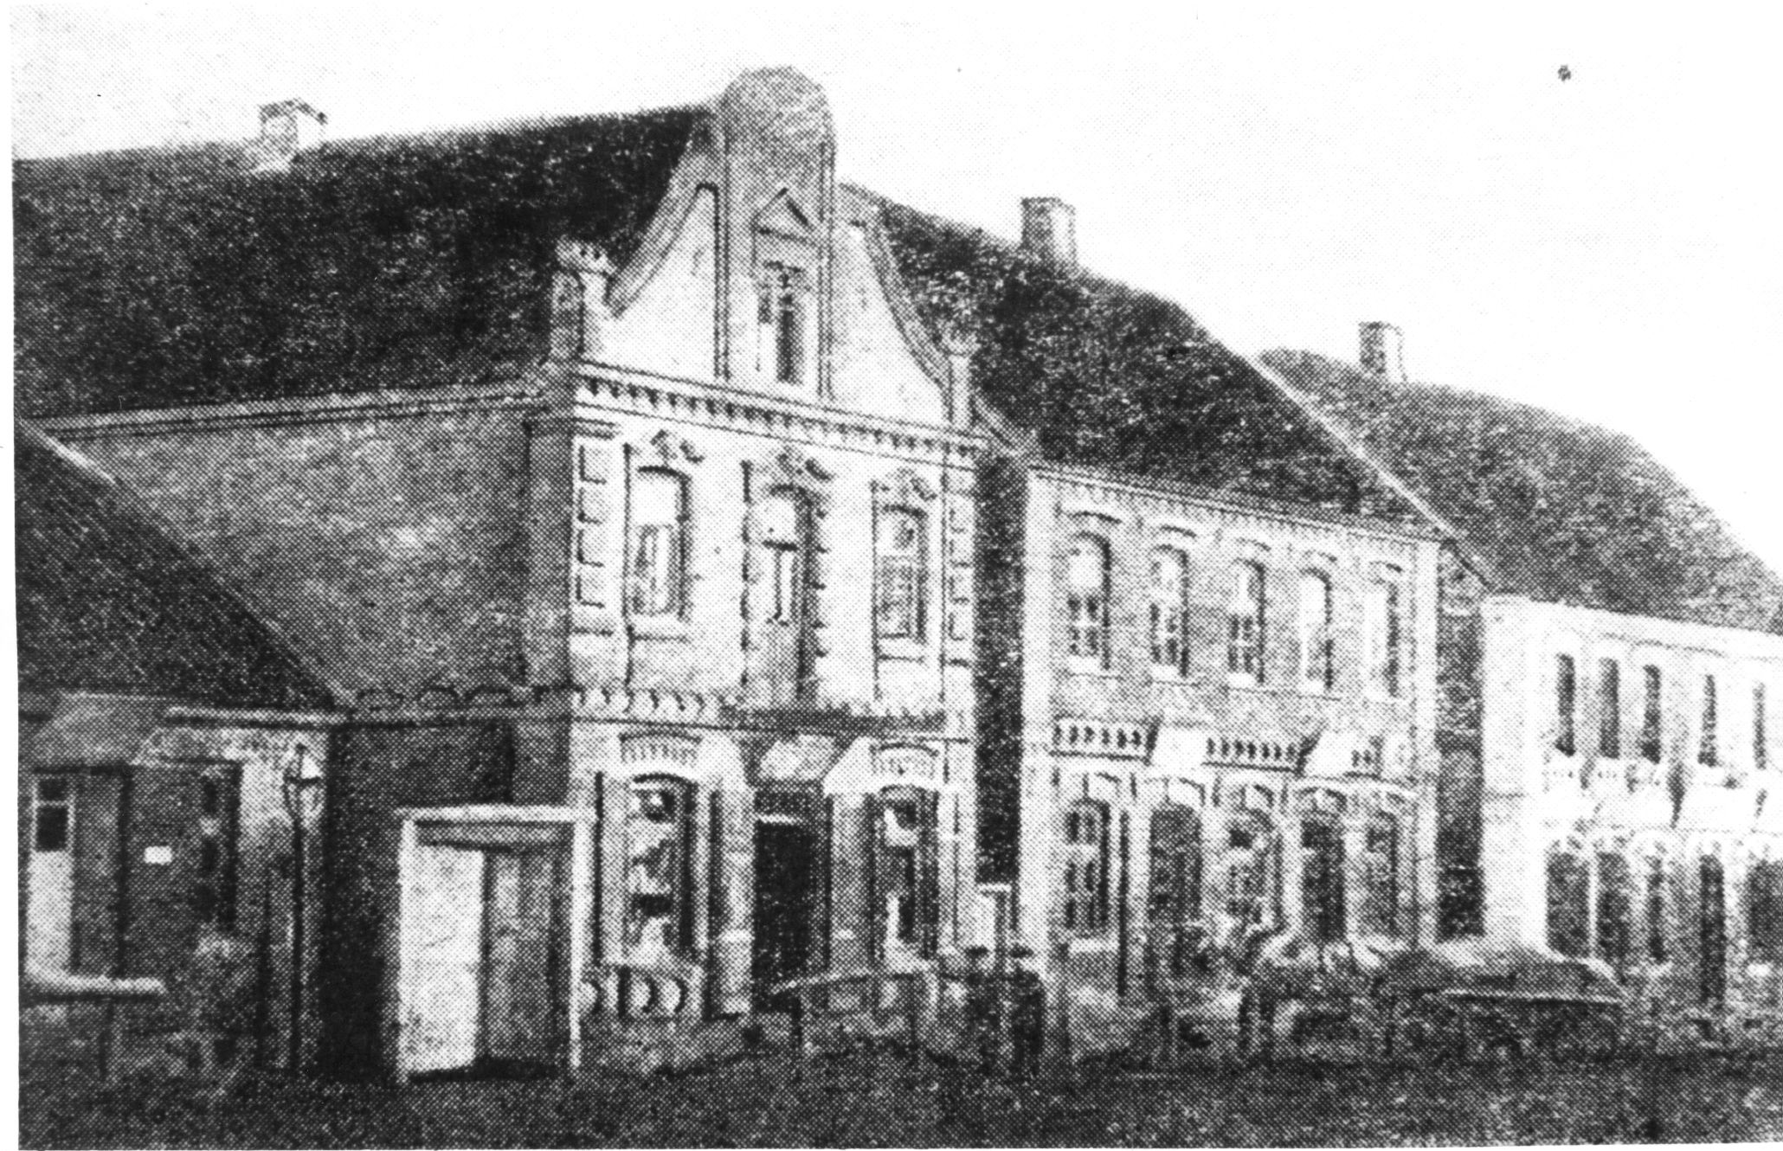
Fig. 4. The eastern side of Bazarnaya Square
Third House. First 2 windows - Wasserman had a leather shop. In 1923-25 I was his errand boy: to go where he sent me, to help, to serve. When buyers came in on market day, to show the goods, to see that they weren't stolen. In 1935 he went bankrupt. He went to his father-in-law in Linkuva. There he had a schwiger, a mother-in-law. She, too, grew old, and they took him in. Then there was another owner's tearoom in the house, not Jewish. Next windows lived a Lithuanian man, Melis, and even farther the shop of Aperavicius, also a Lithuanian.
А. Photo 18 (31.08.1982) South side of the square (corresponds to the second top view in Fig.79 of the mentioned article "Zeimelis").
Ф. From left to right [pictured].
The first house. This is the Schulgeifer house. There used to be the house of Leyser Haesch , which I can still see (see Fig. 79). It was the home of the poor. The leftmost door is the shop: a Latvian sold treff meat. The second door is the shoe shop of the Lithuanian Riles. Farther on, the Jew Avreml Matsunsky had a bakery. Avrom Shulgeifer bought the place from Hayes and in 1935-38 put a new house on it. It did not take him long to rejoice in it. He himself lived, as before, in an apartment by the drugstore. There they had five or six rooms, kitchen, room for servants. And this house he rented out.
А. To whom?
Ф. I mentioned Itkina. Her son married some Kremer, he lived on the second floor on the left with his wife and mother-in-law, and on the right I don't remember who lived. Downstairs on the right, the Latvian Platbaldis had a fruit shop. And on the left Lithuanian Baikshtis had a manufactory and leather store. Lately he also gave me work: I used to make his billets. They had shops in the front and apartments in the back. There was no third floor in the house, just such architecture.
In the house [it is not clear which one] lived Yankelevich, the banker.
The second house. This is where Schulgeifer himself lived. It has a pharmacy downstairs. The pharmacy had always belonged to [Roza] Abramovich. She was the mistress of the pharmacy, had an assistant, who [in the early 20s] went to Africa. [Rosa] was short, lame, with a crooked back. She had difficulty coping alone in the pharmacy. She advertised that she was looking for a pharmacist to assist her. Schulgeifer wrote to her offering his services. He was a young man, much younger than she was.
She summoned him. And he started working for her. He himself was from Vilnius, a refugee, lying around somewhere. And there was such a [unintelligible in Yiddish - "a bilzov na shmalzu"] fat hole. They got married in 1926. Of course, it was a marriage of convenience. She didn't have any looks, old, then deaf. But a cultured woman.
Since they had no children, they took in a foster child in 1928. They came to Kaunas to the orphanage. They took an orphan boy, 9 months old. His mother died in childbirth. His father was a bricklayer. He fell off the roof and crashed to his death. The boy was Jewish, circumcised, all right. They adopted him. Then they hired a German bonne from Klaipeda for him. She spoke German to him. When the boy grew up, he was taught the violin by a musician from the church, which had a Catholic center. The priest [Kurlanskis], the apothecary, the head of the [railway] station, the head of the post office - they were all friends. They visited each other, they knew each other well. I went to see Shulgeifer one day on business. He had a priest: they played chess.
А. Photo 13 (17.07.1983). Again, the south side of the square.
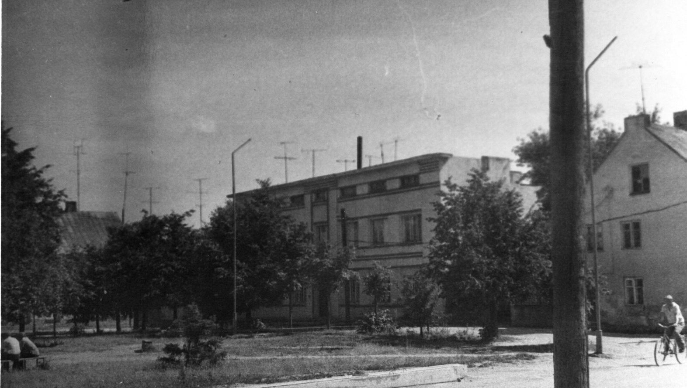
Fig. 5. The south side of the square.
On the back of the photo, text in pencil: "13. Zeimyalis 17.07.1983. Bazaar Square. View of the house built by Schulgeifer on the site of the house he bought from Leiser Haesch".
Ф. When all of them [the Jews after the Germans came] were taken away, the priest of Zeimyalis found out about it. They [Schulgeifer's acquaintances] came running and said that they knew from Schulgeifer that the boy from the orphanage was really a foundling. That the Shulgeifers simply said that they had taken a child from a Jewish orphanage, but that in fact he was a foundling. And we don't know if he's Jewish or not. He might be Jewish. There's a 50% chance. But it's not 100% certain.
The bandits respected the priests. Moreover, there was more than one priest in Zeimyalis. There is another church four kilometers from Žeimialis. He took Antares and Vaitekunas from there. They were both serious and gray-haired. They both came. And they gave him [Kurlanskis] this boy. They took him away from that barn. Of course, Schulgeifer also said: "That's right, that's right, it's not from the Jewish orphanage, I just picked him up." Of course, he could say anything then. In 1945, he was already 17 years old. The first time he served in units that caught bandits. He walked around with a rifle. Then the priest died. The boy went to Panevėžys. He was a chauffeur. Your relative [Jascha Mariampolski] said that he had already died a few years ago. He must have been 60 years old.
А. Yukna told me the story that a magician lay in a glass coffin for a month in the Schulgeifer house.
Ф. No, it was in a glass coffin in Kaunas. Jukna heard the ringing, but doesn't know where it is.
А. Was he actually being fed?
Ф. I don't know, .
А. Postcard with a view of Bazarnaya Square.
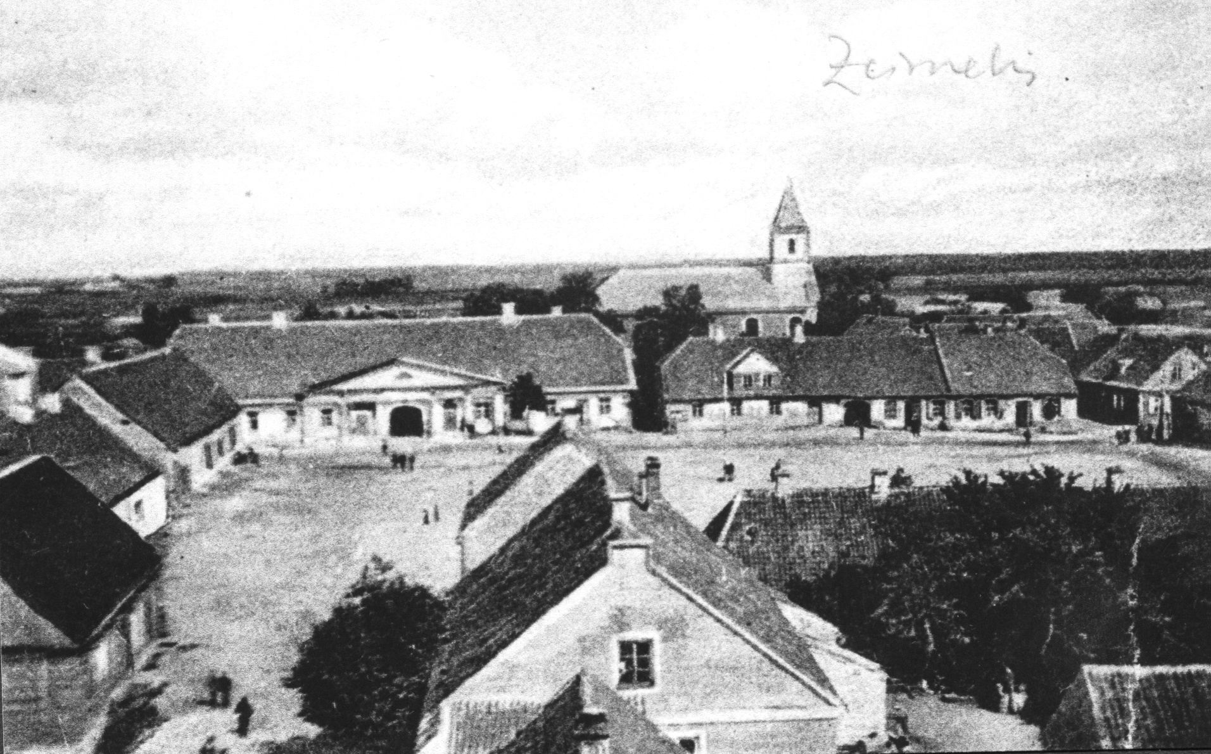
Fig. 6. Postcard ~1926.
On the back of the card is text in pencil (Jukna's handwriting): "Žeimelis. Bazaar square. ~1926. There is a Catholic church in the background. Postcard published in Ukmerga".
Ф. Small tavern on the right, large tavern on the left. To the left the west side of the square [corresponds to the third view from above in Fig.79 of the mentioned article "Zeimelis"] right house belonged to 5 sisters. Zon, their father, had a shop of iron. Remember in this book there is that in 1905, the men stole pieces of iron from him and made themselves fighting guns, spades and the like. Zon left the house as an inheritance to his daughters, dividing it into five parts. The first daughter had a bakery. The second had a grocery store, the third by her husband Yankelevich had a manufactory store, [the husband of the fourth] Benomin Tarutz traded in iron and leather, billets. I later worked for him. The fifth sister lived in Riga and gave the premises to a hairdresser. I don't know the fate of the first sister. The second and the third one, Jankelevich, were killed by the Germans. Tarutz died. The fate of the fifth, who lived in Riga, is also unknown to me.
The next house is in the direction of the church. Before World War I, there was an Itkin clockmaker on the corner there. This house belonged to a Jew who lived in Tallinn, or maybe even Finland, but more likely Tallinn. I don't remember the last name, I think it was Shulem, or maybe that was his name. In the middle of the house the Latvian first had a shoe shop, then a teahouse. And on the corner closer to the church, the widow Itkina, when her husband died, opened a shop of petty trade. But lately she closed it too. In the beginning we had 15 shops, then they all closed. Consumer demand dropped. We didn't need so many shops. And Lithuanians in every village opened their own shops and almost ceased to come to the city for shopping.
Zagorsky is very accurate in his memoirs, so the discrepancy in his words about the owner of the same house on 5.06.1988 as "Lithuanian Lupas" and on 3.06.1989 that "the house belonged to a Jew who lived in Tallinn, or maybe even in Finland, but rather in Tallinn. I do not remember the last name, it seems to be Shulem, or maybe that is his name" requires an explanation. It seems that the first statement about the Lithuanian owner dates back to the mid-1930s, as it mentions the Tarutz house, built after 1934. It is known that the Lithuanian government at that time greatly restricted the economic activities of Jews, and the house could well pass from Jewish possession to the Lithuanian owner. The second statement, about the Jewish owner is made when looking at a photograph from the 1920s. At that time, the house may well have belonged to a wealthy Jewish foreigner.
А. There's a school building on the postcard. You didn't go there?
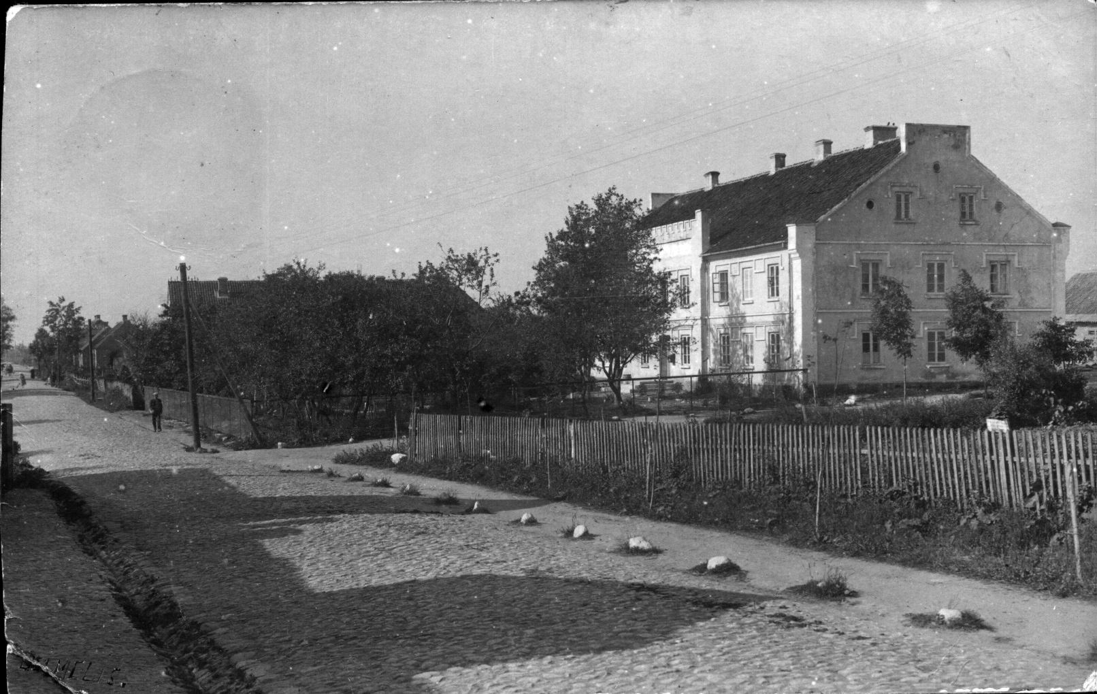
Fig. 7. Postcard. Zeimyalis. Gymnasium
Ф. No, here they taught in the official language, Lithuanian. My mother was a pious, simple person, so she did what the leaders of the community said. They said you had to go to cheder, so she sent you to cheder. She had to teach me, too.
А. Photo 19 (31.08.1982). Was there a pharmacy here?
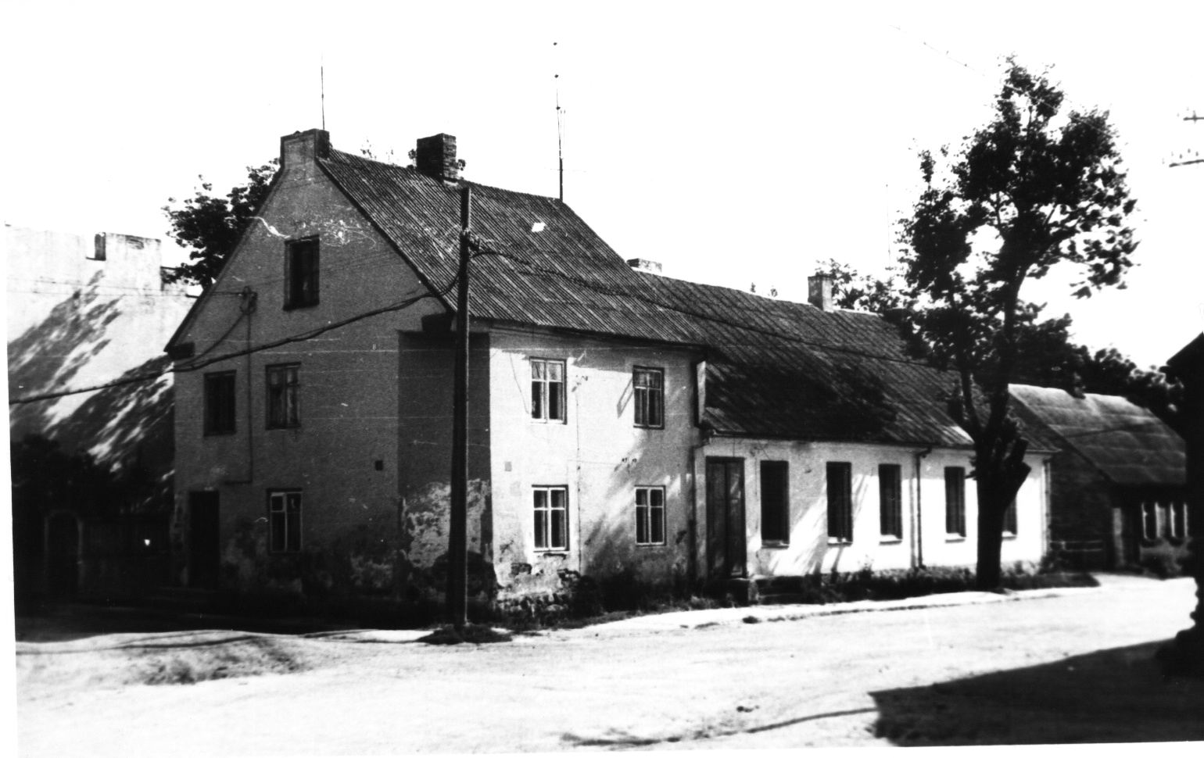
Fig. 8. Bazaar Square in Žeimelis
On the back of the photo the text in pencil: "19. The market square in Žeimelis. House of Rosa Abramovich (presumably). 31.08.1982. Photo by A. Hayes.
Ф. The pharmacy is on the right in the one-story section of the house where the door is. The window on the first floor to the left of the door also belonged to the pharmacy. In the two-story part of the house on the second floor was the apartment of Welwl Ehrlich, with windows on the square and on the street. He had a store on the first floor, the door was from the corner, in the photo bricked up [the former door is shown in the second top view of Fig.79 of the mentioned article "Zeimelis"]. The window adjacent to the corner door is Ehrlich's grocery store. And the window and door to the square - Ehrlich's warehouse, he kept in it kerosene, tar, which he could not keep in the shop. If someone asked for it, he would go there, pour it there, and give it away.
The next house was Milunsky's [gray, one-story]. A girl lived here, whom I looked after. Her family lived in the house for 20 years. The father died in 1928. There was a widow left with five or four daughters. She had a shop - sugar, soap, plain shop. Her daughters married. The last time she lived with her two daughters. In 1939, after joining the USSR, one daughter, a teacher, was given a place in Birzai, and she went there. The mother stayed with the younger daughter.
А. Is the widow alive or dead?
Ф. Milunsky? That old woman? They killed her, she was about 80 years old. Maybe they didn't even kill her, but threw her in the pit alive.
А. Photo 18 (31.08.1982) . Next to the church is just the Milunsky house. A small house with a few windows?
Ф. Yes, yes.
А. Photo 16 (31.08.1982) . North side of the square. [Corresponds to the upper view in Fig.79, in the mentioned article "Zeimelis"].
On the left is the Great Inn. On the right side of the gate there used to be a residential house. There used to be a door in place of the second window on the right [see Fig. 79]. In the house lived Ephroim Ber, a merchant, he traded in linen. Then Behr sold the house to Israelson and left for Africa. Israelson was latterly headman of the synagogue, and had a large manufactory shop (2nd guild). And to the left, under the gable where the door was, was Yankel Gehr's shop. Then Izraelson gave this shop to his wife's sister, who lately conducted petty trade in it.
The other half of the house was bought by Wilenchik.
А. Photo from 1988 with the caption "View from the church to the Great Inn". You can see the left side better.
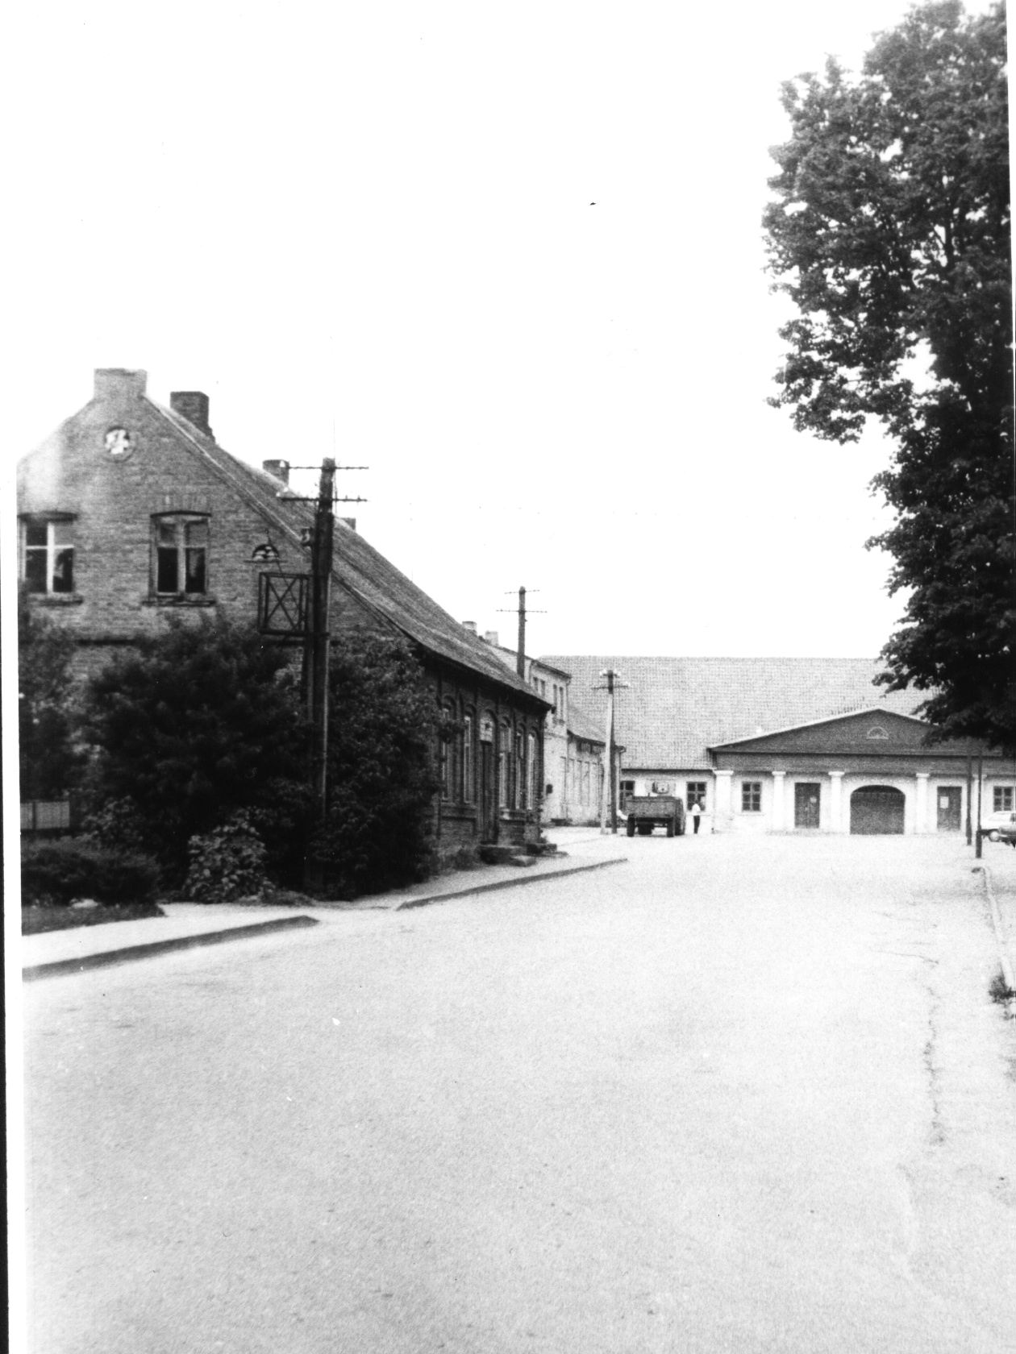
Fig. 9. Žeimelis. View from the church to the Big tavern. 1988 г.
On the back of the photograph is text in hard pencil: "No. 9. The house opposite the pharmacy".
Ф. From the gate to the end to the left [in the Great Inn] everything belonged to Vilencik. There was a tavern in the front, and until about 1925-27 there was a stodola in the back, i.e., a visiting yard. They would come and put the horses to rest. And when the lomoviki withdrew, they built a mill and a power plant there.
Here [the first house on the left] first lived old Isroel Green, who was required to return the mortgages. In the thirties he died, and his son Bere Green lived . The house once had a tavern (a schenk). Shinkar. Then Bere grew old and rented the premises to the Lithuanian petty trade cooperative, and the house remained his.
А. Photo 18 (17.07.1983) . Joniskis street. View towards Bazarnaya Square.
The two-story one on the left is Hera's house . On the second floor was a Jewish bank run by Yankelevich. The house was residential. There was a dentist here, I told you, this girl. On the first floor, in the right [far] wing, lived the mother [Abe] Hera. She had two daughters. One got married in Yoniskis. The second, a dentist, lived in the left wing. She remained an old maid.
А. Photo 12 (17.07.1983). This is a closed window in a house that once belonged to Moses Haesh. This is a corner house.
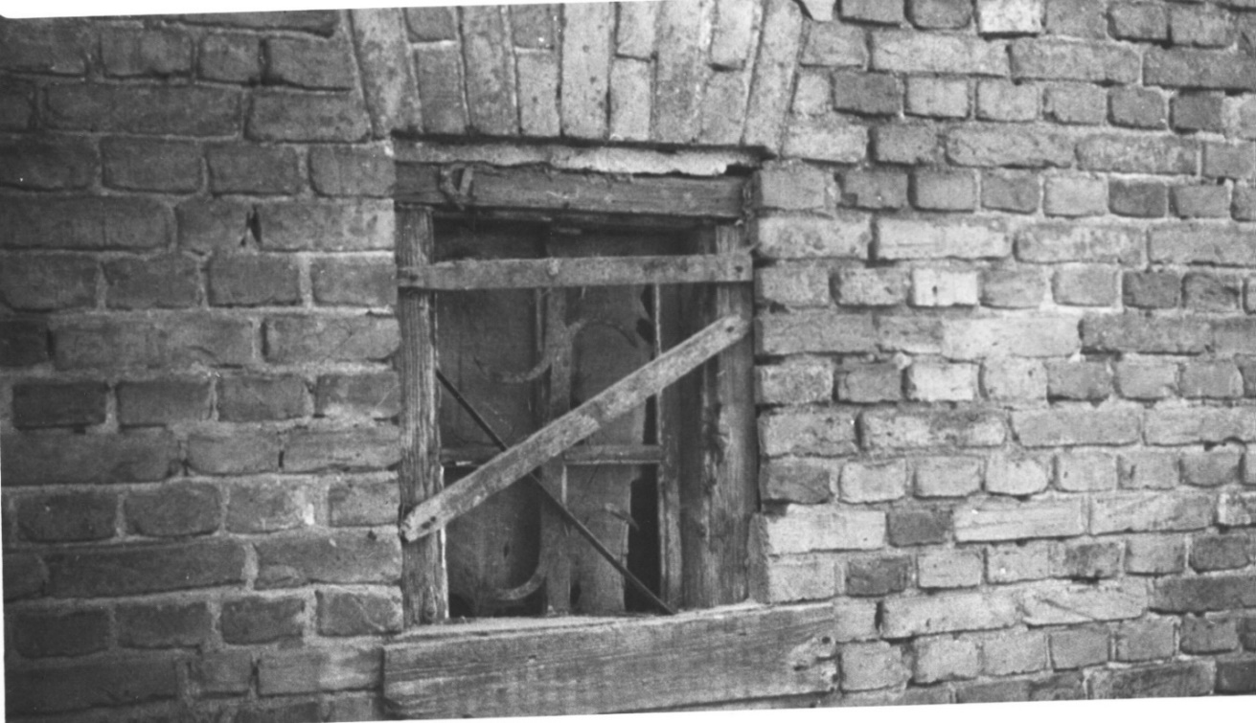
Fig. 10. Žeimialis. A window in the house of Elia-Matys Haesh. 1983 г.
On the back of the photo text in pencil: "12. Zeimyalis 17.07.1983. House of Elia-Mates, my great-grandfather. View from the yard to the basement window. You can see the old wrought iron binding".
Ф. Well, maybe. One side [of the street] was Leizer Haesha. And the other side was Meishe Haesha. In the house of Meishe HaYesha on the back side, towards the synagogue, there's an old window boarded up, I photographed it, the gate, this gate, and this same window.
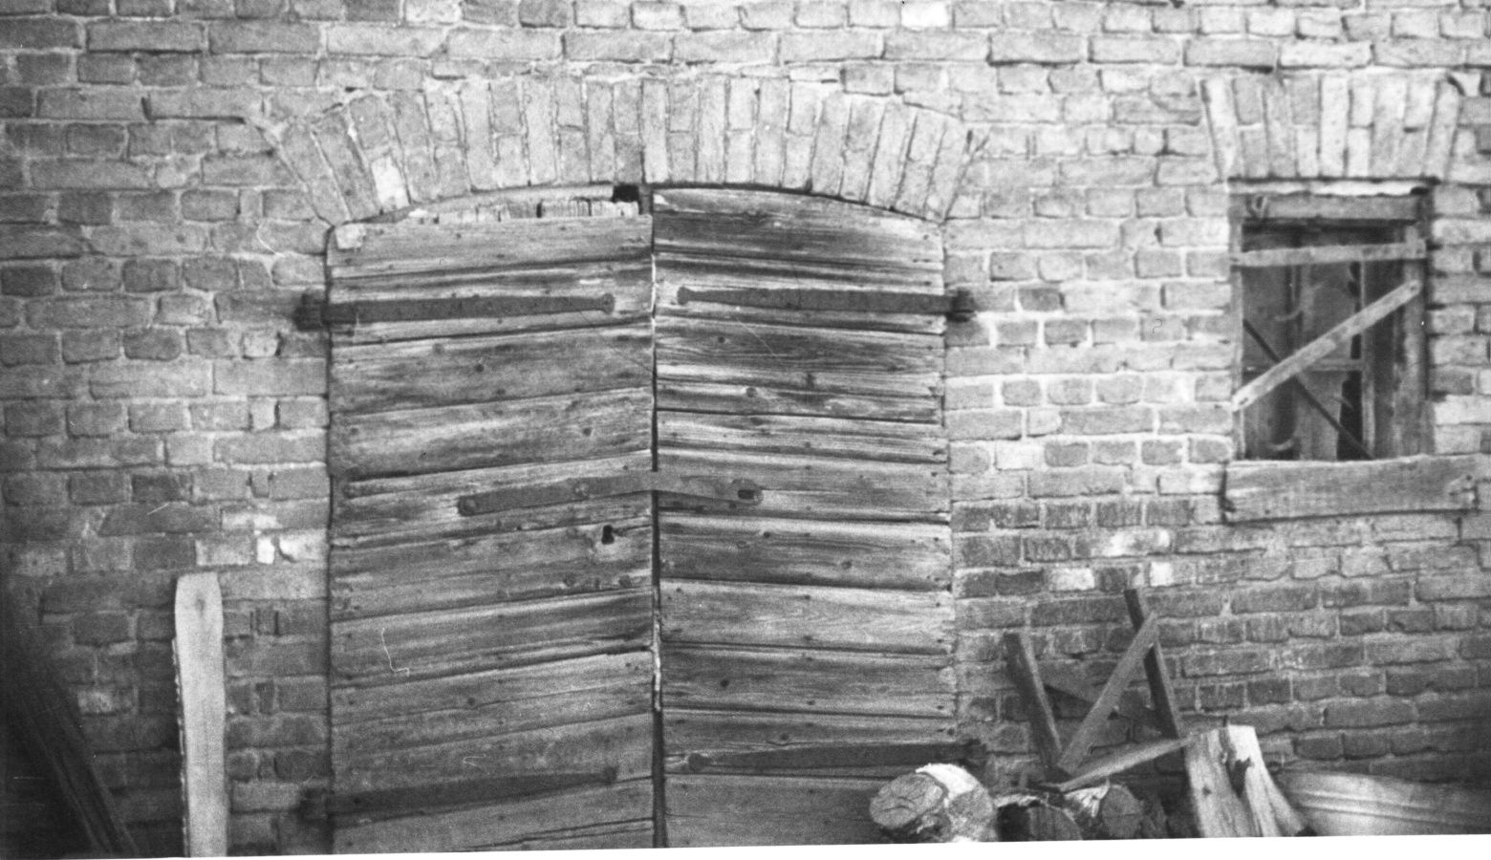
Fig. 11. Žeimelis. The basement floor in the house of Elia-Mates Haesh. 1983 г.
On the back of the photo text in pencil: "11. Zeimyalis 17.07.1983. House of Elia-Mates, my great-grandfather. View from the yard to the basement floor".
А. Photo 10 (17.07.1983) . The view from Pasvallio Street. This is still to the right of the Meishe Haesh house.
Ф. It's some kind of barn, it's not an apartment.
А. The picture says that there was a synagogue here somewhere.
Ф. There was a synagogue. At the street.
А. Photo 1 (August 31, 1982). The house of Moses [formerly Matys] Hayesh in Zeimeli. View from the yard. Do you know who lived here?
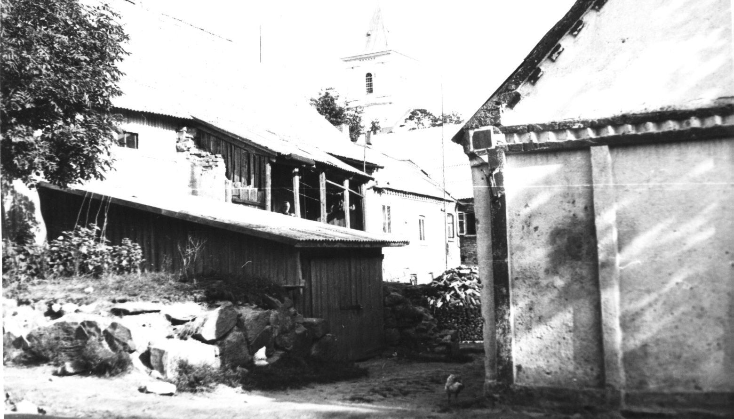
Fig. 12. Žeimelis. The House of Moses Haesh. 1982 г.
On the back of the photo the text in pencil: "1. The house of Matys Hayes in Zeimyalis. View from Pasvallio street. There is a church in the background. 31.08.1982. Photo by A. Hayes.
Ф. No one from the yard lived here. A lot of people have lived in the house in 20 years.
А. And these two windows? The house next door to Meishe Haesh's house.
Ф. These must be the windows where the bell ringer of the church lived. Opposite there lived a bell ringer, if that's the case.
А. Whose house is the next door, the one that's half visible?
Ф. First the Lithuanian Freiman lived here, he had a shoe shop, and then Beniomin Berman, a tailor. And then there was the synagogue.
А. Photo 2 (31.08.82) House [formerly Matys] Haesh. View from Pasvallio Street. On the right, where the door, who used to live?
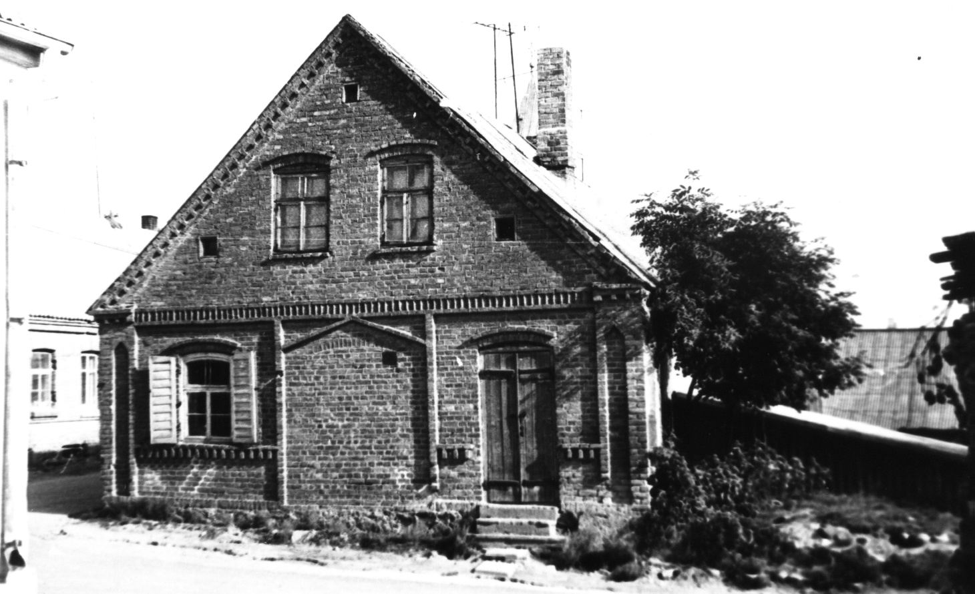
Figure 13. the house of Moses Haesh. 1982 г.
On the back of the photo the text in pencil: "2. The house of Matys Hayes in Zeimyalis. View from Pasvallio street. There is a church behind. 31.08.1982. Photo of A. Hayes.
Ф. There was a shop here and a barbershop there.
А. Who lived on the second floor?
Ф. I don't remember. A lot has changed in 20 years.
А. Photo 3 (31.08.82) . Bauska street, view from the square. The window is the same as in photo 2.
Ф. Izraelson used to have a manufactory shop here [on the corner]. And there, further down Bauska Street, was the militia.
А. Photo 4 (31.08.82). Bauska Street. This is the next house. You say this is the bellringer's house?
Ф. No, this is also the home of Meishe Haesh.
А. Is the bellringer's house next, then?
Ф. No, the ringer is even further away.
А. Then the one we saw two windows is not the ringer.
Ф. Yes, that's not the ringer. And in picture 4 the leftmost house is where I learned my trade in 1925-1926. This is where the billetsmith Reuven Friedman lived, he went to Canada about 1928-30. What I remember about my apprenticeship is that Friedman was such a godless man that he didn't even go to synagogue on Yom Kippur. He was considered progressive, he was a communist. But he was such an exploiter! In the two years I worked for him, he taught me nothing. I just babysat his kids, that's all. You have to let me do something. I was 15 years old, and he only gave me small things - to cut something. Didn't teach me how to do serious work. I fought with my wife, they called each other names.
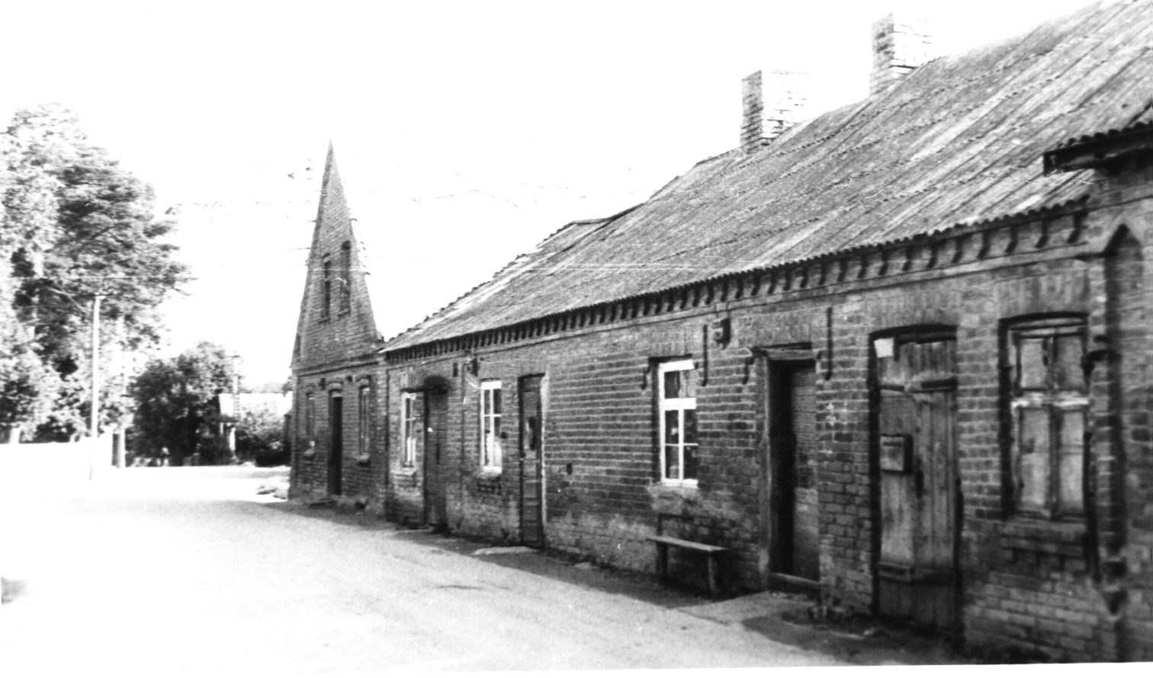
Figure 14: Moses Haesh's second home. 1982 г.
On the back of the photograph is text in pencil: "4. Bauska Street in Zeimelah. The second house of Moses Hayes, in the foreground the edge of the house of Matys Hayes, inherited by Moses. The last house, facing the street, may also have belonged to Moses. Photographed on August 31, 1982. Photo by A. Hayesh".
А. Photo 5 (31.08.82) . Bauska street. View from the church.
Ф. In the first house of Meishe Haesch, on the corner, there was Izraelson's shop, then the militia. In the second house, which was lower, there was Gurvitz's bakery, even closer Vytautas Matislav, a shoemaker, a big drunkard.
А. Photo 6 (31.08.82). View of the house of Moses Haesh from the yard.
Ф. Well, from the yard doesn't make any difference. Here I remember there was such a garden from the yard .
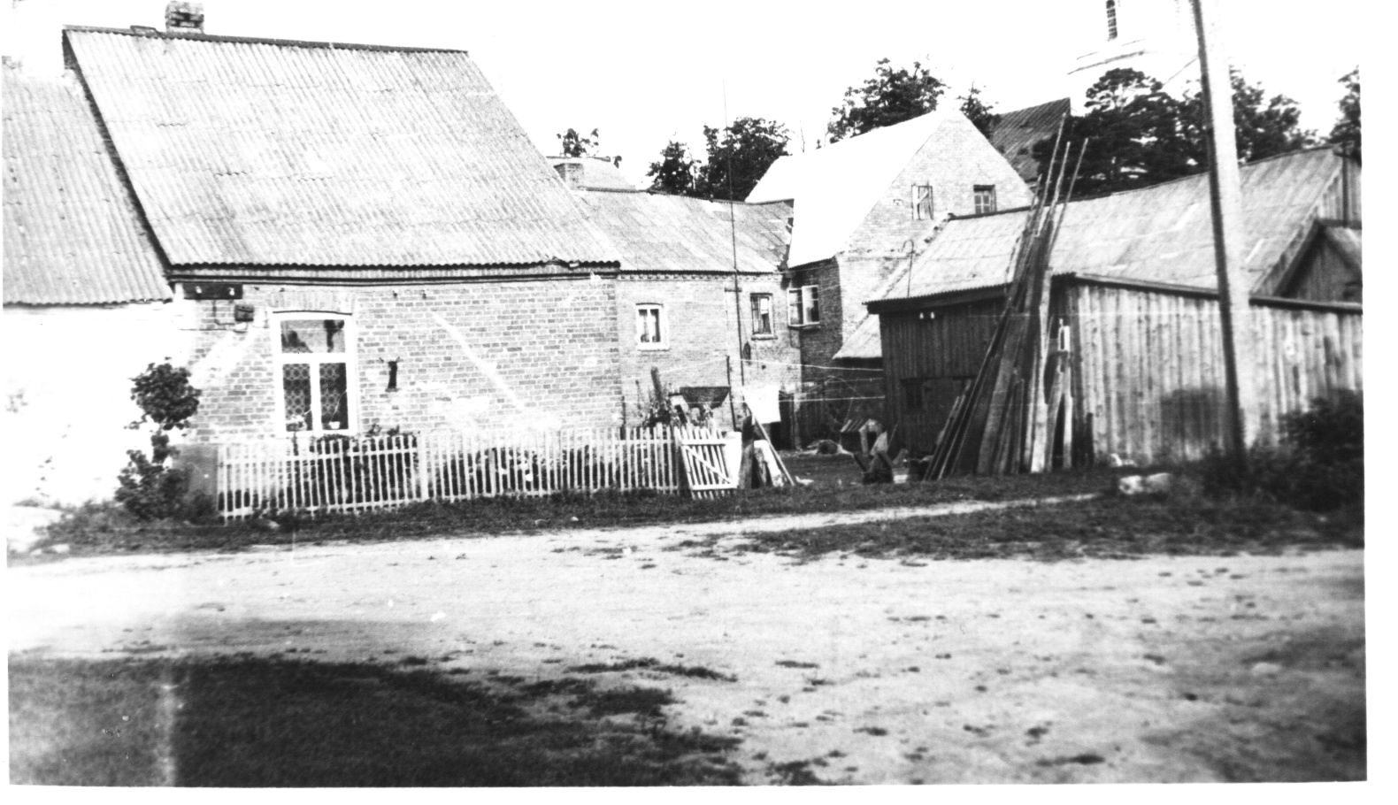
Fig. 15. The same houses from behind. 1982 г.
On the back of the photograph is text in pencil: "6. View from the courtyard of the houses belonging to Moses Haesh. You can see the second house and the house standing at the end. At the back is the church. 31.08.1982. Photo by A. Hayesh".
А. Photo 8 (31.08.82). Bauska street. The house of Leiser Haesch is the closest to the church. Who lived here?
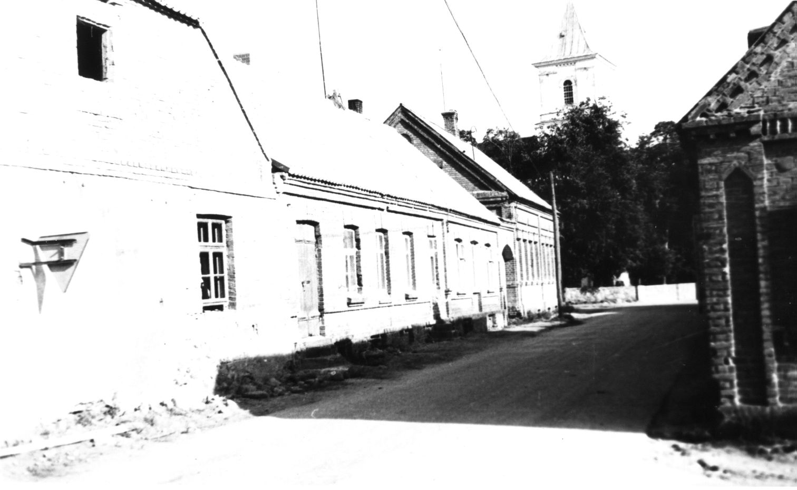
Fig. 16. Bauska Street
On the back of the photo the text in pencil is "8. The house of Leizer Haesh in Zeimelis. In the foreground on the left is the main house. In the background - the church. 31.08.1982. Photo by A. Hayes.
Ф. In 1923-24 - Reuven Friedman. First lived here, and then moved to the other side, also to the Hayes house. After him Kaulinas, a Lithuanian, had a bakery, the latter lived with the widow of Gitel, the owner of the power plant. He died at age 33 in 1933.
The house closer - they wanted to make a mill, but it didn't work out. No one lived in it.
There is a published photo of the same type of street, referring, judging by the name of the street, to the 1930s.
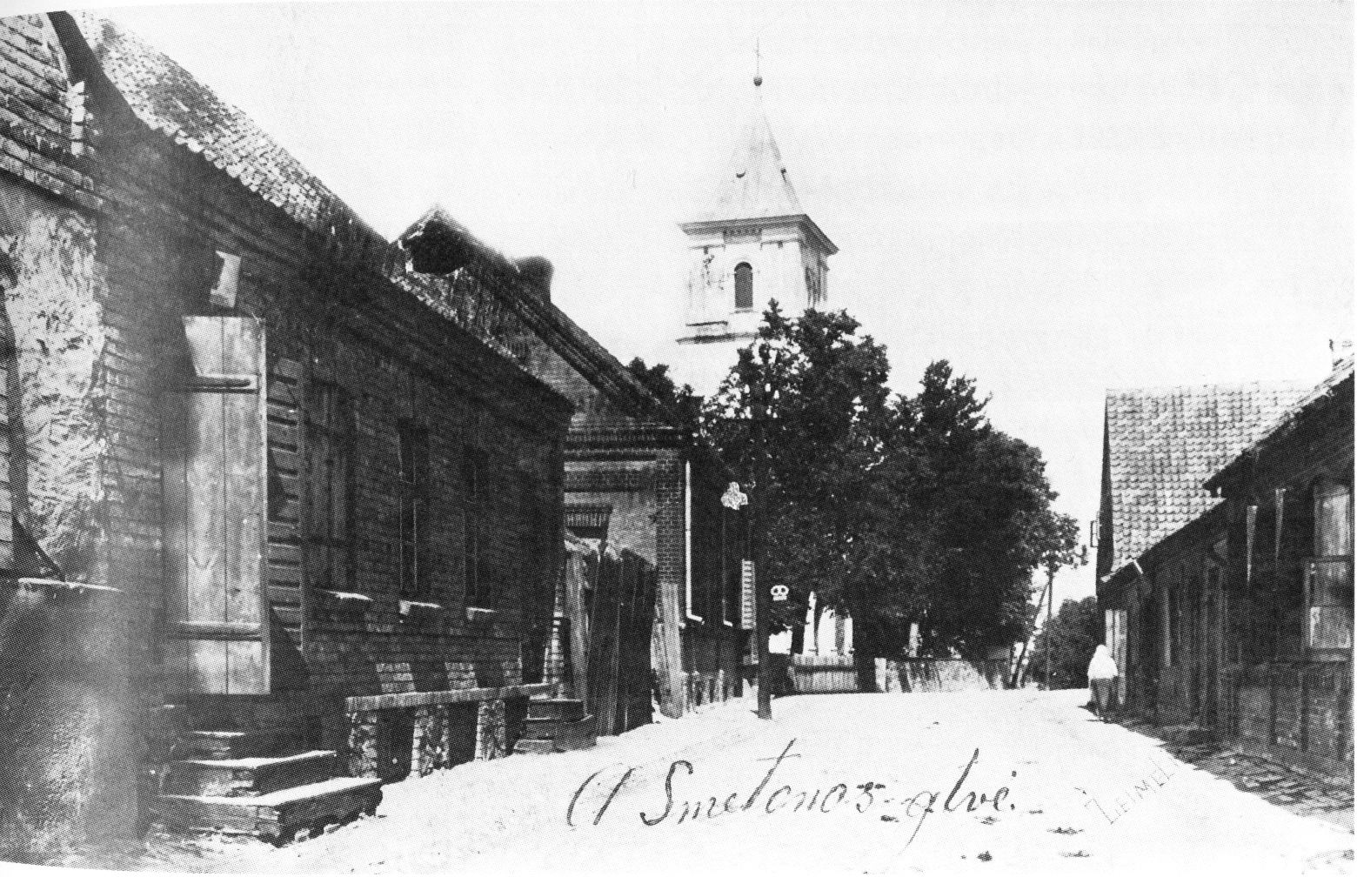
Figure 17. northeast corner of the square
During last year's walk in Žeimelis on 4.06.1988, F. J. Zagorski photographed some houses. At my request, the pictures were printed in Panevėžys by Jasza Mariampolski. When I received the pictures I wrote on the backside the time and place of the photographing and tried to establish the relation between the houses by looking at them very carefully. In a few cases I succeeded. I asked Favel Yosifovich to comment on the photos.
А. The photo from 1988, where the trucks are standing.
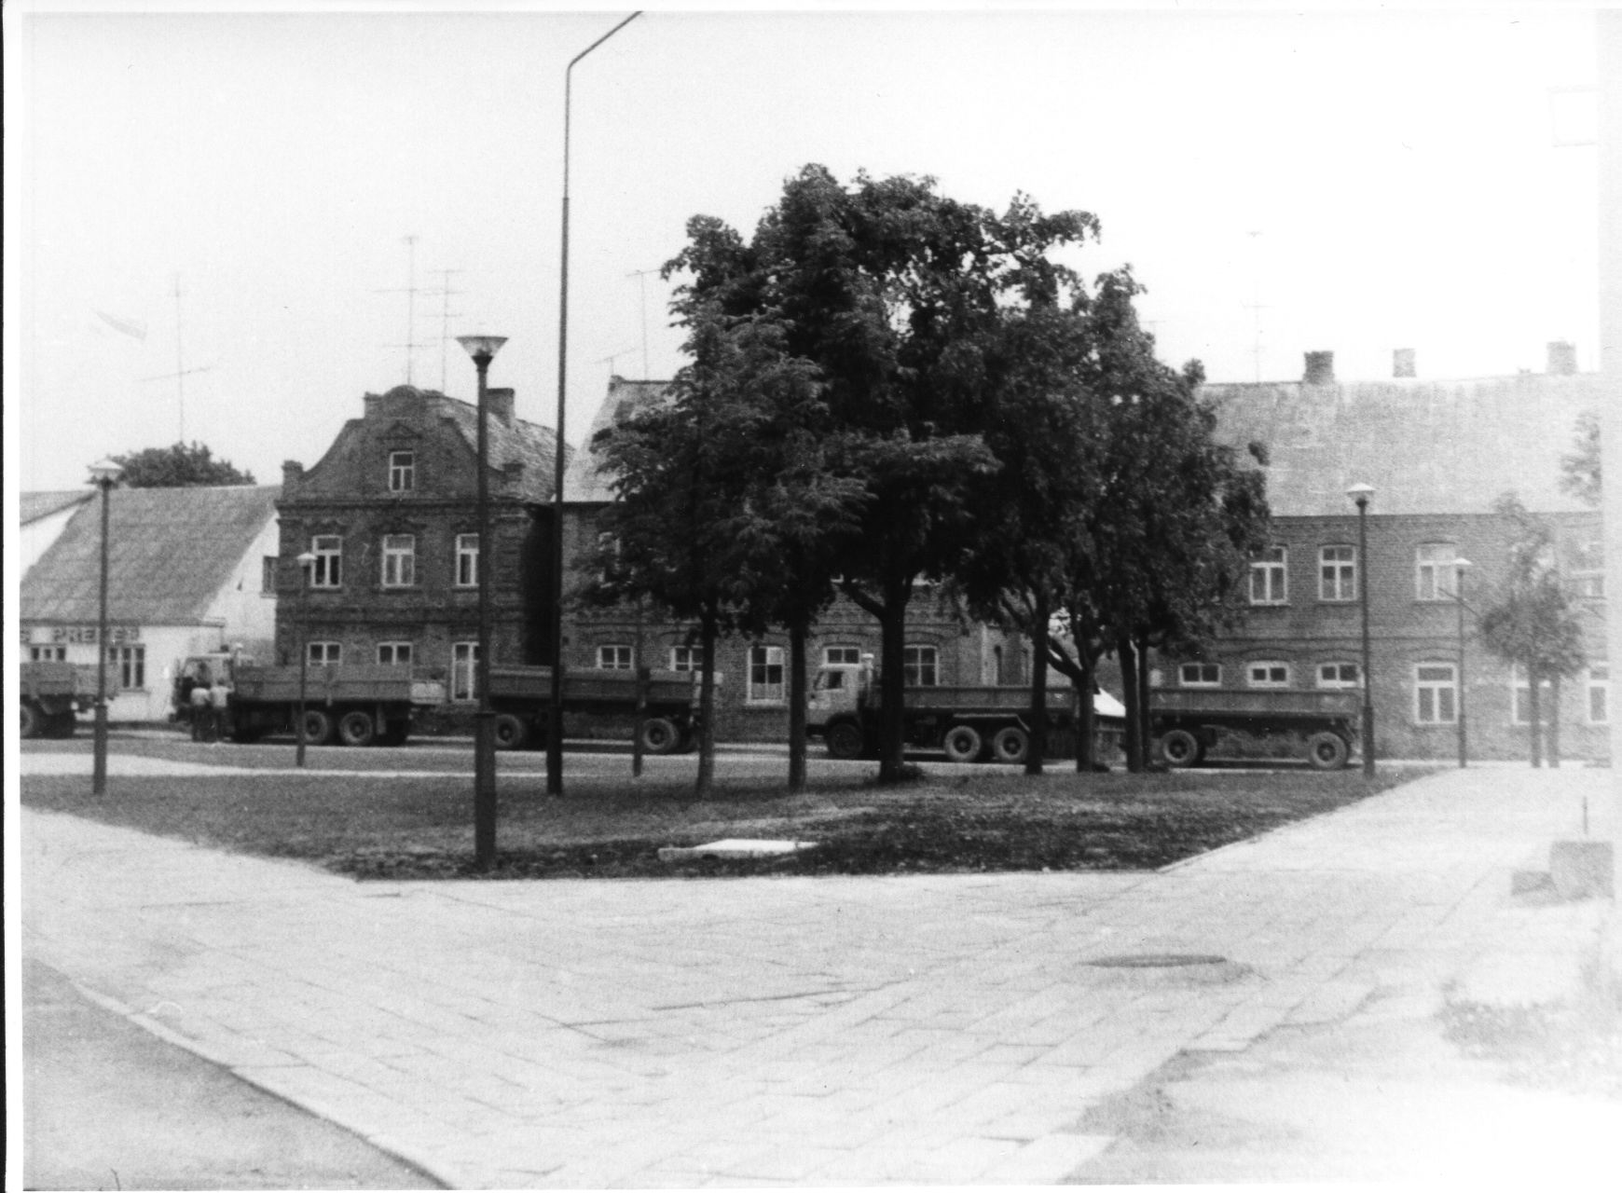
Fig. 18. The eastern side of Bazarnaya Square. 14.06.1988
On the back of the photo text in pencil: "No. 1. June 1988.
Ф. This is Leizer Zagorski, this is Bulis, this is Melis . This is where I joined the errand, and here on the edge Aperavicius had a store, here what was - I don't remember, and here on the second floor Melis had a doctor Rudys. This oak tree was planted in 1925 as a sign of Lithuanian independence.
А. Photo 2 1988.
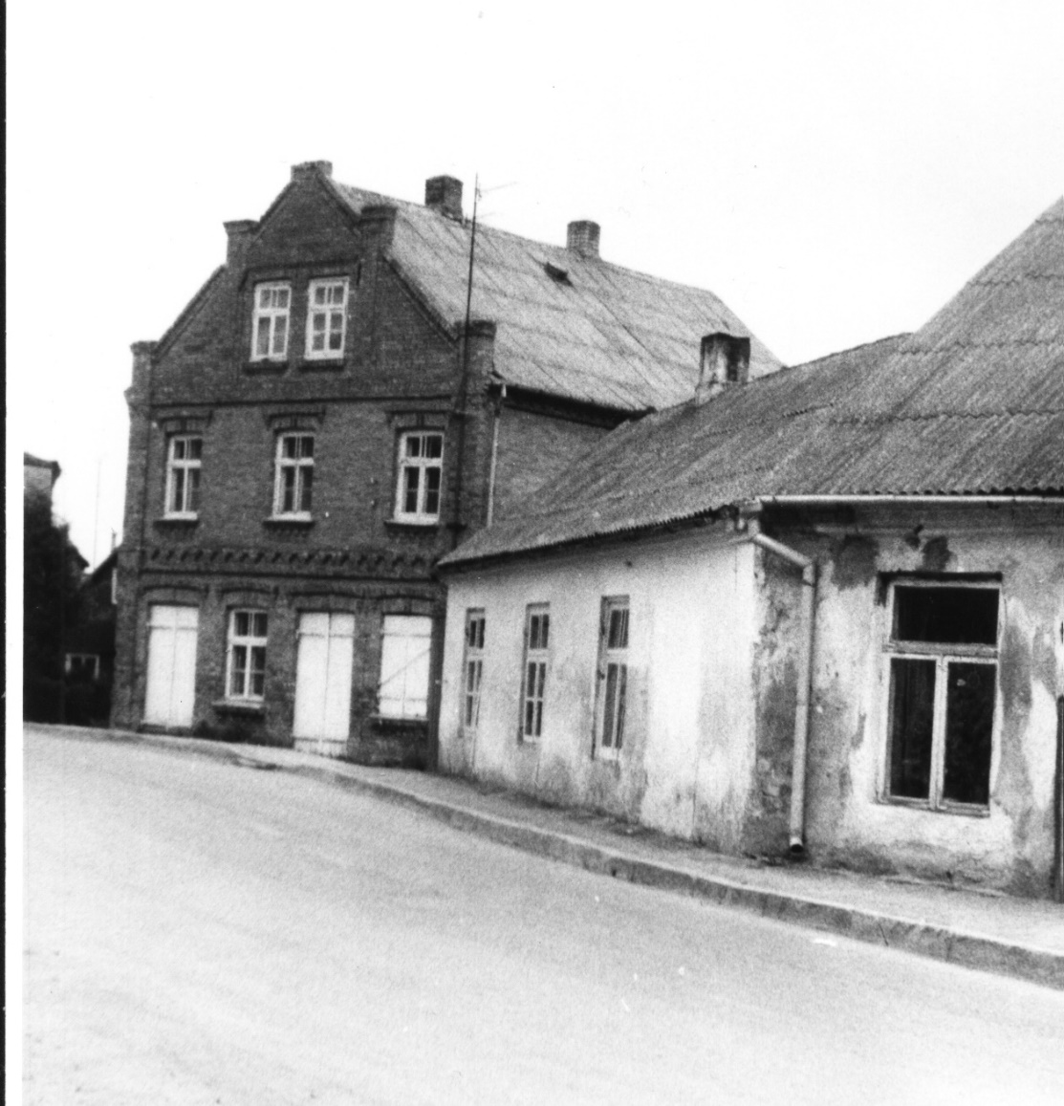
Fig. 19. houses on Linkuvos street. 4.06.1988
On the back of the photo texts in soft pencil: "No. 2. June 1988. Žeimialis" and in hard pencil: "Photo 2 and photo 3 - adjacent, clearly by the spots on the window of the right house.
Ф. [The left house. There was nothing on the] third floor. Nobody lived here.
А. Tell us about your home. Where did you get it?
Ф. Hired. At one time Rosa Abramovich lived here. Her father and the owner of this house were brothers. So he was her uncle. He died in 1914. A widow was left with five daughters. Then the son went to America or Africa. Then in 1924 he came and took them all away. Then here lived tailors, Jewish Tabak girls, three or four orphans also with their mother, they were tailors. Then the house was bought by the priest, who bailed this boy out, his last name was Kurlandchik. And when all the portmanteaus girls got married and moved away, we took over the house in 1935. And before that we lived where the two-story store is now, there was a little house, which was demolished and this store was built in its place.
Ф. The house next door was the brother of Rosa Abramovich . He had a whole row of houses. He was a big merchant, a linen merchant. This one belonged to him, too. It's such a big space.
А. Photo 3 1988. House with an outbuilding, with a mezzanine. Two-story left cottage, who is in it?
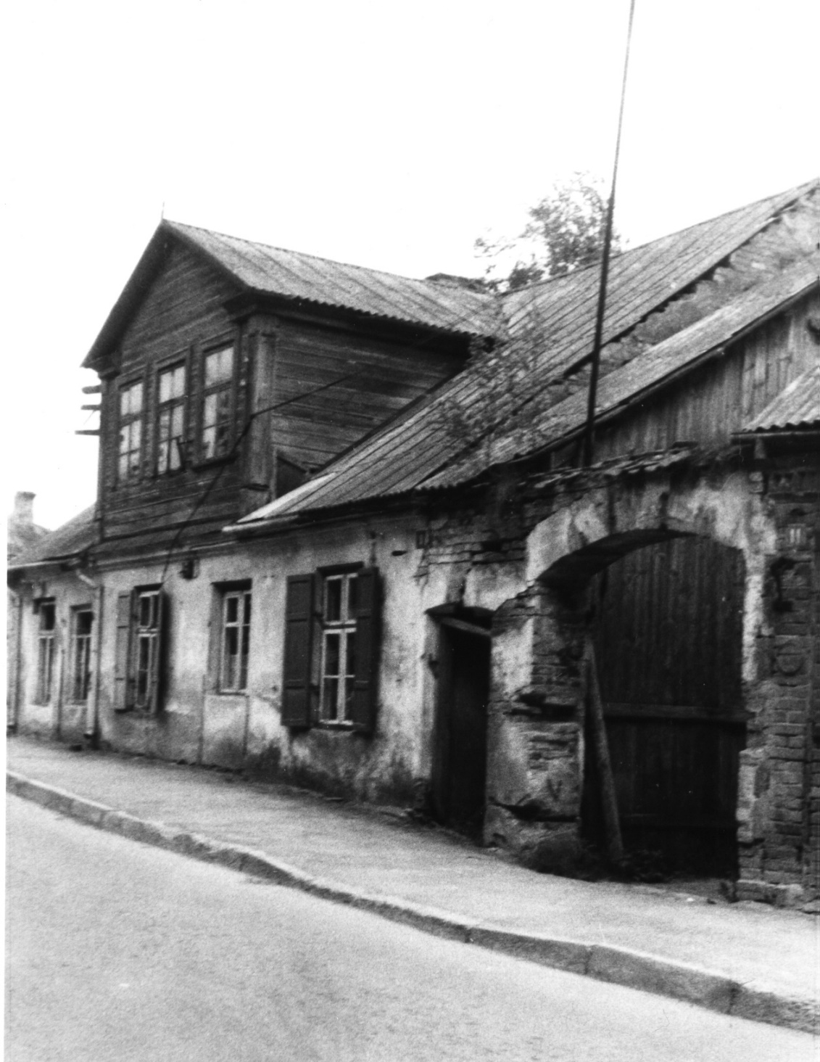
Fig. 20. House No. 9 at Linkuvos street. 4.06.1988
On the back of the photo the text in pencil: "No. 3. June 1988.
Ф. It was Betis. Remember I was talking to an old lady like that. This is their house. At one time it was a reading room.
А. Is that on the 2nd floor?
Ф. No, the left door. Then there was a milk collection point. The owner would bring in the milk, he would centrifuge the cream, send it to the factory, and give the return back.
А. So, on the first floor, left windows, reading room first.
Ф. The second floor was residential: the left two windows were the owners, the next was the secretary of the village council, Vilemavičiūtė. She had an illegitimate baby girl. I met her here the other day. The village council existed under all authorities. Downstairs is a shoemaker's shop, the last one, I think, lived a tailor. It was Abramovich's. And there was another one here. That's where Tzofnis lived.
А. Photo 4 1988.
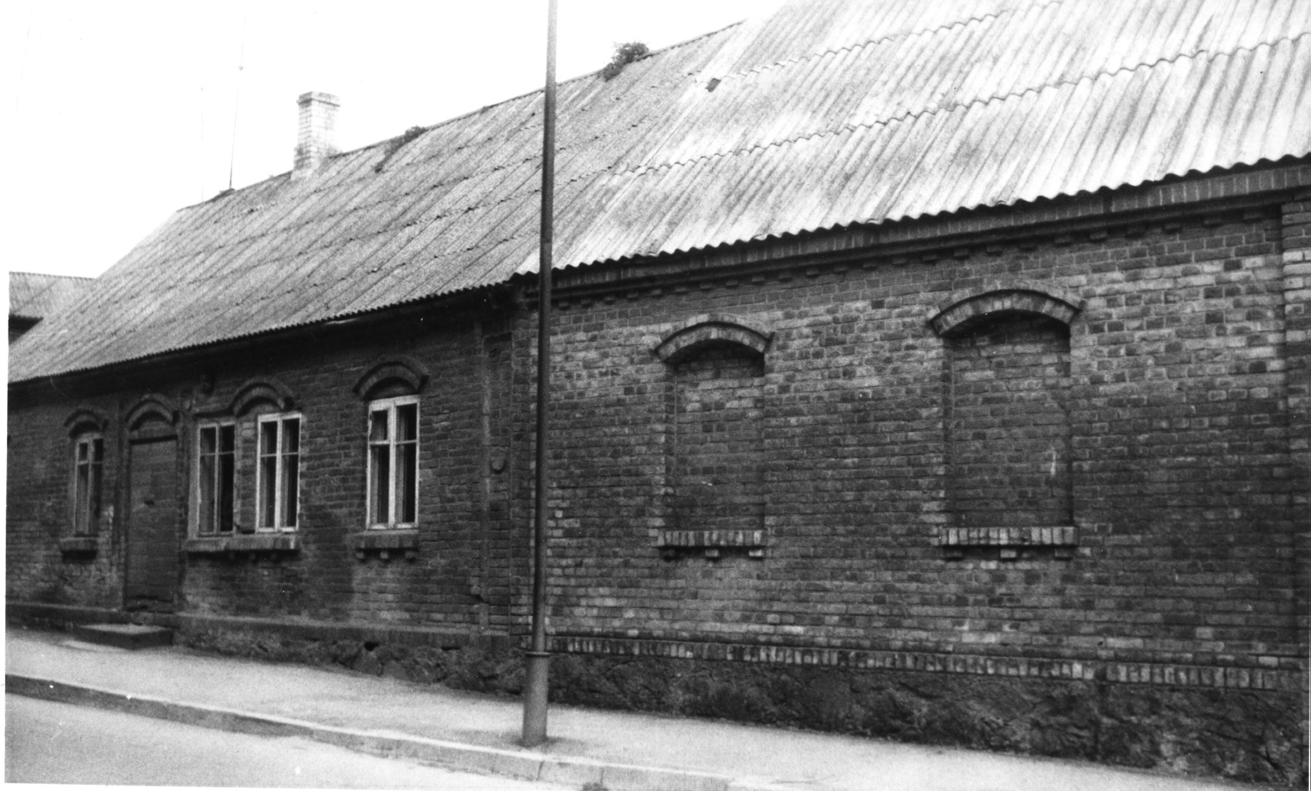
Fig. 21. On the left side of the house number 11 on Linkuvos street. 4.06.1988
On the back of the photo the text in soft pencil: "No. 4. June 1988. Žeimialis" and text in hard pencil: "Judging by the brick pattern on the vertical edge of the house (groove with a circle) photos 3 and 4 are adjacent.
Ф. Yes. There must still be one here. Remember, I was talking to the old lady Yushka there, she lived here. Tzofnis, a widow, lived here. She had two children who lived in Kaunas . This should be the house where the savings bank is.
According to Augustina Kukavičiūtė, the oldest resident of Žeimialis:
In the bourgeois years there was a Lithuanian penitentiary in a small one-story stone house. In Soviet times, there was a savings bank there. In July 1941, all captured Jews were driven into this house .
А. Photo 5 1988.
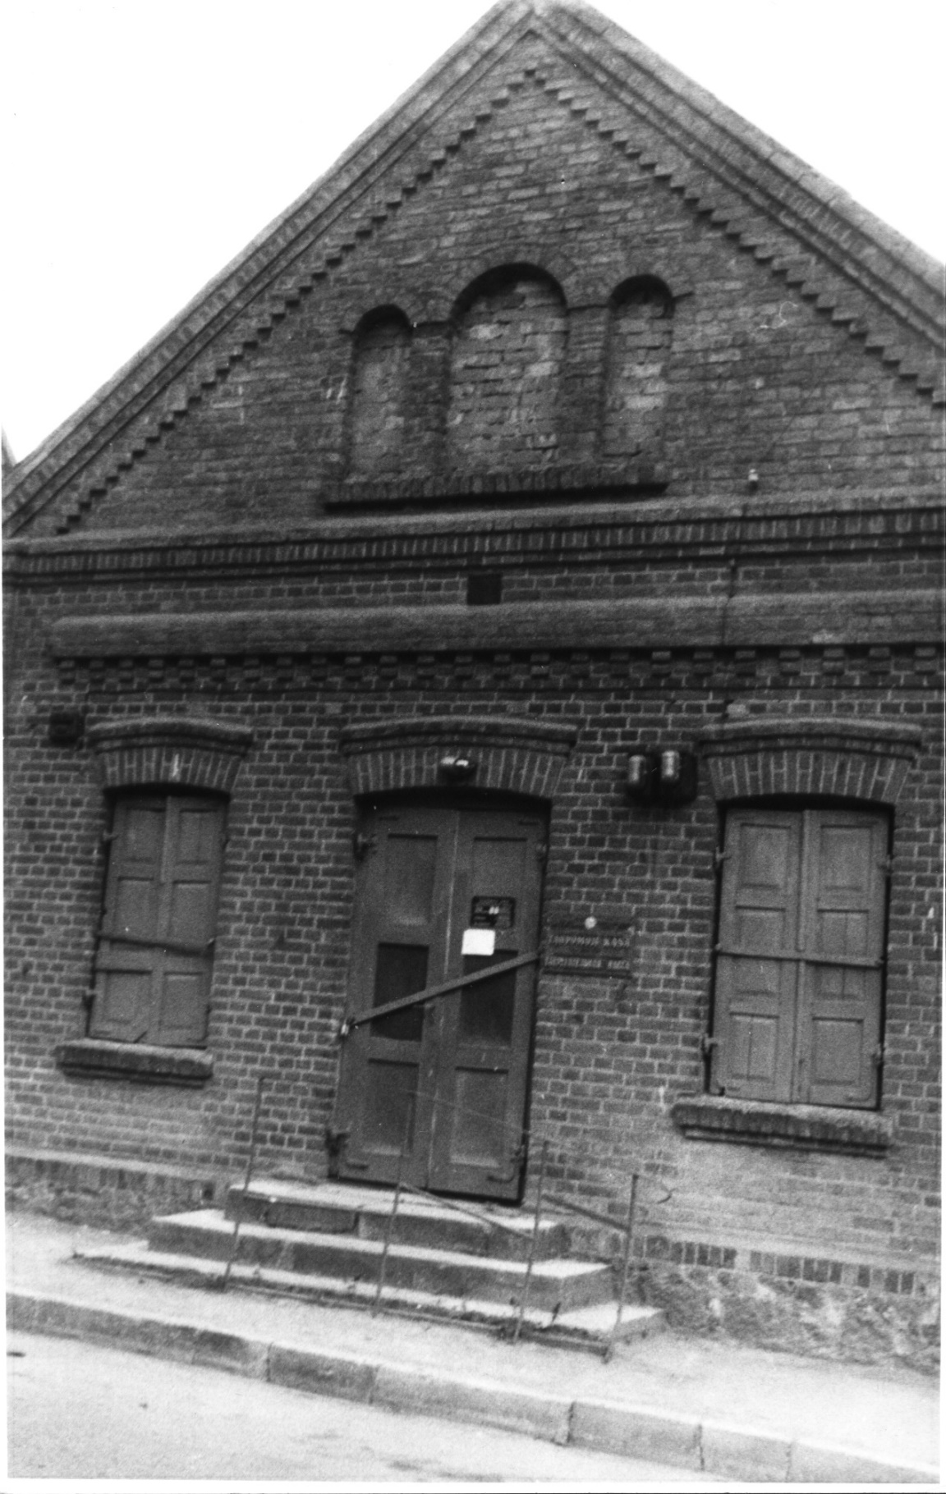
Fig. 22. a savings bank. 4.06.1988
On the back of the photo the text in pencil: "No. 5. June 1988.
Ф. Next, Wolfson's houses, bought from Abramovich. Wolfson was a tailor, already an old man. His children were businessmen. They were tailors, they made a lot of money. A whole street almost went to him from Abramovich.
-----00000-----

Autobiographical part
А. Faivel Yosifovich, I would like to record a little bit of your personal memories, your biography.
Ф. I was born in 1910. My first childhood memory: we had a teacher, Ziv, who came to us, and my mother fed him lunches, as they say was on the snack. What he taught, I don't know - I was four years old. I remember he was showing me the alphabet then - "aleph" - and he threw a coin over my head: "If you learn, God sends you a coin." I look and keep raising my head to see if another coin will fall. That's what I remember.
Then I remember more: we were kicked out, evacuated.
А. This was in 1915?
Ф. Yes. We had a Lithuanian neighbor. He must have been instructed to do so. He harnessed his horse and drove us. I was a boy. I slept all the time. Riding as a child is always [a joy]. I remember when we stopped somewhere, my father got wine somewhere and made kiddush . The day we were kicked out, or the day before, the day after, was Shvues. Father was pious and prayed over the wine on the way. Shvuez is such a holiday. Next Friday will be Shvuez.
А. So the evacuation was two or three days before Schwuess?
Ф. Yes, yes. We were taken to Dvinsk. There we were loaded into wagons. I remember even before the loading. Sitting by the railroad. Here comes the train. I was frightened and rushed to my mother, that it would run over us. Silly boy, it was the first time I had ever seen a train, I didn't understand that it was running on rails.
At each station we were greeted. There were young men from some organization with white and blue bows on their arms. As they saw children, refugees, gave us sugar, bread, everyone helped us. We were brought to Tambov. We were unloaded. They put us in a big, big house of two or three stories, apparently, of the community. There were many refugees there. Each family was given a room. We got a bathroom. The bathrooms were big, they put bedding in them and we slept there. I don't remember how long it lasted. Then we were assigned apartments. We lived somewhere on the very outskirts of town, no sidewalks or roads, like in the countryside. Then my mother found something more suitable, and we moved from the outskirts to Bolshaya Ulitsa. There was also Priyutskaya Street. I was about 7 or 8 years old now. Our apartment wasn't too far from the city streets then, but at first it was some kind of backwater.
We lived in the same apartment as Bloch. We had one room, he had two, one of them passed through to us. My father was a shoemaker, he put a workbench and a bench and worked there in the corner.
Then I went to school in Tambov. We were taught in Hebrew. There was a textbook: "A coachman watering his horse," - we studied that. Then there was an exam. "What does the coachman do?" - "He drinks his horse." Zagorski said this phrase in Hebrew.
We lived there very well. Before 1917 we had everything there. We had no ice cream in the place, and that was the first time I tasted ice cream there. I cried out five kopecks from my mother. I went to buy it. There was a man with a red beard, with an apron, selling ice cream. I give him a dime. He says, "Not enough." I'm in tears. "Well, don't cry." He took some ice cream, put it not on waffles, as he was supposed to, but on a piece of paper, gave me a taste. I was happy: I didn't care as long as they gave it to me.
Then, already in 1918, things got bad in Tambov. I digress. The second month after the outbreak of the Patriotic War, I came to Novosibirsk, and there was no bread. And then in Tambov, how many years the war was going on, and before 1917 there was plenty of everything: buns and all. My parents gave us kopecks, and we bought both buns and waffles. Whatever you want, you buy.
There were captive Austrians living in Tambov. In 1918 we started going to them at night to buy bread, and we were getting ready to leave. The Austrians worked in bakeries, stealing bread there, the accounting was not too strict. Or maybe they worked in a state-owned bakery, and the manager was in on it. We bought a lot of bread in 1918, dried dried bread and headed back.
There was a man named Noseon Tuh, a businessman. His father was a lousy organizer, and his mother kept him under her thumb. Noson took a freight car with his father for two. They drove back. Seven weeks of road torture. We arrive at the place. We unload. We live in barracks. Then we have to get the wagons again. So we unloaded several times. On the Lithuanian border, in Sebezha, we were laying for a long time, until they gave us another carriage. Then customs: don't take this, don't take that. This is how we got to Žeimelis in August 1918, just before the Jewish holidays.
А. Is your father a native of Zeimelis?
Ф. Father of Birzai. My father married my mother at the end of the last century, they lived in the village. And in 1905 they were kicked out, like all the Jews. They came to Zeimelis. After their return in 1918, my father lived for six months and died in 1919. He would be 70 years old now. Then they suffered like that: the mother was illiterate, she didn't know any trade. Then my mother's brothers from America found out about our misfortune and started helping us, sending us money.
Before '20 we had Germans. Relations with them were very good. We had a private business. My mother bought flour, baked buns and carried them to the Germans, to the apartments where they lived. They always paid, treated with a lot of respect: "Witwe, Witwe is a widow, don't hurt her." Later my mother served the teachers, cooked dinner for them, got potatoes. There was leftovers for us, too.
On my return, I studied in cheder. What could I do. My mother had no opinion of her own. She was influenced by the elder of the synagogue, the rabbi: "A boy should learn the Torah. Secular - it leads to godlessness." How could I resist? And then I was not alone. No one studied secularly, very rarely. The rich went to secular school. The rich were the rich. They had to. We poor people don't have to go to secular school.
А. It was 1919. You were nine years old. And how did events develop after that?
Ф. I went to cheder until I was 13 years old. In 1923 I joined the Wasserman's shop as an errand boy. I worked there for a year and a half. He paid me ten litas. Then we decided it wasn't the answer. I went to study with that godless Freedman. He didn't teach me anything. Then I went to another one: Wasserman hired a billetsmith, he brought him from somewhere. I studied with him for a year. All this for free until I was 16. When I was 17, I went to work for Tarutz, in an iron and leather store.
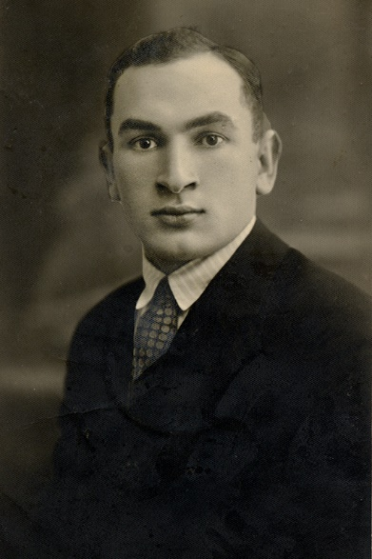
Fig. 23. Fayvl Yosifovich Zagorsky
And from 1937 on, I was already working on my own. I bought a machine, and in the big house I showed you, where we moved, I put it in the kitchen and sewed blanks (shoe tops) there. A billet maker is an independent specialty, a separate job. There are shoemakers who make both tops and bottoms. But they have very rough hands. Billet (top) requires finer hands. And that versatility doesn't pay off. By the time they make the blanks, you can make half-boots. A billet costs a lit and a half, and he charges three or four litas for a half shoe. It's not worth his trouble. And then he just doesn't know how.
When our brothers entered Lithuania, they stopped selling leather, so I entered...
А. How did the elimination of private trade take place?
Ф. The Lithuanians, the big owners at one time, created a cooperative. It was in Bazarnaya Square. I mentioned it. Then the cooperative was nationalized, it became state-owned, and its accountant was instructed to oversee private trade. The wholesale stores, where there were bases, were closed to private traders.
In the private retail stores, in each of them they placed commissars, taken from the street from sympathizers of the new government, from the same Žeimelis. The owners were in charge, but they put the commissars in charge. And when the Russians came, there was an influx of customers. They started to grab all kinds of goods. The accountant went to see who was making a big turnover. He found big turnovers with Izraelson and Yankelevich: 150 thousand litas a month, or maybe two or three. Their stores were nationalized, taken away from them. And the small stores - Tarutz, Baikshtis - they were no longer selling goods to them. The wholesale bases were already state-owned and supplied only their state-owned stores. The small traders died little by little.
When the private trade, the private sale of billets, ended, I went to Siauliai and after New Year's Day 1941 began working in the large shoe factory "Batas," confiscated from Frenkel.
А. Isn't that the Czech "Batya"?
Ф. No, it's not "Batya," it's "Batas.
It was my luck that I worked half a day on June 21, 1941, and had the other half free. The 22nd was a day off, and on the 23rd I was on the second shift. So I went home for the Sabbath. And just on June 22 the war started. If I hadn't left Siauliai, I probably would have stayed there. How would I have got to Žeimelis after the war started? And then the war started, I didn't go to Šiauliai. And in Žeimelis a lot of acquaintances had gathered, and they evacuated by horse.
In Žeimelis, many people had a radio, and we learned about the beginning of the war even before Molotov's speech. We had refugees coming from Poland in 1939-40. They told. That the Germans would kill, of course, I did not think. But they would take me to work, send me somewhere. And I have a sister in Moscow, I told you. They said on the radio that the Germans would come in for a day or two or three, and then they would throw them back. I thought I would go to Moscow, stay there, and then come back. See how it turned out!
А. Were there many of them with you? How did this evacuation take place?
Ф. Horses.
А. Where did you get them?
Ф. Those who had horses evacuated. Those who didn't have horses didn't evacuate.
А. But you didn't have a horse, did you?
Ф. On foot, with this wagon train. Here I sat down for a while, and he gave me a ride. Then on foot, we walked all the time.
А. Your parents, you said, didn't want to go.
Ф. Mother said, where would she go? She was about 75 years old. Maybe she didn't want to. I said I was leaving, that I couldn't stay here. In a month and a half I'll be there. "Well, go, well."
А. And where did you come to?
Ф. It would take another two hours to tell.
А. We're about to run out of film here, so tell us what you can.
Ф. We reached the Dvina River in Latvia. And there are no bridges there. We took a ferry. We took the ferry across.
А. How did you get on the ferry. There must have been a lot of people?
Ф. It's a deal. They were transferring everyone there by ferry, with horses, with everything. And there I got lost with my countryman. Then I was alone. Oh, how much I suffered! We got as far as some station in Matone. My feet were swollen. They told me: "Go, there's a train. Go ask for the captain." I went over, as much as I knew Russian, I asked to be taken. He allowed it. I got on. There were women, children there. We were attacked by a plane. Bombed that train. It was coming. Pilots saw it coming. I don't remember exactly anymore. Either it was standing, or it stopped on purpose to let us run out. Our wagon didn't get in. But there were freight cars with wounded behind. One of the wagons caught fire. The wounded could not get out themselves, they were burned alive. It happened near Abrene, not far from the Russian border.
Then I walked again. Then we reached the border. For three days the Russians wouldn't let us go any farther, because they didn't have any instructions to do so. It was 30 km from Ostrov. Then they let us through. Going further. There was a barrier, cordon, people in civilian clothes.
- Who are you?
I was young, walking fast, rested from two days at the border. They freaked out, looked at each other, winked and let me through. I went happily, they let me through. I walked two kilometers. There were still some Russians standing there:
- How did you get in here! Why did they let you in?! There are Germans here!
There's a river here. The bridge is wooden, broken. There is a dead soldier in the water. And I see, from the other side of the river small German tankers come out. Back and forth, started shooting. Probably saw that the bridge was broken, turned back.
You see what bastards they are. They shouldn't have let me through. They knew there were Germans there. But because they asked me that I was Jewish, they let me through to my certain death.
It was already near evening. I looked: the sun was coming down here. That means it's west. I came from here. It wasn't far from where they let me through. I threw everything off. I just took my pants on and ran through that field. I ran and ran and ran. Then I met a man. He told me. Go in this direction, a column passed there recently, a whole convoy of evacuees. I was the only one that was let through by that cordon, they didn't let anyone else through. I ran again, maybe six kilometers. I was young.
I caught up with the wagon train. They were complete strangers. But there were many Lithuanian policemen among them. They were still wearing their uniforms. They were also on foot. I joined them. I walked with them. Then we spent the night. Some chairman of the collective farm was there. He gave them dinner. And I was such a fool, I was too shy to eat dinner. I still had a spool of thread in my pocket. I gave it to some collective farmer. He gave me some bread and milk. All this was near Ostrov, on Saturday. I spent the night at the man's place.
The next day, we walked and walked all day. I couldn't walk anymore. We reached Shashihin (Sashihin?). I remember it well. There was a train standing there again. I climbed into it, whatever happens. It took us to the district center of Petukhovo, in Siberia. Outside Chelyabinsk. They kept us there for a day or two, fed us lunch. Then the wagons came and they took us to the collective farms. We stayed there for a day or two. Then they told us. I can't speak Russian very well. But there were people from Riga, who spoke well. You are being imposed on us. We have nothing. We have nothing ourselves, and you will all die. We were all in summer clothes. There is a big frost here. Save yourselves, go to Central Asia.
We went back to Petukhovo, took the train to Novosibirsk without any ticket. I told you that I was standing there in Novosibirsk, covered in hair. I look at the big window of bread. I want to eat. A woman comes up to me. Probably a Jewish woman:
- Young man, what are you standing there for?
- Here you see the bread. Here you see the lunch break.
- They give out bread on a card here. You don't have a card.
- Where I got the card from.
- You shouldn't be standing there.
Again I went to the train. They gave us a kilo of bread, water, tea. I arrived in Alma-Ata. From there they took us back to Taldy-Kurgan. There we were sent to the foothills of the Himalayan mountains in the village of Malinovka. I was sent to live with the secretary of the village council, Pyatnov. I lived with them for nine months. They were very good people.
On July 4, 1942 I was mobilized. I worked in Karaganda in the coal mines for four years.
А. So you were a miner?
Ф. What did it take to be a billetsman there? There were teachers, professors working in the mines. Everybody worked. Coal was badly needed. Donbass was already overrun by the Germans. The situation in the mines was very difficult. Ragged, naked, hungry, but all the same: there was no danger of death. How much theft there was, how much blat, how much everything, my God, what was done there before our eyes!
А. How did you come back to Lithuania?
Ф. It's already 1946. They won't let me out of the mine. We wrote to the military registration and enlistment office to be released as mobilized. They answer: We mobilized you, but gave you to the mines. Can the mines release you or not? And the management of the mines doesn't want to release the free workers. I cheated then. I went to the shoe shop there. The manager was a Jew. I asked him to hire me. He gave me a paper that he was hiring me. I took it to my boss at the mine to get him to let me go. I promised to make him boots for it. So he let me go.
I went to a lawyer. My boss let me go with a referral to the shoe factory. The lawyer said:
- In the Soviet Union, a worker is not a dog. He cannot direct you. Since he set you free, you're free to go wherever you want. It was May 1946. And on June 1 the train passes were canceled. I had earned a few thousand. I wanted to buy a ticket to Lithuania. I was told I couldn't go there, it was a restricted area. I took a ticket to Moscow, where my sister was. I stayed with her for two or three weeks, then came to Kaunas, Lithuania. I started to earn money there, to work, everything is as it is now.
А. How did you settle in at first?
Ф. He speculated at first. I went to Šiauliai, bought leather underground, took it to Kaunas, and sold it. I had no money. An acquaintance lent it to me. I went with him. Then one of my fellow countrymen, with whom I went together, had to settle accounts with me, to share the profit (parnose). But he wouldn't settle up with me, because I spent the night at his place. He took everything.
Then I went to the industrial plant, found some hole under the stairs, like you have on the elevator stairs. I got a job in the workshop there. Workers were needed. I got a job with an artel. It gave us a room, as it should be. I've been working all my life like that. In 1975 I just went to the military shop.
А. How did you manage to get an apartment?
Ф. Also through a lot of connections. It's common here. I'm registered. The superintendent got 1,000 rubles in old money. He wrote me a warrant.
-----00000-----

Transcript of an audio recording made in Leningrad on June 4, 1989
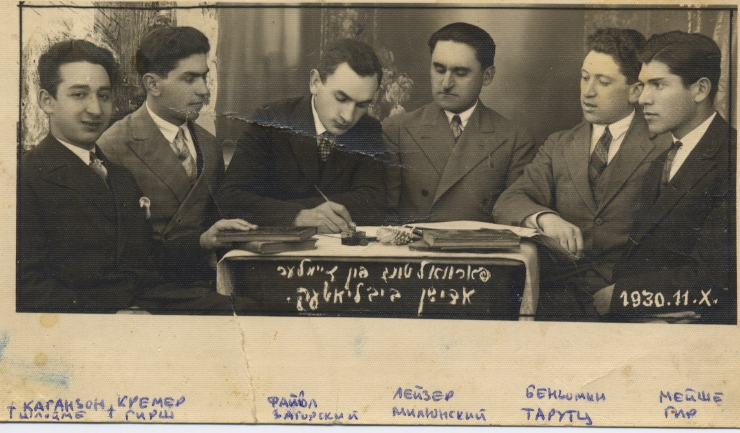
Fig. 24. The Jewish library's readership. 11.10.1931
А. Please tell us what you know about these people, from left to right.
Ф. The first, Shleime Kaganzon, is from, or lived all the time in Mažeikiai. He is a baker. He was invited by Wasserman to join him, so that he could make blanks at once and those who bought leather at Wasserman's shop did not have to look for a cobbler. Wasserman also sold ready-made shoes. When the seller made it himself, it cost him less. That's why he hired him. He lived with him. This must have been in 1926-1927. Before Wasserman's bankruptcy he worked for him. He then got married in Vaškai, a place near Žeimialis, on the road to Posvola. He must have been killed there.
The second, Hirsch Kremer, was a shoemaker, a laborer. His family were tuberculosis patients. All of his brothers and sisters died. He, too, eventually died in 1937 or 1938.
The third me.
The fourth was Leyser Milunsky. He was a very progressive, humanist or socialist. He was very supportive of the Soviets. In every discussion he justified them. I don't remember his recent attitude toward these trials of 1934-1937, what his opinion was. But he was a so-called Marxist. He was killed by the Germans in Zeimelis.
The fifth, Benjomin Tarutz. Remember, the five sisters each inherited a piece of the store. It was the eldest son of one of them, Mera Tarutz, who had a leather and iron store. I first apprenticed with Caganzon, and then I went to work for him, too. He hired me too, as he also had a leather store. During the war he went to his married sister in Kurshany and probably died there.
The latter, Meischke Ger. He had a penchant for drawing. His mother had rich brothers in Africa. They sent money, and he studied in Paris for a year or two. But he never turned out to be a painter. In 1935 he went to Palestine, he had a brother there. He died eight years ago. The first time I was in Israel 15 years ago, I visited him. By the time of my second visit, he was no longer alive.
А. I'm interested in the very first days of the war. You didn't tell me enough detail about them. Here came the message, who said what, how did they take it?
Ф. Very depressed, dear, very depressed. Very depressed. The first days we were still kind of calm, you know, because they were bragging about how they were going to beat us back, we were kind of going to live. The fate of the young is, of course, yes. But still we were calm. On Sunday the war started, Monday, Tuesday. On Wednesday, troop units began to depart through the place. There were guns going by with long guns like that. And soldiers.
А. Has there been a lot going on?
Ф. Not much, since we don't have the main route. I don't know where they got confused, that they were already stretching through our place. Everyone had already lost their spirits. Of course, no one was working at the place anymore. Everyone gathered in clusters in the Bazaar Square and reasoned and reasoned. Some of them had horses, horse-drawn carriages. And others did not. There were those who loaded, packed (eingepakt) themselves a cart. And then, "Ah, the hell with it!" - brought it back into the house. They stayed. Fools. Avrom Tabak was packed, Abe Beder some there was too. And I got one that I kind of pulled off, they really put the fear on me. It was Polish youth, refugees. That they [Germans] kind of mocked the young, forced them to work, did not give them anything to eat. I thought I would go to my sister's for a while. Of course, they wouldn't let us go to Moscow.
А. Approximately how many and when, did all the refugees come out of Zeimelis at the same time? Or did each one go out on his own.
Ф. No, no. We went by wagon train. In it were: Meishe Lekunisok, Mote Jakushok, Meyer Man, Mathes Lekunisok, and Girschke Lepar. Meyer Man had a sister in Sverdlovsk, and his other sister and father remained in Zeimyalis. He reached out to her. He survived and told me later how his sister scolded him, why he didn't take his father and sister with him. He said they weren't going. There were about four or five submarines coming out. But there was a lot of foot traffic behind them. I went with them. Then the Polish girls, boys. They were evacuated to Zeimelis. Their society rented some big room. They lived in it. There were about fifty people in the wagon, along with the children.
А. Were they Jews?
Ф. All Jews. No, there were two Lithuanian boys. They were Komsomol members.
There we had a bus confiscated. The bosses: Chaim Glezer, Baginsky, he was the secretary, some Lithuanian Komsomol members and some others, they left by this bus. This bus had been confiscated earlier, since we had established Soviet power, six months before or more. That's why they had the bus and left.
А. Where did you go? The main points of the road?
Ф. We went to Shalosha. Then Biržai. From there we went to Skalskaniste, that's Latvian, we called it Schoenberg. It's on the very border between Lithuania and Latvia. In Lithuania it was Biržai, and in Latvia it was Stenberg. There was no authority there anymore. That's where the firefighters loaded up. Then we went to Nairi. There we were taken by ferry across the Dvina. I went across early on the ferry. They hesitated there. And I got lost with them. There was so much trouble, my God! There was a chemist and three wagons coming from Shaloshe. Someone told them, I was sitting there, and I saw that three carts had abandoned their horses. The carts were abandoned, they were standing. I took these horses, threw away all the stuff: pillows, everything. I only left a sack of grain to feed the horses.
-----00000-----

Formatting, illustrations and explanations of the text - the author of the publication.
The literature on Rabbi Kook is extensive. On his sojourn in Jemelah since 1888 see. Simcha Raz. An Angel among Men. Jerasalem. 5673. P. 69-75. (Simcha Raz. An Angel among Men. Jerusalem. 1913. P. 69-75). These pages are presented on the Internet: RAV KOOK - RAV KOOK (mannbarry.net) Date of access 28.01.1922. On the role of Mathes Haesh, the great-grandfather of the author of the publication, in the election of Kook as rabbi of Jeimel see. HAYESH. Chapter 2: A genealogical inventory of the first three generations. Paragraph 13. HAESHI (barrymann.net) Date of reference 28.01.2022.
Kuk was born in 1865 in Griva, Vitebsk province. (Russian Jewish Encyclopedia. Vol. 2. Biographies. K-R. M. 1995. P. 102).
For more on this eviction of Jews, see the article by Anatoly Haesh. Eviction of Jews from Lithuania in the spring of 1915. Chaesh1 (berkovich-zametki.com) Accessed 30.01.2022
The case was in 1930. For more details, see the article by Anatoly Haesh. The Lithuanian "Beilis Case" (1930-1931). Beilis.doc (live.com) Date of access 28.01.2022. .
The photo is shown below in the entry of June 4, 1989.
For more on the apple trade, see the memoirs of Israel Yakushka.
Translation from the Lithuanian by Roza Belyauskienė (Vilnius).
At that time, the window and the door.
There was a door there, too, which was later turned into a window.
The house can be seen almost entirely in the ~1928 photo of Bazarnaya Square in "Materials of the fourth meeting with F.J. Zagorski 4-5.08.1988".
For more on Schulgeifer, see B2788.doc (live.com) Access date 10.02.2022.
Another date is ~1921. Photograph by J. Bulyčio (Žeimelis. I dalis. Versmė. Vilnius, 2010, p. 117 (Žeimelis. I dalis. Versmė. Vilnius, 2010, p. 117). Absence of the Freedom Oak planted in 1925 in the picture makes this dating more probable.
It is not clear which book we are talking about (presumably, "Essays on the History of the Lithuanian Communist Party. Translated from the Lithuanian: in 3 vols. 1897-1920. Vol. 1, Vilnius 1973).
Zagorski's brilliant memory is confirmed by the record of my father's words, "My grandfather's house had an orchard. There were several fruit trees. And there wasn't much fruit in general, not always. I remember I used to run there as a little boy to play, there was also a yard, even bigger than ours" (recorded on 15.03.1985).
The handwritten text in the drawing is A. Smetona Street.
Zagorski names two-story houses from left to right. New - names the owner of the second house and mentions doctor Rudis.
"No. 9 of Alter Abramovich. In the house lived his clerk Tsemakhovich" (from the materials of the fourth meeting).
The next house [Linkovskaya St.] #11 also belonged to Abramovich, the widow Tsofnis lived there. The next house is Abramovich's warehouse (from the materials of the fourth meeting).
See the article by Anatoly Haesh. After the Occupation of Žeimelis. Subchapter "Concentration of Jews in Zhelguzys barn" B2788.doc (live.com) Date of reference 10.02.2022.
Kiddush, literally "sanctification," is a blessing pronounced on wine or grape juice.
During his first visit to F. Zagorski in Kaunas, the author of the publication inscribed the names and surnames of the persons in the photo.
This refers to Polish refugees who ended up in Lithuania.
See Proceedings of the Second Meeting with F. Zagorski.
Žeimelis // Lietuvos TSR urbanistikos paminklai. Vilnius, 1978. I, p. 139 (Monuments of urban planning of the Lithuanian SSR. Vilnius, 1978. Volume 1, p. 139).
All Russia 1900. Russian Book of Industry, Trade, Agriculture and Administration. Address-Calendar of the Russian Empire for 1900. [SPb], edition of A. S. Suvorin in 2 vols. Pet. 675.
Žeimelis // Lietuvos TSR urbanistikos paminklai. Vilnius, 1978. I, p. 135 (Monuments of urban planning of the Lithuanian SSR. Vilnius, 1978. Volume 1, p. 135).
See Proceedings of the Second Meeting with F. Zagorski.
See ibid.
See ibid.
See Proceedings of the Fourth Meeting with F. Zagorski.
See Proceedings of the Third Meeting with F. Zagorski.
Hera's house is shown twice in the materials of the fourth meeting with F. Zagorski.
See ibid.
See Proceedings of the Second Meeting with F. Zagorski.
See Proceedings of the Fourth Meeting with F. Zagorski.
Žeimelis. I dalis. Versmė. Vilnius, 2010, p. 121 (Žeimelis. Part I. "Versmė. Vilnius, 2010, p. 121.
Photocopy of Barry Mann from a photograph in Faivel Zagorski's personal archive.
Photocopy of Barry Mann from a photograph in Faivel Zagorski's personal archive.

