Subscribe to DeepL Pro to edit this document.
Visit www.DeepL.com/pro for more information.
Haesh A. И.

Materials of the first meeting with Israel Yakushko on April 30, 1999

A trip to Israel Yakushku in Herzliya
Israel Yakushok lives in Herzliya, 6 Baal Shem Tov St. on the fifth floor. It's near the central bus station, but most buses from Haifa don't go there. Tel. 09-96-8239. Israel has a beautiful modern house, built three years ago, and a luxurious two-room apartment. He and his wife Ida live in the apartment and their daughter, a speech therapist, lives in a neighboring house. Their son is a pediatrician.
Israel, 1921, born in Zeimelis, has a high school trade education, worked in a military trade shop in Kaunas, and his wife is an infectious disease doctor. Israel has a good memory and told many interesting things. His native language is Yiddish, so his Russian is not quite perfect.

Contents of a talk on transcribing a sound recording
A(Anatoly). What do you know about the past? When did the Jews come to Jeimeles in the first place? Do you know anything about this subject?
And (Israel). It's hard for me to answer. But I have an acquaintance. He was born in Vashkai.
А. This is the former place Konstantinov.
И. Charlie Berman.
А. The Bermans lived in Zeimelis.
И. And then they moved to Jaimalis. And in 1936 they went to Johannesburg. Family. This is my cousin.
А. On your mother's side?
И. Yes, her maiden name is Zvidgal (Zhvidgal). She's from Vashkai.
А. Didn't the old folks tell you when they showed up at the Jemels?
И. Since 1791. The Jews were kicked out of the Ukraine to the west. They went to Poland, to Lithuania. Some of them walked 2,000 kilometers. And they came to the Lithuanian border, some went to Poland, some went to Zeimelis.
А. Why were they kicked out? At that time the partitions of Poland were taking place.
И. I can't answer that. Why do I know? I was told by a Russian man. I served seven years in the Soviet Army. When we went through the Volga, the Ukraine, we entered one village, and everybody there had the last name Yakushov. Our last name was Yakushok. I started thinking. I found one old man. I asked him, "How is it Yakushov all?" He says, "Jews lived here. There is even a synagogue destroyed." This village in the Ukraine. And he went with me and showed me the ruins of this synagogue. In 1791, the Jews were expelled from Ukraine, from Poland. Some went to Romania. AND .
When they came to the Polish-Lithuanian border, they started asking . In Russia there were Ivan Petrovich, Chaim Mendelovich. And they all said village. And they said Yakushok. And the village was called Yakushov. They wrote Yakushok. That's how the last name Yakushok remained. That's what my grandfather told me. There were four or five families with the last name Yakushok.
А. So your family is from the Ukraine?
И. Yes, from the Ukraine.
А. And the other families?
И. Izraelson and Mendelssohn came from Germany. And Baginsky came from Poland. Mendelovich is from Poland. Ehrlich is from Germany.
А. You haven't heard of Hayes, where did he come from?
И. I can't say that.
А. What else do the elders remember from the history of the community?
И. My grandfather told me: "I remember 1914. The First World War. In 1915, in the morning, Cossacks showed up in Zeimelis. They came to the market on horses. They were beating up left and right! They gathered all the Jews to the market and started questioning them. Then they took them all to the synagogue. The rabbi came. He said: "These are our saviors and we have to cooperate with them." The Cossacks did not believe the Jews. They took some Jews".
А. What were they looking for?
И. They were looking for Germans, spies. And one woman, a young, beautiful woman, slept with one, and they all left. I know this woman. Her name was Masha. Masha Gershon.
(I bet I am that Masha is not a Jewish name, Israel insists that Masha is. Me, that I don't know the last name Gershon in Jaimel).
И. Surname Zalmanovich. Б.
Ida. You could ask Zyama. But he hardly remembers. В.
А. Were there ever pogroms in Zeimelis?
И. No there wasn't. There was a trial in Zeimelis.
А. This will go to the next question. Were there any major fires?
И. Yes, I remember the big fire.
А. Who was on fire?
И. A rich Lithuanian man lived there. All the rooms he had burned down. I saw the fire myself, not far from us.
А. Your brother Moshe mentioned this fire. He said there was arson.
И. Yes, there was arson. This Lithuanian had 120 hectares of land and had cows. We lived close by. I remember such big cows were dead. I was five or six years old.
А. Tell us about this famous trial. I don't know the year it was.
И. 1929. I remember well. I read the newspaper.
On Saturday night, the Jews always slaughtered the cattle and prepared the meat for Sunday. There was a slaughterhouse. Some of the Jews who slaughtered the meat took it to Riga, it was not far - 70 km, and some of the meat was sold in Zeimelis. An inspector had to check and print this meat.
It was in the winter of 1929. There was a well flush with the ground. There was a lot of snow. And ice. He came in at one o'clock in the morning and imprinted the meat, came in drunk. And when he came out, the Jews finished their work and went home. Ksendz, went on drinking there. At 3:00 a.m. the inspector didn't come home. It wasn't far from there. Let's go look for him. The slaughterhouse was already closed. Everybody had gone home. And he wasn't there. We went around and around, and he fell down the well, dead.
Then two or three policemen who were in Zeimyalis came and took away all the butchers. Got Mates Lakunishok, then they took away who was supposed to carry this meat. Got Fleischmann Abraham.
А. Is he dead?
И. Abraham, his wife and son Notka all died . Then came Leizer Man. The youngest was Mathesh Lakunishok. They took them away. They put them in jail, there was such a jail in Zeimyalis. Г.
"You killed him!" They refused: "No, no, no. It was a very dangerous situation. It was just before Purim. They were afraid there would be a pogrom.
A policeman from Joniskis arrived. They were transferred to Siauliai, the four arrested. Then three months later there was a trial. The Siauliai court accused the four Jews of killing the inspector and throwing him into the well. Matza and Pesach were still tied up there. I remember it well. All the Jews were afraid. They closed the apartments.
There was a trial in the spring. I remember on a rainy day standing where there was a fire, Jews talking. There's a trial going on. Azriel Burstein says, "What are you looking for? You see how the sky is crying. They'll get it." Д.
They gave him 20 years, then they gave him 12 years. And the youngest one got a reform camp.
Rav Krenitz went to collect money. They sent him to America. When he came back, he got a good lawyer in Kaunas. And the Supreme Court rehabilitated them all. Except the youngest. Mathes Lakunishok served four or five months in prison. And we had a holiday .
Е.
Ida. He remembers such details during the years he was in the army. He remembers such episodes! Memory! No one remembers as much as he does.
А. Where did you study in Zeimelis?
Israel pulls out albums with masses of pictures . He took his sister's album when she died. A picture of a tin roof being made (Y01). "That's Lacunichok. I know." Finds a snapshot of a beth midrash (Y03). A number of other professional photo portraits.
И. There was a "Hashomer Ha-Tzair" - a Zionist organization. This is Wolovich (Y26) - the head of its branch.
А. Look, Liusya! He's got Israel Hayes. We'll have to take it again. I've never seen that picture. Ж.
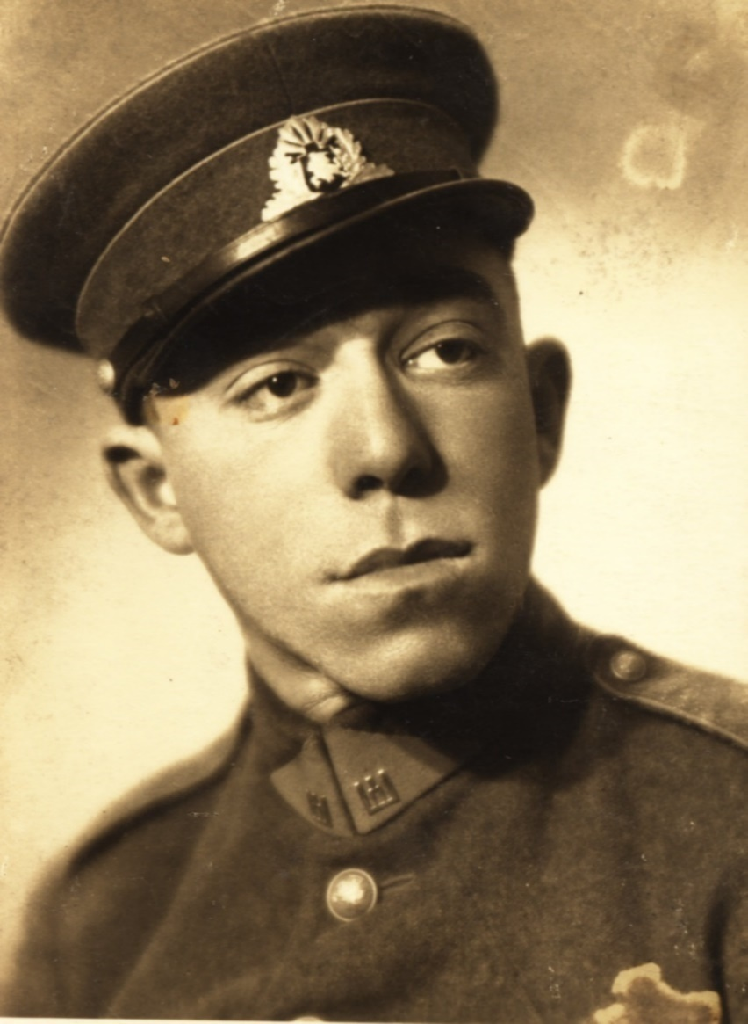
Figure 1. Israel Hayesh in uniform. Mid-1930s.
И. I don't remember his mother. I know where they lived. (Flips through the pictures, commenting on some):
(Y14) Gel. Before the war he studied in Paris. Artist.
(Y27) Izraelson. Already the Russian army (not about Izraelson). This is my brother. Edelman .
(Y59) This is Abremke Tzofnas.
(13) Etka Burstein.
(Y28) Maccabi soccer team.
(70) Lubka Man.
(Lots of pictures) Yisroel Haesh.
(Y38) Etka Burstein.
(Y13) Hanitka Gel.
(Y58a) Abremke Tzofnas.
(Y59, 60) Avremke Baginsky.
(Y26) Jewish school. This is the second teacher. His father was a shochet. З.
The fourth person who was apprehended $—$ was a Shohet.
А. Tell us about your school. Were you in cheder?
И. I was not in cheder. My brother was in cheder. The cheder was in the synagogue, a room like that, where they studied. And then they thought about it, collected money, and built this Jewish school. There were four classes in that school. I started studying in 1929.
А. When was the school built?
И. In 1932.
А. Where did you study before that? In a Lithuanian school?
И. No. There was a school on Linkovskaya Street. I started school there. You had to go up the stairs. Then when they built this school, in third grade I went there. In third grade I went to that school. И.
А. Who were your first teachers? Wolovich?
И. Volovich was no more. I did not study with him. Rav Krenitz, who died, taught us twice a week. The last year Volovitch was. К.
Schneider became a rav in late 1939. Krenitz went elsewhere. He had children in a Lithuanian school.
А. So you don't remember your teachers by name?
И. One woman is young.
А. Haven't you heard anything about the Jewish farmers who came out of Zeimelis?
И. Haesch had 17 hectares of land .
А. Was it his own land? Because everyone said he rented it.
И. Not true.
А. Where did Haesh have the land?
И. Beyond Žeimelis, 1.5 kilometers.
А. Which way?
И. Toward Krukai (and Joniskis). Л.
Vilenchik had 14 hectares of land across the street. That's where he worked. One of the Vilenchiks, there were two brothers. They traded wheat, flax. They bought it from Lithuanians, Latvians, then sold it to Riga. And when the Soviets came, one of them went to live next to Haesh, on the other side of the road. He had 14 hectares of land. He built a beautiful house there.
А. What did Haesh grow on his land?
И. Wheat, rye, clover - very good fodder for horses. We also had clover, had 3 hectares of land toward Linkov. We had four cows. Then there were two cows left.
А. Moshe said that you were selling apples.
И. There was a garden. Then we bought one.
А. Don't you remember Baron Grottoisen's garden?
И. Yes, I remember that big orchard well. But there weren't many apples there, because all the trees were old. Six kilometers away. Those were German yards, the Germans were building there.
А. Did you not catch Baron Hahn?
И. He didn't live there. The houses stood there. White, beautiful. They still are. It was his estate. He came once a year. М.
А. Now tell us about the arrival of the Russians in Lithuania, what was it like?
И. I lived in Zeimelis until the end of 1936. I finished school, 4 classes, and went to study as a locksmith. I studied for 2 years. I worked for 2-3 years as a locksmith, for one, for another.
А. Who, don't you remember?
И. It was the Lithuanian Sichkus in Zeimelis. Then at Leiba Lakunishka's. They made all kinds of tin things. We made watering cans, teapots. We took them to the market, and Lithuanians bought them from us. There was a market twice a week.
My grandfather used to make pottery. I was a boy, about seven or eight years old. Grandpa had a cart. We rode with him. Gathering clay. The trough was like this. In the trough we would crumple the clay with our feet and pick out the stones. Then I made it with my hands, there was a machine (potter's wheel). There was such a stove. I used to put it in the stove. Then we glued ears. We used to go to the market in Zeimelis. Lithuanians bought it.
My grandfather's name was Yosef Yakushok, and my wife Sarah (he can't remember her maiden name). They made big pots, smaller pots for milk, and different ones. I always carried them to the market with my hands. I had to be careful when putting them down: they would break. And my grandmother always gave me 20 cents for ice cream!
А. Where did you get the ice cream?
И. There was a Jew who came there. He had a car. He was selling ice cream. It cost ten cents. It was very good.
When my grandfather died in 1936, the pottery business was abandoned, but his booth, where he made pots, remained in the yard. And the machine he used to make pots was left behind. The potter's wheel. He used to push it with his foot and make it with his hands. Why am I telling you this? In 1939 my sister Basya married Leiba Lacunischka. And he made a battery there, where he worked. The power plant in 1933 was made by Milunsky.
А. I think it was somewhere near Haysh's house.
И. Not far away. Haesh's house is now a museum. I've been in it.
А. When was it opened?
И. In 1993.
А. In the market square?
И. Yes.
А. On the corner, in this house?
И. Not on the corner, in front. There used to be a restaurant there.
А. So this is the Great Inn .
И. No, it's a museum, up ahead, a two-story house . I know where the Big Inn is. That's where the power plant is.
(I'm showing a plan of the place to make it clearer) .
И. We used to live here. Balčunas' house.
А. Where is the Haesh Museum?
И. Do you think Hayesh had one house? The whole of Bauska Street was Hayesh's house . It was the police who were here. Н.
А. You said that you used to work for Hayes.
И. Not me, my brother, Heskel.
А. Who died in the war?
И. Dead.
А. What was his job?
И. A clerk at Leyser's. О.
А. What kind of store did Leyser have?
И. There was no store. Twice a week Lithuanians came to the bazaar. Heskel took the goods they sold. And Leyser himself gave them money.
Then after lunch Heskel took them for a walk. They ate lunch, and he took them for a walk where their land was, 17 hectares they had. That I know for a fact. Heskel worked before lunch, he didn't work after lunch. П.
He'd come, spinning around, watching the horses. That was all his work.
А. How many horses were there? You don't know?
И. Four, I think, are good.
А. Were you acquainted with Lazer yourself? Did you have any meetings with him, any confrontations? What was his personality like?
И. I was a boy, I was shy, a little afraid. After all, he was considered a rich man of Zeimelis. Р.
А. But there were other rich people there, Abramovich.
И. Abramovich, Milenchik, Boyarsky, Izraelson. Boyak Krenitz, Hone Tose, Leyser Gel. Not rich people, but Leyser was a know-it-all! Showed respect when they saw him. С.
But one day, I remember it well, Leyser was sitting on a bench, after lunch. In the summertime. Where all the Jews gathered, near the Great Restaurant. What was the name?
А. Large tavern, with columns.
И. Korchma. With columns, yes! Jews used to gather there. And they always told "stories" there. There was a Havka. It had a store, a kiosk. Т.
Leyser sat down on the bench. He always told how Stalin took his boots off him (Wasn't it about his arrest by the Penza Cheka for boot speculation that Leizer recalled in this "tale"?) .
We wanted to listen and they chased us away.
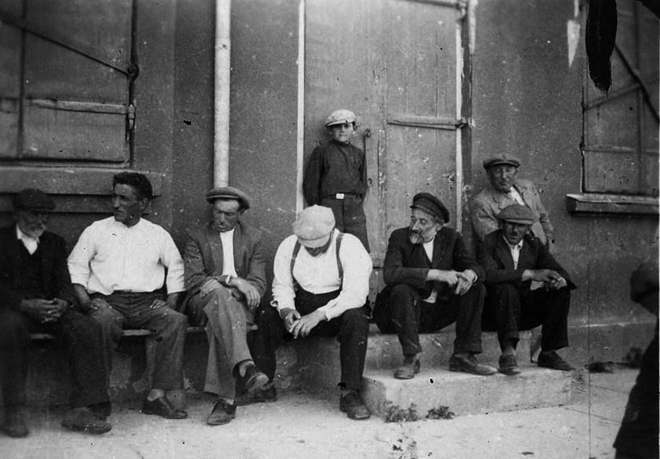
Fig. 2. Shabbat in Zeimelis
I ran up barefoot, no shoes, we went without shoes in the summer.
I was about nine years old. Lazer says:
- Ingele, ingele, wer bist du? (Boy, boy, who are you?)
- Ich bin Mote Yakushok sun. (I am the son of Mote Yakushok).
- Oj, wie scheine ingele! (Oh, what a handsome boy!) W.
I will not forget this in my life.
Running around barefoot, playing soccer in the market square. We boys. Notke, Girschke, Shmulka, Danilka, many boys. Barefoot. We played soccer, not like now, but with a rag. Ф.
А. Can you give me the names of these boys?
И. Girshka Jakubovich, Rufka Tosha, Abka Lepar. Avremka Boyarsky, Notka Fleishman, Srolka Gershon, 4 brothers - Haimke, Joschka, Berka, Srolka Lakunishki. We always played against them. And we always fought if we lost. The Lakunishki fought against us, the hevra (here - the team) was different.
А. Did you know the Mann family?
И. I knew Leyser Man, Yosel Man, Freida Man. I knew where they lived on Joniskis Street. Leyser was a butcher.
Did he get into this story with the death of the inspector?
И. Yes. An old man. With a beard. Oh, Zorokhovich!
А. Fourth, who got into this story with the inspector?
И. Tatka married Zorokhovich. H. He was not from Zeimyalis. He came to Zeimyalis. And they made sausage. They bought meat. I went to their place to buy sausage. 100 grams for breakfast. Very tasty sausage. I still remember how good it was.
It was in the thirties, maybe 1934. They made sausage and sold meat. There was a place to sell it, and the housewives would come and buy the meat. On Saturday night they always slaughtered the cows so they could buy meat on Sunday.
This was before the Russians came. Our horses had a chestnut-colored filly, such a beauty. I loved her so much! I always took her to the pasture. I had to get up at 4 o'clock. Mom would get up at 4:00 to the cow and take our horses out to pasture. We had that filly for two years. Grew up beautiful, big, tall legs.
Police Chief Grybauskas came: "Sell me that horse. My father came home and said, "Mom, Grybauskas wants to buy this two-year-old mare from us. She was still unbeaten. But a good one. And we all started crying, "Daddy, don't sell, don't sell!" Grybauskas gave us 600 litas. Daddy sold her.
А. You couldn't quarrel with the chief of police.
И. My father began to collect her. Gribauskas came in. Wanted to take her. She started jumping and kicking. She was feeling it. I took her, patted her down, calmed her down, took her. She broke everything there, ran out and came running back.
Then Grybauskas thought, I should put a saddle on her. But there was no way he could approach her. When she saw him, she always started jumping and dancing. I calmed her down, put the saddle on and started riding her. How beautiful it was. Around the bazaar, chest out, dashing around on her. And the kids were watching. Ooh!
Grybauskas then still bought her, kept her for two months, took her to Kaunas and gave her to a big boss as a bribe to get him out of Zeimelis for a higher position. Pretty Woman. She then participated in many competitions. She took a lot of first places. We knew that. But 600 litas was enough to live on for six months, to feed the family.
Then one of our horses died one day. We cried so much, and my sister cried so much! My mother said:
- If I die, you won't cry as much as you cry for this horse.
Now let's move on.
When I was at the Zeimelis Museum, I found there a photo of the 8th grade graduation of the gymnasium. On it was Zagorski, not Faivel, but another.
А. Who lived in the house across the street from Leyser?
И. His father was making hats. And I found a cut (trim) of the Sefer Torah. The opposite (upside down) hanging. Then, what matzah is made with.
А. Can you remember anything else about Leyser Hayes? When the Soviets came, they say they took everything away from him.
И. This I can tell you. I went to Siauliai and worked there. I came home to my father and mother for all the holidays. Moshe also worked in Siauliai. And when the Soviets came, the Russian soldiers, I was in Siauliai. I got up at 4 o'clock in the morning. That was in 1940. It was June 15. Suddenly there was such a noise. I see huge tanks coming down the street. First time I saw a tank. Scared straight. I was 17 years old. My friends from the other street came running. There are more tanks there. I wondered. We walked around, watched.
And then I somehow accidentally went to Zeimelis.
А. Did the tanks come to Siauliai?
И. Yes. Several soldiers came to Zeimelis. I got a leave of absence from my master. I worked in a shoe and leather store as a clerk, Braker Taub. Ц. The owner paid me 60 litas a month. That was a lot of money. I could live beautifully. I came to Zeimelis. And immediately there were people there who were against Lithuanians, and who were they? Jews!
Avremka Baginsky. He graduated from four grades of grammar school. He became secretary of the party. Haim the barber became head of the village council. I'll remember the last name later. Meir Yakushok became a policeman, chief of police.
When the Russians came to Siauliai for the first time, some commissar or non-commissar gathered everyone in the square, and he started talking. And who was there. The Shlevich brothers from Siauliai. One of them was the deputy secretary of the city executive committee, a Jew. And they started singing the "International" (Israel has a leaflet with the text of the "International" on it) in Yiddish.
Then we were all given bicycles. We were instructed to ride through the villages. To register Lithuanians who were rich landowners. Those who had 60 hectares of land were still allowed to keep them, but no more, everything was taken away. And the cows, and the horses. And all the estates. And I took part in it, though I was not a Komsomol member. But I participated, somehow by inertia. And then they went through the village and took everything.
А. So the Jews met the Russians well?
И. Very! That's why more of them died than in Holland and other Western European states. The most important thing is why I told you this.
А. I'm sorry, say that again.
Russians came to Zeimelis. Three Russians and one Lithuanian. They spoke Russian.
И. They nationalized all these premises. Leiser Haesch had the first thing he had, leaving him with only one apartment.
А. When was that?
И. It was late June, early August 1940. On May 15 (so in the record) they came, the Russians. They nationalized everything. They took the mill from Milunsky, from Izraelson, where they sold gasoline and manufactured goods. The small colonial stores were left with their owners. They took everything on Bauska street from Leiser Haesch.
А. Where did they leave him the apartment?
И. Where he lived. In the corner house in the courtyard. I'd been there a few times. Entrance from the courtyard.
А. Maybe you remember what he had in his apartment?
И. I don't remember. Freida always met me. I used to bring them milk. They didn't have any cows.
- A dank, ingele. Thank you, boy .
The table was there, the kitchen. Everything was beautifully cleaned. I was always afraid of getting my shoes dirty.
А. So you didn't go into the apartment itself. Only into the kitchen.
И. Only to the kitchen. From the yard. There was a small vegetable garden, flowers were growing there. I remember that, too. Ч.
And so the Russians came in, nationalizing the big cases. Some of it was left behind.
They went into the kiosk (booth) that my grandfather had made, to see my son-in-law Leiba Lacunishka's workshop.
А. What workshop?
И. A tin workshop? In the room where my grandfather used to make pots. A Russian said: "Write it down! Nationalize it. There's a factory here." Where these pots were made - "Factory! Write it down, nationalize it!" That's how we laughed back then. I laughed. These Russians and Lithuanians said, "Write it down - production.
А. Nationalization took place. Everything was taken away from Leyser Hayes. Nothing was taken from you?
И. They took away three hectares of land from us. And we didn't have a house. We lived in Balchunas' house.
When the Russians came, life improved. For example, my brother and I personally. The owners were afraid of us a little bit. We were workers. I say to the owner: "I have to know how much wages I will get now." The boss said, "Don't go anywhere, don't ask, that's how much I have to pay!" And he was paying LTL 265 a month!
А. Did you get less before that? Did he used to pay 60 litas?
И. Yes, 60 litas, but everything got more expensive. My brother worked as a store manager, the biggest store in Siauliai. His store was not nationalized. He sold goods for the military from the Frenkel factory. Rich people, Jews. And there my brother would get more leftover leather and sell it. When the war broke out...
Before here.
А. How did you end up in Zeimelis before the war began?
И. The first day of the war on September 1, 1939.
А. This is the war with Poland. Were there any refugees from Poland?
И. We were in Šiauliai, we were in Žeimelis. I was in Siauliai at the time.
When the war started, I'm talking about June 22, 1941, there was an airfield near Siauliai. They were bombing there. And we were very afraid. I tell my brother:
- Are you going to work today?
- No, the store is closed, it's being bombed. What to do?
I say:
- Go to the store, get all the money and let's go to Zeimelis.
He says:
- What are you, taking government money?! No! Sh.
So we got on our bikes. Buzya Ehrlich gave us a bike, and we rode.
А. Ehrlich of Zeimelis?
И. He lived in Siauliai. We had one bicycle, and we rode to Zeimelis. 56 kilometers, 2-3 hours. We arrived in Žeimelis. There Lithuanians brought pieces of iron (splinters). Some kind of bomb was thrown somewhere. The Lithuanians brought it, began to show it (speaks with a threat in his voice):
- See! See!
А. You mean like threatening?
И. Right. It was a Sunday. In the evening my brother says:
- The suits were left behind, everything was left behind in Siauliai, what are we going to do?
I say:
- You know, I'm going to ride my bike to Siauliai, pick up all the suits and come home.
Mother said:
- No, you can't, you can't go anywhere.
I rode my bike in the evening, it was already dark. I knew the road well. On the way, I heard bombing in front of me. Everyone was afraid. I thought: "I'm going back. Not going to Siauliai". Siauliai was a big city. Then I saw a bus coming.
А. Towards Šiauliai or Žeimelis?
И. Towards Jaimalis. I raised my hand. He stopped. I got on the bus. Almost empty bus. Conductor. The Lithuanians say:
- How the Jews were given! Everyone should kill the Jews. What were they doing to us. They go with the Russians! And so on.
I got scared. First stop, it was getting light. That's for Monday. I was already afraid of Lithuanians. The conductor asks:
- What are you getting out?
- I need to be here. Щ.
Went out in a village 32 km from Žeimelis. Walking. Walking, walking. Here comes a Lithuanian man with horses. I raise my hand:
- Give me a ride!
- Zhidus? I don't take Jews.
Then, when it was 17 kilometers to Zeimelis, the same bus pulls up. Full of people. All Jews! Who ran away from Taurage, ran away from Šauliai, ran away from Radviliškis, ran away from Raseinai! I went in, and it was as if we were home. And we came to Zeimelis. We waited and waited. On Tuesday, some girls I knew came, we were walking around, laughing.
On Wednesday, a brother came, Moshe. He says to his parents:
- There's nothing to do here. There's nothing to sit here anymore. We must run away. The Germans are not far away. Already, they say, in Joniskis.
We listened to the BBC. We always listened. Schneider knew German well. His wife was German, Zelda. Daddy used to say:
- What are you talking about? Where are you going?
We had two horses.
А. Did Leyser have a horse left or not?
И. I can't tell you that. I think they took everything from him. They said they took everything from Leyser. At home, they said there was a lot more gold hidden. He had pots and pans of gold hidden somewhere.
А. What did you find, or was it just something you said?
И. Dozens of Russians. No, we didn't find any. But my brother knew who worked for him. A cast-iron one.
А. Pot?
И. Somewhere upstairs he was holding. Leyser took to his place when they took everything from him.
А. So it wasn't taken from him?
И. No.
We said we had to go, we had to go. Mom wanted to, Dad didn't want to. Then mom took it, went to Nisha Zagorski for advice, came and decided to go.
И. We bought 6 kilos of flour and 10 kilos of sugar, my mother immediately baked khaly, and we got ready. The whole hevra (here - group) went around the place to people who had horses: "Let's run away from here! The Germans will kill us all!"
А. So that's what people passing by told you?
И. Yes, and we began to talk like that. And Israel Gehl said (he came back from Russia in 1921):
- Where are you going! My mother in 1919 sold all her gold and things for half a pound of flour. You will starve to death there! And he agitated not to go.
And some did not go. Azriel Burstein, Gutl Judelewicz, Abram Fleischman, the Vilenchiks, Ehrlich, Yankelewicz, who could have gone, besides, could have bought horses and gone. And here we are on Thursday night...
А. I heard that military units passed through Zeimyalis on Wednesday?
И. Yes, they were walking back from Riga, retreating. They went through at night, and they told them to open a cooperative store. And they bought up all the canned goods, everything, everything, everything. Cleared out the whole store. And they paid, they paid.
А. Is that infantry or artillery?
И. There was artillery, several 76-mm guns, and several anti-tank guns, some infantrymen, and there were a lot of Nazis. Small soldiers, not tall. They passed through at night to Siauliai. And in Riga the Germans were already .
In the evening, at 5 o'clock, after loading the carts, we started to leave Zeimyalis for Bausk. There is the river Jelgava there. We had to pass that river, the most important thing. My father said that when we passed the river, the Germans would not catch up with us, it was a big river. And Lithuanians were happy: "The Jews are running!
We left as a family, my father left and my mother left. There were families Yakushok, Lakunishok, Karo, a few other families. When we passed the village where our landlord, a Lithuanian Balčiūnas, from whom we rented and paid our rent, lived, he says to my father:
- Motke (my father's name was Mordechai, Lithuanian for Motke), why are you running away? Come over to my house with your family, stay with them, the war will pass, and you'll come back.
- No! The Germans are coming here! - And we went.
We passed Baron Hahn's estate and came out on Jelgava. The horses were already tired of dragging, and we started throwing things away, throwing things away, throwing things away. We also took the dog with us, but he was getting tired, asking to be taken on the cart. And my mother, who was already 60 years old, was sitting on the wagon. We were eating challah and sugar.
А. How did you get across Jelgava?
И. Oh, the crossing! Even before the crossing, we lost Fayvl Zagorski. He was asleep in the synagogue. And we were all in it. I don't remember which place it was. When we went up at night, he stayed there to sleep. We never knew where he was or what was wrong with him.
It was impossible to cross there in the evening. There was only a ferry, there was no bridge. The Latvian ferryman - (does not carry) in any way! At least we were persecuted. We went to him, we persuaded him. A lot of people went to him. I don't remember what the place was called. My daddy went to him. He said, "I will go to him. I'll make a deal with him, I'll bribe him." It was at night. He went and gave him 700 litas (probably rubles, Israel can't remember exactly). The ferryman came to the crossing. There was a steep descent to it. Got in with the horses. And we all went over. And came out on the other side (clapping his hands). Thank God (speaking Hebrew). Got away from the Germans! It is wide, the Jelgava could be 800 meters, or maybe a kilometer. And it is deep. And on the other bank there is asphalt!
Oh, it will be easier for us here!
А. Where did you go next?
И. To the Latvian-Estonian border, it was necessary to pass to Pskov. Ъ.
And when we passed, my brother Moshe, Berka Lakunishok and two others took their bicycles and said, "We'll ride ahead. We'll get to a place and wait there." The bikes were. Asphalt. And they rode forward. And we with the horses, with the little children were left behind. We went to the Latvians, asked for food. Some of them gave some potatoes, we bought some. And they (gloating): "Zhidu, zhidu, the Jews are running!"
We approached some place in front of the border. They tell us that the Germans paratroopers took the bridge ahead. They are standing there, we can't get through.
А. Have you landed a landing?
И. Landing. My father went to the Latvians. He knew the Latvian language and asked:
- Which road to take to Pskov?
The Latvian says:
- It's a bad road, you can't get through.
- Well, show me that way!
There's a small river and a bridge over it. And at night we got off and walked, 35 kilometers and came out on the asphalt.
А. Did you have one cart and two horses or were there two carts?
И. One cart and two horses. One horse is tired, completely tired, no longer eats anything. We went out on the asphalt, we go to Pskov. In the morning we entered some village or place. The Russian soldiers detained us, began to ask questions, then they told us:
- The border here is two or three kilometers, that's where the village is. Go to the village. We'll put you to your homes, and tomorrow you'll go to work here, digging trenches.
We were happy, the river was there, we swam in the river. We ate dinner, got something to eat. And the next day we went to work. An officer came:
- Quickly quit your jobs: the Germans are 20 kilometers away.
Everyone ran home. They harnessed the horse again. And the other horse was dragged. It didn't walk anymore. We headed for Pskov. We came to the border. The soldiers would not let us in.
- Refugees, refugees.
А. You say you are refugees.
И. I didn't go. My dad did. He knew Russian a little bit. I knew one word of Russian: "I'll give it to you!"-when we fought, I didn't know any more.
We slept for several hours at the border. Then they said there was some kind of order, they let us through and we passed. It was in the morning. And everybody was hungry! Hungry!
А. Of those 46 people (who left Žeimelis) there was not one of your carts, but several?
И. Not all. Abraham Fleischmann was back. He used to say, "What am I going to do? The kids are getting tired, I'd rather go back...". A few people came back from the road.
А. How many families have crossed this line?
И. Five or six families. Everyone was walking together.
They came to the first village. They want to eat. I went to a woman in the village with a young Motya Yakushka . We asked for bread. I will never forget these words. She speaks in Russian:
- That you came here! We are starving to death! And you ask us for bread! No bread! There's nothing!
I look at the empty house. There's nothing there.
We reached the state farm and thought: "That's it. This is our last stop. We don't go any further. We are calm here. The Germans won't come here. The border is Russian. How will the German come to the border? He won't come so easily!"
When we came to the state farm, they gave us wheat porridge in the evening. We ate there and went to bed. They gave us a place in the school. We slept there. In the morning one came running from somewhere, shouting:
- Get out of here, all of you! The Germans are here! Ы.
We barely got away. And then we drove up to Pskov.
There were only barracks, barracks, barracks on the outskirts. Most importantly, we found a store that sold bread. We ran to the store, bought 9-10 loaves of bread, because we wanted to eat.
There is a river in Pskov. It was necessary to pass a bridge. Bombed. Soldiers went over the bridge. But still they passed that bridge. But someone fought back and died there. A woman.
А. Zeimelskaya?
И. I think so. Ь.
They came out on the Leningrad highway. The Germans are shooting, bombing all the time. Because the tanks are passing. A lot of tanks. To Leningrad. Dad said, I think he was in charge of everybody.
- We have to go to Porkhov.
I lost my dog there. I cried and cried and ran 5-6 kilometers to find her. The doggy was lost.
In Porkhov, they showed me chocolate and loafs in the store. The chocolate is good. The loafs are the 2nd grade. But so hard. But all the same. We took the loafs. How do you take the biscuits? No paper. We bought some rope to hold a cow with. They tied the buns around themselves. Everybody was jealous.
There was her supervisor not far from the station. He said:
- No trains, absolutely nothing. Because the station is being bombed.
But we were not bombed. And at night a freight train came. Red wagons. One came running, said that this train was going to Yaroslavl, to Kalinin. He said: "Quickly! Quickly!". We gave him a few hundred rubles to detain the train. And we came quickly with horses. Horses are not allowed. You need a crane to lift the carts. Daddy got some kind of blow, his finger was badly injured. We got into the wagon.
А. Did you keep the horses?
И. No, three - Ephroim Berman, Yankel Karo, the third I don't know, took our horses. They said:
- We'll go," as if it were possible to take horses with us at another station, "how is it to give up horses!
We boarded the train. The train was still standing for another eight to ten hours. We wanted to eat. We went to the station master to find out when we were going. He answered: "Only in the evening, if the train is moving, they bombard it. There is a place there, go".
We took our bikes, and I and two or four of us went to a place. Most of the bikes we had were foreign. I had a Dunlop, the others were German, maybe a Durrkop. It's morning, it's 5 or 6 o'clock, it's light. A railroader was walking home. When he saw us, he looked at us (suspiciously), stood there and left. Then, just as we arrived at the place, the police picked us up.
А. Spies?
И. Spies. At the station, the cops detained us. Spies. And there was a Lithuanian. Knew Russian. He was a Komsomol member.
А. So there was one Lithuanian on your team?
И. There was one Lithuanian, Grigas. He was from Zeimelis, but he didn't come out with us, but joined us on the road. He was in the militia under the Soviet regime. He was very tall, thin. He was always short of food. He later died at the front in the Lithuanian division in Klaipeda. Grigas started talking to them, "No, we are refugees. We want to eat. So and so." Nothing (no result). The bicycles were taken away. Then the chief came in, a colonel, a lieutenant colonel, I don't know. Came in. He spoke in Yiddish! Started asking, "Where are you, where are you from?" In Yiddish. He understood (everything). "We came (to find) something to eat." Started to tell him. Then he says, "No, they are not spies." We called the train station. They are waiting for us there.
And so we went in the morning. I remember some store, a wooden house. There we went in on the other side. They let us in. We bought nine loaves of bread. And we went out. They only gave us a loaf each. Old bread. It didn't matter. So we loaded up, got a sack somewhere. When we came back, we asked:
- Where the bikes are.
He says.
- This goes to the war, - confiscated, gave a piece of paper, - after the war, you'll get compensation.
One bicycle was only brought back to bring bread. The colonel says, "So velomashine!" Very nice car. We had a Brenobor, such thick tires. It was the best.
- This "Brenabor" we picked up, made a lap around the market square.
Then they came to the train.
- Ooh! A feast! There's bread! - Nothing is given (anywhere). We distributed the bread. Everyone was in the same wagon.
And so we arrived in Yaroslavl. We had a walkie-talkie before. My sister's husband was an electrician. We overheard German. Knew the situation. And when he came to check the radio, they detained him. They asked where he was from. They let him go, but took his radio and the last bicycle. They gave him a piece of paper, after the war you would come and get the radio and the bike back. It was in Yaroslavl in the evening.
Next, Israel looks at the pictures I received from Barry Mann, which I showed to Moshe Yakushku on April 26, 1999.
Viewing 6-2
Number | Name by I. Yakushku | Name by Barry Mann
1 | Aba Leiba Tzofnas  А. It says Boruch Itkin  (hesitates in doubt) Maybe | Baruch Itkin
3 | Doesn't know
4 | Simha Tabak | Simcha Tabak
5 | Eruhimke Man | Yerucham Mann
8 | Feige Man | Feige Mann daughter of Leizer Mann
10 | Rivka Singer | Rivka ? married a singer
View 7-2 .
Number | Name by I. Yakushku | Name by Barry Mann
35 | Heika Marczunski | Chilke Marcunski
36 | Stirka Marczunski | Stira Marcunski
7 | Doesn't know
8 | Doesn't know
21 | Doesn't know
31 | Mateska Lakunishok
32 | Moshe Yakushok | Mordechai Yakushok ?
33 | Shifra Tabak, that's right. | Shifra Tabak
34 | Baska Zagorski, right. | Boska (Batya) Zagorski ?
37 | Ganz | Motka Yakushok
38 | Meike Jakushok
30 | Genohke Tarutz | Henoch Tarutz
25 | Aaron Singer | His sister married Isser Israelson
19 | Hana-Etka Burstein | Etke Burstein
16 | Zelda Lakunishok | Zelda Lakunishok
18 | Moyshe Gel | Moshe Gel
15 | Luba Man | Libe Dveire Mann
12 | Benjamin Tarutz | Benjamin Tarutz
Preview 9-1
Number | Name by I. Yakushku | Name by Barry Mann
3 | Tzemach Yakushok, right. | Tzemach Yakushok
8 | Haesh | Photographer
9 | Mateske Lakunishok
12 | Moyshe Yakushok
10 | Meike Jakushok
17 | Man | Yerucham Mann
11 | One of the Luckies, that one I know, but I don't know his name.
14 | Shmulke Tarutz. He's in Israel, he's dead | Shmuel Tarutz
15 | Boruch Itkin, right. | Baruch Itkin
19 | Motke (Mordechai) Yakushok
20 | Ganz | Leybke Gandz
18 | Itzka Burstein | Itzke Burstein
Israel is looking at my pictures.
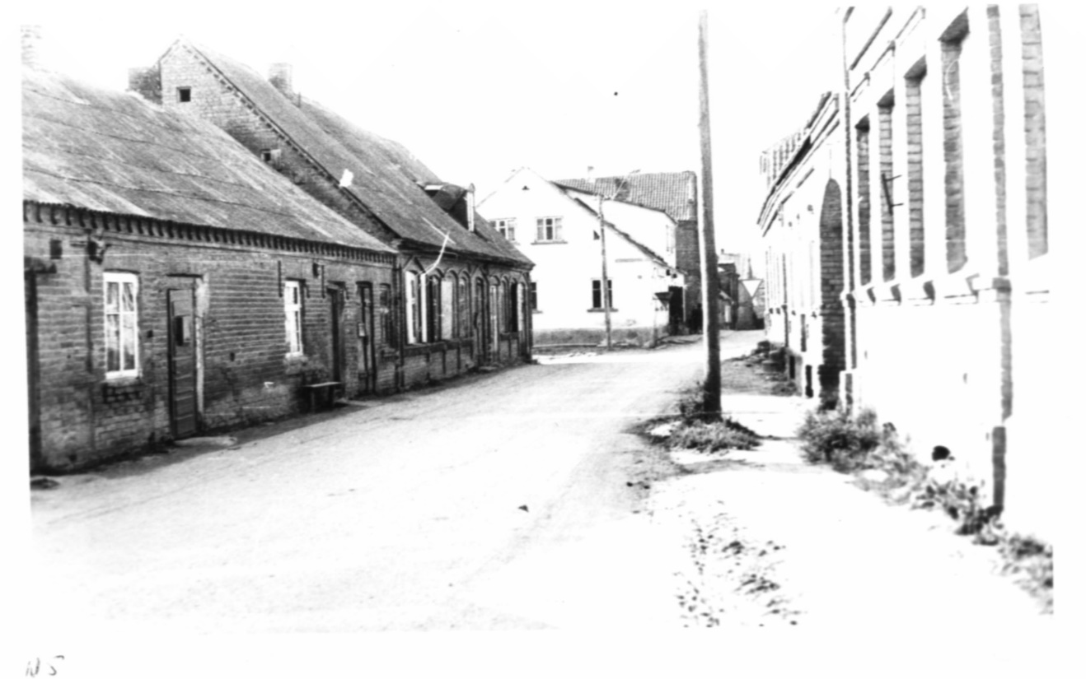
Fig. 3. Žeimelis. Bauska street. View from the church
И. The first house on the left was Glaeser's bakery.
Israel wants to invite you back.
И. I have records from the beginning of the war.
We go in the car from Herzliya to Tel Aviv, since Israel does not know where the station in Herzliya is. We are in a hurry. There isn't much time before the last train to Haifa leaves on the Sabbath. I turn on the tape recorder in the car.
И. I took the cow out to pasture in the morning. Mom would take the horses out in the morning, Rosa Abramovich would walk in the morning. I always met her on the way back. Э.
А. Who drove the bus? They say that the bus was confiscated by party members and left immediately.
И. Boyarsky. I was the conductor. Y. Immediately they ran away.
Zagorski wrote the book. The Lithuanians wrote it. After 1991. There are our surnames and those of Lithuanians who fled. Я.
Israel reported additionally about its own brothers:
Haimke died - suffocated in a tank.
Yefim (Chaim) Motelevich b. 1926. Died in Ukraine in the spring of 1944. Asked me how to find out where his grave, where he was buried.
Yekheskel Motelevich Yakushok, born 1919. He was in the Lithuanian army, joined the Red Army. In 1941 was in Mazeiki. Was retreating to the Daugava, Belarus and Leningrad. He died on the way, shot. (The information is confusing, there are others about the same).
Another brother, apparently Leivi, came out of Dachau. He was 1 m 83 tall and 47 kg. Ate and died. We don't know where he was buried.
On May 5, in a phone conversation with me, Israel Yakushok added that Leiser had a nice coat with ponytails. They were taken away on Saturday, June 7, and he went to the pit in the coat. He didn't want to take it off. And Freida yelled: "Take it off, maybe they'll let him go." He didn't take it off. They beat him up and took his coat off .

Appendix
Questions on the audio recording of 04/30/1999
А. WHERE WERE THE JEWS EXPELLED FROM - FROM UKRAINE TO POLAND OR FROM UKRAINE AND POLAND? FROM WHERE TO WHERE IS 2,000 KM? UKRAINE IS NOT ON THE LITHUANIAN BORDER. DID THEY GO THROUGH POLAND OR BELARUS?
Б. HOW AND WHERE WAS YOUR FAMILY EXPELLED DURING WORLD WAR I? WHERE WERE OTHER FAMILIES EXILED TO? WHO CAME BACK FROM WHERE?
В. WHO IS THE ZYAMA YOU CAN ASK FOR THE LAST NAME OF THE CAR?
Г. WHERE WERE THE JEWS IMPRISONED IN ŽEIMELIS WHEN THEY WERE CAUGHT IN THE BUTCHERS' CASE?
Д. WHERE WERE THE JEWS STANDING AT THE SITE OF WHAT FIRE WHEN BURSTEIN SAID THE PROPHETIC WORDS?
Е. INTERESTED IN THE STORY OF THE GLASS COFFIN IN WHICH SOME JEW WAS LYING?
Ж. IS IT TRUE THAT ISRAEL HASH WAS A PHOTOGRAPHER? IS IT TRUE THAT HE THEN WENT TO LINCUVA? DID HE DIE IN ŽEIMELIS OR IN LINCUVA? DID HE HAVE ANY BROTHERS, SISTERS, RELATIVES? WHAT WAS HIS RELATIONSHIP TO LEYSER? WHAT ELSE DO YOU REMEMBER ABOUT ISRAEL HAYES?
З. SHOCHET IS THE OCCUPATION OF THE FATHER OF THE SECOND TEACHER OR IS THAT HIS LAST NAME?
И. WHAT WAS THE SCHOOL ON LINCOVA STREET - A LITHUANIAN SCHOOL? CAN YOU SHOW ME THE LOCATION OF THE JEWISH SCHOOL ON THE PLAN OF ŽEIMELIS? IS IT STILL THERE TODAY?
К. WHY DIDN'T YOU LEARN FROM WOLOWITZ IF HE IS IN THE PICTURE?
HOW OLD ARE YOU IN THIS PICTURE? WHAT YEAR WAS THIS PICTURE TAKEN?
IS THIS PICTURE OF ALL THE STUDENTS IN THE SCHOOL OR ONE CLASS? HOW MANY CLASSES WERE THERE IN THE SCHOOL?
WHY ISN'T YOUR YOUNG TEACHER IN THE PICTURE?
WHAT SUBJECTS WERE TAUGHT AT SCHOOL?
WHAT CLUBS OR EXTRACURRICULAR ACTIVITIES WERE THERE AT SCHOOL - ART, SPORTS? DID YOU GO ON EXCURSIONS? WHEN?
Л. TO THE RIGHT OR LEFT OF THE ROAD, THE LAND OF LEYSER HAESHA, IF YOU GO FROM JEMEL?
М. HAVE YOU HEARD ANYTHING ABOUT PRINCE ANATOLY LIVEN?
WHERE WAS THE BRICK FACTORY LOCATED?
Н. WHERE WERE THE POLICE? IN WHAT PARTICULAR HOUSE?
О. WHO ELSE SERVED UNDER LEYSER HAESH, BESIDES HESKEL? TSUNKAS, TETRAGAS, GRIGALUNAS? HAVE YOU HEARD OF THEM?
П. IS IT CORRECT THAT HESKEL DID NOT WORK IN THE AFTERNOON? HOW MANY YEARS DID HESKEL WORK AT LEYSER? IN WHICH YEARS?
Р. WHAT DID LEYSER HAESH LOOK LIKE? HOW WAS HE DRESSED? HOW TALL WAS HE? DID HE WEAR A KIPPAH?
С. WERE MILENCHIK OR VILENCHIK RICH? I DIDN'T CATCH THE LAST NAME. BOYAK KRENITZ? I DIDN'T HEAR, WHO WAS THE BOYAK?
Т. WHAT WAS THE LAST NAME OF THE HAWK? WHAT WAS SHE SELLING?
У. WRITE DOWN MORE ACCURATELY THE QUESTION WIE OR THE INTERJECTION JAH! SAID HAESH.
Ф. WHAT ARE THE RULES OF THE RAG GAME? HOW IN FUTBALL?
Х. WHO MARRIED ZOROKHOVICH?
Ц. BRACHER TAUB - IS THIS THE CO-OWNERS OR THE FIRST AND LAST NAMES?
Ч. WHAT WAS FREUD'S ATTITUDE TOWARD HESKEL? WHAT IS KNOWN ABOUT HER?
Ш. WHICH BROTHER WAS IT, MOSHE OR HESKEL?
Щ. WHERE DID THE BIKE GO WHEN I GOT OFF THE BUS?
Ъ. WHY THE LATVIAN-ESTONIAN BORDER?
Ы. WERE THERE GERMANS IN THE PLACE? WHERE DID ALL THIS TAKE PLACE? DID YOU HAVE TO HIDE FROM THE GERMANS? HOW DID THEY LEAVE, HOW DID THEY GET OFF? I COULD NOT DECIPHER THE TAPE.
Ь. WHO DIED IN THE CROSSING AT PSKOV? THE WOMAN'S LAST NAME?
Э. REPEAT THE STORY OF THE ROSE AND THE COW. THERE'S A BAD RECORDING IN THE CAR.
Y. TELL ME ABOUT THE CONDUCTOR JOB, ABOUT THE BOYARSKY, ABOUT THEIR ESCAPE? WHEN, HOW?
Я. HOW TO SEE A BOOK ABOUT ZHEYMYALIS WRITTEN IN 1991?
WHAT IS KNOWN ABOUT PRUKHNO?

Editing, formatting, illustrations, and explanations of the text - the author of the publication.
This and the following letters (in bold italics) indicate places in the text where questions arose when studying the audio recording after it was transcribed. See Appendix "Questions about the audio recording on 04/30/1999" at the end of this file. It was intended to ask these questions to Israel at the next meeting.
Probably at the border the Jews were asked for a last name they did not have at the time. The topic of giving Jews surnames is beyond the scope of this publication.
That is, branding.
There were probably several people sitting at the table, and they kept drinking.
This refers to the death of 8.08.1941
This information from Israel is not very accurate. For details and accuracy see Anatoly Haesh "Lithuanian "Beilis case" (1930-1931)" in the almanac "Jewish Starina" #2(49) March-April 2007. Haesh1.htm (berkovich-zametki.com) Accessed 24.05.2022.
The photographs of these albums were re-transcribed by Barry Mann, except for the photograph of Israel Hayesh, which Israel Yakushok had previously given to the author of this publication. All copies of the photographs are numbered and are available online at the sites listed below. The description of the photos was made by Israel Yakushko later. At the first meeting he simply showed that he had a lot of them. (Y01-Y13) Page 1: http://http://www.mannbarry.net/Zeimelis/Photos/Yakushok/album/index.html.mannbarry.net/Zeimelis/Photos/Yakushok/album/index.html (Y14-Y27) Page 2: http://www.mannbarry.net/Zeimelis/Photos/Yakushok/album/index2.html (Y28-Y42) Page 3: http://www.mannbarry.net/Zeimelis/Photos/Yakushok/album/index3.html (Y42-Y56) Page 4: http://www.mannbarry.net/Zeimelis/Photos/Yakushok/album/index4.html (Y57-Y70) Page 5: http://www.mannbarry.net/Zeimelis/Photos/Yakushok/album/index5.html (Y71-Y80, Y1946) Page 6: http://http://www.mannbarry.net/Zeimelis/Photos/Yakushok/album/index6.html.mannbarry.net/Zeimelis/Photos/Yakushok/album/index6.html Date of reference 11.06.2022. Hereafter, instead of placing photos in the text of this publication, their designations on the six sites indicated will be indicated.
We are talking about a man in a Russian military uniform. It is not clear who Edelman is in the photo, because further, in the description of the photos, Israel did not indicate Edelman in this photo or in others.
Israel's response shows that he is not familiar with the term "farmer Jews. Haesh was a merchant, not a farming Jew, although he did have land.
Apparently a power plant was mentioned.
The word "ahead" is misunderstood as the house next door.
Israel here notes that on the side of the Great Coaching House, the house of Leizer Haesh was two stories. But in 1999 the second floor had not yet been restored.
The houses on the opposite side of the street belonged to Moses Hayesh, who had not returned to Zeimyalis from Penza, but Israel did not know this because Leizer Hayesh, at Moses' request, was in charge of his houses.
For an episode with Leyser's arrest in 1920 by the Penza Cheka for petty speculation in boots, see. Chaygl03.docx (live.com) Date of reference 13.06.2022.
Israel did not specify which one.
Freida knew Russian.
Wrong statement, the Germans broke through to Riga on June 29.
This story about Leizer Haesh's fur coat has several versions. This version of Israel Yakushka, who did not witness the shooting, is not the most credible.
See "Conversation with Meishe Yakushk.docx" Fig. 1.
YAD VASHEM ARCHIVES - YAD VASHEM ARCHIVES - 185eo9 (mannbarry.net) Date of accession 21.06.2022.
Zeimelis 6-2 Text.jpg (979×706) (mannbarry.net) Date of access June 21, 2022.
Zeimelis 7-2 Text.jpg (1498×976) (mannbarry.net) Date of access June 21, 2022.
Zeimelis 9-1 Text.jpg (1442×869) (mannbarry.net) Date of access June 21, 2022.
Photo by A. Haesh on August 31, 1982.

