Subscribe to DeepL Pro to edit this document.
Visit www.DeepL.com/pro for more information.

Proceedings of the fourth meeting with Israel Yakushko on 24.05.1999

The Fourth Trip to Israel Yakushku in Herzliya

Meeting with Esterson
И. It was at a funeral. He, Charlie Berman, says, "Please meet your cousin. This is Feigele's son, and she's in Germany, and this is Rivka, her mother." Well, "shalom shalom." They are very religious. I said I know Charlie. He died . She says:
- Haim?
- No, Charlie, his name is.
She doesn't want to call him that, the name isn't Jewish. So I talked to them, sat with them. They live in Ramat Alon. Charlie Berman knows their address. And he meets them. When there was my son's wedding, I invited them, I wrote them. They didn't come because they feared it wasn't kosher. That's my understanding. We talked to them for twenty minutes, reminisced about the past, and that's how our conversation with them ended. She's from Zeimelis, too. He <Charlie Berman? How the family has been created since 1905. All of them he searches for. And finds them all before... Charlie Berman knows more than I do. I know less.

Synagogue
А. First question. The synagogue in Zeimyalis has not survived, it is dead. There are no pictures of this synagogue and not a single drawing. Can you draw from memory, at least approximately, what this synagogue looked like? Since there is nothing at all now, at least something.
И. <Draws, part plan: bathhouse, rabbi's house, beit sefer, shamesh lived on the left, part view of the synagogue building from the side
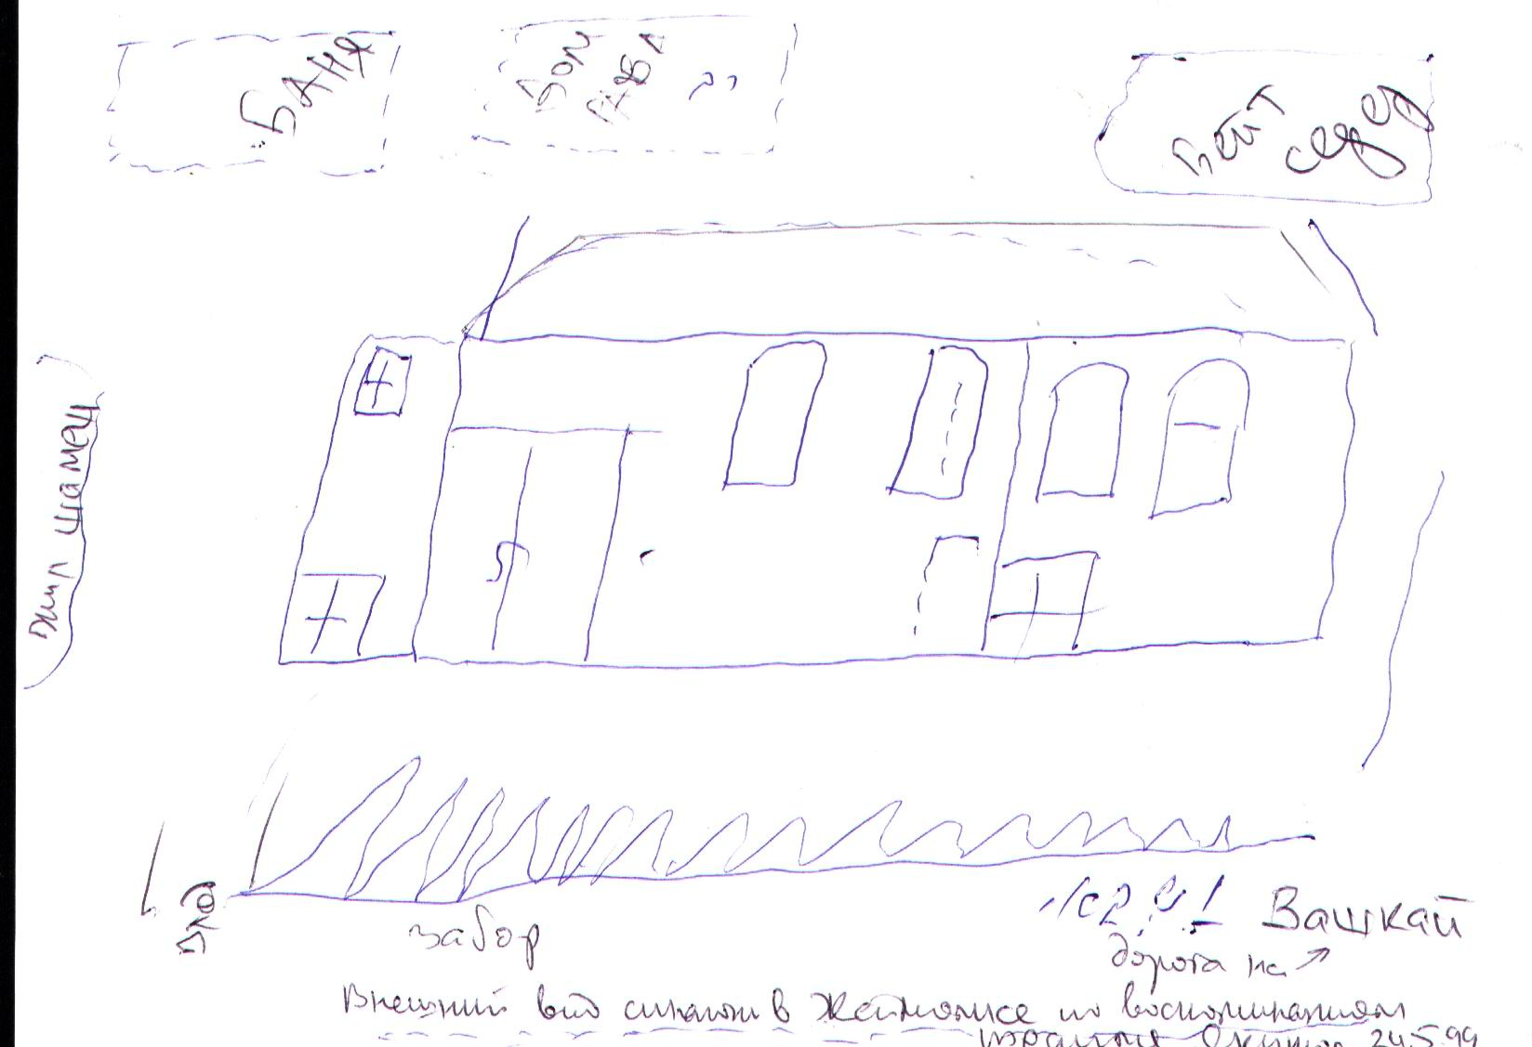
Figure 1. The exterior of the synagogue in Zeimyalis
(from the memoirs of Israel Yakushka 24.05.1999)
There's a fence with slats. You could be looking at the street. This is Vashkai Street. Entrance for women, entrance for men. There was a window here. The roof was red. There were big windows. This side <right side> was closed, it didn't work. There were windows on both sides, four windows. I know that for a fact. There was a wall here, there was an aron kodesh <puncture>. There were counters <benches> in two rows. And here <to the right> was closed. There was a part of the Sifrei Torah . the letters were not good.
А. Genise?
И. Held there, not junk. The benches, the backups that had been changed. There was an iron door and entrance. The windows were closed with wooden shutters. Always they were closed. Here was the house where the rabbi lived. Here was the bathhouse. One would come in from the street <Vashkay>. I remember it well. Here a little house down here, the shamesh lived, and here a beit sefer - there is a picture (Y03). That's it. Here <between the fence and the synagogue> there was an open space and here <by the bathhouse. It was narrow. By the fence they played soccer. And during the breaks they played soccer here <by the bathhouse>.
I once broke a window in a bathhouse.
А. Was the roof of the synagogue semi-circular?
И. No, it was triangular, red-tiled, four-sloped, cut at the ends. The wall between the compartments was stone. To the right of the synagogue was an aisle. Children were running around.
А. Was there a descent inside the synagogue?
И. No, the descent was here <by the shamesh house>.
А. <Discuss the picture of the Maccabi team > What's in the picture? <Israel thinks it's taken against the backdrop of a synagogue.

Homeowners and tenants
<Showing photo 3 of 1982
To the left of the synagogue, according to Israel, is the house of Leizer Hayesha <apparently, Moses Hayesha, inherited from his father Matisyahu-Eliyahu Hayesha, which was run by Leizer>.
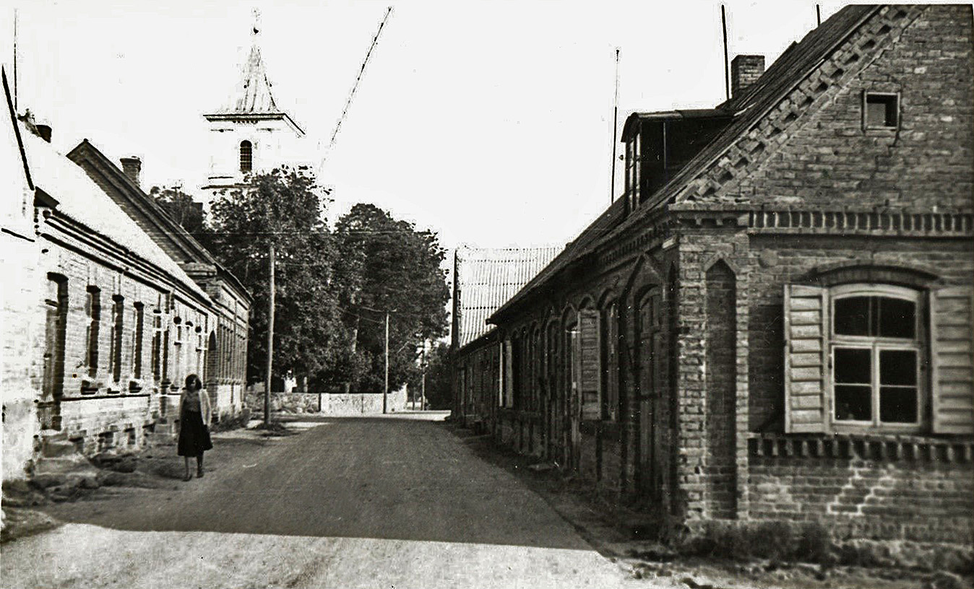
Fig. 2
On the back of the photo text in pencil: "3. View from the square. In the foreground on the right is the house of Matys Haesch, inherited by Moses Haesch, behind it the second house of Moses, the last house, probably also belonged to him. On the left is the house of Leiser Haesch. In the background is the church. 31.08.1982. Photo by A. Haesh".
И. The first two houses Leizer Haesch, the third a Lithuanian. There was a barbershop here on the right. The police were here. On Bauska street the police. Here the bakery.
А. Let me explain. The house of Matisyahu Eliyahu Haesh, my great-grandfather. The front facade. The door on the right was the barbershop, and on the left was the police.
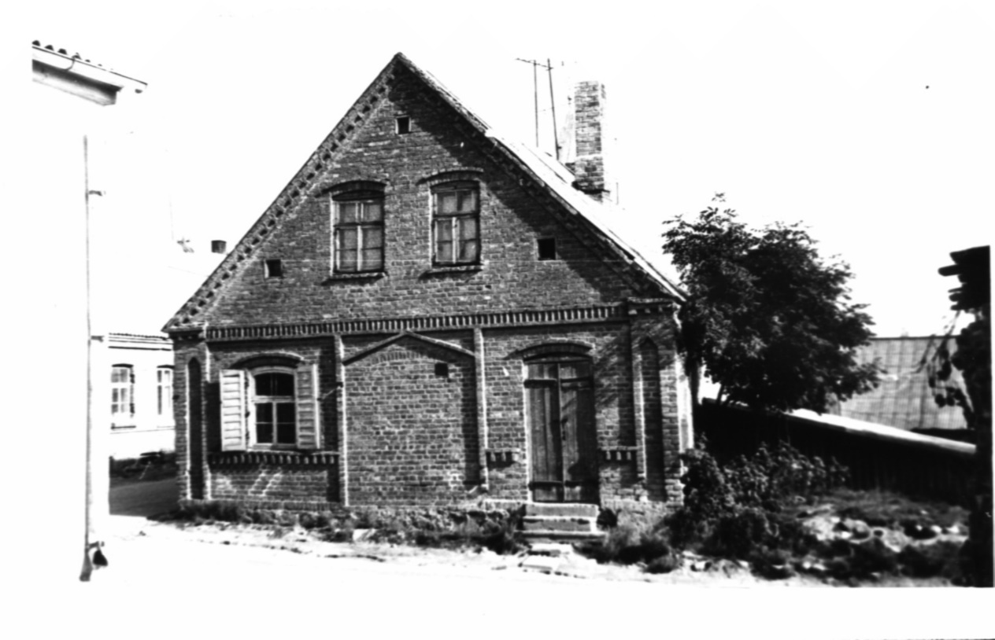
Fig. 3.
On the back of the photo is text in pencil: "2. The house of Moses Haesh in Zeimyalis. View from Pasvallio street . Behind the church. 31.08.1982. Photo of A. Hayes.
И. The entrance was from there, from Bauska Street.
A. (Probably looking at photo 2 above and 4 below from 31.08.82). Here is the entrance to the second house. Nearby you can see the end of the first house.
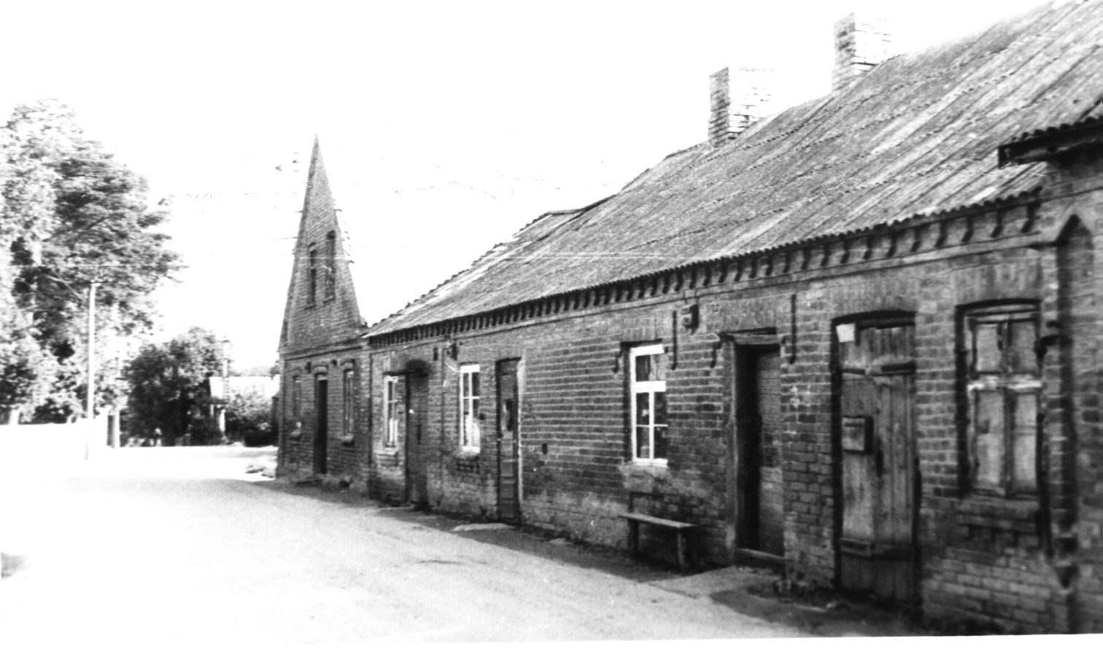
Fig. 4
On the back of the photograph is text in pencil: "4. Bauska Street in Zeimelah. The second house of Moses Hayes, in the foreground the edge of the house of Matys Hayes, inherited by Moses. The last house, facing the street, may also have belonged to Moses . Photographed August 31, 1982. Photo by A. Hayesha.
И. That's right. You could have gone past these houses to the synagogue, too. Down to the right behind these houses.
А. Behind Bauska Street, behind the house that faces Bauska Street, you could go around the back and go to the synagogue.
I. (Probably looking at photo 8 of 08/31/82). This is Leysera Haesch, this is Leysera Haesch, this is Leysera Haesch.
А. This is the second side of Bauska Street, where the church is.
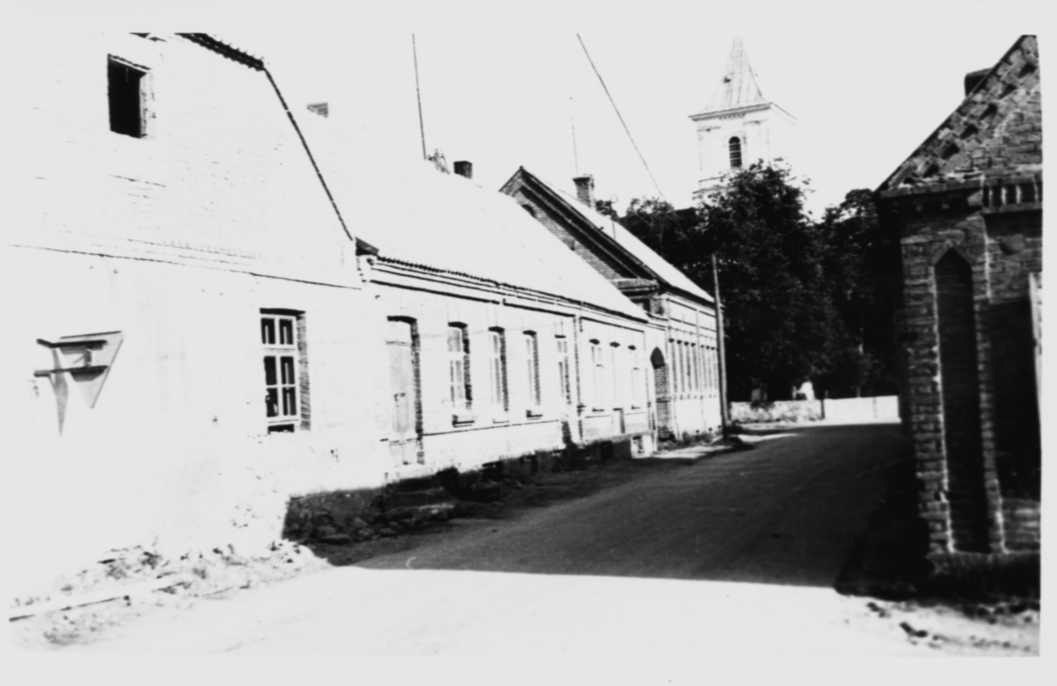
Fig. 5
On the back of the photo is text in pencil: "8. The houses of Leizer Haesh in Žeimelis. In the foreground on the left is the main house. In the background is the church. 31.08.1983. Photo by A. Haesh".
И. Leiser Haesch lived in the first house, only the entrance was on that side. It was the school <the nearest house to the church>, the Lithuanian school. This is Leizer Haesch's house. By the church. On this side was the entrance and on that side was the entrance. Nuns, not nuns lived, I can't say. We never went into that house. I just walked through. And across the street, behind the end house in Figure 4 was Jesús Christus. You know, we were little kids, you can't look that way, we were always told.
А. That the cross with the crucified Christ stood? In front of this house?
И. The cross stood in front of the Lithuanian church, there was a garden. It was behind the end house. Here <apparently in the end house> lived Shohet and teacher Green. That was his son. They lived here. We used to go on Thursday to cut the chicken at his place.
А. Let me explain. We are talking about picture 4 Bauska Street.
А. Which door did you go through when you were carrying Freida's milk? Not through that one? <Showing the gate from Bauska Street in Fig. 5
И. No, that's Bauska Street. From the square to the main gate. There was a corner house. And there was a big yard there. A very big yard. Because Lithuanian peasants came there with their carts.
А. You told me on the phone that when Leyser Haesh had his fur coat taken away, he was beaten up in this square. And you said that he seemed to have given up the coat himself.
И. No. Laser? They told him to give him the coat. He didn't want to give it back. They didn't beat him that badly, but they took it off him by force.
А. <Telling Ozolins' and Jukna's version >. Leyser lived a little longer.
И. I want to tell you, maybe. That's what the Lithuanians told me. <Israel knew Ozolinsh> Ozolinsh lived here. For this house. <Bauska Street further Shochet> Shochet lived in Ozolis's house. Leizer Haesch's <home> ended here <details that not the end house, but the previous house> There was a fence there. Then there was a cross. Ozolis' house. Ozolis had two three houses and big barns. And a backyard. There were two big dogs. We used to go through his yard to the Bershtelis river and those dogs would bark. And we were always afraid of them. I remember that very well.
А. <Showing the plan of 1897.
И. Ozolis lived here, just beyond the church.
А. And the bridge over the river was where?
И. Na Vashkai.
А. You promised to read excerpts from the diary concerning Hai Haesh's quarrel with his neighbors over the relocation of the fence.
И. I can tell you that. I can even draw it, if you want.
А. I have absolutely no idea where Israel Hayes lived.
И. <Draws> Joniskis Street, Bazaar Square. There is a picture when Smetona arrived .
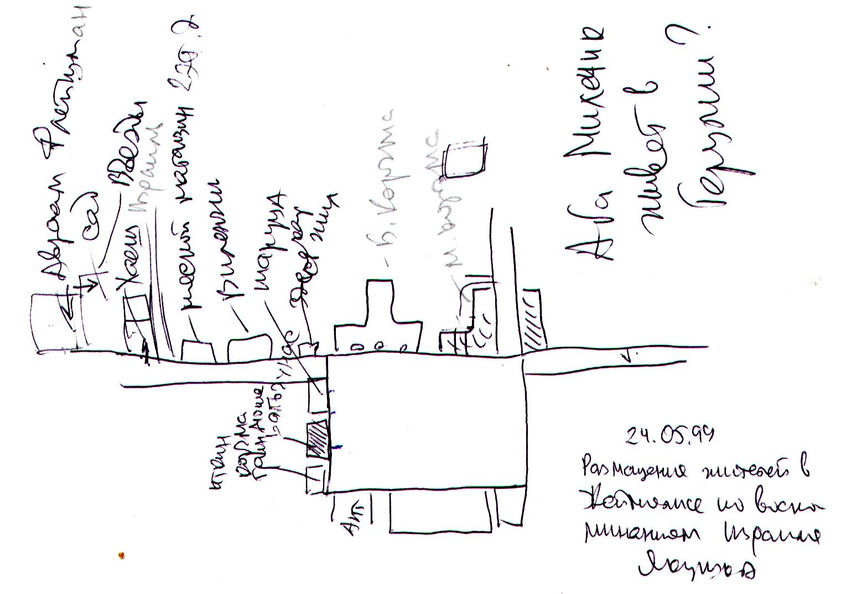
Fig. 6 Placement of residents in Zeimyalis according to the recollections of Israel Yakushka
А. Let me draw it. This is the square, Bauskaya Street, Vashkay Street, the house of Leizer Haesh, to the left of the Big Tavern. That's where Iser Izraelson lived.
И. Yes, there's an alleyway here, <close to here> Man lived. We lived in this place, <shows in the square second from the corner> Balchunas' house. This is Tarutz's house. There was an iron store. It's a small house here, a small house. Moshe Green's tavern was here. This was his house. Here lived Itkin, had a store. They sold notebooks, pencils. He was a watchmaker himself. He died at the age of 49.
There were three Itkin: Baruch Itkin, Chaim Itkin, and another one. And there was a girl. The house of Balchunas was long, not small, and there was another entrance.
А. Where did Israel Haesh live?
И. St. Yoniskis. Here was the bakery . Here Vilenchik. Here was the butcher store. A two-story house. Upstairs was a Volksbank.
А. Yankelevich. I know this house.

Haya Haesh and Mina Fleischmann
И. Yes. There's an alley like that here. Vilenchik lived here. Israel Haesh lived on the corner of the alley. The house wasn't an end house. There was a house the length of the alley. The entrance was here. There was a sidewalk here. The garden was like this. Abraham Fleischman lived here. The entrance to these <her and Fleischman's houses> was here. She <Hai Haesh> had a small yard, tiny. But there was a big garden. And they were always fighting over this entrance. They lifted <i.e. moved> the fence by half a meter. Because this entrance was a state entrance.
The story was told that they always lived on good terms. But always they were suing the state to have that piece, the entrance, theirs, half in half. They kept changing those fences. Somehow Mina Fleischmann and Haesh, I don't remember what her name was , had to go to court in Yoniskis to get that piece of land, the entrance, to be theirs too. There were big swamps. Up to the railroad, up to the station. There wasn't asphalt, like now, but rocks. And there were ditches like that. It rained all the time. The ditches were full of water. There was a moon. They were walking to the train, and it was going at 4:30 in the morning. It was small. Klein ban. <Uzkokolayka> He walked two hours to Yoniškis. 20-24 kilometers. And they were going to sue the state to give them that piece, the entrance, to have their land. In the fall, it's dark. Haya says to Mina Fleischmann:
- Mina, Wos darf mir gejn in di blotos? Sej hob gemacht a trotuar.
А. Mina, why do we have to go through the swamps? <translate me, durch blotos - Israel repeats after me. They made a sidewalk.
И. Kum arein gejn a trotuar. Ein und zwei hundert gehernt, un <non-intelligible> in di wasser. Di ganzen gelacht. <Look, we walk on the sidewalk. A hundred times we heard that we went and fell water. Everyone laughed>.
- Mina, Mina. Why do we have to go through the swamps? They made a sidewalk there. Look how shiny it is. And it was water and the moon glistened in it. And they went and fell into the water. And they came back. They got this piece afterwards. Then they started fighting for that piece. That half meter, that half meter.
There was a sidewalk in front of the Hai Haesh house, 60-70 meters. We used to skate. And she always poured sand on her property so we wouldn't break her sidewalk.
I could tell you more about how I fought, how we played soccer. But are you interested in that?

Episodes from Israel's childhood
И. This was in 1927. Because my brother was 7.5 years older than me, my sister Batya was older than me. I came into the school one day. Taking pictures with them.
А. It was you who told the story.
И. I also want to tell you. Before Easter it was. There were big swamps in the marketplace. It was wet. My father came from Riga and brought matanot (gifts) for everyone, and beautiful brown shoes for me. I went to the synagogue. I wore shoes, beautiful stockings, 3/4 length pants. As I walked back from the synagogue, it was already dark. There was no electricity yet. I couldn't see how to walk so I wouldn't get my new shoes dirty. I stood on the other side of the Bazaar Square, shouting:
- Young lady, young lady, come here.
She came in these high boots, rubber boots, took me on her screamers and dragged me. She walked through the swamp, carrying me so I wouldn't get my boots dirty. I remember well.
А. How old was it approximately?
И. I was 9 years old, in 1931, and Basa was 12 or 13. she was older than me.
Another ugly incident. I didn't like Hasya Boyarsky because she, fat and redheaded, was always complaining to my mother that I was bad, that I made grimaces at her children. Hanka was a girl and Avremka a boy, making grimaces. Our house and theirs shared a fence. And I really made grimaces. They ran and cried, "Mama, he's making grimaces." And she'd come complaining. And I got it for making grimaces. I told my mother:
- I won't do it again," but somehow I always wanted to grimace. One time Avremka was making grimaces, and I hit him. There was a hole in the fence, I pushed him, and he fell. Hit himself, maybe. And he ran screaming like that.
They had a store, a monopoly, a bus. Mendl Boyarsky. These are his children. She came, I was already feeling guilty here. She came and started.
- Feiga, take his pants off and give it to him properly. Almost broke my Avremele's arms.
-Mote, what should we do with him?!
- Give it to him.
Came into the other room, took off my pants and gave me, not hard.
We had a doggie. She stood there crying. Viking was her name.
- Which was lost on the road in 1941?
- Yes. In Porkhov. After that I made a vow to myself. I won't touch Boyarskaya's children, she'll get what's coming to her.
Time passed. After the one where Hasya walked, the doggie half a kilometer away, when she saw her, ran and barked. Hasya would throw rocks at her and she would run and bark. And always when Hasya walked by our house, the dog would jump out and chase Hasya.
It was summer. We went swimming in Bershtelis. There was a dam (dam) for swimming. It was far away. Then I said:
- Let's go home, it's a long way to Linkuvos street, about a kilometer. Let's go, all of a sudden we see Hasya swimming naked. And we were kids, about eight years old. It was me and Abka Milechik, the tailor's son. He lives here in Israel, in Herzliya. He used to work in a military factory.
А. Is he alive?
И. I don't know, a long, long time ago I only met him twice. Once my wife met him.
There was a swamp . Hasya was swimming in it. And it came out of the water. The grass was tall there. We hid. We made these tortillas. We started to throw them. She shouted, called a Lithuanian name: Mikolauskas. Another one. Several times we threw it. Abka says:
- Let's get out of here.
When we got upstairs, she saw me. What happened next, there's nothing to tell.

Comments on the video
Next, Israel shows us a video he shot during his trip to Zeimelis.
Ida. We went and took our granddaughter with us. She's 19 now, she was 14 then. She took a video camera and filmed. It was like an organized trip, because our son-in-law has a friend, and this friend's wife is Lithuanian, Violetta. And she works at a travel agency. We left here on September 19. And she organized the trip for us from start to finish. We got off the train in Vilnius. A chauffeur came to pick us up with a car and took us to the best hotel on Laisves Alley (Freedom Alley), "Neringa". We stayed there for two days. And then she organized a hotel for us in Kaunas. We traveled all over Lithuania: Trakai, Radviliškis, Šiauliai, Joniškis. In Žeimelis we were 23, after Siauliai.
И. Zagorski Naum drove us, Fyvl's son. A small car. She was only doing 50-60 km an hour. Very slow going.
Ida. His daughter is in Israel. She is Lithuanian or Russian. She is not Jewish. Our granddaughter is filming. We got out of the car. It was very cold .
А. Whose mill is this?
И. This is a Lithuanian mill. A kilometer and a half from Zeimelis. I don't know what his name was. We drive in from Yoniskis Street. We are not there yet. Soon it will say "Zeimyalis.
<To enter the city.
И. These are the new houses. The Lithuanians live there. Before the war there were none. Now there should be a railway station. That's where Žeimelis begins. This is where the Manes lived. The old house. Bazaar square. We lived in this house. The door, the entrance. Now they made a window here. Itkin lived in that house. That was Bera Green's house. That's Balchunas' house. Can you see it upstairs? That's where I kept the pigeons.
That was Tarutz's house. This is where we went into the courtyard. This is where Boyarsky's bus used to drive in. There was a garage in the yard.
А. I was in Zeimelis in 1982, 1983 and 1991.
И. And we were in 1948 for the first time. This is our yard. Drunkards used to walk here a lot. Faivel Zagorski worked as a bakery clerk in this window. Tarutz's house is red.
А. What house across from the pharmacy showed up there.
И. This is Berah Green's house. <Skip, the movie is fast-forwarding. That's the pastor's house.
<Watch and record again Israel's explanations with the VCR sound turned off> .

Leiser Haesch House
И. Gymnasium on Linkuvos Street.
А. That's where we were, there used to be a museum there.
И. The museum is now in the house of Leyser Haesch, which faces the square. The second house from the Great Inn. This is a picture of Zagorskaya. She died. And her son lives here in Herzliya. This is another Zagorski surname. And this is the grave, written in Hebrew, Yiddish and Lithuanian.
А. You just said that there was an inn or restaurant on the second floor of Laser Haesh's house and that you were throwing some candy there.
И. The inn was. We weren't the ones throwing candy. The Lithuanians who came to the bazaar and sold what they had, then went into this tavern.
А. The room there is very small. There was just a mezzanine on the second floor.
И. There was a restaurant on the first floor, too. But half of it, not all of it. It's full now. And then there was half of it and there was a staircase going up to the second floor. I had never been there before the war. The Lithuanians, when they sold flax, wheat, etc., always went to the monopoly to buy vodka. At Boyarsky's the poor peasants drank. I don't remember the last name of the owner of the restaurant. Bakauskas. Richer peasants used to come here. They went to the restaurant. They ate. They drank. They would go to the second floor and throw candy. And we kids would grab the candy.
А. Sixth, you say there was a bakery. Did you come in from somewhere around here into the house? Milk, when you were carrying it.
И. From the square. There was an entrance here and here.
А. You could have walked across the yard.
И. I walked here, most <from the square>.
А. It is said that Freud was not allowed in this door that it was always closed. <The answer is not quite clear.
И. The big tavern is Izraelson.
А. In what place was the museum made. <The answer is not very clear. Perhaps the passage at the Little Inn was closed during the restoration.
И. The museum is narrow and long. 25-30 meters. I think I came in from Bauska Street. This is where Leyser Haesch had his warehouses. There was a big kitchen. About 12 meters. Two brown beds. lots of pillows one on top of the other. Dark bedspreads. It was a little dark in there. Not much sun. North side. There was a lot of sun here. Here Hatzke worked for him in this two-story upstairs warehouse. There was a staircase. There was a door here. And here was a wooden staircase.
А. What did Leyser keep on the second floor?
И. Sacks of wheat. The flax was kept downstairs. The sacks were 50 kilos each. We had to bring them upstairs and put them down. We had to carry them on our backs.
А. You told an interesting story about a pot, quite unusual for us, new for us, about this pot of gold coins.
И. He kept them in a warehouse somewhere in these parts. The cast-iron pot was.
А. What is the approximate size?
И. Two and a half, three liters. Lots and lots of them, but they were closed.
А. Did you see that. Or was it Hatzke?
И. Hatzke knew. "Haesch has gold," he told me. I asked him: "How do you know?" He said: "He's got a pot like that in there. It's closed there, not so easy, secret like that."
А. It must have been very heavy and Hatzkel had to carry it from place to place.
И. I can't say that. <When they nationalized him, they only left him the apartment. He took this pot with him.
А. Where did they leave him the apartment?
И. Here. But it was reduced. He had a big apartment. Probably 60-70 square meters. It was a big apartment for those days.

Photos from Yad Vashem
А. Can you identify anyone here in this picture?
This tall one, you say some kind of rabbi, maybe you know him?
И. <shows picture of the man at the table> Izraelson.
А. On the right in the cap is Israelson, and what is the name?
И. Iser Israelson.
А. And in the hat on the right, who could it be?
И. This is Laser Haesh .
А. Do you think Lazer Haesch?
И. I think that's what he looked like.
А. Did he look like that?
И. That's what he looked like. The goatee was small.
А. Yes, it is known that he had a small beard.
И. Leiser Haesch.
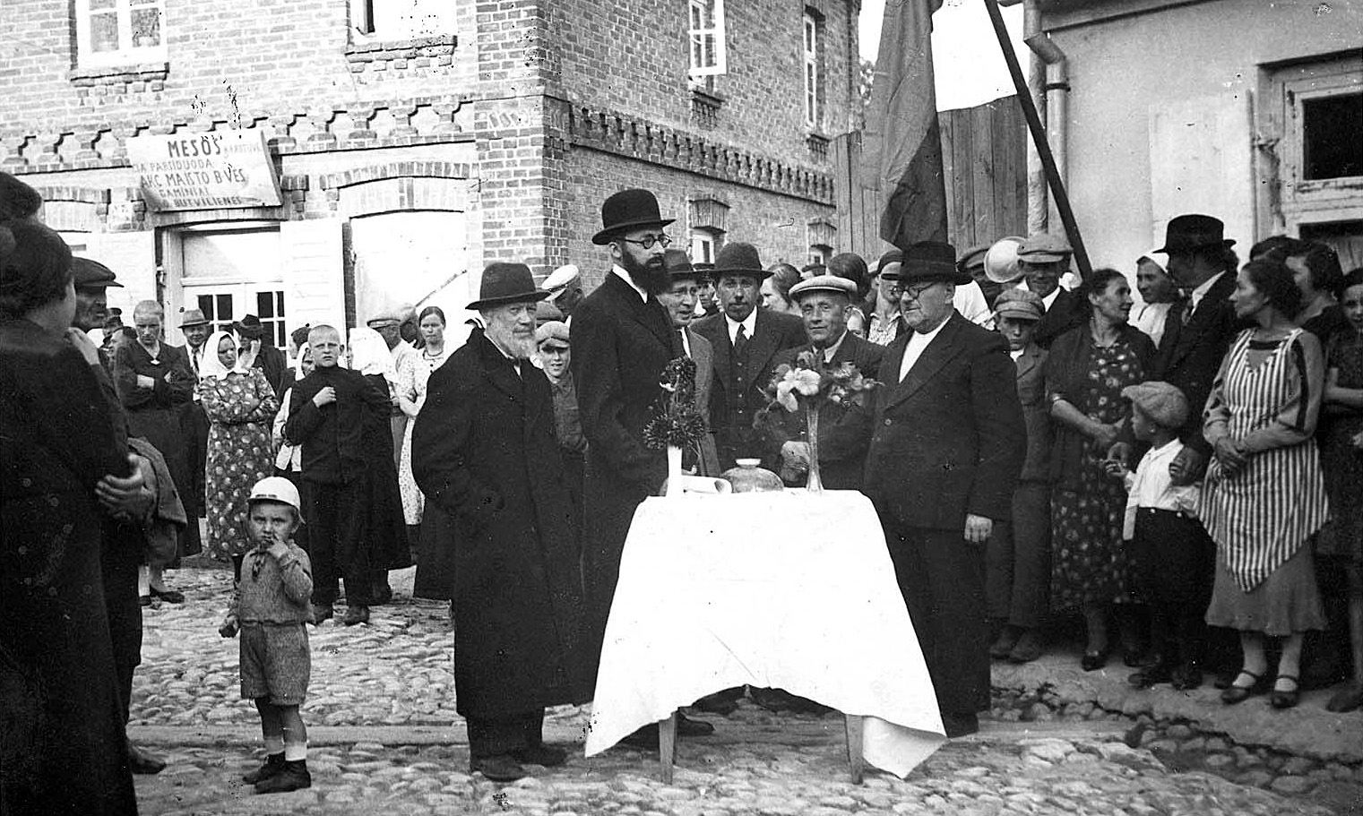
Fig.7. Žeimialis awaiting the arrival of President Smetona. Spring 1931.
А. The thing is, I don't have...
И. This is Gel.
А. To the left of Israelson in the hat is Gel.
И. It's Laser Haesh. I don't doubt it. I've been sitting around here somewhere. Yonish Street. Oh! Mesos parduotuve. They sell meat. Mesos parduotuve. It's on the second floor. You see, this is the second floor here? This is where Jankelewicz had the Volksbank. And here was Mesos parduotuve <meat shop>. I see that Mesos is written. This corner house was a butcher store not kosher. This was where they sold vodka. And this was a bakery. I was here.
А. So you are on the left side of the picture.
И. I got sick. I got sick when I arrived... I got whooping cough. I remember well.
А. And yet you went out sick and watched?
И. No, I wasn't sick yet. The same day I got sick. I had a fever, that's all.
А. And who can this leftist be? Is it this rabbi?
И. Krenitz.
А. Was he tall?
И. He was tall. A big one. Krenitz, yeah. Oh! Schulgeifer.
А. Between Gehl and Rav is this Schulgeifer?
И. Yes! Yes! <The joy of recognition in Israel's voice> Schulgeifer.
А. And this <the lefty> who could it be?
И. I think Lazer Man.
А. Leyser Man?
И. I think so. They put the bread here. Oh! Wait, wait, wait. That Abka Milechik!
А. To the right. The little one in the cap.
И. Dovidka Yakushok.
А. Above him the tall one. Also wearing a cap. To the left of the woman both stand. Who can this woman be? <In a striped apron.
И. I can't say that.
А. And this one? <Seeing to the right, in a spotted dress.
И. Somewhere in here I am. I was sitting at a height so I could see well.
А. And who could this woman be, this one?
И. Also one of the important ones. It's a Lithuanian.
А. The boy is Lithuanian.
И. This is a Jewish boy.
А. Who's the boy?
И. Gutel boy, that I don't know.
А. Wait a minute. At the table are: the leftmost, according to Israel's assumption, Yakushka, Lazer Man, then Rabbi Krenitz, then Schulgeifer, then Gehl. You don't remember the name?
И. Geley had several brothers.
А. One of the brothers.
И. Izraelson.
А. Then Iser Israelson and the most right-wing Leiser Haesh.
И. No, no, not Lazer Haesh.
А. Not Leyser Haesh?
И. I now know for sure! Velvel Ehrlich.
А. Not Leyser Haesh, but Velvel Ehrlich.
И. Velvel Ehrlich. He had a store on the corner near Schulgeifer. Where his pharmacy was. At the Beit Knesset <synagogue> in Rosh Shana <Jewish New Year> he was always hazan <kantor>. Velvel Erlich, I remember him well. Izraelson, he was short. This is Schulgeifer, yes. That's Leizer Haesch.
А. Left?
И. Left Leyser Haesh.
А. Not Leyser Man, but Leyser Haesh?
И. Leiser Haesch, Leiser Haesch! That Gael, he was tall, that's Krenitz.
А. But it was said that Laser Haesh had a goatee.
И. A little beard. Oh! I can't tell you now, this one or that one <points to right and left>, I doubt it. This Welwel Ehrlich, or this Welwel Ehrlich. This one is Leyser Haesh or this one is Leyser Haesh. One of them is Leyser Haesch. I know it was always rich people, there were people rich and they always met Smetona.
А. What was the occasion for this visit?
И. In the thirties.
А. What was the occasion of his visit?
И. Elected the president again. Several times they elected him.
А. Was it electioneering?
И. After the election.
<Next photo.
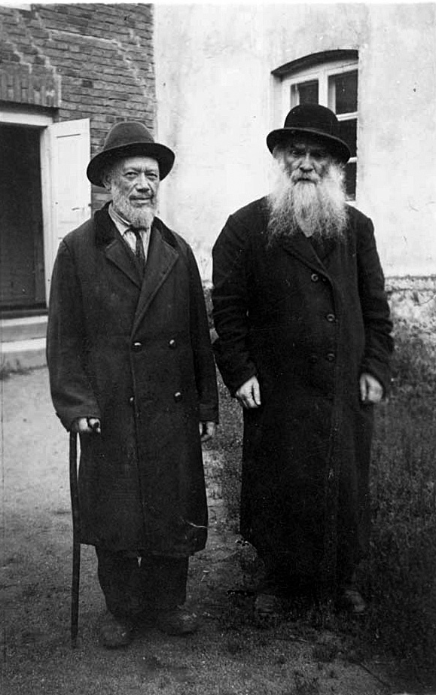
Fig. 8
А. Let's have a look. Let's read what's written at the bottom.
I.<Reading in Hebrew the caption under the picture> These are representatives of Meir Bal'anes, there was such a tzaddik. They came from Israel <Palestine> to collect money in Zeimyalis.
А. What is this? <bottom photo
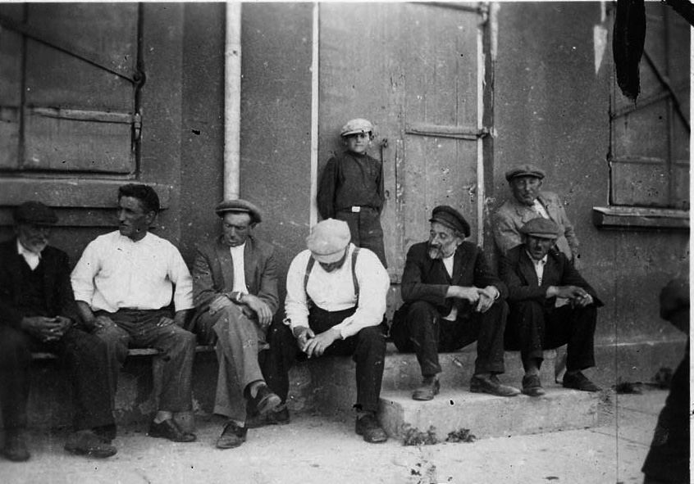
Fig. 9. Shabbat in Zeimelis
И. That's very interesting to me. <The rightmost one> Faive-Girsha Yakushok, <the third one on the right in the white shirt and suspenders> that's my father, Motel Yakushok, <the next to the left> Yudel Yulelevich, traded, had a store, then <in the white shirt> Azriel Burstein. Do you know where they sit?
А. No.
И. Where the mill was. It's called a prisba there. <reads caption under photo> Saturday after cholnt. They ate. They are resting. Telling tales.
А. Isn't this the place where the Jews used to gather that you told me about?
И. Yes. That's the one. I don't remember this boy. That's my father, I know. I want to show you a picture of my family <shows>

About the parental family
А. In an old album of Israel Yakushok there is a picture from 1936 of his entire family, with his father, Motel Yakushok, and mother, Feiga Yakushok, sitting in the front row in the center. To their left is Haim Yakushok, to the right is Israel himself, in the back left to right: Levi Yakushok, Moshe Yakushok, Batya and Heskel. <describes the dead - Haim, Levi and Heskel.
А. There are three dead people on it. What are their full names?
И. Hatzke, his name was. He was in the Lithuanian army, then in the Russian army. He died in Zeimyalis.
А. I didn't understand, did he go back to Zeimelis or not?
И. All four of them returned to Zeimelis.
А. Repeat the names of all four.
И. Yeheskel Yakushok, Yelka Baginski, full name Eliyahu, Hershka Hayet, full name Hershel, and Yoshka Lakunishok, full name Yosef.
There was a library. "Ha Shomer ha Tzair" - she <Basya> participated in the cultural life of Israel. She read all the books in the library. When I couldn't read yet, she used to read Jules Verne to us in Yiddish. There was no electricity yet. There was a lantern <once> the horses. She read us until one o'clock in the morning "Children of Captain Grant" and "Tashkent - di stot fun breit <bread city>". So many books she read. We sat. I listened and listened until I went to bed. There were several Polish writers: Korczak and others, Jewish writers, Sholom Aleichem. I read Sholom Aleichem several times in Yiddish. Then Mendel-Moicher Sforim, Chaim-Nachman Bialik, Peretz. Then I read biblical books. My father read, at the age of 95 he was reading the newspaper without his glasses: "Yediot Ahronot".
Basya, she was in Žeimialis all the time, got married in Žeimialis, and what is more important, many pictures of Žeimialis that we had, disappeared somewhere. A lot of pictures she had. When we left Žeimialis, and she married Leiba Lakunišok, she was a tailor, had a Singer car, she gave the car to the Latvian Jaanajkis.
А. Did you give it to him?
И. No, buried. And there's a lot of pictures in the car in her drawer. Leiba Lakunishka had a lot of pictures. And Basa herself. And when we left Žeimialis and came to Lielupe, which is already Latvia, we had to go and the horse was already tired. We had to take off <an unnecessary load>. And we left the photos with the Latvian. And when after the war she went to Lielupe once and wanted to find. There are not only photos, there are a lot of things. Everything was taken off the cart, so they could continue <travel>. She got the car after the war, which was buried. She came in 46 and they took the car right away.

Viewing pictures from 31.08.1982
А. <Showing my photos of Žeimelis 1982> Let's go in order. Photo 17. On the left is this house.
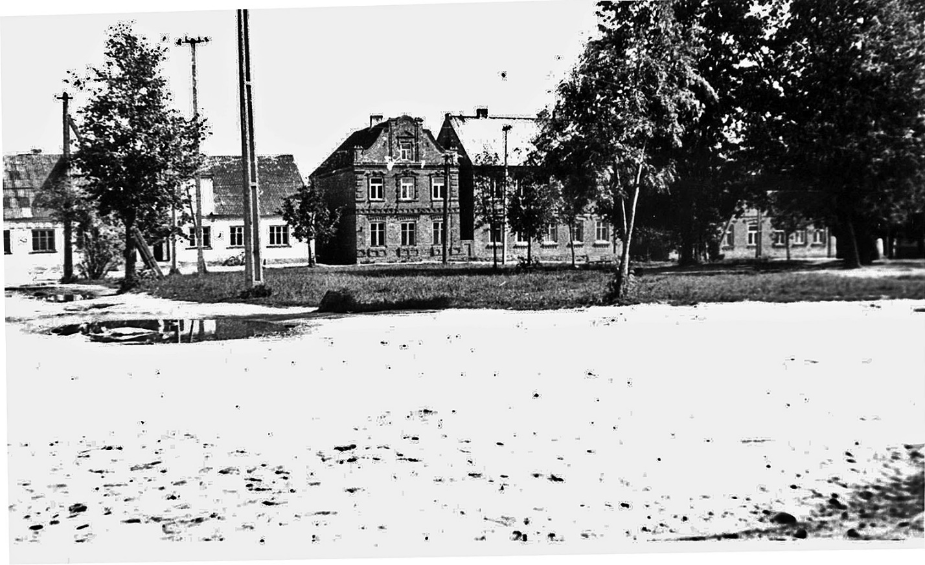
Fig. 10.
On the back of the photo text in pencil: "17. The market square in Žeimelis. View from the side of the house where the canteen is now. 31.08.1982. Photo by A. Haesh".
И. This is the corner house. Vashkai Street is on the left. Nisim Zagorski had a store here and sold flour. And my mother used to buy it, she always went, I helped her. Ten kilos of flour <took> on Thursday. On Friday morning, she would make a stove and bake for the whole week, so the children would have something to eat. Nisim Zagorski lived here with his daughters and his wife. Intelligent two girls they were. They had studied somewhere other than in Zeimelis. For the last year they were already living in Zeimyalis. They all died.
А. You don't remember names?
И. No.
А. Didn't his brother live on the right?
И. Here lived his brother <specifies next house>. He had a manufactory store. He was always smoking cigarettes, and his wife always scolded him. And his coat was full of cigarette holes. He always hid <from her burning> cigarettes.
А. Wait, the right side of the first house.
И. There was a hatter here.
А. Do you remember your last name?
И. I have it <in my notes>. Bought good hats from him, for Easter.
А. The next two-story house.
И. There was a store on the first floor. They lived in the back there. Zagorski's brother. And between the houses they could go to Buse Ehrlich's place. Through the passageway between the houses.
А. Who lived on the second floor?
И. I can't say. The second two-story house lived Malyunas, a Lithuanian. A manufactory store. And then Linkuvas street comes out, it's a small street. In the third two-story house was a Lithuanian bakery.
А. Was the Smeetona meeting at these houses?
И. No, on Yoniskis Street, there are brick houses, two stories. Stairs of some kind.
А. Is this where Jankelevich's bank is?
И. Yes, yes. Then Briona lived there, and then there was a big yard, a street, and then Haesh <Haya> lived there. Lepar lived there, Beder lived there, then Lakunishok lived in the house I showed you in the picture.
А. <Showing a photo from 1982
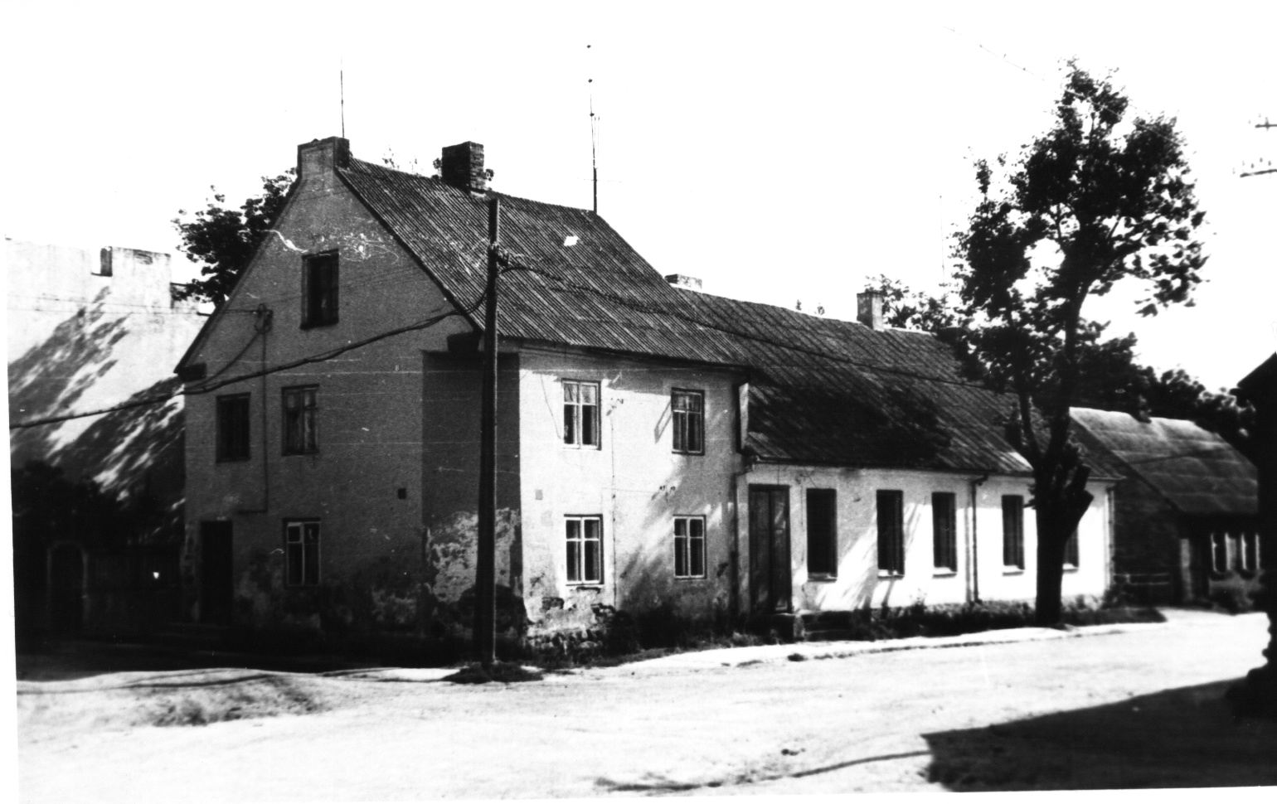
Figure 11. Rosa Abramovich's houses
On the back of the photo the text in pencil: "19. The market square in Žeimelis. House of Rosa Abramovich (presumably). 31.08.1982. Photo by A. Hayes.
The house where Schulgeifer's pharmacy, who lived in this house?
И. Welwl Ehrlich had a corner store here. A colonial store like that. They lived on the second floor. I used to go to their place. The one-story next door was a drugstore. The entrance is to go in to them. The whole Schulgeifer house. Two windows are the pharmacy, and then the apartment.
А. Did the two-story house belong to Ehrlich or Schulgeifer?
И. Schulgeifer.
А. They say the entrance was from the corner, and he had a kerosene store next door, so when he had to sell stinky stuff, he would go there.
И. That's right, he sold kerosene and also what they smeared the carts with - tar. It always stank. He kept that store closed. That store window, I remember buying from him.
А. And the back house?
И. Jews lived there. The Milunskis. There was a store for them here. <The name doesn't remember, but he has it written down. There was a church here. In the gap between the two houses was the entrance to the store <break in the record>.
А. You say there was a wooden house here.
И. The Marchunsky family lived here.
А. What can you say about her?
И. Why did the Jews live in the townships? Where did they get their livelihood from? There were no offices <i.e., places of service - A.H.> This one had a store and that one had a store. And the others bought from the Lithuanians. They came to the bazaar. They bought skins from them. They bought cattle from them, they bought testicles. They took them to Joniskis. They sold them there. They earned a penny. And we lived from that. There were 22 stores in Žeimelis. Not a few. We were talking about picture 19.
А. Now Image 2 from 8/31/1982 On the left, you say, was the police, and on the right was the barbershop.
И. It's on Bauska Street. No, on Vashkai. I want to show you a picture , who had this barbershop. He couldn't read or write. Never went to school. And when the Soviets came, he became chairman of the village council. Haim Glezer. Here was only his barber shop, and here was the police station. Farther away lived a tailor, and even farther away was the synagogue.
А. What's the tailor's last name?
И. Leiser Haesch bought this house. Such a low house. He was some kind of count. Bought this house for a penny. Here in Zeimelis all the houses - the bricks were red. Somebody built these houses. Some count. He lived 8 km away from here. Two yards of such big ones.
А. Anatoly Pavlovich Lieven. He built these houses. The whole place was his.
И. I remember before the war they built this two-story house , then they added more. And all the houses in the center remained as they were before. All red brick. So someone built them. Taruta's house was brick. The Balchunasa house wasn't brick. It was an earthen house.
А. The little tavern was also earthen.
И. Yes, yes.
А. Behind the police still houses, what was in them? <possibly referring to photo 4 of August 31, 1982>.
И. This is Leiser Haesch's home. The Lithuanians lived here. Paid for it.
We paid 4-5 litas per month for the apartment. Where did Balčiūnas get the house from. He was in the Lithuanian army in 17-18, when they got independence. And all Lithuanians were given houses that belonged to Germans. His wife had land. And he bought this house for 400-500 lit.
А. So you think this house once belonged to the Germans?
И. Only, only. I now understand that all the houses, also the house where the mill was, and the two-story houses, red brick ones, were built as they were built in Russia. There, further on, on Yonish Street, where my grandfather lived, Leizer Man lived, where Hone Tosche lived, before Milunsky, there were already wooden houses, painted. And Milunsky, where he had the mill, was still a red house. And next to where Kremer lived and Haska Kremer, there were already earthen houses. And on the corner was a red house. That's all on Yoniskis street.
А. Let's take it in order. Whose house was the first one behind the Big Inn? Yankeljevich's?
И. No, the first house was Vilenchik's. Two brothers, Shmuel and Simcha, who traded. One of them had land, Simcha Vilenchik. And the first house behind their yard was an electric mill. They built a warehouse there in the yard. Further down on the right side was the butcher store. On the second floor was the Folksbank. Then further down was the entrance to the courtyard and the corner house was also red brick, two stories. Jews lived there.

Jewish trade in apples and miscellaneous
My father had <rented> a big basement in this house, probably 80 square feet. We used to buy apples and keep them there until Easter. For a long time. We paid 20-25 litas a month to the landlady. It was a lot of money. But it was cool in there, arranged well.
We used to buy orchards from Lithuanians. We always sold summer apples to Siauliai and Panevėžys. We drove by wagons and sold them in bulk at the market. There were always winter apples left by Roche-Shan: antonovka, sherinka, papinka, pomegranate, red apples, very good ones. I remember their names. And there were also green apples, I don't remember the names. These were considered winter apples.
Dad always bought his garden from a Lithuanian. You named one .
А. Grottoizen, it was the Baron.
И. Yes, he had 600 trees. Dad paid <for the gardens> 800 litas. It was a lot of money. We worked in the summer, took care of the garden. There was a watchman, so they didn't steal. Dad did not have a lot of money, because I told him what it used to be, that they were running away, that he was left without money .
What were the people living from in Zeimelis? There were a few who bought apples. But the biggest merchant was my father. The summer apples we picked from the tree: white naliva, ranobel, robin. We sold them in Siauliai and Panevėžys and paid the owner for the proceeds. There were winter apples left over. And my father always tried to buy in two or three places. And also participated with him. Hone Tosche participated, one Berman also participated, invested money. We went to the bank, took a loan. And they paid good money for the loan. The remaining apples - that was the profit. From that we lived. In winter we traded apples. They bought other things. In the thirties my father bought cattle, testicles. There was a warehouse, called a cage, where they kept the testicles.
The goods, apples were taken to Riga, and from there my father brought smoked fish. He sold it here in the markets. And he lived off it. And he wasn't the only one. We had a lot of money. Didn't have any land. There were some who lived worse. The Gershon family, they had nothing. The father died young. There was a woman left, three children. Had to help. Collected money. That's how they worked, that's how they lived.
А. So, your father rented a basement in this brick two-story house.
И. Beautiful cellar, round vaults in the middle. Apples, when you store them, you have to go through them, because they rot one from the other. And we were always going over them, going over them. We used to lay straw. They made such wooden bunks, higher and higher, to use the <volume>. And there were windows, out on the street. We watched, closed in the winter, so as not to freeze. If in summer we sold a whole wagon, 7-10 quintals, in winter we sold also in bulk, but not so much: 2-4 boxes, 150-200 kg. Apples were expensive in winter.
There used to be a lot of apples around Zeimelis. And people lived from it. There were several families who did it. A Lithuanian had a big orchard, 150 trees. I remember, there is such a village called Lashen. There was a teacher in it. My father bought an orchard from her for seven or eight years in a row. She got that garden from the state. And she sold it to Jews. What would she do on her own?
А. So the gardens were sold in the spring?
И. Yes, no apples yet. Buyers already knew, felt, how much this tree could give. The old trees gave a bad harvest, and the young ones a good one. Then, in 1937-1938, they already started selling apples to Germany, to England, for export. In beautiful crates, they got more money there.
They also bought bacon pigs. A young man, Mathis Lakunishok, he was not religious, he did not go to the synagogue, and he started buying pigs. On a market day there were 30-50 carts of bacon pigs. And he sold them to England. His father had a butcher store that sold kosher. And the rabbi, when his son started buying and selling pigs, forbade Jews to buy meat from his father's store. This was used by Lazer Man. They bought from him. Then father Lakunishka went to the rabbi, there was a meeting there, because Jews are not allowed to sell pigs. It took a long time to solve the case. They took into account, as if my father was handicapped. After three or four months, it was allowed, as if Mathis wasn't their son. True, he left Žeimelis. But he still traded.
What else did the Jews do? Buying horses. At Nemokshchai. They had good horses there. Rav Krenitz was there before the war. He left from Zeimyalis. In Joniskis there was a Jew, Pupko, who traded with England. Mathis got in touch with him and they started working together. He bought horses in Zhemialis, in Nemokshchai, in Yoniskis, and sold them to England. He wasn't in the pig trade, so they let my father keep a kosher store. It was like they were making good money from it.
He got married, Mathis Lakunishok. He lived somewhere in Russia. I don't know if he's alive or not. He married a rich girl from Zhagar, and that's where he started. He drank a lot. He went out with women. He was so promiscuous.

Again about houses and homeowners
А. The next house on Yoniskis Street, on the right side we go?
И. Next Hai Haesh, a wooden house, long. After Hai Haesh there was Fleischmann. A wooden house. Then Trumpf. The dentist. Then there was the red brick house. There was the Faive Yakushok. My father was his cousin. One Yakushok still lives in Rishon Lezion, Meir. And Pruchno lives in Rishon. Meir is my second cousin. Etla? Yakushok. My father? Yakushok. Also my son.
А. Was the brick house the last one on the right side?
И. There was a field of some kind, and then there were long houses, lived by peasants, not Jews.
А. Now on the left side.
И. Corner house - there was a bakery at first, then the house passed to another.
А. Whose bakery?
И. Yulelevich, there was Girshka Yulelevich alone, I already told you about him. It was Yankelievich's house.
А. So the corner house belonged to Yankelevich.
И. And in the middle Yankelevich had another house, before Tarutz.
А. We're talking about the corner house that stands in Bazaar Square. <There's some confusion here, I'm showing the plan of the city. Perhaps the reason is that I'm talking about the second house on the left side of Joniškis Street, and Israel is talking about the second house from that street on Bazaar Square.
А. The second house on the square from the corner, I understand-you lived there. Whose corner house?
И. Tarutz. near our house is not a corner. I showed you: they were building. The iron store was. I showed you a picture.
А. You not only showed it, but even presented it.
И. Here Yankelevich had a manufactory store, a small store, narrow, some room. Nearby was Boyarsky.
А. But there's a whole house here? Then this Tarutsev house is not a corner house.
И. Not a corner one. It's near our house. Not corner. It's not right here.
<registration suspended - skip
Berglauf<? > on the second floor. We lived here. This is where the entrance is.
А. This is a picture of the Tarutz house under construction.
И. They were building the second floor. The first was always there. Here was Yankelevich, a manufactory store. The house was long. Yankelevich. Then Mendel Boyarsky, had a colonial store. Then "monopol", where the vodka was. And here the corner here was the entrance from here. Yulewicz had a bakery here.
Now on the left side of Yoniskis Street. First house. Here would have been the entrance to the yard of Yankelevich, Boyarsky. Further on was a long house, a clay house. Yulelevich lived here, there were two more Yulelevichs in Zeimyalis, Gutl. Then my grandmother lived here and also Kare. This is a relative of mine, a cousin. My grandmother lived with her daughter. The third lived Kremer Ikar, a clay house, and then Milunsky, that's already red brick house. Next was Hone Tosche's house, a wooden house. These must have already been built in the 30's. Then Gel, had a store, a wooden house.
А. Gel, what's on Yonyskis Street, too?
И. Yes, then there was a passageway, and behind it was the last long wooden house - Leizer Man lived there. Then Zorokhovich lived there.

Minor topics
А. I see, you said that some Haesh was coming in '41.
И. I don't know which Haesh. It was Benjamin Berman who told me that. It was your father's brother or the other <? >. One came to see Leyser Haesh.
А. So you didn't see it yourself?
И. No.
А. When did Berman tell you this? Because according to family legend, no Haesh ever went there.
И. Arrived.
А. We don't know about that.
И. He came. I know about it well, all I know for sure is that Haesh was coming. And wanted to take him to Russia. He didn't go.
А. In 1935, Aron Haesh, a very wealthy relative, a brother of Leiser, came from Palestine.
И. This I cannot tell you. In 1941, before Germany attacked the Soviet Union, there was one of Hayesh's sons in Zeimyalis. Dad told me about it. The man who came wanted to take Leyser to Russia. He refused: "I can't leave my houses." No, the houses were nationalized.
А. So why was he at home if he had everything taken away from him?
И. They took everything away. But he's in Zeimelis, it's hard to get out when a person is after 70 years old.
А. There were such negotiations between the families. <Telling the known.
И. My dad told me.
А. Papa or Berman?
И. Berman no. Dad that the son of Leizer Haesh came and wanted to take him to Russia. After the war he told me.
А. He's confused about something.
И. Maybe. One Yakushok came from America, too. A rich man. He was from Žeimelis. The most beautiful monument in the cemetery in Žeimelisė was his.
А. Where did Tarutz run away from? From the place when they collected in the square, or did he run away from the barn?
И. From the barn. Him and Joschka Lakunishok.
А. Or from the grave?
И. From the barn. The barn was next to the grave.
А. The barn was 200 meters away from the grave.
И. Yes. They ran away at night. The barn was old, dilapidated. There was one there who was following them, a soldier, not a soldier. And they ran away. They had stores in Zeimelis. We had bicycles for sale there, too. They got bicycles somewhere. They ran away to Joniskis and to Žagar. In Žagar they were taken and killed.
Hershka (Hershel) Haet, Hatzke <Jakuska - A.H.> and Elka <Baginsky> were killed by Lithuanian bandits. Not in Zeimyalis. Before Žeimelis.
А. Were they still on their way to Zeimyalis? On the road to Zeimyalis?
И. Did they move back to Zeimelis? They thought their parents were there. They ran away, deserted, were captured, I don't know. And before Žeimelis, they were killed. Latvian, I think, bandits.
А. There was a room in your story where Ita lived.
И. That's where the bathhouse was.
А. The house where the bathhouse was?
И. It was also called an almshouse, but it was a bathhouse.
А. Does your list that you made for Yad Vashem include Israel Hayesh, or just his mother?
И. There is Israel Hayesh and there is his mother Chaya Hayesh.
А. You said someone came to scold you when you broke the window. Who came?
И. Shamesh scolded me, demanding that they put in a new window.
А. Did you have to put it on?
И. My father put in a new window.
А. You talked about the torchlight procession that took place in Zeimelis in 1938.
И. Yes, it was organized in 1936.
А. In 1936 more precisely?
И. More precisely. The camp has been made. This is Beitar. It's a party organization. In the camp we sat at the Latvian-Lithuanian border for three days, Friday, Saturday and Sunday. Then we walked through Zeimelis through the bazaar two or three times. It was organized by Itzka Burshtein.
А. Did Itzka organize all this? Was he the head of the department?
И. The leader of Beitar was in Israel . In 1936 they came from Israel in a brown uniform, like the Italian Fascists, the Mussolinas. Then there was this tall handsome guy walking around with a belt. And he organized this torchlight procession.
А. How did the Lithuanians react to this?
И. They didn't react in any way. They must have gotten permission from the <Jews>.
А. What position did he have, that he organized all this.
И. He was in Israel. He was in charge of the Beitar of Zeimyalis. Benomin Tarutz was at first the head of Beitar Zeimyalis, but he was more involved in the trade, then he left and younger people came in. I was also involved in this business. I wasn't a leader, but I also took part in formation training. You learned, I already knew "left", "right", "at attention". Most of them were boys, they went to "Beitar". There were very few girls. There was only one girl, Miliunska.
А. When I asked you about the Hayesh section, you said there were two roads from Zeimyalis to Krukai. Was it the right road or the left one?
И. On the right road we drove to Krukai and on the left road we could go to Krukai through the village of Trumpakois. They made a circle there, went on that road all to the right. There the land near the forest is 17 hectares.
А. I didn't understand on the right road the land was on the left side of Leiser Haesh or on the left road?
И. On the right road there was no land of Leizer Haesh, only on the left road. On the right road was Simcha Vilenchik and there was 4 hectares of land Jewish pasture for cows.
А. You said that Wilencik's land was just across the street from Hayes' land. So if you go...
И. That I can't tell you. I can't remember that, but I think I'm right in my first answer. The good land was at Leyser Haesh.
А. Were there any other signs of this site: on the mountain, under the mountain?
И. A flat place.
А. Where was the slaughterhouse located? In what street or on what road? How far from the place?
И. You have to go along Yoniskis Street, reach Trumf, that's the dentist, there was a street or alley, it had no name, we walked there, passed Azriel Burstein's house on the right, a wooden house, then such a tall, you saw his wooden house, and further on the right side was another house, we played soccer there after taking the potatoes off. Further down lived a farmer. He had a big well. He had horses, cows. And further, 300 meters, where there was the zigelnaya.
А. Tsigelnaya is a brick factory? Ruins, you said.
И. The remnants are still there. There on the corner, you could go out on Bauska Street. There was a slaughterhouse there. Clay building, cement floor, to blood <flush out, provide> sanitation. There used to be a well on the right.
И. We were not afraid to walk there. The peasant who had land there, he was a very good man, he could always let us through his yard, we always drank cold water from the well, he never scolded us. <Less called him Chuprinskas>. And he didn't have a dog. There were dogs farther away. That's the road we used to walk to the slaughterhouse. And we were always afraid to go through this place. Always. We tried not to go to that place, because that well was level with the earth. Then they closed it. There was no well, but we were afraid after that incident in the 30s.
А. You told me when your Basya came to collect the cannon...
И. Yes, on "Keren kaemes a Yisrael.
А. ... And she was saying, I couldn't make out what:
И. Iser, Iser, zhalevet nit, gib meherer auf "Kerem-kaemes". Wenn wet kumen di russen, all wet zunehmen fun alles. Gib mir af "Kerem kaemes. (Iser, Iser, don't be sorry, give more to "Kerem-kaemes," because when the Russians come, they will take everything from you). He was a rich Jew. He sold gasoline, manufactured goods.
А. You talked about the Jewish pasture of four hectares. Was it somewhere near the Vilenchik houses?
И. Behind the Vilenchik house. They never got approval. 4-5 hectares, I don't remember exactly. At first the Jews had 30-33 cows, which were let out and driven to pasture every day, there was a Lithuanian shepherd. And then, lately, there were 12-13 cows left. There was no more money to keep a shepherd. The land was never fertilized, and the pasture was neglected.
А. You mentioned your cousin, whom you had only seen once?
И. Esterson. I knew it existed here, but I only saw it once. At the cemetery. Charlie Berman told me about it.
А. Then you said, when we were going over the list of the dead that I left for you, that apart from this Berman family, you don't know any others. At the same time there are pictures of Mina Berman and Rivka Berman among your photographs.
И. These are all in Africa. They went to Johannesburg in 1936. The father in 1933-34, Charlie Berman - he too <to Africa? They are cousins. And Leyser Man and Naftali Berman.
А. When we were parsing Raska Fleischmann, we decided that her full name was Rachel, but there on the list it says Zirel. Could it be that her name was Zirel?
И. Maybe. <I knew her as> Raska Fleischman. She was a beautiful girl.
А. Let's move on.

Route along the USSR from Porkhov to Arsk
И. We didn't know Russian. Only my father told us that we were refugees. We were a little upset that the bicycles were taken away. When it got dark in the evening, the train started. We rode through Kalinin and some other stations. Then we drove to Murom. Behind Moscow. We were hungry. There was nothing to eat, we ate everything. We took a kettle of 8 liters. We were told that they give soup to refugees at the station. We went and got soup, lots of it. We were satisfied. We went out to eat.
А. Pea?
И. No, peas would be good. Onions!
А. Onion Soup.
И. They were hungry, they were full. After that they got diarrhea. Terrible diarrhea. And we were running, at every station. You can't do that in the wagon.
А. Was it a freight car?
И. The freight, red cars. We left Murom. Passed a big bridge. Came to the Chuvash SSR. Very big station. Lots and lots of lines there. We were fed there, too. They gave us better food. We ran to buy it. The shops were still there. There was nothing in those shops. Coffee was sold in the stalls. We bought bread. Mom sold something. We had 25 kilos of flour in those wagons. But we couldn't do anything with it. That wagon was not only ours. There were Russians in it, so poor, who were also running around like we were. It was impossible to cook. And here we stood for a whole day in the Chuvash SSR. It was the capital, Cheboksary, not Cheboksary, I don't remember. The next day they took us further. Going to Sverdlovsk. "Oh, Sverdlovsk is nice, our relatives are there!" We knew about it. Mom's cousin. They stayed there in Sverdlovsk, a big family. They didn't go back to Lithuania after World War I. After the Second, they came to us in Kaunas.
We arrived at Kazan station. We stood there. They put us in some kind of a dead end there. Then we drove on. In the morning we arrived: such a small station, Arsk. And there was a command: "Unload. That's it." And we all got off the train. We had a wagon still. We had this flour and a pood of sugar. It was a big deal. Mother was trembling over it: what would we eat when we stopped somewhere? Then some Tatars came, took our wagon, harnessed our horse, such a little Siberian horse. They took us to the village of Yangayul. A Tatar or a Russian came out. Somebody <of us> knew Russian. The Tatar said: "To this house you will go, to this house you will go and to this house. You will go to work. I lived there in Arsk for a while. The swamps are so scary.
А. I don't understand, did you live in the countryside or in Arsk?
И. In the village of Yangayul. A Tatar village. There was their church in the field, a Muslim church.
А. Mosque.
И. They didn't know Russian at all. And then we went into the house. The owner's name was Lamal. My mother came out. She asked and showed with her hands: "I need water. And she kneaded the dough. She found the iron and made pancakes hot. We ate. How tasty! Then we boiled water. Mom took a sack of sugar, half a pound, and started pouring it on us. And there were crumbs of sugar. And the children <Israel shows how some two or three of the hostess's family with a whistle of inhaled air sucked those crumbs into their mouths. Then one came in, he knew Russian, an invalid, said: "Oh! We only sold sugar on holidays, on May Day and on <October Day> of the Revolution. But otherwise we have no sugar. We worked there for several months at the collective farm. In the field. Wheat was harvested: June, July, August. The horses there were bad.
My dad knew agriculture. He helped them. He didn't know Russian very well. They listened to him. He would point with his fingers. He would tell them whether or not to take it off the field. That we should take everything to one place. Then "work it". Like they did in Lithuania. And they took it straight from the field with harvesters. Half of it stays in the field. Then the rains come. And that's it. Then my dad went to the woods to cut firewood. And the axe fell and broke his leg. It was very painful, swollen. There was no medicine. Mom went and got urine from the horse and cured him.
А. Horse urine?
И. Yes. I went to the village. We went on foot to look for work.
А. Who came with you to the village?
И. I don't remember: Prukhno came, Yakushok came, Berman and us. And a few others. All to this village. 17-25 people. I don't remember well. And so we went to the village to look for work. What are we going to work in the collective farm?
А. Pruhno, that she has been with you since Zheymyalis?
И. Her husband was Motl Yakushok. A second cousin. She went and her mother was with her. And the girl is small. She lives in Rishon <Letzion>.
When we went to look for a job, I said I was a locksmith. I used to be trained as a locksmith. Others said something else. One said he was a shoemaker, another said something else, and Bati's husband, she was a dressmaker, he was an electrician. And he was hired right away. There was a big hospital there. The wounded were brought in from the front. And they hired him right away. And we wanted to eat. We asked where we could get something to eat. We went to the canteen. We stood in line. We got wooden spoons. Beautiful spoons. They gave us soup, I don't remember what kind. Then they gave meat. Oooh! Chicken meat was given. And it was rabbits! I ate rabbits. I came home.
А. Rabbits cannot be eaten according to Jewish tradition?
И. You can't eat, but when you're hungry, you eat everything. Diarrhea. 18 times a day. Terrible. With blood. Dysentery. Everyone was dying of dysentery. They took me to the hospital. Such a small hospital. My mother came...
А. Did you get dysentery alone?
И. Two more. One died: Baginsky Tufka died there. He was with us. He was smaller, about 14 or 15 years old. He was with us. He was working at the tomatoes. Hungry. Had enough tomatoes. Didn't peel, nothing. He died there. We buried him. And my mother came in, "Where's Tufka?" Tufts is gone. My mother went to the doctor: "I want to take my son." And she took me away.
А. Picked up from the hospital?
И. Little hospital. Yes, that saved me. Scared when she found out Tufka Baginsky had died. Made scones. They had a stove there. Carried wood from somewhere. She made breadcrumbs and cured me.
А. Of your family were you and Basia?
И. Me, Basya and Haimke. Father and mother. And Moshe was somewhere, they didn't know. Levi didn't know. Then I was cured and went looking for work again. Some people came to the village. They were looking for workers. And I signed up. In a tin shop, where they make things out of tin. I went to work there. Pieces of tin. They make this kind of stuff out of it. And all the time they wouldn't give me any money. How did they pay you? I got half a head once. That's meat. Another time they gave lungs. The third time they gave soap. I never got money, because at the bazaar it cost 200 rubles a kilo. Daddy didn't eat meat. But we ate, only horse meat. We bought frozen potatoes. We made kugels. Slept on the floor.
А. Did they give you a separate room?
И. No, we left the collective farm. Because Leiba Lakunishok worked as an electrician.
А. No, when you came to the village, did you get a separate room or did you live somewhere behind the stove?
И. No, just behind the stove. Then, when Leiba got there in the hospital, the whole family came
А. Was Leiba already married to Basa?
И. Yes, six months or a year, in 1941 they <were married>. We moved to Arsk.
А. Did he get a room in Arsk?
И. Yes.

Life in Arsk
И. There was a big, big hospital in Arsk. We were not kept in that hospital. We took an apartment somewhere, two rooms, from a tsarist soldier. He always came to get the rent with the bill. And so knock-knock, knock-knock. We always laughed <at his calculation> 25 rubles a month we paid.
Then we met some officers who lived near the hospital. We called one officer Otzar. Basya was a dressmaker. They used to come to her to re-stitch old things. She had a handmade machine from somewhere. And they carried bread for the work. They worked in supply. One was a Jew, I don't remember. And they called Otzar the officer who brought the bread: three loaves, two loaves.
Daddy got it from the collective farm, he earned it, they gave him rye flour in the fall. Mom baked bread, the oven was there, I remember big loaves like this and she gave us a slice each. How delicious it was. I remember that bread today.
Then it came - Dad was drafted into the army. He looked too young. He had an overgrown beard. Seven years more <age> they said. They took him anyway. With a young son they took, with Haimke.
Haimke worked as a tractor driver on a collective farm. The tractor would not start in winter. He was always swearing. He <father> says to him: "How you swear!" Haimke: "Without 'mother', the tractor won't start."
I'll tell you briefly.
А. Why weren't you taken away?
И. I had a reservation. And he had a reservation. And Haimke was a boy, 15 years old, sent to Engels.
А. Did you get armor from the iron you were fiddling with there as a locksmith?
И. The reservation, yes. There was a workshop. White boards, pieces of metal, some kind of products for the army, nonsense. But never any money.
When Daddy was taken away, Mom was screaming and crying so much, nothing helped. She and I cried, too. Dad went, worked there for two weeks and ran away, deserted. He came back to the village.
А. I wonder how he wasn't captured and shot.
И. My dad was a lucky man. With Haimke, together, on the Volga, by steamboat. There were no steamboats. He came to Kazan. We had a holiday: Dad came: "Everything will be.
Then the military came. It was already winter, December 1941, they were taking us into the army. Me, Leibe Lakunishok, a few others, Haim Lakunishok, one more. We came to Kazan. The frost was so hard, it was 42 degrees in Kazan. I wore boots. There were eight of us and one Lithuanian. He knew Russian well. Maybe he was Russian. Dad accompanied us. Couldn't leave a kid like that. In the morning we went to the market, dad had another 42 rubles, we bought me felt boots.
А. And he wasn't afraid of being arrested?
И. No, I wasn't. He had a beard and a much older passport. I remember an episode like that. When Dad was here in Israel in the Beilis Hospital. His passport said he was 102, and he asked me: "Tell them I'm 95, they'll think I'm an old man of 102. In my passport I'm older so I don't have to serve in the army." Because he came with a passport from Russia.
When we got to Arsk. Everyone gathered at our house, and everyone was crying, crying . There was no way I could cry. My mother said to me: "What a stony heart you have, that you can't. You have to cry." - "I can't."
When my father bought me felt boots and went into the movie theater, they gathered all the people there and quickly, quickly passed. I couldn't say goodbye, kiss <father>. We went into the movie theater, it was dark, dark. Everyone with duffel bags, who had bread, who had no bread. I had 3-4 loaves of bread. When we went, we did not know where they would take us. And that's when I cried. I cried for three hours. In that movie theater. Everyone asked, "What are you crying for?" I couldn't help myself. I won't forget that in my life. Besides, my dad stayed there, couldn't get into the movie theater. He went to the supervisor, started saying, my son is here, you have to let me go in to see him. They didn't want to, they didn't want to, then they did. We said goodbye, kissed, my father cried a little, he said: "I'm going to Arsk and get on with my life."

Fighting in the Lithuanian Division
We rode in a passenger car for two days. Everyone tied sacks of bread to their feet. I tied them too. The next morning, on the second floor, some officer said, "Look, look. I pull out - an empty sack. Some kids got in, the little ones who were in the camps, ran away, stealing this bread. We started running, looking for it. We caught it. We ate a loaf and a half, we had a loaf and a half left. There was also some butter. It was not far from Murom. The railway line is high. The snow is probably three meters high. And what did the officers do? My blood stopped. They threw all seven of them 12-13 years old kids off the train. They fell like this. A semi-circle like that, the train was spinning and you could see it. How they were screaming, it was just scary to watch. Why did they do that? They were afraid for themselves. They were kids from the camp, hungry. I thought: "So they stole it. I won't die from it".
Let's go, here we come. Balakhna. That's the Gorky region. That's where they formed us: the Lithuanian division.
А. What year is this?
И. Early 1942.
А. Did you get to the very beginning of the formation of the Lithuanian Division?
И. Yes. There were no officers yet, there was no barracks in Balakhna. Our Third Settlement was called. There were wooden barracks. Each company was 90 Jews and 30 non-Jews. 123 people in a company. And they sang Jewish songs. Then some commissar came and called one, another one, another one. No more Jewish songs were sung. Not Yiddish, but Hebrew.
А. Ah Hebrew!
И. There were a lot of students there, people who had gone to gymnasiums, who were involved in Jewish organizations. Everything was there in winter, food was given very poorly. There was one guy from Shauliai. His name was Bot. He was a little crazy. When they got bread rations, it was always at night, two o'clock, one o'clock in the morning. Everybody ate the ration: 650 grams, they were hungry. And he always took a knife and cut it into little crumbs. I asked him, "Why do you crumble? Are you crazy?" He snarled: "You ate it, and I'll be eating for another three hours."
А. Hunger goes away some time after eating.
И. We thought he was a fool, and he wasn't a fool. Then everyone has to get up in the morning, go to class. It's cold. It's freezing in the winter. He always didn't get up. The doctor in charge, Rubinson, he was with Plunger, then Cher, was the doctor. Kibarsky. He was a specialist in heart disease. He's here in Israel. I met him. He was a little guy, skinny. And so, one day he was summoned by Botha.
In 1942 we lived there on the Volga in a pioneer camp. Near Balakhna, formation training. They gave us very bad food. And everybody started swelling up. Legs, arms. What did they give you? Salted herring, nothing. Then you go to the Volga and drink, drink, drink water. Then a doctor came, checked and they started to give all of us millet, such a liquid groats. It got better.
Going to the front in the winter of 1943. Nevelsk direction. We didn't get far from Moscow, and the order was: "Go back to the Kursk-Orlovsk front. The Germans broke through there, and they went 120 km forward, reached Tula, that's 120 km from Moscow. That's in 1943. They sent us there, without any combat training. Our commander so far was Yushkiavich, a Lithuanian, only lived in Russia, a colonel. We were taken off the railroad and sent without combat training with 96 mm guns, 76 mm guns and 45 mm anti-tank guns to the front.
We had to walk 60 kilometers. There was no road. Nothing. The snow was 1.5 meters. We walked for eight days until we reached the village of Alekseevka. In the book about the Lithuanian division they write about it. Alekseevka is a huge village, 7 km. We came to Alekseevka. They did not give us anything to eat for seven days. What do the soldiers do? Looting. They steal. They go into the village...
Why were we thrown into this? Because the Germans were retreating. It was an unfavorable position for them. They were retreating without a road. And we had to catch up with them for 60 kilometers. Without ammunition, without food, without anything, they were left, because there was no road. And we came in Alekseevka and engaged in theft: where we stole a chicken, where potatoes and so lived. On the eighth day they gave us soup. I remember the kitchen came. Oh! Everyone said: "The kitchen came." What was given? Potatoes not peeled, crumbled in water, no salt. We ate them anyway.
And so we were sent to the front, to the front line. We left Alekseevka, passed 2-3 km, and went to the front. So we had a division of 13000 men. There was Semidvorka village behind Alekseevka (seven homesteads). There Germans kept machine-guns and mowed us down. From company of 120-130 men only 25-30 men came out alive. There is a plain, no mountains. All field was one killed, snow-covered. We could not take Semidvorka in any way. How many Germans were there <ironically>?! We were mowed down.
Immediately, as soon as they found out, the colonel was put on trial. Because without <art>preparation they attacked, only had <guns>: some an automatic rifle, some a rifle and nothing else, and there a few bullets. The next day a few people gathered to collect the dead. And me. We harnessed the horses ourselves and carried them like firewood <stacked>. We took them behind the village, dug a hole there and threw them in the hole. Much, much, much. Several nights we worked.
А. Did they take the village or not? Why, when you rode the horses, you were not killed?
И. The Germans didn't shoot at night. We rode at night, from 9 p.m. to 6 a.m.
Then they took us off the front and kept us on re-forming. We came from there to Tula. We were standing near Tula. In Yasnaya Polyana. In this garden I was. Balagaevka was a village there, Alexeevka. Several villages. We stood there for several months.
In May 1943 they threw us to Kursk front again. I got up in the morning of June 5, it was impossible to count German planes in the sky. A Russian tank division was behind us. They were flying and bombing it. A lot of bombs. Not us. Several planes we shot down. One was a Fokke-Wolf. We ran to watch. Then at the Kursk Bulge we attacked. We took the Eagle.
Then they took us off the front again. They kept us there. We were replenished: Uzbeks, Kazakhs. Only the Lithuanian division was called. Few Lithuanians and Jews remained: Kazakhs, Uzbeks, Tatars. When they were killed, they ran and danced <their funeral rites>.
After that we were sent to Belorussia: Nevel, Polotsk, Velikie Luki. The Germans held firmly there. Only one episode I have to tell you.
А. Velikie Luki is of great interest to me. It was my grandfather's birthplace.
И. I was in Velikie Luki. It was in the winter of 1943-1944. I was in artillery all the time. Not far from Velikie Luki, in 17-18 km, our gun was crushed by direct hit. We all hid then. We didn't get a new one. And we were all sent to the infantry. It was a black day of my life.
А. Yes, artillerymen have always been less likely to die.
И. They were farther from the front line. But in the last year they became on the front line together with the soldiers. And in our time they stood behind the hills, and always ate, there stole, took-not taken, and always had a <benefit>, and the infantry 130 men <that> is infantryman.
So they send us to the infantry. They took 15-20 soldiers there. I went to the commander: a Jew from Kiev, Volonchuk, a handsome guy! He died in Siauliai.
- Am I really the worst soldier? You had a platoon, I was still a gunner, what did you send me?
He answers me with a question:
- Why aren't you a Komsomol member?
I understood everything. I didn't talk to him anymore, saluted and walked out.
А. I don't get it, was he in your division?
И. He was a battery commander.
А. In the Lithuanian division?
И. Yes, Senior Lieutenant. I was his gunner for two years. They demanded to send a unit to the infantry there: "We should send a unit to the infantry. And so I got in the infantry. The next day I took everything I had, there was a submachine gun and a gas mask. I went to the infantry.
Came to the infantry. One lieutenant came to the regiment - Pavlov. He said:
- Who wants to get in touch? - I raise my hand.
- I want in liaison (not infantry)," and he writes down five people: me, Katsukeev, Volchok, Meka, another Lithuanian from Novosibirsk, Vinkus or Vilkus.
А. This was all in the Lithuanian Division?
И. Lithuanian, only Lithuanian. Regimental liaison officers. Good! We came there. We were taken by the scouts. We went to the scouts. Doing what? Looting. Stealing during the day. Meat. Whatever we could steal, we stole. Cooking.
At night we have to go and get a German "tongue.
I remember we went, crossed the front line, at night, one o'clock in the morning. We went in. The grass was already there, it was in the spring. We crossed the river. We saw someone was there. Just a German soldier. We grabbed him.
А. What was he doing this soldier?
И. Sitting. I was on duty.
А. Were you able to sneak up on him?
И. Yeah, on the other hand. He must have been sleepy. I guess so. The three of us, me and Mecha and Volchok. Volchokov, they called him Volchok. We started beating the soldier so he wouldn't scream. He says, "I'm not German, I'm Austrian." Doesn't matter, a German, that's all. He was already wounded. Then he asked: "Wasser, Wasser" (water). So we took him and brought him. Heroes!
А. Was he already wounded?
И. No, we hit him. With a rifle butt. I gave him a slap, his bones must have broken. So he wouldn't yell. Otherwise the Germans will start shooting. We dragged him, then he walked. We gave him some water from the river to drink. We took him to the regiment commander. I remember him. The political instructor was a Jew, Sher. They took "Tongue" and started to ask him questions. The rest was none of our business.
It's been a few days. No more "tongue" here, no more reconnaissance. Let's go back to communications. 120th Mortar Company. Major Potekaev. He says, "I'll take you here to my place." So I didn't go anywhere. Stayed in communications. I worked on a radio. First time in a dugout, but last time they sent us to the front together with the soldiers.
In 1944 Volchok and I went to the front line. We did not know where the front line was. Let's go, such a hollow. In spring, it was still March, there was still some snow. Water was flowing all the time. When they started shooting, I said:
- Oh, Wolfie, we got the Germans.
We didn't know where the front line was, it was moving all the time, and we went into the Germans. Lying down, I said:
- Stay down, don't move! - It was morning.
- How," he says, "do you lie here all day?
- It can't be helped.
Lying down, my stomach is wet, everyone is wet. My fingers don't work. Where to warm them up? We did have a machine, though. He says:
- I can't take it anymore. I'm going back. Ours is over there.
I say:
- Don't go.
It was 700-800 meters away. There were bushes there. And when he went up, the sniper "Pooh". And I was laying, laying till the sub-evening. It was the second half of March. Already wrote in the newspapers, there was the Lithuanian <division> newspaper "Devina shauke" (Motherland calls), wrote that Volkov and Yakushok died with the Germans in the reconnaissance. And I was coming back in the evening. <Our guys started shooting at me. I yell, "Friendly, friendly!" Then one of them yells: "Who are you?" Me: "Don't you remember me? Yakushok! Yakushok!" He: "It was in the papers that you died."
They took me away and gave me "Glory" 3rd degree, no "Red Star". I have all the medals.
А. Did you go with the coil, to pull the connection?
И. Yes, the connection was pulled.
А. Is his last name Volkov or Volchek?
И. His name was Volchok, and his last name was Volkov. He was Russian, small. All this was in the area of Nevel-Velikiye Looki in 1944.
Then in 1944 they took us off the front, kept us for a while, it was already summer, May. He <commander? > said: "Forward to Lithuania!" The 3rd Leningrad <apparently? Baltic Front liberated Polotsk, Nevel and Velikie Luki, and we went forward to Lithuania. The first morning we went into Švenčionys, then to Ukmerga. Then in Lithuania we already started fighting. We reached Radviliškis. That is not far from Siauliai. The Germans were already resisting. And we started to fight with them. We liberated Radviliškis. After Radviliškis, we were sent to Kelme. In Kelme, there were already heavy battles. There was the Dubisa River. It was narrow and very deep. We went through at night, all wet. We crossed to the other side not far from Kelme. There were hills. They were holding on there, the Germans. We were 1.5 km from Kelme. You can already see Kelme. We entered some Lithuanian farmstead, just one house. I threw the submachine gun on the table. A woman came out, frightened.
- I need a towel to wipe my feet.
- Take your "katyuha" (to the machine gun), - with a shiver in his hands. She brought a long towel from the village, cut it into pieces, and made dry shoelaces. Then we say:
- We're hungry.
- There is nothing, the Germans stole everything.
I went into the loft, lard like that, hanging smoked pieces, sliced up the lard, had a good bite.
And our officer ran away, Aleksandravicius, disappeared somewhere. I became a platoon commander.
And so, I admit it in my heart. There were a lot of Jews there in Kelm. I had been there several times before the war. There was a factory there. Me and a Jew, Tarshis <his last name>, went to the second floor, opened the windows and started shelling the front, it was Lithuanians who were being killed, killed, killed. With machine guns. They thought it was Russian artillery. They were running, running. We were shooting, a kilometer and a half away, wherever, wherever, it didn't matter. We were shooting.
А. I don't understand. You went into a building of some kind.
И. It was a tall building, a factory that processed flax. They went to the second floor, broke the windows and started shooting at the civilians that were running there. You could see it was good. How many people were killed there, I don't know. Then they went back when we had shot off.
А. Why were you shooting? Did you think it was the Germans?
И. The Germans were there too, they were mocked there... We already knew. We went through Ukmerge, we went through Radviliškis, we went through many places, we went through Rossienės, we already knew that all the Jews had been killed. Lithuanians. One Lithuanian says to me: "I don't understand, how many wrote in the newspapers that Russian soldiers were killed, you still don't have enough railroads, you are still looking for roads in the countryside. Where are you, how many of you, no end?! How many soldiers do the Russians have?"
When the Germans retreated in the evening, we entered Kelme. There I meet this officer who ran away, Senior Lieutenant Aleksandravicius:
- Where are you going?
- In Kelma we go.
- No, Kelme was not released. I freed Kelme (wants to show heroism). Ah, the communicators. That's good. Takes me, a few others.
- Go ahead.
There's a bridge there: go through, take the bridge. No one there <us> is not there. Let's go.
- Shoot! - he commands me.
Then I call the officer, Pavlov, on the radio:
- Pavlov, Alexandravicius, is he crazy? That he's chasing us, seven soldiers, that he's chasing us?
- Screw him and go back.
He was already a major, regimental commander Pavlov. Alekasandravicius was a senior lieutenant. He wanted to show heroism. I started to fall back. He comes up to me, takes the revolver, says to me:
- Russian officer, a bullet in your mouth! - he says to me.
I say:
- Are you crazy, Aleksandravicius? - He was a Karaites, not a Lithuanians. I retreated 7-8 meters. I had a machine gun in my hands. I said:
- Well, who will shoot first? - With a machine gun he's afraid. And we went back. We came. They caught him later, he was sent to the penalty company. I don't know, then he died or didn't die.
We passed through Lithuania, came to Kelmė, came to Siauliai. I met a lot of Polish Jews, and Jews from Siauliai who went to Siauliai. I got to know <they>.
А. Did they stay alive?

Saving the Milechik Family
И. Yes. And you know who I met? Abe Milechik, my friend, I told you about him, whose father was a tailor. He lived in Siauliai in the ghetto. When the first day, when the Germans came, he says, they sent us to the bazaar, the big bazaar in Siauliai, they took people, he was a young man, healthy, he was a good soccer player, they took to clean houses where Russian officers lived. He went into an apartment. It was full of poop. There was shit. And he had to clean it out with his hands. The Russians were pooping all day, I don't know, their latrine was messed up. And they were like that <on the floor>.
Abe told me, I sat with him. He told me for a long time.
А. About the Shaulay ghetto he was in?
И. Yes, about the ghetto. I have to visit the ghetto.
А. It turns out that there were many Jews in the Shaulia ghetto who survived and waited for the Soviet Army? Is that right?
И. No, not all of them, but some of them. There were 5,000 Jews in Siauliai. And if 60-75 Jews I knew survived. Some were in the army, and some escaped somewhere. And here he tells about himself.
When the Germans came, they lived on Podizhu gatve (Podizhu street). I used to go there to play cards with them always. That street is still there now. At night there was a knock at their door. And my father was a little crazy, insane. He went to the door:
- Who?
The SS, two German officers. They say:
- We want to take a room from you.
He says:
- We have a small apartment here - three rooms, really.
They say:
- Nothing, nothing, give us a room.
And they gave them a room, and they all lived together.
When Lithuanian bandits started looking for Jews, there were always Germans at the entrance: "This is our apartment. And they gave them food and that was it. Good Germans, the SS.
А. And did they live the whole war with these SS men?
И. I haven't finished talking yet. It's very interesting. When all the Jews were taken to the ghetto, they took them too, the whole family: Hanka, Tzipka, Abka, Belka Milechiki, Esther, she was their mother and father. They took them to the ghetto.
А. Repeat the composition of the family.
И. Hanka Milechik, Esther Milechik was the mother, Tsipka Milechik, Belka Milechik, and Abka Milechik. Four children they had. One boy and three girls. And the father, I don't remember his name.
And the Germans collected all their things and took them to the ghetto, those SS men. They worked in Siauliai. I think they were office workers, I understand. And when there was an action, the Jews had to dance to the second floor. Who jumps up, he's healthy, he stays, and whoever is sick... Abka jumped for his father and for himself. And my father was left behind.
The Germans drove everyone to work: in Joniskis, another place, I don't remember, in Krukai, and once in Zeimelis. And he was scared, Abka.
I say:
- Why were you scared?
-They recognize me. Because we were in Linkovo, they found out there that one communist, took from our hevra <group of comrades> working for the Germans, and shot him.
He was afraid. He came to Zeimyalis. He was there for a short time in Zeimyalis. They went in Zheymyalis to Norkuny. The village is Norkuny. The Germans sent them to ask for bread, butter, testicles. And he went to collect bread, butter, testicles for the Germans. One found out - are you a Jew? He grabbed him. The Germans came, Abky was gone, but the Germans took him back.
The first run, in 1944, on July 31-August 1, we went there <to Shavli>. I remember that summer well, because I lived there, I knew everything. Three weeks before that, two Germans came, took the whole family, went to the road to Kurshenai and into the woods. They set up a dugout for them there. And they left them in the dugout: "Stay in the dugout in this one. When the Russians come, then you will come out." They lived in the dugout for three weeks. They were afraid to come out. Then my father said: "Abka, come out, take a look". He walked a mile or two along the road. There are no Germans. He heard: they were singing in Russian. They all went free. Not a single one died in the family.
A tragic case with this family. Abka Milechik lives here. Hanka Mileczyk lives here. She married a German officer. Went to Germany. Then came back with the child, a German. Where she lives now, I don't know, but Abka Milechik lives here in Herzliya, I told you.
Besides, Abka Milechik told me everything.
А. Abka Milechik, does he come from Žeimialis?
И. Yes, in 1937 he came to Siauliai. We were friends all the time, we played soccer. And so, Abka tells me this. Many years have passed. He is looking for these Germans and finds one from Bremen. Wielen Zurich. He went to Bremen, meets him. That one came here, meets him. They are all old men now. And here is the one that saved, of these SS men is still alive.
In 1945 they came to Vilnius. The father was insane. Mother and Hanka were in Germany. And my father kept saying, "Where is my Estherka? Where is my Estherka?" And he threw himself in front of the train station there.
Abka lived in Siauliai before the war. Then they went to live in Israel. He worked in a military factory somewhere near here in Herzliya, I don't know, it's a secret factory. Abka is a specialist.
А. This is such a unique story that you told about the rescue of Milechik's family by the SS Germans that I think it has already been written somewhere. It can't be that he didn't tell it to anyone before.
И. He told me all this.
А. It should be in the papers somewhere.
И. That I don't know. Before I left, I didn't know anything. He told me this here, when I met him once 15, 18 years ago.
А. So you haven't seen him for 15-18 years.

End of the Combat Path
И. Now I want to go back.
In 1944 they throw us into Courland. The coast. There was the Kurland Bulge. Liepaja was holding on great. Till the capitulation. We fought very hard with them. We went to the sea. They were given ammunition, they were given everything.
From Germany, from North Germany. I was also in Kaliningrad.
135 height was called, we had to take it. We were taken by 25 soldiers at night and went to take this height. The Germans had 3-4 machine guns there, there was nothing else. They fired <from the height> better, and we wooded out to the height. We started advancing at night. We came out. He says, "You will not advance at night. In the morning, when it's light."
I look at how many dead soldiers there are. Snow. 1944, in the spring still. I took, brought four dead, so two, two by two. I covered them with snow. The Germans shoot, snipers. They know when a dead one passes, the bullet reaches you. And so held on for half a day. Then we attacked and knocked the Germans out. And they ran away: there were 5-7 Germans, no more.
А. Did you lie half a day, protected by corpses?
И. With corpses, yes. Not just me: another one, and there was another Komsomol member there. He says, "I'll go to the river, make boiling water in the woods, then I'll bring it to you." He went. A German sniper was sitting there shooting at him. I noticed that he fell down. Still my friend. It is necessary to get him out. I made a circle on a crawl. Came out into the woods, there I lowered myself, rested a little, then came to him. The whole face in blood: <sniper> hit in the head, he speaks something, something speaks. He was a Komsomol member, the Russian guy was Bogomolnikov. He sang such beautiful songs, bandit songs. He was in a camp, then he was sent to the front.
I walked up to him, and he was wheezing, "H-h-h-h-h-h." Nothing.
How to get it out. I took his belt. Tied it to my legs and started dragging him. I see the Germans shooting. First tree. I just stood up: "Pooh". They took off my hat and hit me in a tree: a bursting bullet. My hat was high. I was all wet. I took a sledge to drag him, he died. I checked his pockets. What did I find in his pocket? A German slogan "Hende hoch! Hitler gut, Stalin kaput." German. They were throwing flyers. He kept it just in case. He was a Komsomol member.
Then we went to Mažeikiai. We passed the Salants. There was some Gaon Yosef Salanter there, a big man. And there's a museum about him in Salanty. They don't write that he was a Jew. Let's go to Latvia. In gute Kontsy - two such places in Latvia. And we were there until the German troops surrendered, could not get them off that line. Nothing worked, as many offensives were made.
А. Do you continue to be a communicator?
И. Yeah, all the time after the broken cannon. I was already working on the radio.
А. Everything you're telling us is the military way of a signalman.
И. Yes. All the soldiers I met said, "What are you still alive?" And I answered, "Apparently the Germans haven't made such a shell and bullet to kill me yet. I was a communicator all the time. Because all the artillerymen were dead. They were sent to the front line. All Jews, most of them were in the artillery and died. I stayed alive.
In 1945 the Germans surrendered. We came to their unit. A senior German officer came in. He came to see us. I know a little bit of Yiddish, German too.
And so the German (Ukrainian?) woman says:
- Tell him to take off his gun.
I tell him this. He asks me:
- What will happen to us?
I say:
- What? You'll go to Siberia for two or three years. What will happen to you? They won't kill you there.
We took the trophies, some coachman came on a wagon, we took the chocolate bars, some stuff, we stole everything, took everything, threw the coachman out, threw his stuff away, took the horses and drove away on a wagon.
Then the war was over. We were there for another three or four months in Courland. Then from Courland they took us all over Lithuania. Every place, every town: Radviliškis, Ukmerga, Rossienės. We went to do parades. Then we arrived in Vilnius. In Vilnius there was a big parade of the Lithuanian division. Heroes!
I was supposed to get the Order of Glory, 2nd degree, and they didn't give it to me because I wasn't a Komsomol member. There was one who was in the SMERSH, Karmanitsky. He was a party man. He was in prison before the war. He told me after the war, when we submitted Yakushka Israel, and he was not a Komsomol member (I was not a Komsomol member, because I could not), they crossed me out. I got "Glory", got the Order of the Red Star, the Order of the Patriotic War, then another "Glory", "For Combat Merit", this and that, etc.
Then I served more in the army until 1946, and on May 27 I was released. I was demobilized.

Return to Lithuania
I went to Kaunas. My parents lived there. They returned from the Tatar ASSR in 1944.
А. Did they know you were alive?
И. Yes, I got a letter that my brother died. We found out that Moshe was alive, he became a barber in Moscow. There was a labor battalion. I came to Kaunas.
In 1946, he began working as the director of a grocery store in Kaunas. I worked there for four years. Then I studied at a technical school. Graduated from the Technical College of Merchandising. Then I worked. They threw me from place to place. We had a secretary, Konyukhov. He was always telling me why I didn't join the party. I answered: "In order to join the party you need to prepare, you need to know, not so easy, came and said: "Sign me up to the Party". I didn't want to join the Party.
In 1946 they searched our house. They knew that we had many books in Hebrew. They found the books. Somehow we got out of it. It was my sister, not me. There were several books about Zionism, about Israel. Basya had a lot of books.
Then again in 1953, they had to take us, all Jews, to Siberia. That was also the case. Then the case of the doctors.
А. That in 1953 you had something in Lithuania? What kind of incident?
И. Yes, Jews were searched. They found Jewish books in one man's possession. This was before Stalin's death.
In 1953, I got married. All the accidents in life. I meet Ida. I went to the store manager to eat. And I meet Ida by chance. We met. She graduated as a doctor in 1953. I worked in Kaunas. She was sent to Pskov region. She came to Kaunas before going to work. All by chance. The meeting was like this. It was in July, and in August we had a wedding.
Until 1972 we lived in a communal apartment. Two other people lived there. One was a Lithuanian.
А. Well, it's the same for everyone.

The story of the deceased
А. About the dead, tell me, since no one will tell me about them. I'm ready to hear about any of them.
И. Avremka Baginsky.
А. This is at Y60.61 medium .
И. They were soldiers, they died in Zeimyalis. No, Joschka died in Žagar, he was not in Žeimyalis. Left Herschel Hayet. He died with my brother before Žeimyalis, and Elka Baginski died before Žeimyalis.
А. Is there something you wanted to tell me about Baginsky?
И. Baginsky died in 1944. His sister lives in Israel. Etka Baginskaya, whether she is alive or not, I do not know.
E. ...He was an officer.
А. In what year in 1943 or 1944?
И. In late 1943, early 1944. At a party meeting he died.
А. How?
И. There was a party meeting in the company in the village. He led and a direct hit by an artillery shell. Three or four people were killed.

Shots by Hana Gehl
А. Maybe you could take a look at this picture for now? <showing a picture of the monument> They say it was some kind of temporary statue in Zeimelis.
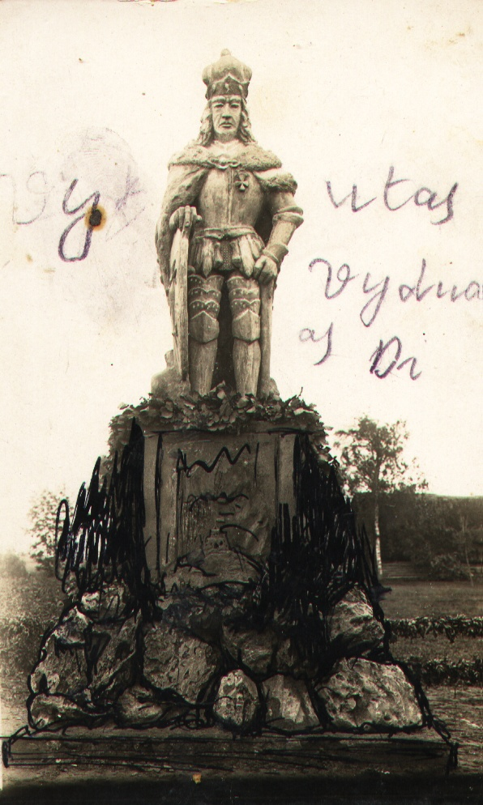
Figure 12. Vytautas
И. Vytautas. It's not in Zeimelis. It's in Lauxodis. I know.
А. Tell me about it, please. Hana Gehl told me that her brother made this monument, as if it had been put up somewhere in Zeimyalis, stood there temporarily, and then it was removed.
И. Yisrael Gel. This monument he put up. He was a sculptor and an artist. This is Vytautas the king. He <the monument> stood in Lauxodis in front of the store where the Jews used to live. I know that. It's 1929-1930, I think. It then collapsed.
А. Was it plaster or what?
И. This I can't say. Gael studied in Paris.
А. Now this picture. From what Hana Gehl (by her husband Wilk) gave me, N21 by her numbering.
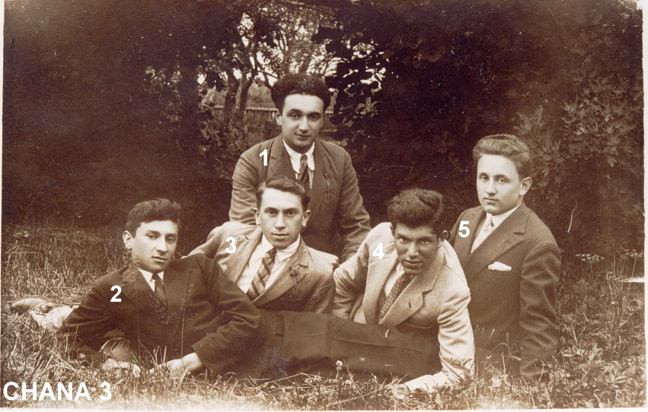
Fig. 13.
Boruch Itkin 1, Aron Yankelevich 5, Abo Ger 2, Tarutz Hanoch 3, Moshe Gel 4
И. The uppermost one is Boruch Itkin 1. She never told me who was here, who. Ganz is the rightmost. Can't remember the name, Eruhimke, I think, or Yudka, ich gedenk nit < can't remember>. No it's not Ganz, Jankelewicz 5. It's his son.
А. You said he had a daughter.
И. Son and daughter. In the center (Hanoch Tarutz, Genochke) 3. And the left one I don't remember.
А. Next photo. From what Hana Gehl (by her husband Wilk) gave me of N14 by her numbering.
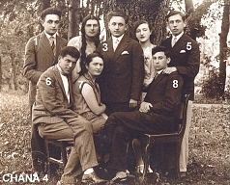
Fig. 14.
On the back of the photograph is the inscription: "On the right to the left stand: Moisei Briker, Roza Milunskaya, Aron Yankelevich, Musya Leiserovich and Boris Itkin, sitting: Abo Ger, Tzipa Tosse and Moisei Ya. Hessis. no. 14. Zeimelis, 13/VII 1929 m."
А. Photo N17 by Hana's inscription.
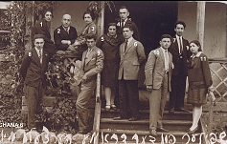
Figure 15.
И. The leftmost one standing in front of the lattice of the porch is Boruch Itkin 8. Next to Gel 9. Above Katz 3? Faivel Zagorski. 4
А. Who sits above Itkin?
И. This is the older generation. 1928. Tobacco Shoshana 1. This one was very beautiful. She went to Africa.
А. Next photo #23
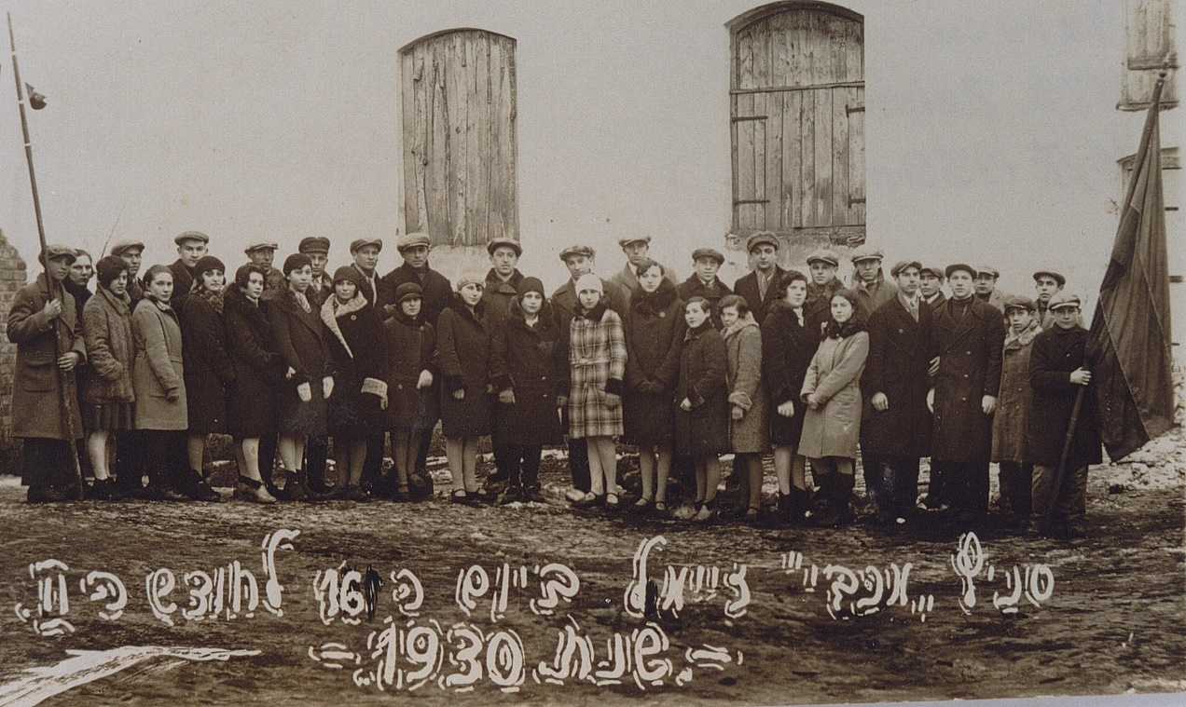
Figure 16. "Zeimelis's Maccabi. 1930 г.
И. In the right three in a light suit stands Shmuel Tarutz. The walker is Yakushok, that's right. She participated in all these circles. In front of Fayvl Zagorsky stand two, of whom the woman is Hodka (Goda) Yakushok.
А. It's very hard to see them all here.
И. Itzka Burstein <above the left window, head covering the lower right corner of the left window,
Schmulka Kremer <closes right corner of same window
Havka Lepar <wearing a black coat with a big puffy collar, tall in the area between the windows
Rochka Glaeser < one across to her right in a light-colored coat
Boruch Itkin <over the right window a head rises>
Lubka Man <just to the right, below>
Gel <just behind Lubka Man, the head is a man's head.
Man <during this, he didn't say his name>.
Moshe Yakushok <holds the flag>
А. Photo N36
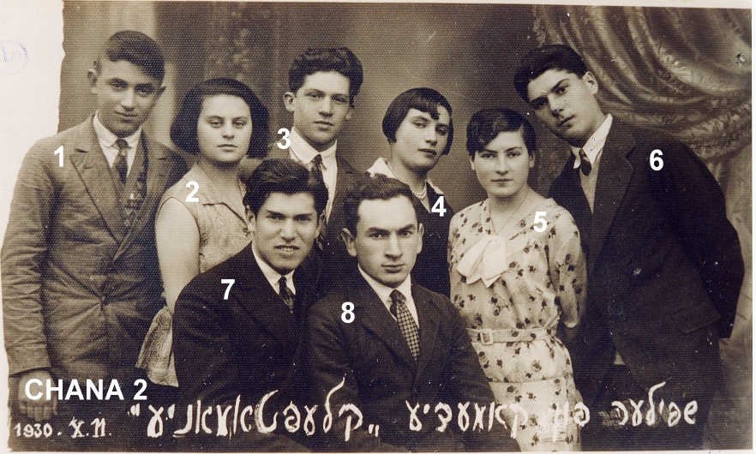
Fig. 17. performers of roles in the comedy "Kleptomania
From left to right in the back row:
И. Aba Tsofnas 1, Hana Marchunskaya 2. Wait, let me see what it says <looks at the back>. It is written correctly. Genochke Tarutz 3, second from the right Etka Cohen 5, Shoshana Tabak 4, Itzka Burstein 6.
А. In the front row. I know the left one.
И. In the center is Gel, Faivel Zagorski. In Cleopatra. I haven't performed in these years yet. Year 30. 1935-1936 I started.
Another photo

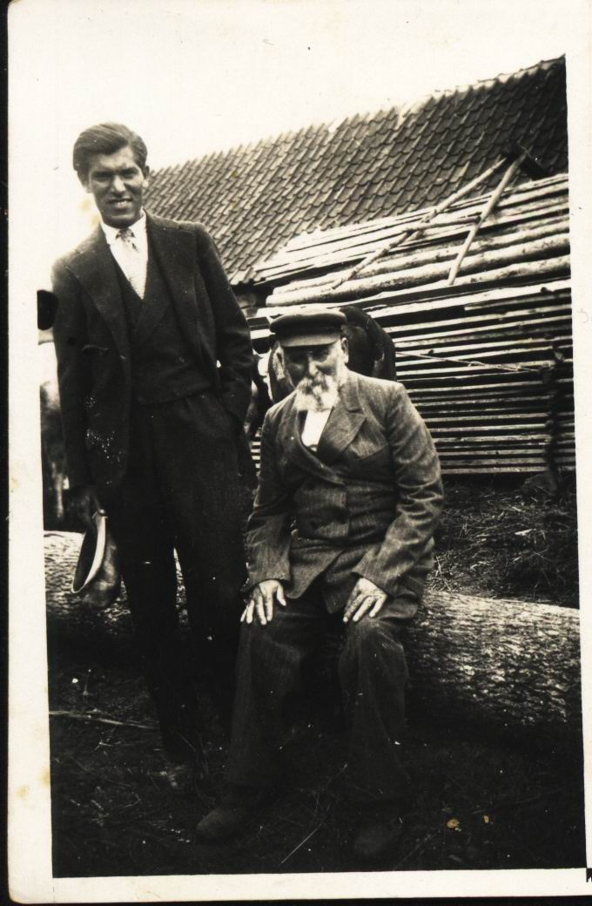
Figure 18.
И. That's Gel and his father. He was such a joker, scary <sighs, looks at the inscription>. Yankel Gehl. He was such a joker. In 1936 they were electing, 18 exequity, Jabotinsky, I told you about it. We came to him. In 1936 I was no longer a boy.
О! I remembered the name of the Lithuanian who had the massacre: Czuprinskas.
I told Gael:
- We should vote for Jabotinsky.
And he:
- For whom? For Czuprinskas? Should we vote for Ciuprinskas?
That's how we laughed. Czuprinskas was a good Lithuanian.

Thief Yuks
I want to tell you more about Jukes. There was a friend of mine who was a fighter, a good friend. He was a pickpocket. A Finn. Lived in Leningrad. And one day he and the eldest went into a big china store. He was 15, 16 years old. He was thin and blond. There was a woman and her daughter with a scribbler. And so the older one said. She had a bag. There was money in the bag. Wanted to buy something. Cut that bag off and ran out the other door. Caught him. They gave him a concentration camp. He went to a concentration camp somewhere in the center, Kazan, not Kazan, I don't remember. Then they took them all into the army. A young guy came to the army, 18 years old. He always told me this:
- I won't take your specialty anyway. And what is life like in Russia?
Asking:
- How did you start?
- It used to be like stealing: peasants came, brought testicles - they stole an egg. There was such a little neglected church, they used to change there. And that's how I got to the big pickpocket. Got into the army. After the army I got a leave of absence. Came to Leningrad. Met his friends. Started stealing. Stayed a thief: "This life is good." And he got 7 years.
I have another very important story to tell. We were in Courland. We were sitting there, there was a barn, only the walls were there. There were Germans on the other side of the river. In Courland, we had to fight back. In 1944 it was winter - October-November. We always made a fire in the middle there, to warm ourselves up. And all around were our dugouts.
I'm going back to Jukes. It was raining. In the evening, at night, a wagon arrived, one soldier. I asked:
- Where are you going?
- Going to the front. I have dry rations for officers.
Jukes says to him (thief, crook):
- Where are you going at night! The Germans are here, it's raining, it's dark. Stop your horse. Tomorrow morning you'll go to the front, or you'll end up with the Germans.
He stopped his horse, got on the wagon, covered the wagon with a tarp, and slept.
- Let's go, Yuks says to me, to see what's there.
- I'm not going.
He went. Half an hour passed, maybe 15-20 minutes. He came back, brought two pieces of American lard with salt. I said:
- What are you crazy? It's an officer's ration!
He says:
- What? Never mind. I want to eat good food.
- What are you going to do now?
We're communicators, we have a walkie-talkie. Katsikeyev was sitting on that radio. We were free. I said:
- I'm afraid to carry the hay into the dugout. If we get scared, we'll end up in a penal company.
- Well, give me the backpack.
He took the lard, went and dug a hole and buried the lard. All this happened at night. In the morning this soldier gets up:
- Stolen!
Shout, noise. The officers, the political instructor come running at once. The Russian was a political instructor, he looks, checks all the dugouts at once. Nothing was found. The soldier was crying, screaming:
- I'll get a penal company, they'll shoot me there! So and so...
It was over. A few days passed. Jukes says:
- Go dig out, cut off a piece, we'll eat.
I say:
- I'm not going, I'm afraid.
He went. I sat on the radio in the dugout. He dug out, brought a piece like this. We cut, we had bread.
А. Has that soldier already left?
И. Do I know? It took three or four days. The soldier was from a Russian unit. We are eating. And who? The political officer comes in. We didn't eat a big piece. We cut off such a small piece and ate it. It was so good.
- What are you eating? - and that Jukes was such a smart guy, I feel sorry for him. I loved him like that. He's a crook, a thief, but a good, honest, very honest guy.
- You know, I have a girl there in the village. I come, she gave me lard. Do you want me to taste it?
Eat:
- Tasty Lard.

Editing, formatting, illustrations, and explanations of the text - the author of the publication.
This last name is named by Israel far below.
The entire preceding text is poorly understood.
Apparently, synagogue books.
Chana Gel - Chana Gel - Chana 1 (mannbarry.net) Date of reference 5.08.2022. See Figure 16 below.
Israel keeps talking about the right side of Bauska Street
Israel calls it Vashkay Street.
Israel Yakushok said it was the home of a Lithuanian.
According to this version, after the shooting, Leiser was thrown into the pit in a fur coat.
See Figure 7 below.
Explanation of the handwritten inscriptions in Fig. 6 to the horizontal street (Yoniskis), here: Avraham Fleishman, garden, arrows indicate the entrance, Haesh Israel, butcher store 2nd floor house, Vilenchik, here Ger lived, Big tavern, Small tavern; on Bazarnaya Square left (west) side (from above down): Taruta, Balchunasa, Itkin korchma Moshe Green; around the corner of the square is a pharmacy.
Where the bakery is, it is not marked.
Further names correctly, the name was Chaya.
Probably a lake, not a swamp.
Next, the video is discussed.
This was not done.
Vodka store.
That's what Hana Gel told me when she met her in Israel.
Coins - Russian tens (See InterviewJAI1.docx)
Judging by the photo on the passport of Leyser Haesh, Israel Yakushok is wrong here.
See Figure 3 above.
There is no such picture in Israel Yakushka's new album.
Apparently, we are talking about the new Shulgeifer house on Bazarnaya Square.
See Figure 4 above. Israel Yakushok did not know that Leizer Haesh was not the owner of the second house, but that he was running it at the request of his brother Moses Haesh.
I called a German, not a Lithuanian.
During World War I.
That's right in Palestine.
Maybe by the fate of the Jews under occupation that became known.
YAKUSHOK - YAKUSHOK - Y60.61 (mannbarry.net) Accessed 15.08.2022.
The numbers and CHANA in the photo were added by Barry Mann.
The additional definition of the persona is mine by analogy with the other pictures.
YAD VASHEM ARCHIVES - YAD VASHEM ARCHIVES (mannbarry.net) Date of reference 7.08.2022 photo 185BO9_

