Subscribe to DeepL Pro to edit this document.
Visit www.DeepL.com/pro for more information.

Proceedings of the Fifth Meeting with Israel Yakushko on April 23, 2000

The Fifth Trip to Israel Yakushku in Herzliya
On April 23, 2000, there was a new meeting with Israel Yakushka, whom we visited with Lucy. We took the train from Bat Galim to Haifa, and since the platform at the station had changed in the past year, we got the tickets from the wrong platform. Now I have to buy tickets at the underpass to the train station and get off on the platform of the departing train. The train has an interchange in Binyamin, the journey takes one hour and five minutes .

Recording of a conversation with Israel Yakushko

Sister Basie's Wedding
И. In 1940 my sister <Basya> married Leibk Lakunischka, and they rented an apartment from Leiser Haesch. It was a long house. Go into the yard: on the right side lived Leyser and Freida, and on the left side <young people>. There was a two-story <flangement, separate> door. There was a small parlor and kitchen downstairs, wooden stairs, and a bedroom upstairs. On March 17, 1940 there was a wedding, in the same house. Everybody came, you know, when a wedding, and Lithuanians come, and a lot of Jews were there, the room was small. I was a boy, 17 years old. We ran around and Lacunishki, walked around, watched.
Leyser Haesch was at the wedding. He and his wife Freida were invited. My sister lived in this house until June 26, 1941, when we fled to Russia. The Hayeshes were sitting there, I saw them there. They were very boring, he didn't talk much. She talked. They sat there for an hour and a half. Hatana <wedding, hupa> was already there, then only the feast. He said he was tired, congratulated everyone, and went out with his wife to his house. That was the last time I saw him.
А. What date did you say it was?
И. March 17, 1941, not 1940, 1941.
А. So his apartment was already taken away from him in 1941?
И. They left this house. They took everything around, but they left this house, the other side. It was a small place, 40 meters.
А. Is that what they filmed?
И. What they filmed. No more than that. Wooden.
А. Is the staircase wooden?
И. Rude.
Too bad, there were so many photos taken during the wedding. And all these photos were left in Pomush. At the Latvian's. There were pictures of Leiser Haesch and his wife. A lot of pictures. After the war my sister wanted to find these pictures. They were looking for them. They said that the Latvian had died. Some of the pictures were found, but not all.
<Seeing in the notes of his pre-war diary, in Hebrew.
Such a Markunas, a Lithuanian. When one drove into Zeimelis from Krukai along Joniskis Street, there was an old, old wooden windmill of Markunas. From Linkova Street there was also a Czuprinskas windmill, but it burned down in 1937.
There were Lithuanian holidays, skoplerama. We all went to Linkuva. Boyarsky's car went 20-22 times, a full car.
<Showing a picture of a bus.

The Mendel Boyarsky Bus
(from the 1933-1934 photo).
И. On this bus, on June 24, 1941, its party leadership fled from Zeimelis. In the background is the house of Leizer Haesh (Small tavern).
А. Isn't that Boyarsky standing in front?
И. No.
А. Israel describes to me a picture of the Boyarsky bus.
И. The leftmost one in the white shirt is a Lithuanian, he is a ksendz, he played soccer 1.
Next to the right in the white cap is Itzka Burstein 2.
To the right in the cap, white shirt and dark jacket is bus driver Gilinas 3.
Standing in front of the bus is his conductor, a native brother of Israel Yeheska Yakushok 4.
Next in white shirt, light tie and light gray suit, breeches, Aba-Leib Tzofnas 5.
Next to me, presumably, is Israel Yakushok. When I was 12 or 13 years old, I wore pants like that with elastic bands 6.
Nearby, in a white cap and shirt, tall, Elka Baginsky 7.
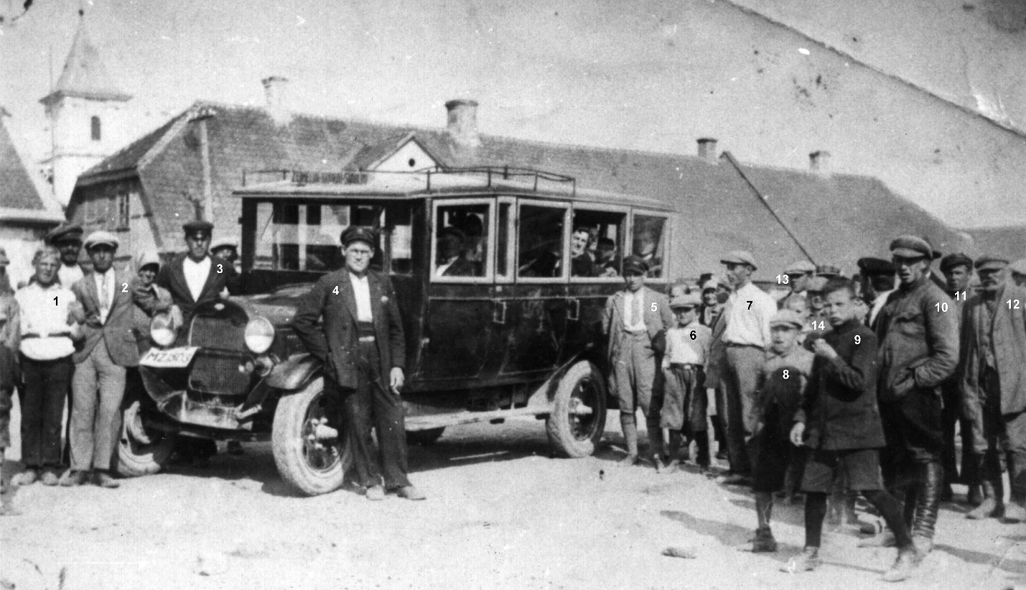
Fig. 1. Mendel Boyarsky's bus
In front, just to the right, the little boy in the cap is Notka Fleischman 8.
The foremost boy in the short pants is the son of Buzi Ehrlich, name I can't remember 9.
In the back, just to the right of Elka Baginski, in the cap is Matus Lacunishok 13.
In Russian boots, tunic - Avreml Baginsky, brother of Elka 10.
Still to the right, a leather hat, one head visible is Berka Lacunishok 11.
The old man with the beard <knows him, but didn't name him> 12.
<There is a long discussion of the Leyser house, which is in the background of the photo with the bus. We also use photo 13 of 31.08.1982.
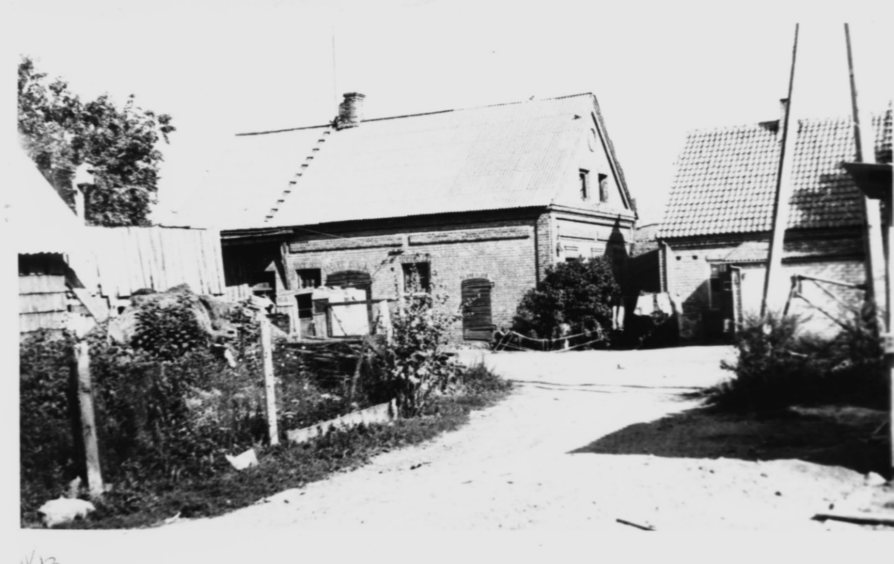
Fig. 2. View from the yard of the former barn and the neighboring house.
On the back of the photograph is text in pencil: "13. View from the courtyard of the house of Leiser Haesch, nearest to the church and the former barn next to it. 31.08.1982. Photo by A. Haesh".
И. One could enter the courtyard of Leyser's house through a gate from two sides: from Bazarnaya Square and from Bauska Street. Leyser lived from the courtyard. Israel walked from the square, it was closer to him. On the corner to Bazarnaya Pl. Glezer, according to Israel, had a bakery < photo 7 of 31.08.1982 >. Photo 2 of 31.08.1982, the right door was a barbershop. Next door was the synagogue.
The warehouse, according to Israel, where his brother worked, was in the yard, where flax and wheat were accepted. There was a carriage and cart shed in the yard, six or seven seats.

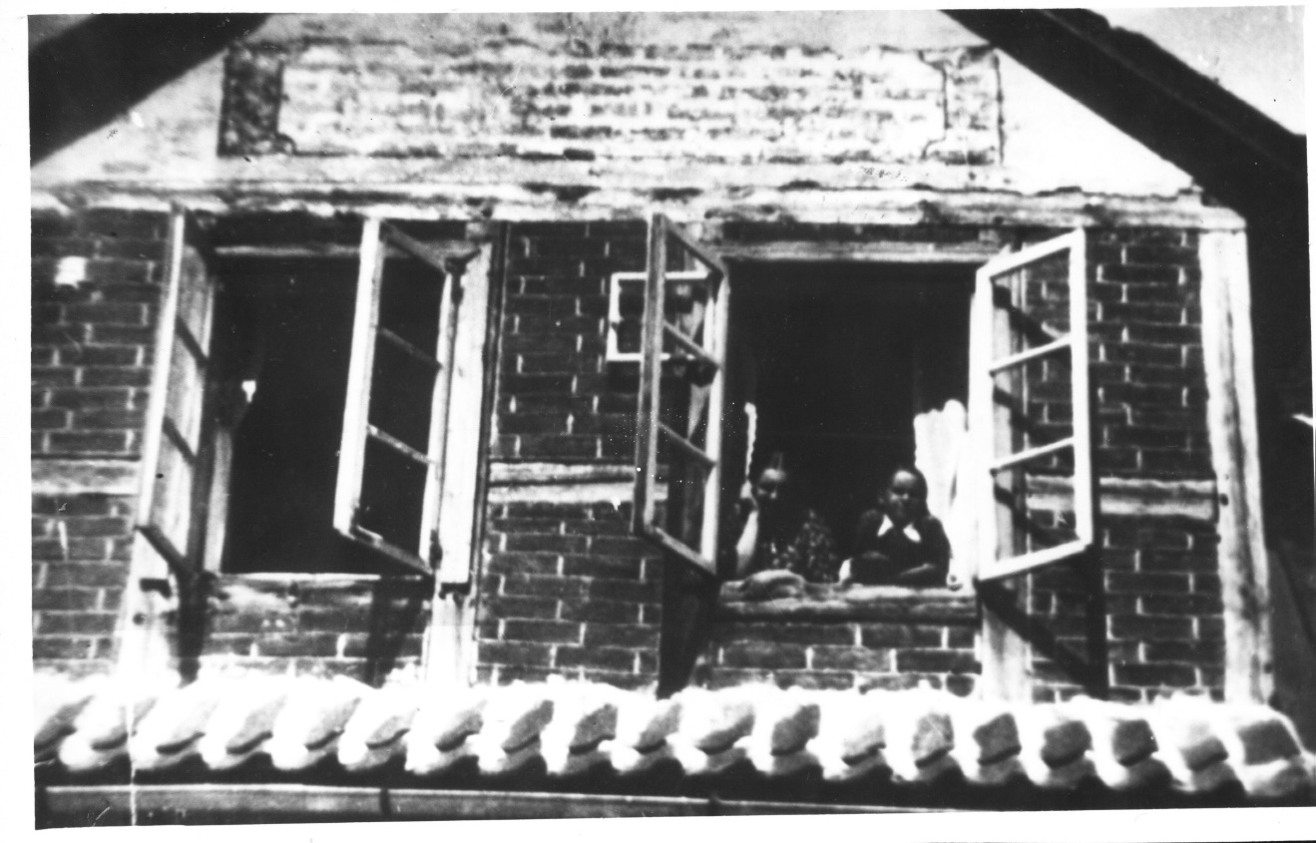
Fig. 3. Zeimyalis. Mezzanine of the Small tavern. Photo from 1930s.
А. Who is looking out of the window. Couldn't it be Freud Haesh?
И. The left could be Freida, and next to it could be Etka Burstein or Haska Kagan.
А. Did they make contact?
И. I can't say.
Merele Crystal called me from America. She is a descendant of the Lacunichock family who emigrated to America in 1907. She was born Segalinas.
Mirele was born in America. She is 72-73 years old. Mathis Lakunishok and Leizer Lakunishok came in 1907. Now there are David Lakunishok, Stephen Ha-Levi and Moshe Ha-Levi in America. And in Natanya, there is Leonid Levin living in a nursing home. This is Mirele's own brother. He is already in his 80s. There is a phone number 972 865 5461 (I learned about Yakushka from Barry Mann).

Questions about last year's entries
"Mother went to see Nisha Zagorski. What was there to talk about?
И. I don't know, but she came and said to Mota, "Go and get a sack of flour from Nisha. He had a flour store. Every Wednesday or Thursday we bought flour from him. Mother wanted to, she didn't want to go. And my father hesitated. He said:
- We lived in 1915, when there were Cossacks. Let's go to the village of Balchunas. We'll wait for the troops to come through, and everything will be all right.
А. Who said you had to flee Lithuania?
И. This is my brother Moshe, my sister Basia, myself and my brother Haimke. Young people. We pressed on. We knew that Jews were despised in Germany.
А. You said that you went around the place with the whole hebrew to agitate to go. Who was part of this team that went to the place?
И. My sister went, I went, my brother went. A few more. I know we went to see Gael. He was anti <opposite>. That they were starving, that they <in Russia> sold some golden things for half a glass of flour. Everyone had horses. Man had a horse, Gelu had a horse, Toshe had a horse. Kagan didn't have a horse because their father died. Fleischman had horses, Yakushki had horses, Lacunishki had horses. Burstein didn't have horses.
А. Did Leyser Haesh have horses?
И. Yes, yes, there were horses. I remember that on the last day we ran to Basa's to pack, packed everything up. And Leyser closed up at home: "I'm an old man, I'm this and I'm that..."
А. So you even talked to him?
И. No, I didn't, Basya told me. She knew a lot. She lived in this house. Leyser didn't have one horse-two or three horses.
А. Did Basie have children?
И. There are children. But they were born after the war.
А. Don't they know anything? Maybe their parents told them something? Maybe there are some diaries left, pictures. Couldn't there be some kind of photo album?
И. I took all the pictures. Sraga Lakunishok, her son, is an engineer. He lives in Tel Aviv. And when he moved into the apartment, he said: "I'm going to throw away all these pictures." I said: "What are you throwing out! I'm taking them all." And I picked out all the ones <that were interesting>. And my daughter lives in Paris. She knew more. She was told more. She was born in 1947. He was in 1954. She might know something, but I don't really believe it.
А. So you, Moshe, and who else went agitating?
И. There were a few more, refugees who fled from Šauliai, from Taurage, from Kelme. They ran to Zeimelis. They lived in the synagogue. They slept there for a few days only. And they also agitated to flee from there. Especially those who were from Taurage. That's on the border with Germany. And they also agitated, they agitated a lot, to escape. And a lot of people gathered then, but at the last minute they saddled their horses back and said, "We'll survive."
А. You say that our troops, who passed through Zeimialis on the last day, were retreating from Riga. But Riga was not taken by the Germans until July 1?
И. I think they were retreating from Joniskis, from Linkuva. Not from Riga. Riga was still free. We passed the Daugava. We went through Pomuše.
А. Where were they retreating from?
И. They were retreating from the central <apparently relative to the border> part of Lithuania, from Siauliai. Siauliai was taken earlier, on the 24th-25th.
А. There were very heavy battles in Shauliai.
И. I know where those battles were fought: Kriskalnis. There are a lot of lakes there between Kelme and Siauliai. And then there's the Dubissa River. There were big battles on it. But some were retreating. Came <to Žeimelis> at night. Small soldiers. Small ones. Then they opened a store for them. They were given groceries. They paid, they didn't pay. The manager of the store was Berka Lakunishok. We just went to the store, we bought sprats there.
А. I am interested in the route of your escape, because your account differs from that of Zagorski. He says that you went through Chaloche, Birch, Skalskaniste (Schoenberg), Nairi, and you say that you went through Bausk.
И. Shalote. I was wrong, we were going to Birzhi, not Bausk. Pomushe on the border of Lithuania and Latvia, up to Nairi, was there on the road. I remember, because we left a lot of things there.
А. Why on the way to Pskov did you talk about the Latvian-Estonian border and not the Latvian-Russian border?
И. There's one there, "spitz" called, near the Estonian-Latvian border and the Lithuanian-Russian border. we only walked a couple of kilometers through Estonia.
А. You said some of the refugees came back from the road, Fleischmann, Rabbi Schneider. Who else?
И. I can't remember.
А. What is the title of the book about Zheimelis that Charlie Berman has?
И. Not Charlie Berman's. Mendelssohn. I gave him this book.
А. What kind of book is this?
И. I was in Zeimelis in 1994. They opened a museum for me and they sold books there. In the museum. About Žeimelis and the environment of Žeimelis.
А. Is it white like that?
И. Maybe. It says who ran away. The Tarusians ran away. The Yakushkis ran away. Fayvl Zagorsky's son bought this book and gave it to me to give to Mendelssohn. He lives here in Herzliya.
А. What is known about the old woman Pruhno?
И. In February of this year she died. Ita Pruhno.
А. How did she get here? The Prukhnos didn't run away with the convoy, did they?
И. This is Moti's wife Yakushka. There is a daughter and a son. The daughter Shulamit was born a month before the war. She lived in Rishon Lezion. Meir Yakushk has a telephone number. He knows her.
А. You said that gymnasium students and German officers came from Linkuva. Who told you there were German officers?
И. There were two German officers.
А. According to other reports there were no Germans there.
И. Not true. Gymnasium students from Linkuva came, and there was someone from Lauxodis. That's what the Lithuanians told me. Molnikas told me.
А. Didn't Molnikas take part himself?
И. After the war, he was also a policeman .
А. You said that he took the coat from Leyser.
И. There were several Molnikas. Why did they take the coat from Leyser Haesh? They thought there were gold coins in it. And Freida said:
- Give me the coat, give me the coat.
Not Freud, but Freed.
Molnikas used to herd the cows my father bought into Riga. Then he became a policeman in '40, under the Soviets. And then he ran away with us: him, Balčiūnas, and Vilkauskas. Three or four Lithuanians were with us. They were policemen. They ran on foot with us. They were not taken on the bus. The bus of party workers only took them.
А. And this Molnikas told you after the war?
И. The other is Molnikas. Two died at the front. The policeman Nanartonis returned. He recounted.
А. But if he was not present, how does he know that there were Germans?
И. Other Lithuanians told. I don't remember last names. There are pictures of them. We took pictures after the war. And my dad was there. They told stories. Then there's one woman, Gudayte or something, who has everything written down. She knows everything. When I was in Zeimelis, they offered me to go to her. But I didn't go because I had already talked to her once. Faivel Zagorski talked to her.
А. I would like to talk to Zalman Berman and Rivka Berman. They probably speak Russian.
И. Yes. Zalman says. He has a cousin in Leningrad, she's a doctor. She was born in Kaunas.
А. In the story about being a prompter, I didn't understand In geheg noch a man.
И. Geheg - to flee, to chase. There two sisters fell in love with the same man, and it led to tragedy. "Chasing the Husband."
А. Where was the place where, according to your stories, the Jews of Zeimyalis gathered and chatted?
И. Prisba was the name of the place. Mom always scolded Dad for hours of chatting there. Milunsky's house. It was on the corner of Bazarnaya Square and Joniskis Street. We kids used to go there to eavesdrop, and we were chased away.
А. You said, "All the Baginskys are brothers.
И. Three <Hertzke, Elka, Hatzke> died. I was at their house as if I were at home. Elka died earlier in the Soviet army in 1941. He's Yosif's son. And Avreml later. With my Hatzke, Hershke and Joschka Lakunischka."
А. It's not clear to me how Hatzkel Jakushok died after all, in Zeimyalis or not?
И. No. They deserted from the Soviet army. They fled back to Zeimyalis, Elka, Hatzke, Gershka. And they were caught by the Lithuanian partisans and shot.
А. Are Gershka and Hershka the same thing?
И. Gershka and Joschka Lakunischka. Joschka is Josef.
А. Are Hatzke and Hezke the same thing?
И. Yes. Same thing.
А. You said that Yeshua Lakunishok is somewhere in Israel, in Holon.
И. Yes, he's 75 years old. I talked to him. He remembers Lazer Haesh. I talked to him about him.
А. He might remember something?
И. No, he doesn't remember anything more than me.
А. Shmuel Tarutz in Natanya, you said.
И. He had already died. He went to Israel in 1936 or 1937.
А. You spoke to someone at a funeral in Raanaan. Very religious. Isn't that the Estersons?
И. Yes. He's been writing the book since 1500, almost from the time of Ivan the Terrible. He finds everyone, everyone. He writes about the family, first, where the roots come from. It's Berman who knows well what Esterson writes. When my son got married, I sent them an invitation. But they didn't come because they were afraid the food wasn't kosher. Charlie Berman told me this. The Estersons live in Raanaan.
А. Doesn't Charlie write his own books?
И. He works at Hi-Tech. Works here in the archives. He has a connection with overseas. He speaks English well. He's about my age. He doesn't speak German, but he has told me several times that he wants to learn Lithuanian.
А. Aba Milechik in Herzliya. Would it be possible to find his phone number in the phone book?
И. I don't know if he's still alive. There's no contact with him. I can't say.
А. You said that some son of Zagorski lives in Herzliya, not Fayvl, but another. Where?
И. This is Mendelssohn, Zagorskaya was his mother. He was also from Siauliai.

Homeowners and tenants.
А. We skipped the description of the inhabitants of Linkowa Street last time. <I use a modern color plan received from Man. I point to the semi-circular house N25>.
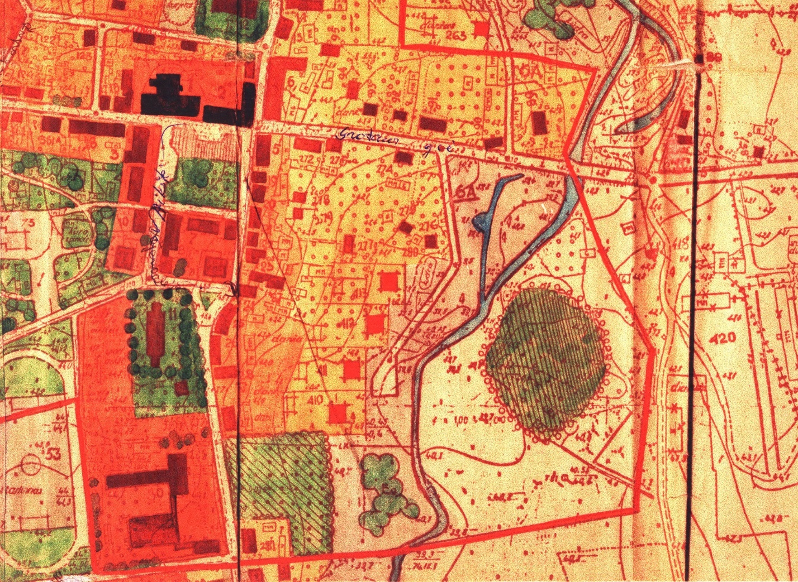
Figure 4. The Žeimelis plan. Before 2000.
И. A wooden house. Faivel Zagorski lived here.
А. That's right. These houses once belonged to Abramovich.
И. This is Abramovich's yard here.
А. The one on the end?
И. < Apparently Israel goes to house N24. This was the school until 1928. A brick red house. It stands now, too.
А. <Trying to clarify which house> So, between the Zagorsky house and the house standing on the end, perpendicular...
И. Zagorsky lived here. The house is two stories high <not quite clear what kind>.
А. Semicircular, is this Zagorsky's house, or did Zagorsky live farther away?
И. The house was long. Here was Lejba Lakunishka's <smith's shop>. And here further on it was already two stories, like a tavern. It was like an inn.
А. On the second floor?
И. Kagn <Kagan>, he lives alone here in Israel. Not Haska Kagn, but others. And further on, Tzofnas lived here.
А. Next to the semicircular house, further towards Linkuva Tsofnasa St. The house.
И. And it was a school.
А. I can't figure out which one is Tzofnasa. Which one is perpendicular?
И. Yes, the entrance was from here, from Linkovskaya St. Behind the school was Alter Abramovich's yard. There was a big, big yard, and there were his warehouses. He bought everything.
А. And further still with such a gap to some distant house?
И. There was a store here. The Wolfsons lived here.
А. The very last house.
И. And this is where my grandmother used to live.
А. What was your grandmother's maiden name? You don't remember? What was her name?
И. Sarah. Papa's mother. Yosif Yakushok was her husband. And then they went to live closer to the square, behind the semi-circular house next door. My cousin was born here. She died already in Kaunas. The house belonged to the Lithuanians. She had a small apartment.
А. Who else did you say lived in the semi-circular house?
И. No, I was wrong, there was a Lithuanian library in this house. Lithuanian newspapers were read. I went to read. And a little further on, the Bershtelis River runs in this place.
А. No, the Bershtelis River is out of the way.
И. Grandma and Grandpa lived here.
А. Two houses next to each other.
И. And next door lived her daughter Shayna and her husband Karo. He was in the Russian army.
А. We're talking about the neighboring houses facing Linkovskaya St. And even farther to the square?
И. There's a big house over there. It's in my picture. It's Lithuanian, beautiful, two-story, built in the 1930s.
А. Who lived here?
И. Physician. Jews did not live here in this house.
А. From the semi-circular house the 3rd house in it the Jews did not live. <Maybe there is an error in my counting here> Next?
И. Next was the Lithuanian bakery. And then a two-story red brick house. It's on the corner of the square. There was a store downstairs for the Lithuanians, and then the store I told you about, from which the Russian soldiers came and took all the food.
А. And what's next on the square?
И. The house is the same, in the depths it went. It was a manufactory store. There was a Jew. I don't remember his name <Israel used to say it was Zagorski's brother>. He was always smoking, sticking his cigarette butt in his sleeve. There was a Nisha Zagorsky on the corner, and between the house lived a hatter. Leib. They were good guys, three brothers. Then they went to Siauliai. Their father was a hatter. The last name is there too <in his list of the dead>. I don't remember now.
А. I didn't understand last time where you lived, where the house you were renting was.
И. The house overlooked Bazarnaya Square.
<Long we're figuring out where Balchunas' house was, where Jakuszka's apartment was rented. Israel does not understand the color plan, which I show him. Then I draw him the Bazar Square myself. He understands my drawing and points out that his house adjoins the west side of the square, it's first on the right in the street that goes from the square to the Lutheran church and is located just opposite the pharmacy. On the 1897 plan N28 (Isroel Green). On the modern plan N10> .
А. You mentioned Etku Baginskaya in Israel.
И. I had no contact with her.
А. What year was she born, approximately? Younger, older than you?
И. Three or four years younger. <1924-1925
А. What is the father's name?
И. Josiah Baginsky. He was a tailor. Mother Reisa or Rocha, I don't remember well.
И. <possibly an omission in the record>. ... 1929. My cousin lives in Leningrad. My last name is Russian, I don't remember. Her husband is Russian.
А. What was your mother's name?
И. Feig. She was born in 1886. Her parents are Kretsmere.
А. Now it is clear that you are related to the Estersons.
И. I received a letter from Germany. My brother alone died in Majdanek, or rather not in Majdanek, but... My son got the letter. They didn't find me. I was living in another apartment in Tel Aviv. And it said that my brother Leivi Yakushok was arrested on August 16, 1941 at Kristaicho Street in Kaunas. He was doing forced labor at an airfield in Kaunas. It's all written in German.
А. Where is this letter? A. Bring it to me, please.
<Copy received from Yakushk and contains nothing new to Israel except prisoner numbers.
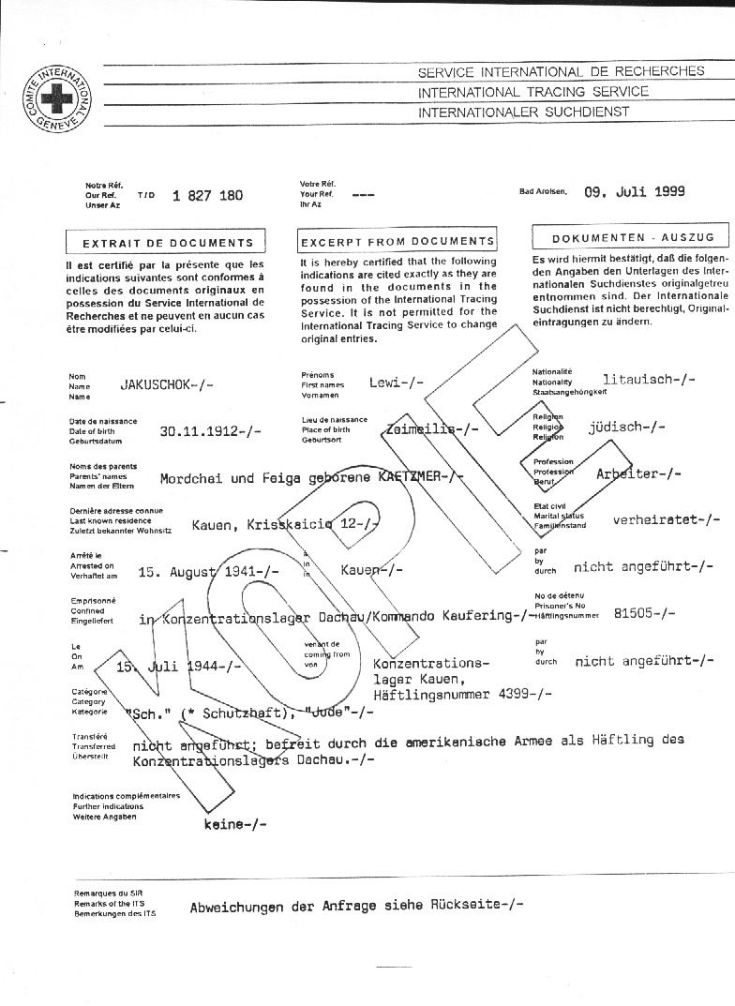
Figure 5. Letter-response on the fate of Leivi Yakushka
И. Esterson has been writing since 1500. He takes the whole family. It comes down to the last one.
А. He wrote me that his wife was from Zeimelis.
И. No, she was born in America.
А. Roots from Zeimelis.
И. Yes, rooted in Žeimelis.
А. Who lived in the corner house on the <western side> of Bazarnaya Square on Joniskis Street?
И. Here was Yakubovich's bakery. Yakubovich's whole house, here the ovens were his and this <equipment> occupied the whole house. On the second floor lived his family. There were three children. And then on Joniskis Street my grandmother and my aunt Sheina were already living there. They had moved here from Linkuva street. And over there lived Gel and Haska Kagan and Milunski and a Lithuanian. All on this side.
According to the other lived Yisrael Haesh, Fleischmann, Trumpf, Mana related.
А. Kibarsky, is that a last name?
И. Yes. He's a doctor. I met him here.

Clarification of combat episodes
А. Please describe the details of your participation in the battle near the village of Alekseevka.
И. We stood with the Orlov front in the reserves.
А. I'm interested in the fight itself.
И. There was a meter deep snow. We were walking, every night, for many kilometers, and they would not let us eat, because the kitchens were lagging behind.
А. They came at night, shooting. A big village, 7 km long. That's where they threw us right to the front. Germans were retreating there. Behind Alekseevka we were delayed. The village of Semidvorka was there. We were not prepared in any way, thrown at night to the front line. There were no shells. I was in 76 mm artillery at the time. Shells were left <behind>, there was nothing to shoot with. Only rifles. And in Semidvorka, a small village on the hill, two or three Germans with machine guns. Started to mow us down. They were falling as if we were dead.
А. Did you also go into the attack or did the artillerymen stay behind?
И. Yes, yes, went into this attack. Then they took us off, as if we were supposed to prepare guns to fire. In the morning it was quiet. They said there were a lot of dead.
А. And were you walking and did people fall beside you, or were you somewhere in the second row?
И. No, we were in the front row. Luckily I wasn't hit. There were 75-80 Jews in each company. On the second night, they took us off the front line. It was freezing! The snow was like sand when you go to the beach. No shells for the guns.
Horses were harnessed. They instructed us to take all the dead from the battlefield.
А. You attacked at the Kursk Bulge, you told me that you took Orel. Tell me something about those battles. Did you also act there as an artilleryman? What did you do there?
И. I was still an artilleryman there. On June 5 (or July, I do not remember exactly), German planes flew, you cannot count how many of them were coming, you cannot! And they flew over us and did not bomb us. Where did they bomb? Behind us. There were tank divisions. There, they told me, they bombed 60 tanks, I can't say exactly how many. The antiaircraft artillery shot down some "Messerschmidt". Then on the second day we went to attack at night. We bombed a little. There were no woods in the Kursk region. There was a flat place. Once in a while there were bushes. On the second night, all artillerymen were taken and sent to the front line to dig trenches and at night, at 11-12 o'clock to attack Germans. And at night there was an attack. I took part in it too.
We did not attack successfully. Some of them went back, some of them were killed. We were taken down.
This was the Orlovsko-Kurskaya Bulge. Then on the left, on the right tank divisions and infantry and artillery started pushing on the Germans and closed them into a cauldron. Then ours, there were more soldiers, chased <the Germans>, we entered Orel.
А. You told me about the thief who fed you, who stole your fat.
И. Wolfman?
А. I can't understand it. One you called Mantis and the other Yuks.
И. Yuks was an Estonian from Leningrad. He was a specialist thief. And Bogomolnikov played the mandolin and sang beautiful songs.
А. Who were you dragging from the field of the murdered man by the legs?
И. It was Bogomolnikov, a Komsomol member, secretary of the Komsomol organization, tall - 180 cm. He was always hungry.
А. And Volchok?
И. He died. He called me a "kike face. I hit him with the butt of my gun. He hid in the pipe, forming a small bridge. Volchok was taken to the hospital. Then the officer started dealing with me. Dealt with the commissioner. Commissar Meer Sher, a Jew himself, but didn't like Jews: "How so! You have no right to do vigilante justice!" This was in Belorussia at the end of 1944.
Zalman Berman, with whom I spoke, said that Basi's wedding was where the store was. The windows overlooked Bazar Square. He said. Leizer Haesch lived in the house where the windows overlook Bauska Street and Bazar Square. I asked him why, because he knows more. He was in Panevėžys. He was a yeshiva student there. Tarutz, where he lived, I said exactly, Yankelevich exactly, Boyarsky exactly. Jakubowicz corner house with a bakery for sure.

Viewing photos from Hana Gehl
<Review photo in front of synagogue . People are identified by Israel, I repeat his words. From right to left>.
(38) Moshe Yakushok, most right-wing.
(28) Shmuel Kremer, next, head sticking out in a Shmuel Kremer cap.
(37) Berka Lacunishok, next to the first, light-colored collar, gray coat. Cap on.
(27) Froyka Yakushok, in the back, in a gray coat, back row two.
(36 Doesn't remember the name, the young man in black.
(26) Mateska Lakunishok, right behind the unknown man in black.
(35) Itzka Burstein, next, seventh from left.
(25) Schmulka Gel, in his gray coat, next, he was in Paris.
(34) Kagan, the girl at the front, but a different one, not the one in Rishon Lezion, can't remember the name.
(24) Shmulka Tarutz, to the left of Kagan, stands under the window.
(33) Lubka Man, in front of him, a neighbor from Kagan
(23) Boruch Itkin, standing under the window, tall head sticking out.
(32) Rochka Glaeser, the little girl in the light-colored coat.
(22) Tarutz Arch, a little to the left, head above it. <Reviewing the enlarged photos called him Hirschka Tarutz.
(31) Shifka Tabak, the girl in the black coat in front of the Arch of Tarutz.
(30) Rohka Itkin, tall, shaggy collar, dark coat.
(21) Orca Mann, father of Barry Mann, who lives in America.
А. No, he went to South Africa?
И. Yes, but he was with my father. They traded cows and took them to Riga. That's Man. He was big like that! In '30 they left, Orca Man.
(29) The girl in the checkered coat, knows her, but can't remember her name.
(20) The young man behind her back, it's not clear who,
(19), (18) Two girls, can't remember last names
(8) Yankelevich, between them, the right head at the left window.
(18) Heika, the wife of Charlie Berman's brother, I forget the last name, there were three sisters.
(7) Wolowitz.
(17) Stirka Marchunska, below? the little one in the gymnasium bonnet.
(16) Haika Marchunska, Stirka's sister, light collar, gymnasium hood.
(6) Tzemahka Yakushok, behind Haika, he died at the front.
(15) Zelda Lakunishok, next to Haika, then became Cher, a tall girl.
(5) Not known.
(4) Mateske Lakunishok, wearing a light-colored cap.
(13) Presumably Yankelevich, just to the left of Fivel Zagorski.
(12) Doesn't remember.
(3) Faivel Zagorski.
(11) Man, third from left in the dark cap.
(1) Doesn't remember.
(9) Someone from the Manes, holding a flagpole.
On the right is the Lithuanian flag yellow, red, and on the left is the Maccabi community flag.
<Photo of "Chana 2" dated 11.X.1930
1 Leybka Tsofnat
2 Haika Marchunska
3 Genachke Tarutz
4 Kagan, Hasya Kagan's older sister. Hasya and gave me this picture during a meeting with Hana Gehl.
5 Shifka Tobacco
6 Itzka Burstein
7 Moshe Gel
8 Faivel Zagorski
<Photo of "Chana 8">
И. It's in Žeimelis, the Lithuania-Latvia verification point <tamozone>. I've been there. This family probably came from Riga. I don't remember them.
<Photo of "Chana 7">
Moshe Gel is standing. Sitting there is his father. He was a big joker. Sitting in the yard. The barn is like this. Shmulke Gel <it's not clear if that's the old man's name, because in the conversation I corrected that it wasn't Shmulka but Moshe>. He lived in Reshon Lezion.
<Photo of "Chana 3">
1. Aba-Leibka Tzofnat
3. Hirschka Tarutz
2. the father was a hatter
А. Isn't that Kramer?
И. Not Kremer
4. Moshe Gel
5. Doesn't remember
<Photo of "Chana 4">
1 Itkin
6 Moshe Gel
He didn't name the others: "I don't remember, it's in the 30s."
<Picture of "Chana 6">
2. Katz
9. Moshe Gel
4. Faivle Zagorski
5. Jankelkiewicz, presumably. Can't remember her name, the one who went to university in Kaunas. I think Joseph Schulgeifer, who was rescued by the priests, was her child.
10. Schmulka Tarutz.

Viewing photos from Israel's album Yakushka
A continuation of the conversation with Israel Yakushko. He tells us exactly who is in what pictures.
<Y7 from the album Israel Yakushka
17 Charlie Berman
23 Tosche
18 Tosche, two brothers, they are related to Gel
1 Yakushok Batya, she has such a hat
7 Freidka, can't remember the last name.
20 Raska Fleischmann
12 Hanka Kagan.
13 Milunsky, who had a mill
9 Lubka Man.
А. 14 is that a teacher?
И. That's not a teacher, that's "Ha Shomer ha Tzair. There were mostly girls there, and in "Beitar" there were boys.
<go to the next track of the audio recording.
<Y26 from the album Israel Yakushka
И. It's a school.
1 Israel Yakushok
17 Haim Yakushok, brother of Israel Haimke, tanker
4 Abka Milechik
3 Lakunishok Yeshua, the one who still lives in Israel
6 Yakushok, went to Africa.
32 Volovitch, teacher
33 Green, teacher.
41 Note Fleischmann
19 Hanka Milechik
18 Tosche, <uncertainly, says:> "I'm confused, maybe still."
21 Rivka Berman
23 Yudka Jakubowicz
<Y28 from Israel's album Yakushka
1 Leiba Lakunishok
2 Avremka Baginsky
3 Moshe Yakushok
4 Gel <Mosheh, I added to Israel's words. Apparently this is a mistake - a discrepancy with past identification>.
5 Gershka Tarutz
6 Gershka Hayet
7 Aba-Leibka Tzofnat
8 Froika Yakushok
9 Itzka Burstein
10 Meir Yakushok, he's alive
11 Haimke Lakunishok
<Y42 from Israel's album Yakushka
And on the left is the goyim. That's the two-story house on Linkova Street. It's an alley.
4 Leiba Lakunishok.
3 Molnikas.
А. The one who was a policeman, or the one who shot Jews?
И. A lot of kids were there, I can't say.
<Y46 from the album Israel Yakushka
2 Israel Hayes
12 Avremka Baginsky
10 Lacunichok
5 Berka Lakunishok
All the Jews are here. This is in Siauliai.
<Y47 from the album Israel Yakushka
И. Mixed composition.
11 Lithuanian. officer.
7-11 all Lithuanians
3, 5, 8 three brothers who lived in Klaipeda, Lithuanians, played in the Israeli team? <apparently Lithuania>. They came to help the Zeimelis team win the round robin game <championship>. The stripes are the Maccabees. This is two teams, not one team. The name of the team was "Shalmas". In '37 all young guys, most of them left Zeimyalis.
Haim Lakunishok,
The priest who played...
2 Gershka Tarutz.
1 Lithuanian, Jankauskas or Janulis, he played in Maccabi all the time
Were there Lithuanians in Maccabi?
И. There were Jews in Maccabi, but they kept one or two Lithuanians when all the young people in Maccabi left. The captain was Leiba Lakunishok. Three or four Jews in the picture
<Y70 from the album Israel Yakushka
Blumka Lepar - first on the left
Hanetka Gel, Lubka Man, Basya Yakushok, Stirka Marcunska, Haika Marcunska
А. You name it so fast, I don't have time to write it down.
И. Nothing to write here, we've seen it before.
А. Well, okay.
<Y77 from the album Israel Yakushka
Shot in the locality of Kurshenai, near Siauliai. Lists numbers of Jews without naming names:
12 Baginsky.
3, 6, 7, 10, 11 - Jews
А. Baginsky is a storyteller who served in the tsarist army?
И. Baginsky - tailor
А. Did he have boots?
И. No, Burstein's. Asriel Burshtein took the boots off some Pole during the revolution and came to Russia, where they were "taken off him by Stalin in Russia.
Baginsky's wife was the Vilenchiks' sister. The Vilenchiks were rich. There were two brothers. They had a big warehouse on Joniskis Street, bought seeds, flax, then sold it. That is how they lived. Then one bought a land lease outside the city. That house is still standing. I, when I drove from Krukai, you could see this house. There was a Jewish pasture nearby, four hectares.
Baginsky was a good tailor of overcoats. All the policemen sewed for him. But there were poor people - four children, I went to them. Avremka Baginsky. He finished four grades of grammar school. He served in the Lithuanian army. And he was a leftist. He was in Beitar.
And then, when the Russians came and occupied Lithuania, he became first secretary. He knew the Lithuanian language well. He was in Zeimelis for a short time, two or three months. Then he was transferred to Siauliai. He became secretary of industry there. His brother Elka Baginski, his sister Etka Baginski and his brother Tuvka Baginski. Tuvka died in Tashkent from illness. In 1941 or 1942.
This Baginski, the tailor, was a very nervous man. When all the children ran away, he and his wife stayed in Zeimyalis. He died like all the Jews of Zeimyalis.
Mann told me this: "Come with me to Zeimelis. - "Where am I going to go, I was a few years ago.
He says, "You know every house" - "I know every house, and I know who lived in that house, too. It's better when you remember.
I love it, but I have no one to discuss it with. Only with Zalman Berman can I talk. How difficult times were. How the Jews lived there. How they went to the market. How they earned candy. They were small. There was no way to teach them then. They were sent to Siauliai. In Žeimelis there was no production, there was nothing, you had to live from something. I talk to him on the phone, almost every week.
А. Yeshua Lakunishok where does he live?
И. Holon. He lived in Šauliai since 1937, but I was more connected with Žeimialis. There's also Meir Yakushok.
А. Who is their father? They have different fathers there, aren't they siblings?
И. There were seven brothers and a sister. Matesca,...
А. Who is the father of them?
И. Moshe, and the mother of Dobra Lacunishok.

Editing, formatting, illustrations, and explanations of the text - the author of the publication.
The meeting was mainly devoted to clarifying and supplementing the information that Israel had provided at previous meetings. Sometimes it was not possible to understand his information accurately.
See InterviewZI2.docx Fig.5.
See IntrerviewJAI4.docx Fig. 3.
Israel Yakushok calls policemen policemen.
This whole part of the conversation "Homeowners and Tenants" is extremely unclear. A much clearer description of the houses on Linkuvos street in Faivel Zagorskiogo's stories. The Balčiūnas house turns out to be the next one, than was understood in the previous interviews.
In the intervening time, Barry Mann enlarged the photo and put numbers on it. Chana Gel - Chana Gel - Chana 1 Left TEXT (mannbarry.net) Chana Gel - Chana Gel - Chana 1 Right TEXT (mannbarry.net) Date of circulationJAI;/d 20.08.2022.
See InterviewJAI4.docx Figure 17.
Chana Gel - Chana Gel - Chana 8 TEXT (mannbarry.net) Date accessed 20.08.2022.
See InterviewJAI4.docx Figure 18.
See InterviewJAI4.docx Figure 13.
See InterviewJAI4.docx Figure 14.
See InterviewJAI4.docx Fig. 15.
Instead of placing photos in the text of this publication, indicate their designations on the six sites indicated. (Y01-Y13) http://www.mannbarry.net/Zeimelis/Photos/Yakushok/album/index.html (Y14-Y27) http://www.mannbarry.net/Zeimelis/Photos/Yakushok/album/index2.html (Y28-Y42) http://www.mannbarry.net/Zeimelis/Photos/Yakushok/album/index3.html (Y43-Y56) http://www.mannbarry.net/Zeimelis/Photos/Yakushok/album/index4.html (Y57-Y70) http://www.mannbarry.net/Zeimelis/Photos/Yakushok/album/index5.html (Y71-Y80, Y1946) http://www.mannbarry.net/Zeimelis/Photos/Yakushok/album/index6.html Date of reference 22.08.2022.
Israel used to say that Tuvka Baginsky died of dysentery in a Tatar hospital, which is probably correct.

